  Year 6 · Shape · Step 6  Missing angles in triangles | 
  Year 6 · Shape · Step 6
  Missing angles in triangles
  1 | One side of the triangle is carried on in a straight line. Work out the size of angle x.  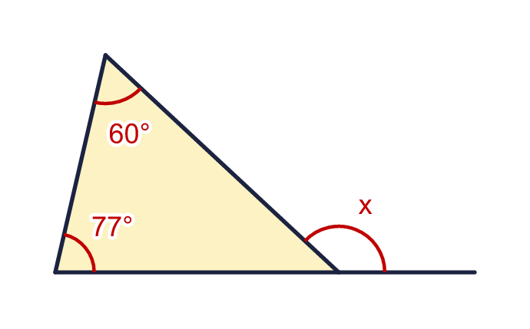
    x = |  | °
  1 | One side of the triangle is carried on in a straight line. Work out the size of angle x.
    x = |  | °
  2 | One side of the triangle is carried on in a straight line. Work out the size of angle y.  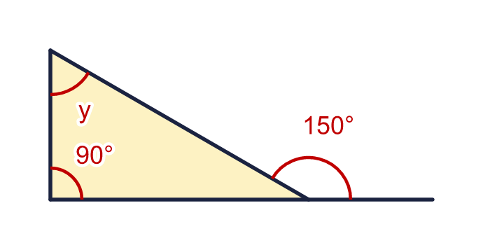
    y = |  | °
  2 | One side of the triangle is carried on in a straight line. Work out the size of angle y.
    y = |  | °
  3 | Work out the size of angle z.  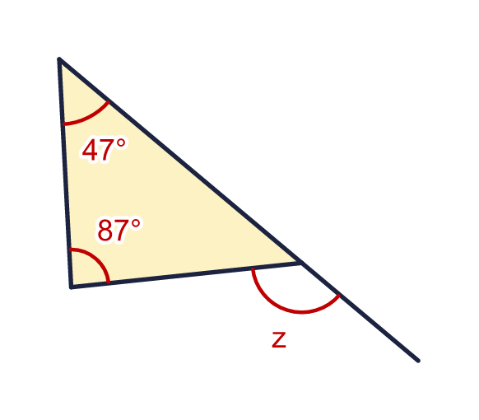
    z = |  | °
  3 | Work out the size of angle z.
    z = |  | °
  4 | Two straight lines cross at a corner of the triangle. Work out the size of angle x.  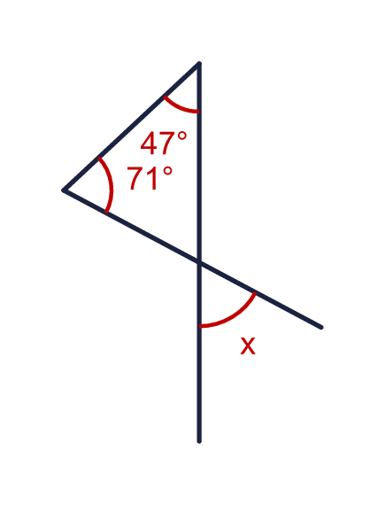
    x = |  | °
  4 | Two straight lines cross at a corner of the triangle. Work out the size of angle x.
    x = |  | °
  5 | This is an isosceles triangle. One side is carried on in a straight line. Work out the size of angle x.  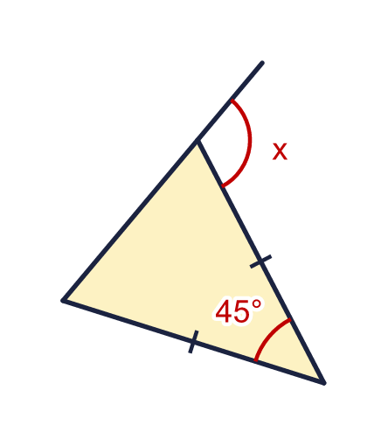
    x = |  | °
  5 | This is an isosceles triangle. One side is carried on in a straight line. Work out the size of angle x.
    x = |  | °
  6 | This triangle has a right angle. One side is carried on in a straight line. Work out the size of angle w.  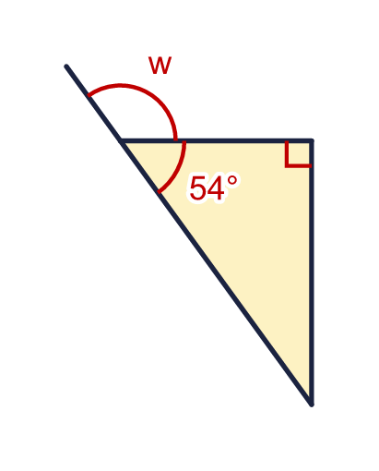
    w = |  | °
  6 | This triangle has a right angle. One side is carried on in a straight line. Work out the size of angle w.
    w = |  | °
  7 | An exterior angle of a triangle is 136°. One of the two interior angles opposite it is 80°. What is the other interior angle opposite it?  a) The other angle is
  7 | An exterior angle of a triangle is 136°. One of the two interior angles opposite it is 80°. What is the other interior angle opposite it?  a) The other angle is
  8 | Two triangles are joined along a straight line. Work out the size of angle x.  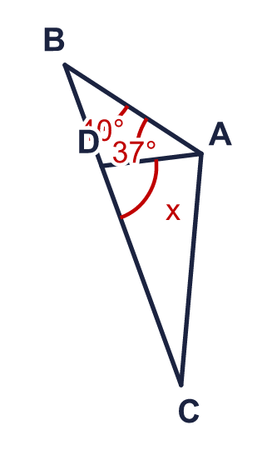
    x = |  | °
  8 | Two triangles are joined along a straight line. Work out the size of angle x.
    x = |  | °

  9 | Two straight lines cross at a corner of the triangle. Work out the sizes of angles a and b.  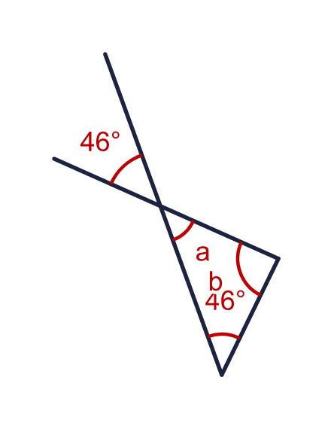
    a = |  | °
    b = |  | °
  9 | Two straight lines cross at a corner of the triangle. Work out the sizes of angles a and b.
    a = |  | °
    b = |  | °
  10 | This is an isosceles triangle. One side is carried on in a straight line.  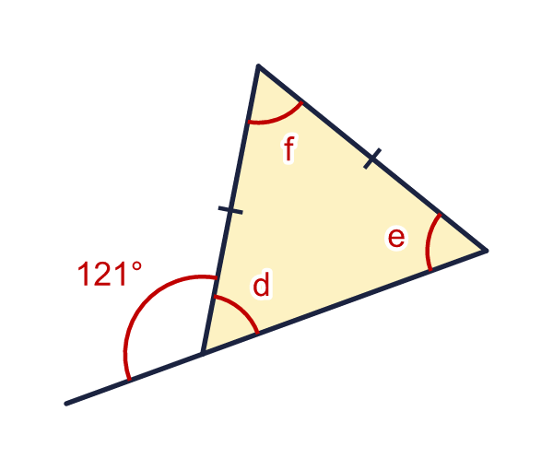
    d = |  | °
    e = |  | °
    f = |  | °
  10 | This is an isosceles triangle. One side is carried on in a straight line.
    d = |  | °
    e = |  | °
    f = |  | °
  11 | The two angles inside the triangle are x and 2x. The exterior angle is marked.  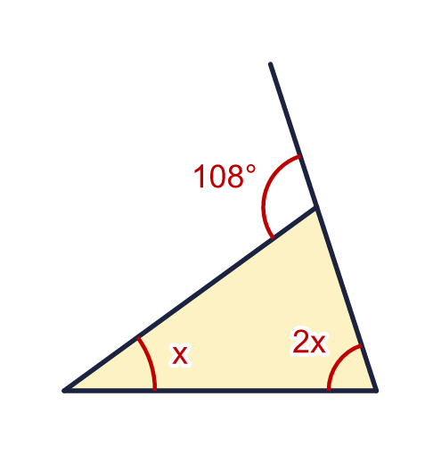
    x = |  | °
    2x = |  | °
  11 | The two angles inside the triangle are x and 2x. The exterior angle is marked.
    x = |  | °
    2x = |  | °
  12 | Two triangles are joined along a straight line. Work out the sizes of angles x and y.  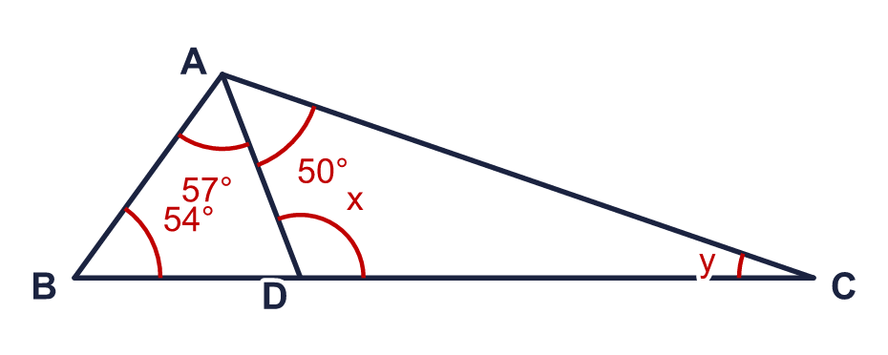
    x = |  | °
    y = |  | °
  12 | Two triangles are joined along a straight line. Work out the sizes of angles x and y.
    x = |  | °
    y = |  | °
  13 | One side of the triangle is carried on in a straight line.  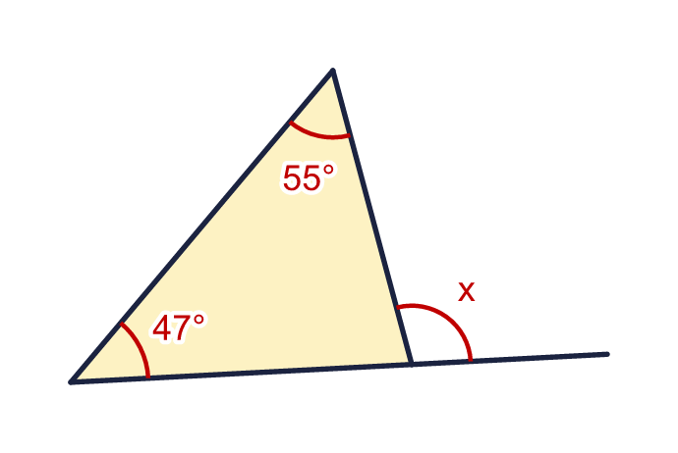  Is Boba correct? Circle yes or no.  Yes / No  Explain how you know.
     | 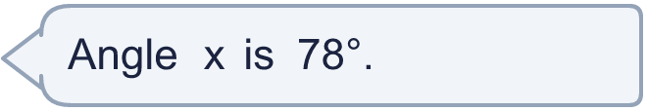
  13 | One side of the triangle is carried on in a straight line.  Is Boba correct? Circle yes or no.  Yes / No  Explain how you know.
  14 | The base of the triangle is carried on in a straight line at both ends. Work out the size of angle r.  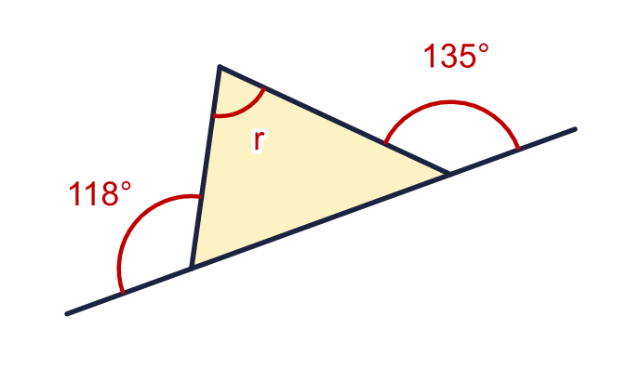
    r = |  | °
  14 | The base of the triangle is carried on in a straight line at both ends. Work out the size of angle r.
    r = |  | °

Year 6 · Shape · Step 6
Missing angles in triangles
Answers (teacher copy)

  1 | One side of the triangle is carried on in a straight line. Work out the size of angle x.  x = 137 °
  2 | One side of the triangle is carried on in a straight line. Work out the size of angle y.  y = 60 °
  3 | Work out the size of angle z.  z = 134 °
  4 | Two straight lines cross at a corner of the triangle. Work out the size of angle x.  x = 62 °
  5 | This is an isosceles triangle. One side is carried on in a straight line. Work out the size of angle x.  x = 112.5 °
  6 | This triangle has a right angle. One side is carried on in a straight line. Work out the size of angle w.  w = 126 °
  7 | An exterior angle of a triangle is 136°. One of the two interior angles opposite it is 80°. What is the other interior angle opposite it?  a) The other angle is 56
  8 | Two triangles are joined along a straight line. Work out the size of angle x.  x = 77 °
  9 | Two straight lines cross at a corner of the triangle. Work out the sizes of angles a and b.  a = 46 °  b = 88 °
  10 | This is an isosceles triangle. One side is carried on in a straight line.  d = 59 °  e = 59 °  f = 62 °
  11 | The two angles inside the triangle are x and 2x. The exterior angle is marked.  x = 36 °  2x = 72 °
  12 | Two triangles are joined along a straight line. Work out the sizes of angles x and y.  x = 111 °  y = 19 °
  13 | One side of the triangle is carried on in a straight line.  Is Boba correct? Circle yes or no.  Yes / No  Explain how you know.  The third angle inside the triangle is 78°. Angle x is on a straight line with it, so x = 180 − 78 = 102°, not 78°.
  14 | The base of the triangle is carried on in a straight line at both ends. Work out the size of angle r.  r = 73 °

