  Year 6 · Shape · Step 1  Measuring and classifying angles | 
  Year 6 · Shape · Step 1
  Measuring and classifying angles
  1 | Look at the four angles. Write whether each is acute, obtuse, right or reflex.  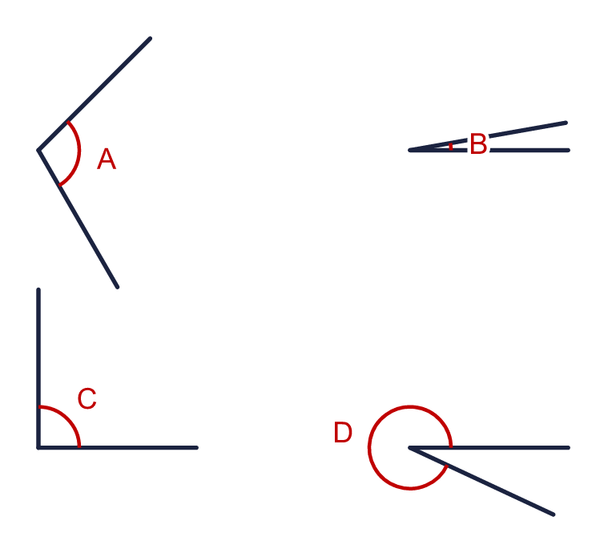  a) Angle A  b) Angle B  c) Angle C  d) Angle D
  1 | Look at the four angles. Write whether each is acute, obtuse, right or reflex.  a) Angle A  b) Angle B  c) Angle C  d) Angle D
  2 | The corner of the angle is at the centre of the protractor and one arm is along the zero line. Read the size of the angle from the correct scale.  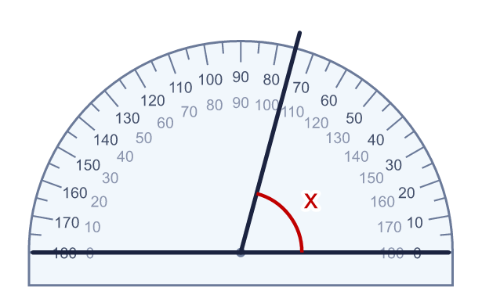
    x = |  | °
  2 | The corner of the angle is at the centre of the protractor and one arm is along the zero line. Read the size of the angle from the correct scale.
    x = |  | °
  3 | Read the size of the angle from the protractor. Start from the zero line.  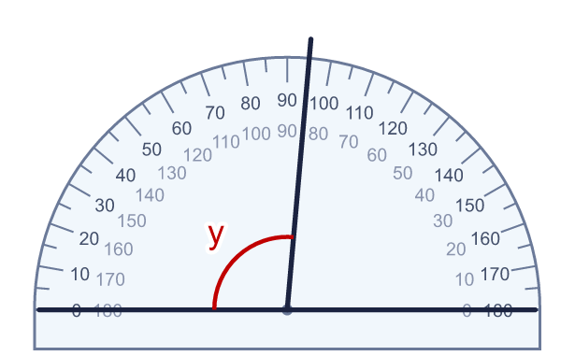
    y = |  | °
  3 | Read the size of the angle from the protractor. Start from the zero line.
    y = |  | °
  4 | Two angles are marked from the zero line of the protractor. Read both of them.  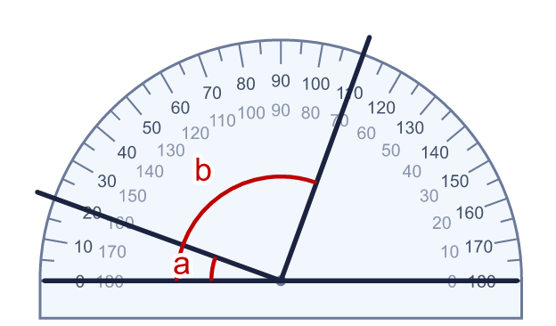
    a = |  | °
    b = |  | °
  4 | Two angles are marked from the zero line of the protractor. Read both of them.
    a = |  | °
    b = |  | °
  5 | Here are six angles.  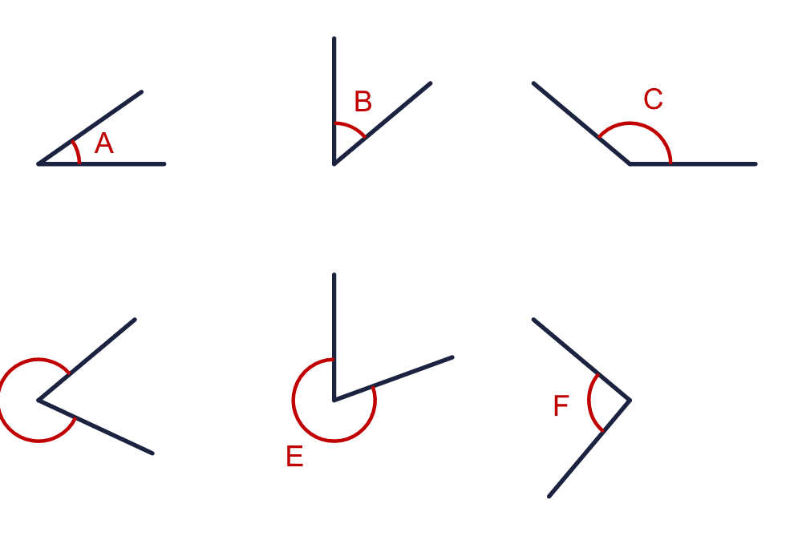  a) How many of the angles are acute?  b) How many of the angles are obtuse?  c) How many of the angles are reflex?
  5 | Here are six angles.  a) How many of the angles are acute?  b) How many of the angles are obtuse?  c) How many of the angles are reflex?
  6 | Look at the four angles.  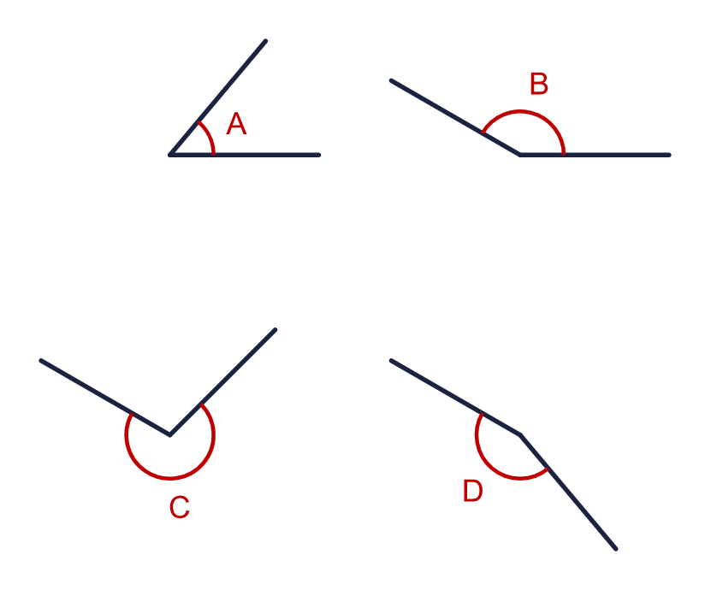  a) Which angle is the largest? Write the letter.  b) Which angle is the smallest? Write the letter.
  6 | Look at the four angles.  a) Which angle is the largest? Write the letter.  b) Which angle is the smallest? Write the letter.
  7 | Write whether each angle is acute, obtuse, right or reflex.  a) An angle of 25°  b) An angle of 225°  c) An angle of 150°
  7 | Write whether each angle is acute, obtuse, right or reflex.  a) An angle of 25°  b) An angle of 225°  c) An angle of 150°
  8 | Write the size of each turn in degrees.  a) How many degrees is a quarter turn?  b) How many degrees is a tenth of a full turn?
  8 | Write the size of each turn in degrees.  a) How many degrees is a quarter turn?  b) How many degrees is a tenth of a full turn?

  9 | Look at the angle x.  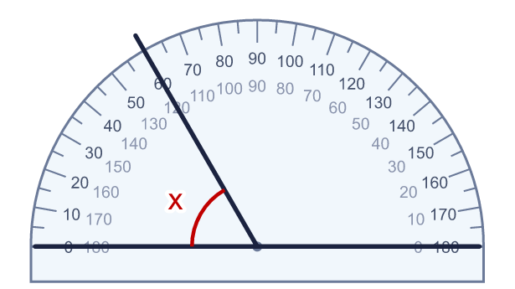  Is Boba correct? Circle yes or no.  Yes / No  Explain how you know.
     | 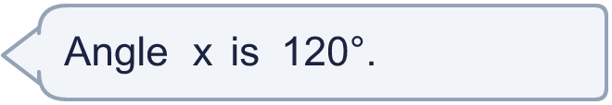
  9 | Look at the angle x.  Is Boba correct? Circle yes or no.  Yes / No  Explain how you know.
  10 | I am thinking of an obtuse angle. It is a multiple of 20. It is less than 107°.
    What size is my angle? |  | °
  10 | I am thinking of an obtuse angle. It is a multiple of 20. It is less than 107°.
    What size is my angle? |  | °
  11 | The protractor measures angle a. The reflex angle y is on the other side of the same two arms.  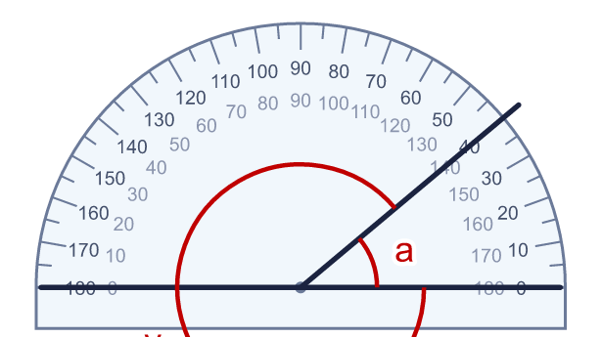
    a = |  | °
    y = |  | °
  11 | The protractor measures angle a. The reflex angle y is on the other side of the same two arms.
    a = |  | °
    y = |  | °
  12 | Look at the four angles.  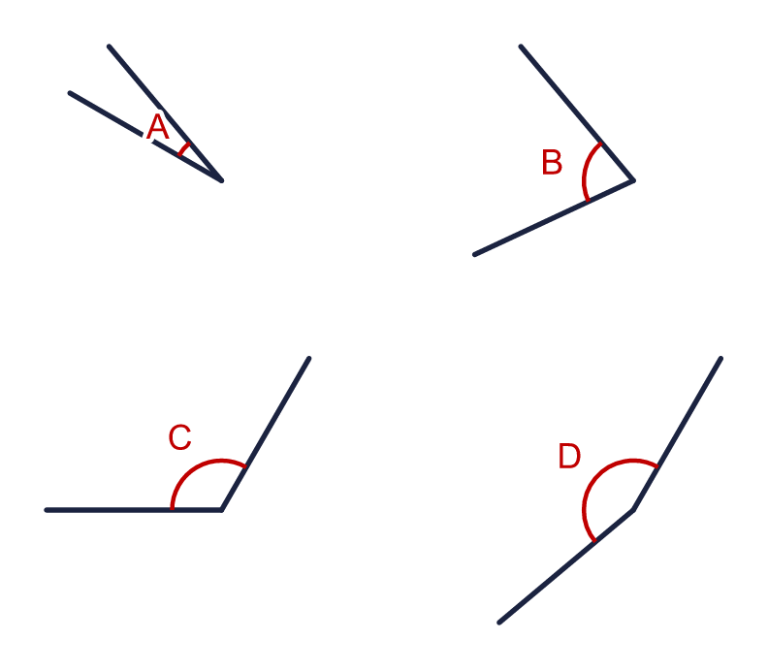  a) Which angle is closest to a right angle? Write the letter.  b) Which angle is closest to a straight line (180°)?
  12 | Look at the four angles.  a) Which angle is closest to a right angle? Write the letter.  b) Which angle is closest to a straight line (180°)?
  13 | Every angle in this shape is either a right angle or a reflex angle. The right angles are marked.  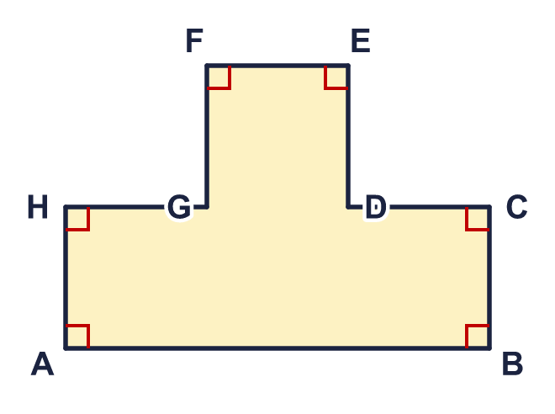  a) How many right angles does the shape have?  b) How many reflex angles does the shape have?
  13 | Every angle in this shape is either a right angle or a reflex angle. The right angles are marked.  a) How many right angles does the shape have?  b) How many reflex angles does the shape have?
  14 | Read the three angles a, b and c from the protractor.  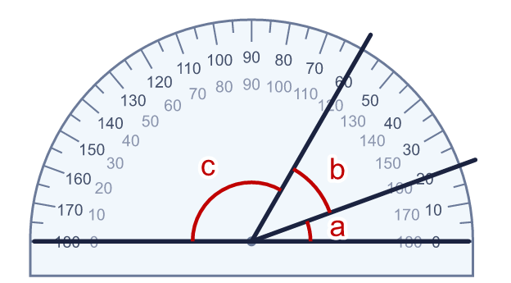
    a = |  | °
    b = |  | °
    c = |  | °
    What is a + b + c? |  | °
  14 | Read the three angles a, b and c from the protractor.
    a = |  | °
    b = |  | °
    c = |  | °
    What is a + b + c? |  | °

Year 6 · Shape · Step 1
Measuring and classifying angles
Answers (teacher copy)

  1 | Look at the four angles. Write whether each is acute, obtuse, right or reflex.  a) Angle A obtuse  b) Angle B acute  c) Angle C right  d) Angle D reflex
  2 | The corner of the angle is at the centre of the protractor and one arm is along the zero line. Read the size of the angle from the correct scale.  x = 75 °
  3 | Read the size of the angle from the protractor. Start from the zero line.  y = 95 °
  4 | Two angles are marked from the zero line of the protractor. Read both of them.  a = 20 °  b = 110 °
  5 | Here are six angles.  a) How many of the angles are acute? 2  b) How many of the angles are obtuse? 1  c) How many of the angles are reflex? 2
  6 | Look at the four angles.  a) Which angle is the largest? Write the letter. C  b) Which angle is the smallest? Write the letter. A
  7 | Write whether each angle is acute, obtuse, right or reflex.  a) An angle of 25° acute  b) An angle of 225° reflex  c) An angle of 150° obtuse
  8 | Write the size of each turn in degrees.  a) How many degrees is a quarter turn? 90  b) How many degrees is a tenth of a full turn? 36
  9 | Look at the angle x.  Is Boba correct? Circle yes or no.  Yes / No  Explain how you know.  The angle is smaller than a right angle, so it is acute. Reading from the zero line gives 60°, not 120°.
  10 | I am thinking of an obtuse angle. It is a multiple of 20. It is less than 107°.  What size is my angle? 100 °
  11 | The protractor measures angle a. The reflex angle y is on the other side of the same two arms.  a = 40 °  y = 320 °
  12 | Look at the four angles.  a) Which angle is closest to a right angle? Write the letter. B  b) Which angle is closest to a straight line (180°)? D
  13 | Every angle in this shape is either a right angle or a reflex angle. The right angles are marked.  a) How many right angles does the shape have? 6  b) How many reflex angles does the shape have? 2
  14 | Read the three angles a, b and c from the protractor.  a = 20 °  b = 40 °  c = 120 °  What is a + b + c? 180 °

