  Year 6 · Shape · Step 9  Circles | 
  Year 6 · Shape · Step 9
  Circles
  1 | The circle has three lines: A, B and C. One is a radius, one is a diameter and one is a chord (a line from one side of the circle to another that does not go through the centre).  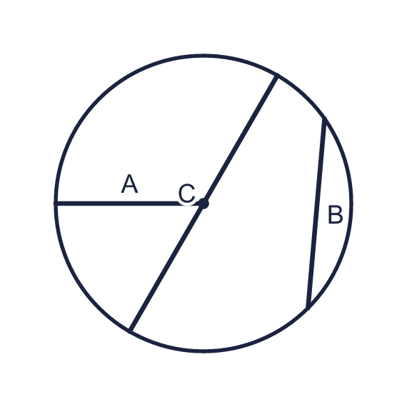  a) Which line is the radius? Write the letter.  b) Which line is the diameter? Write the letter.
  1 | The circle has three lines: A, B and C. One is a radius, one is a diameter and one is a chord (a line from one side of the circle to another that does not go through the centre).  a) Which line is the radius? Write the letter.  b) Which line is the diameter? Write the letter.
  2 | Write radius, diameter or chord for each line.  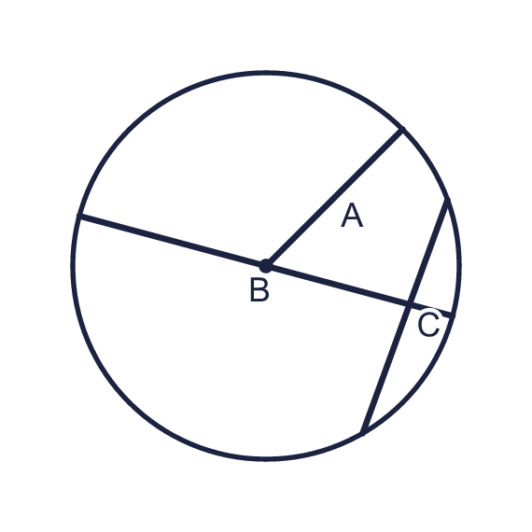  a) Line A is a  b) Line B is a  c) Line C is a
  2 | Write radius, diameter or chord for each line.  a) Line A is a  b) Line B is a  c) Line C is a
  3 | The radius of the circle is marked. Work out the diameter.  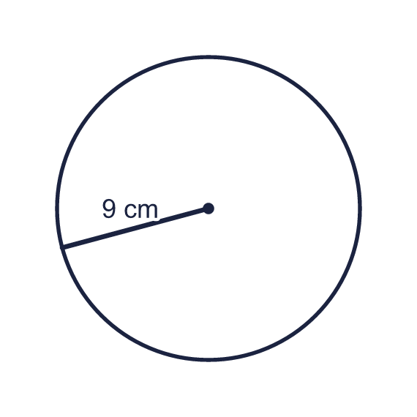  a) Diameter (cm)
  3 | The radius of the circle is marked. Work out the diameter.  a) Diameter (cm)
  4 | The diameter of the circle is marked. Work out the radius.  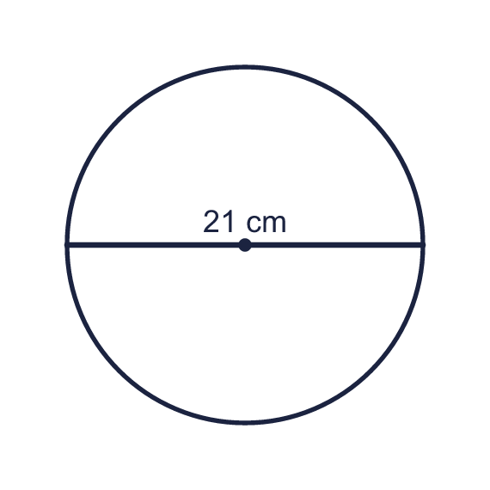  a) Radius (cm)
  4 | The diameter of the circle is marked. Work out the radius.  a) Radius (cm)
  5 | Complete the sentences.  a) The diameter of a circle with radius 9 cm is (cm)  b) The radius of a circle with diameter 12 cm is (cm)  c) The diameter of a circle with radius 15.5 cm is (cm)  d) The radius of a circle with diameter 27 cm is (cm)
  5 | Complete the sentences.  a) The diameter of a circle with radius 9 cm is (cm)  b) The radius of a circle with diameter 12 cm is (cm)  c) The diameter of a circle with radius 15.5 cm is (cm)  d) The radius of a circle with diameter 27 cm is (cm)
  6 | Complete the table by working out the missing radius or diameter.  a) The diameter of a circle with radius 7 km (km)  b) The radius of a circle with diameter 8 km (km)
  6 | Complete the table by working out the missing radius or diameter.  a) The diameter of a circle with radius 7 km (km)  b) The radius of a circle with diameter 8 km (km)
  7 | A circle has a diameter of 20 cm. A second circle has a radius that is the same as the first circle's diameter.  a) Radius of the first circle (cm)  b) Diameter of the second circle (cm)
  7 | A circle has a diameter of 20 cm. A second circle has a radius that is the same as the first circle's diameter.  a) Radius of the first circle (cm)  b) Diameter of the second circle (cm)
  8 | The two circles have the same centre. The radius of the inner circle and the width of the ring are marked.  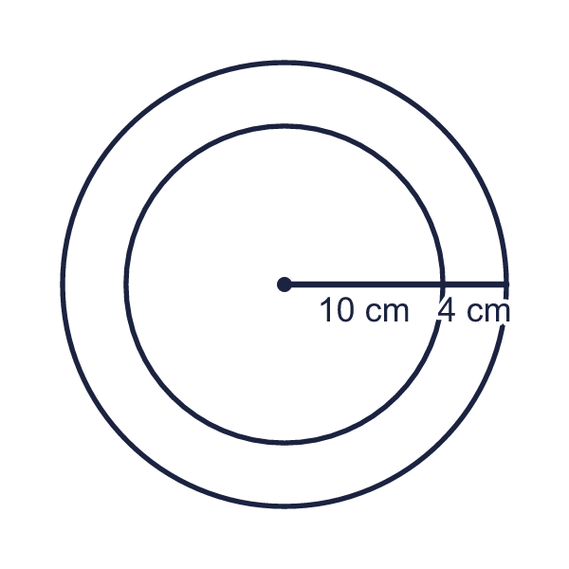  a) Diameter of the inner circle (cm)  b) Diameter of the outer circle (cm)
  8 | The two circles have the same centre. The radius of the inner circle and the width of the ring are marked.  a) Diameter of the inner circle (cm)  b) Diameter of the outer circle (cm)

  9 | The radius of the circle is marked.  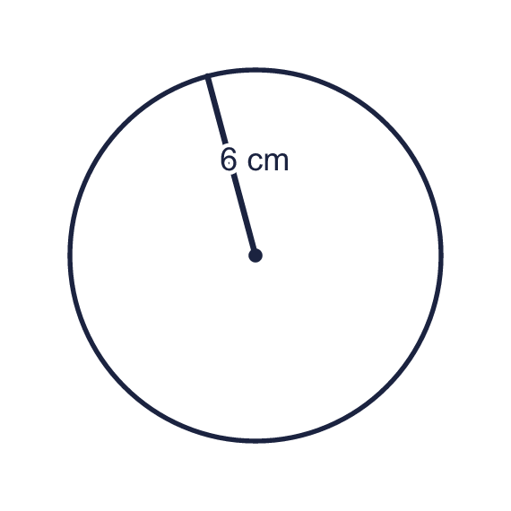  Is Boba correct? Circle yes or no.  Yes / No  Explain how you know.
     | 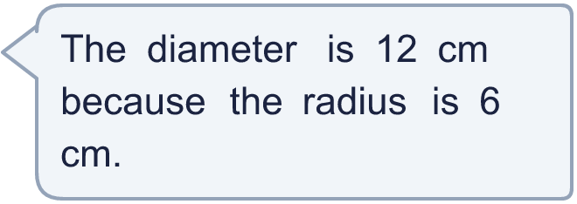
  9 | The radius of the circle is marked.  Is Boba correct? Circle yes or no.  Yes / No  Explain how you know.
  10 | Boba says: “The diameter of a circle is always greater than its radius.”  Is Boba correct? Circle yes or no.  Yes / No  Explain how you know.
  10 | Boba says: “The diameter of a circle is always greater than its radius.”  Is Boba correct? Circle yes or no.  Yes / No  Explain how you know.
  11 | Boba measures the line in the circle and says: “That is the diameter and it is 17 cm.”  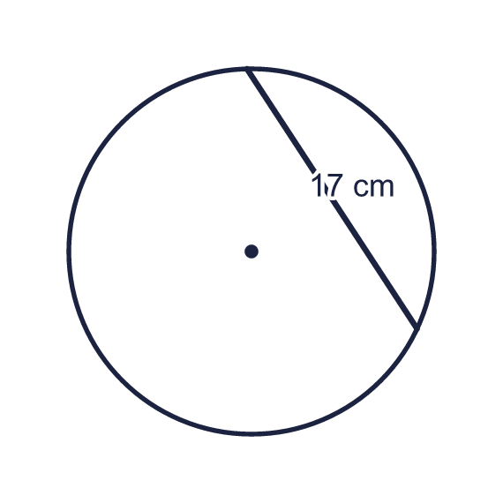  a) Does the line go through the centre of the circle? Write yes or no.  b) Is the diameter of this circle greater than or less than 17 cm? Write greater or less.
  11 | Boba measures the line in the circle and says: “That is the diameter and it is 17 cm.”  a) Does the line go through the centre of the circle? Write yes or no.  b) Is the diameter of this circle greater than or less than 17 cm? Write greater or less.
  12 | The diameter of the large circle is 24 cm. Small circles with a radius of 1 cm are placed in a row along the diameter, touching each other. The first three are drawn.  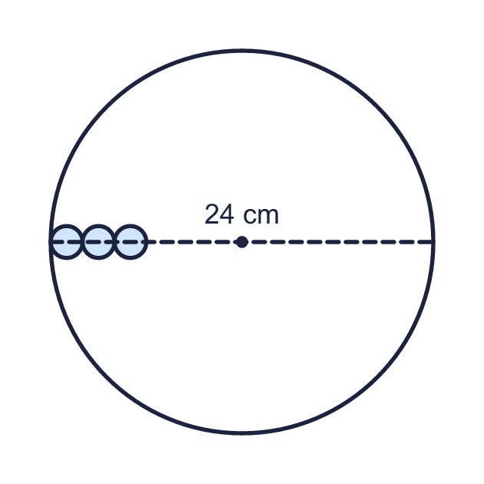  How many small circles fit along the whole diameter?
  12 | The diameter of the large circle is 24 cm. Small circles with a radius of 1 cm are placed in a row along the diameter, touching each other. The first three are drawn.  How many small circles fit along the whole diameter?
  13 | The radius of a circle is (x + 6) cm. The diameter of the circle is 16 cm.
  13 | The radius of a circle is (x + 6) cm. The diameter of the circle is 16 cm.
  14 | Two circles touch each other. Their centres O1 and O2 and the far edges A and B are on one straight line. The radius of each circle is marked.  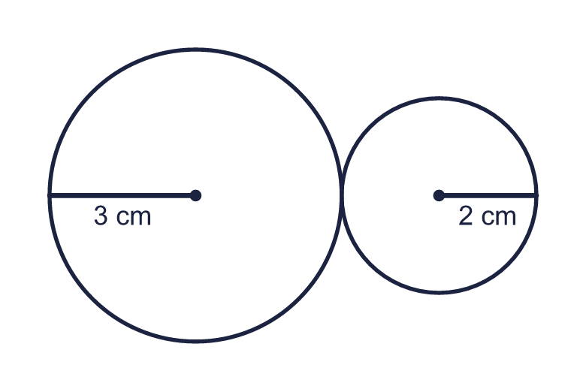  a) Distance from O1 to O2 (cm)  b) Distance from A to B (cm)
  14 | Two circles touch each other. Their centres O1 and O2 and the far edges A and B are on one straight line. The radius of each circle is marked.  a) Distance from O1 to O2 (cm)  b) Distance from A to B (cm)

Year 6 · Shape · Step 9
Circles
Answers (teacher copy)

  1 | The circle has three lines: A, B and C. One is a radius, one is a diameter and one is a chord (a line from one side of the circle to another that does not go through the centre).  a) Which line is the radius? Write the letter. A  b) Which line is the diameter? Write the letter. C
  2 | Write radius, diameter or chord for each line.  a) Line A is a radius  b) Line B is a diameter  c) Line C is a chord
  3 | The radius of the circle is marked. Work out the diameter.  a) Diameter (cm) 18
  4 | The diameter of the circle is marked. Work out the radius.  a) Radius (cm) 10.5
  5 | Complete the sentences.  a) The diameter of a circle with radius 9 cm is (cm) 18  b) The radius of a circle with diameter 12 cm is (cm) 6  c) The diameter of a circle with radius 15.5 cm is (cm) 31  d) The radius of a circle with diameter 27 cm is (cm) 13.5
  6 | Complete the table by working out the missing radius or diameter.  a) The diameter of a circle with radius 7 km (km) 14  b) The radius of a circle with diameter 8 km (km) 4
  7 | A circle has a diameter of 20 cm. A second circle has a radius that is the same as the first circle's diameter.  a) Radius of the first circle (cm) 10  b) Diameter of the second circle (cm) 40
  8 | The two circles have the same centre. The radius of the inner circle and the width of the ring are marked.  a) Diameter of the inner circle (cm) 20  b) Diameter of the outer circle (cm) 28
  9 | The radius of the circle is marked.  Is Boba correct? Circle yes or no.  Yes / No  Explain how you know.  The diameter is twice the radius, so 6 × 2 = 12 cm.
  10 | Boba says: “The diameter of a circle is always greater than its radius.”  Is Boba correct? Circle yes or no.  Yes / No  Explain how you know.  The diameter is twice the radius, so it is always longer than the radius.
  11 | Boba measures the line in the circle and says: “That is the diameter and it is 17 cm.”  a) Does the line go through the centre of the circle? Write yes or no. No  b) Is the diameter of this circle greater than or less than 17 cm? Write greater or less. greater
  12 | The diameter of the large circle is 24 cm. Small circles with a radius of 1 cm are placed in a row along the diameter, touching each other. The first three are drawn.  How many small circles fit along the whole diameter? 12
  13 | The radius of a circle is (x + 6) cm. The diameter of the circle is 16 cm.  Work out the value of x. 2
  14 | Two circles touch each other. Their centres O1 and O2 and the far edges A and B are on one straight line. The radius of each circle is marked.  a) Distance from O1 to O2 (cm) 5  b) Distance from A to B (cm) 10

