  Year 6 · Shape · Step 2  Calculating angles | 
  Year 6 · Shape · Step 2
  Calculating angles
  1 | Work out the sum of the angles in each diagram.  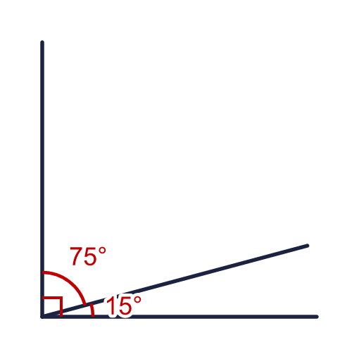  a) Sum of the angles in the first diagram  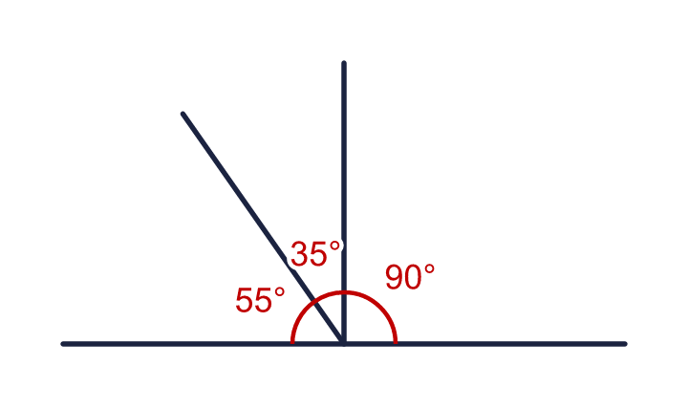  b) Sum of the angles in the second diagram  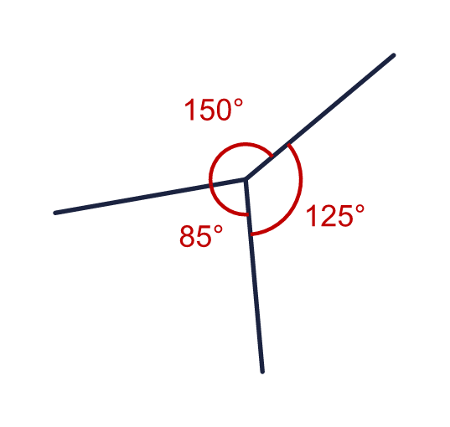  c) Sum of the angles in the third diagram
  1 | Work out the sum of the angles in each diagram.  a) Sum of the angles in the first diagram  b) Sum of the angles in the second diagram  c) Sum of the angles in the third diagram
  2 | Work out the size of angle a.  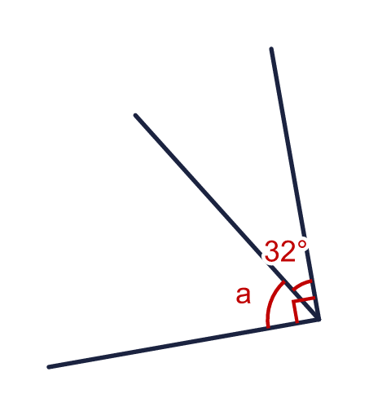
    a = |  | °
  2 | Work out the size of angle a.
    a = |  | °
  3 | Work out the size of angle e.  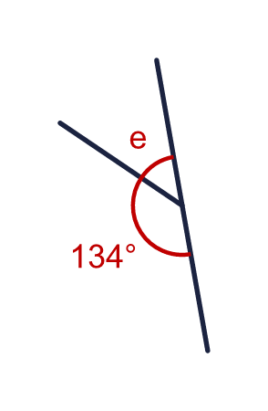
    e = |  | °
  3 | Work out the size of angle e.
    e = |  | °
  4 | Work out the size of angle y.  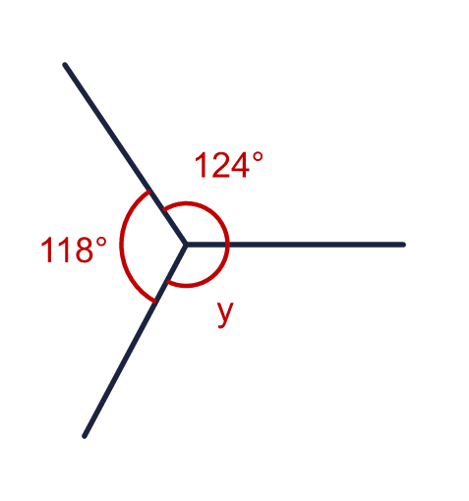
    y = |  | °
  4 | Work out the size of angle y.
    y = |  | °
  5 | Work out the size of angle x.  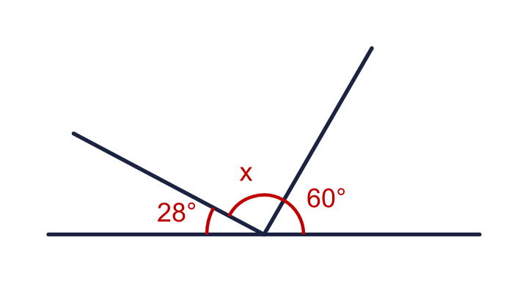
    x = |  | °
  5 | Work out the size of angle x.
    x = |  | °
  6 | Work out the size of angle z.  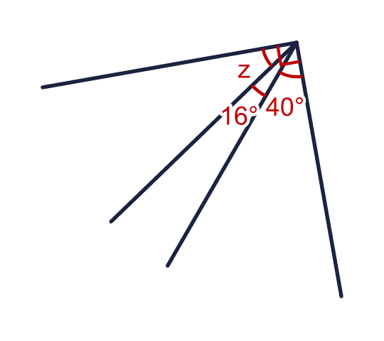
    z = |  | °
  6 | Work out the size of angle z.
    z = |  | °
  7 | Work out the size of angle q.  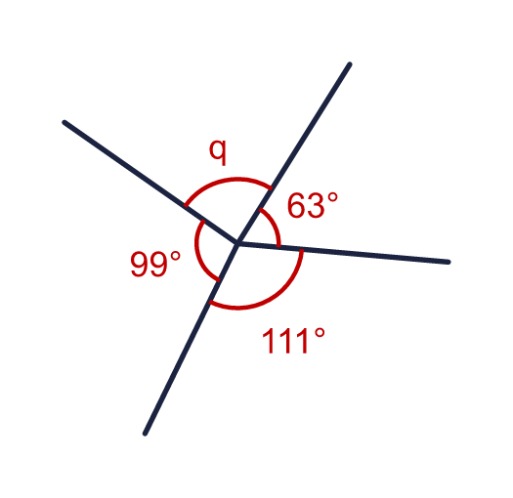
    q = |  | °
  7 | Work out the size of angle q.
    q = |  | °
  8 | Angles on a straight line add up to 180°. One of the two angles on a line is 173°. What is the other angle?  a) The other angle is  Four angles meet at a point. Three of them are 125°, 117° and 51°. What is the fourth angle?  b) The fourth angle is
  8 | Angles on a straight line add up to 180°. One of the two angles on a line is 173°. What is the other angle?  a) The other angle is  Four angles meet at a point. Three of them are 125°, 117° and 51°. What is the fourth angle?  b) The fourth angle is

  9 | Look at the angles on the straight line.  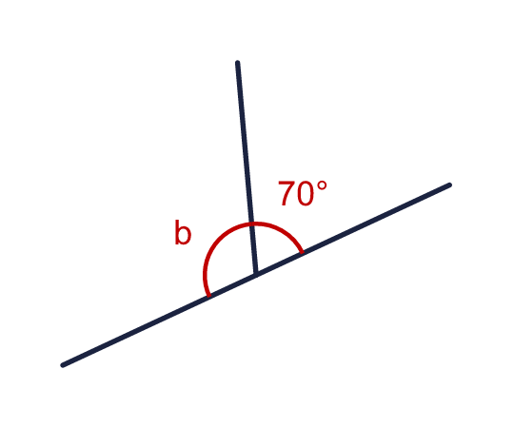  Is Boba correct? Circle yes or no.  Yes / No  Explain how you know.
     | 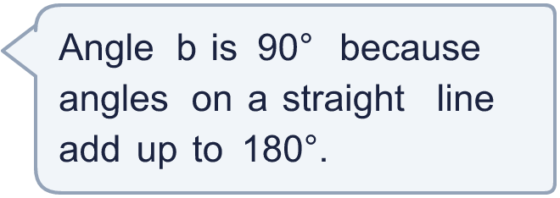
  9 | Look at the angles on the straight line.  Is Boba correct? Circle yes or no.  Yes / No  Explain how you know.
  10 | Angle a is one third of the size of angle b.  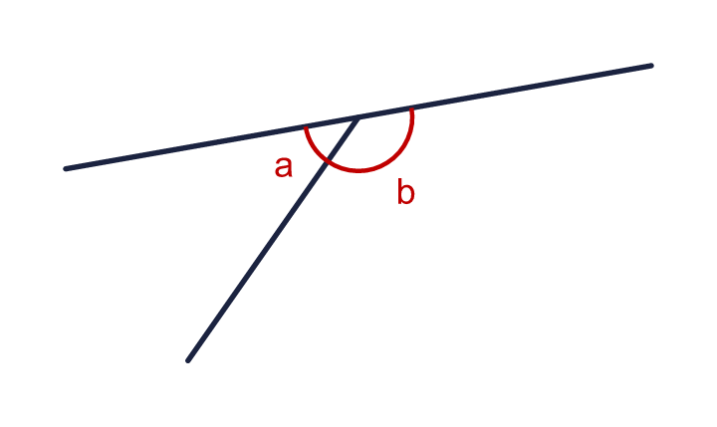
    a = |  | °
    b = |  | °
  10 | Angle a is one third of the size of angle b.
    a = |  | °
    b = |  | °
  11 | Four angles meet at a point. Their sizes are x, 2x, 2x and 4x.  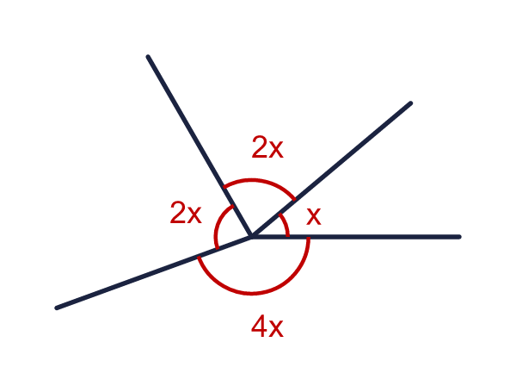
    x = |  | °
    4x = |  | °
  11 | Four angles meet at a point. Their sizes are x, 2x, 2x and 4x.
    x = |  | °
    4x = |  | °
  12 | Angle a is 20° more than angle b.  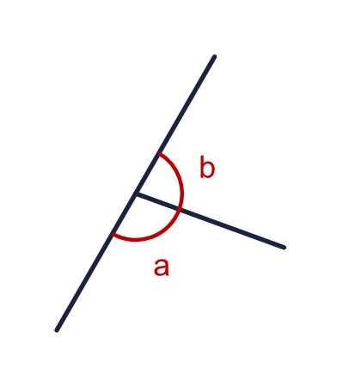
    a = |  | °
    b = |  | °
  12 | Angle a is 20° more than angle b.
    a = |  | °
    b = |  | °
  13 | The diagram shows the angles of a pie chart of favourite snacks. The angle for fruit (f) is 4 times the angle for sweets (s).  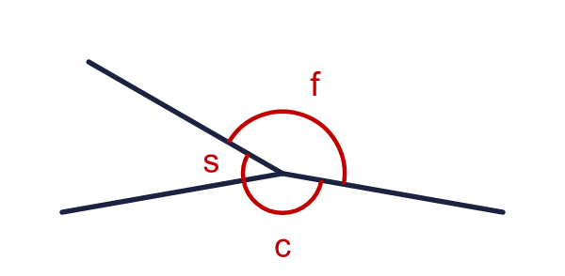  The three angles around the centre are c (chocolate), f (fruit) and s (sweets). Work out each angle.
    s = |  | °
    f = |  | °
    c = |  | °
  13 | The diagram shows the angles of a pie chart of favourite snacks. The angle for fruit (f) is 4 times the angle for sweets (s).  The three angles around the centre are c (chocolate), f (fruit) and s (sweets). Work out each angle.
    s = |  | °
    f = |  | °
    c = |  | °
  14 | The clock shows 4 o'clock. The angle x is marked between the hour hand and the minute hand.  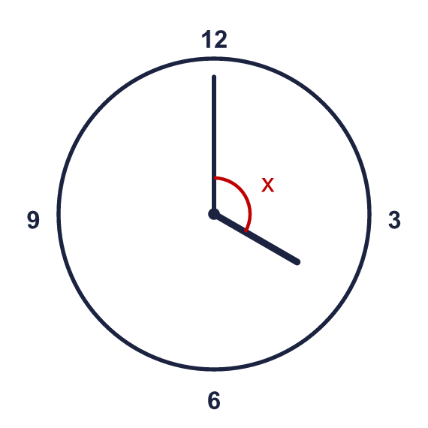
    x = |  | °
  14 | The clock shows 4 o'clock. The angle x is marked between the hour hand and the minute hand.
    x = |  | °

Year 6 · Shape · Step 2
Calculating angles
Answers (teacher copy)

  1 | Work out the sum of the angles in each diagram.  a) Sum of the angles in the first diagram 90  b) Sum of the angles in the second diagram 180  c) Sum of the angles in the third diagram 360
  2 | Work out the size of angle a.  a = 58 °
  3 | Work out the size of angle e.  e = 46 °
  4 | Work out the size of angle y.  y = 118 °
  5 | Work out the size of angle x.  x = 92 °
  6 | Work out the size of angle z.  z = 34 °
  7 | Work out the size of angle q.  q = 87 °
  8 | Angles on a straight line add up to 180°. One of the two angles on a line is 173°. What is the other angle?  a) The other angle is 7  Four angles meet at a point. Three of them are 125°, 117° and 51°. What is the fourth angle?  b) The fourth angle is 67
  9 | Look at the angles on the straight line.  Is Boba correct? Circle yes or no.  Yes / No  Explain how you know.  180 − 70 = 110, so b is 110°, not 90°.
  10 | Angle a is one third of the size of angle b.  a = 45 °  b = 135 °
  11 | Four angles meet at a point. Their sizes are x, 2x, 2x and 4x.  x = 40 °  4x = 160 °
  12 | Angle a is 20° more than angle b.  a = 100 °  b = 80 °
  13 | The diagram shows the angles of a pie chart of favourite snacks. The angle for fruit (f) is 4 times the angle for sweets (s).  The three angles around the centre are c (chocolate), f (fruit) and s (sweets). Work out each angle.  s = 40 °  f = 160 °  c = 160 °
  14 | The clock shows 4 o'clock. The angle x is marked between the hour hand and the minute hand.  x = 120 °

