  Year 6 · Position and direction · Step 4  Translations | 
  Year 6 · Position and direction · Step 4
  Translations
  1 | Four points are plotted on the coordinate grid. Count the squares to describe the translation from P to Q.  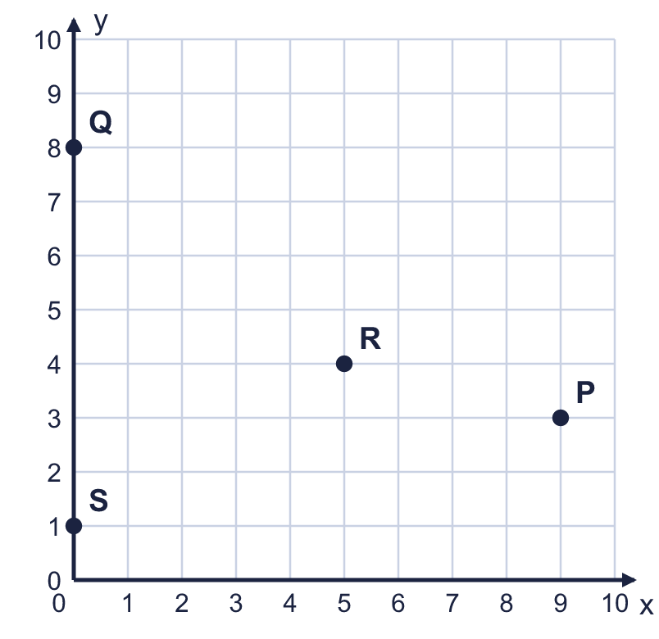  a) How many squares left is it from P to Q?  b) How many squares up is it from P to Q?
  1 | Four points are plotted on the coordinate grid. Count the squares to describe the translation from P to Q.  a) How many squares left is it from P to Q?  b) How many squares up is it from P to Q?
  2 | Four points are plotted on the coordinate grid. Count the squares to describe the translation from R to S.  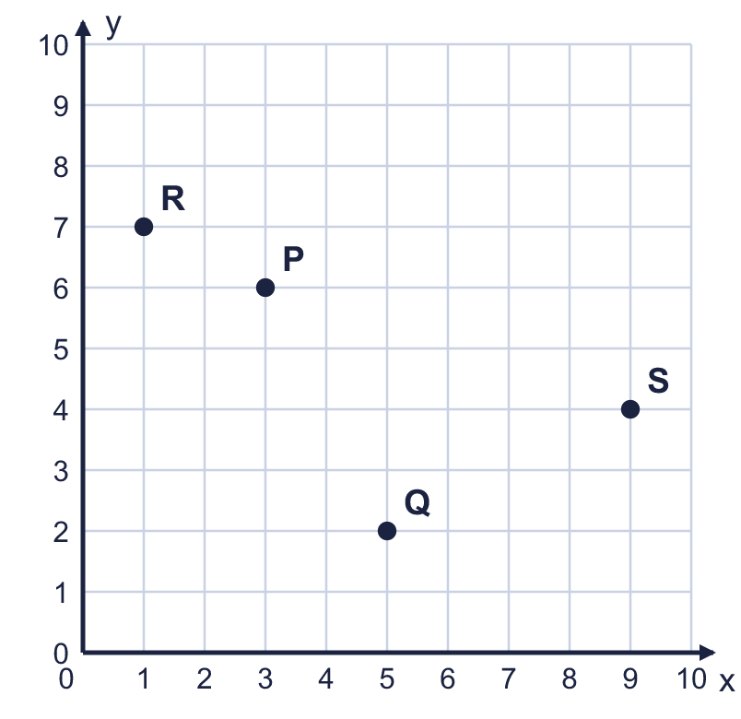  a) How many squares right is it from R to S?  b) How many squares down is it from R to S?
  2 | Four points are plotted on the coordinate grid. Count the squares to describe the translation from R to S.  a) How many squares right is it from R to S?  b) How many squares down is it from R to S?
  3 | Translate triangle ABC 1 square left and 4 squares down. Draw the new triangle in your book. Then write the coordinates of the corners of the new triangle.  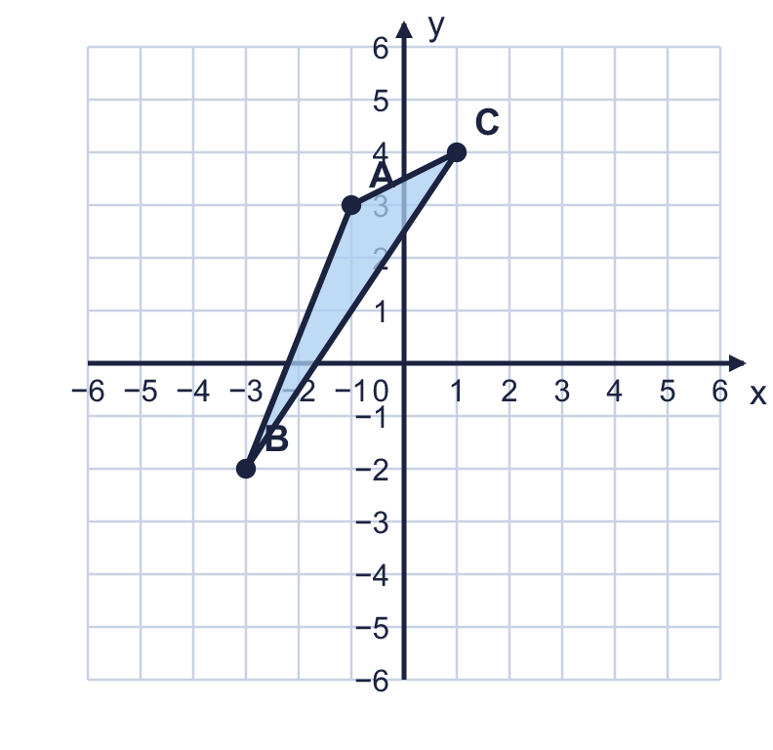  a) Corner A'  b) Corner B'  c) Corner C'
  3 | Translate triangle ABC 1 square left and 4 squares down. Draw the new triangle in your book. Then write the coordinates of the corners of the new triangle.  a) Corner A'  b) Corner B'  c) Corner C'
  4 | The coordinate grid shows shape A and four other shapes. Some of the shapes are translations of shape A: they have been slid, but not turned or flipped.  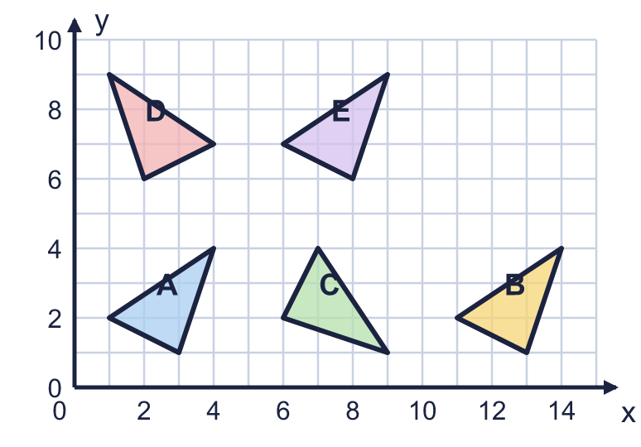  Which shapes are translations of A? Write the letters.
  4 | The coordinate grid shows shape A and four other shapes. Some of the shapes are translations of shape A: they have been slid, but not turned or flipped.  Which shapes are translations of A? Write the letters.
  5 | The point (−3, −2) is translated 5 squares left and 3 squares up.  Write the coordinates of the new point.
  5 | The point (−3, −2) is translated 5 squares left and 3 squares up.  Write the coordinates of the new point.
  6 | A point moves from (−1, −1) to (−4, 4). Describe the translation. Write it like this: 3 left and 4 up.
  6 | A point moves from (−1, −1) to (−4, 4). Describe the translation. Write it like this: 3 left and 4 up.
  7 | Rectangle ABCD is drawn on the coordinate grid. It is translated 2 squares left and 3 squares up.  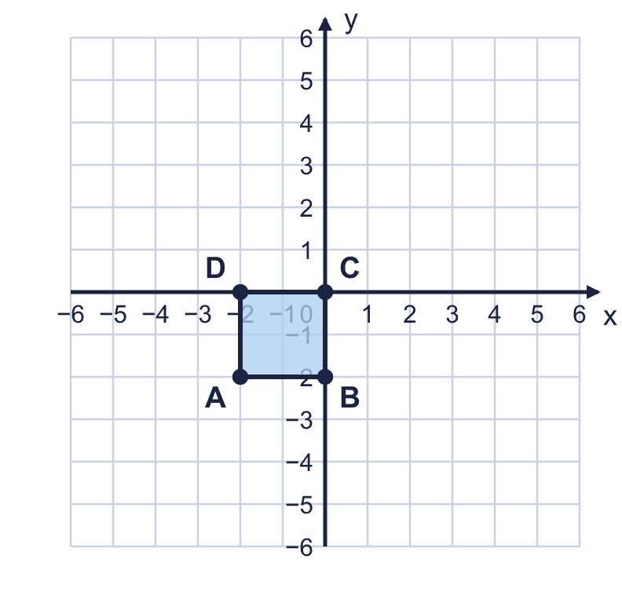  a) Where does A go? Write the coordinates of A'.  b) Where does C go? Write the coordinates of C'.
  7 | Rectangle ABCD is drawn on the coordinate grid. It is translated 2 squares left and 3 squares up.  a) Where does A go? Write the coordinates of A'.  b) Where does C go? Write the coordinates of C'.
  8 | The point (2, −4) is translated 4 squares left and 4 squares down. Then it is translated 3 squares right and 1 square down.  Write the coordinates of the point at the end.
  8 | The point (2, −4) is translated 4 squares left and 4 squares down. Then it is translated 3 squares right and 1 square down.  Write the coordinates of the point at the end.

  9 | Square A is translated to square B.  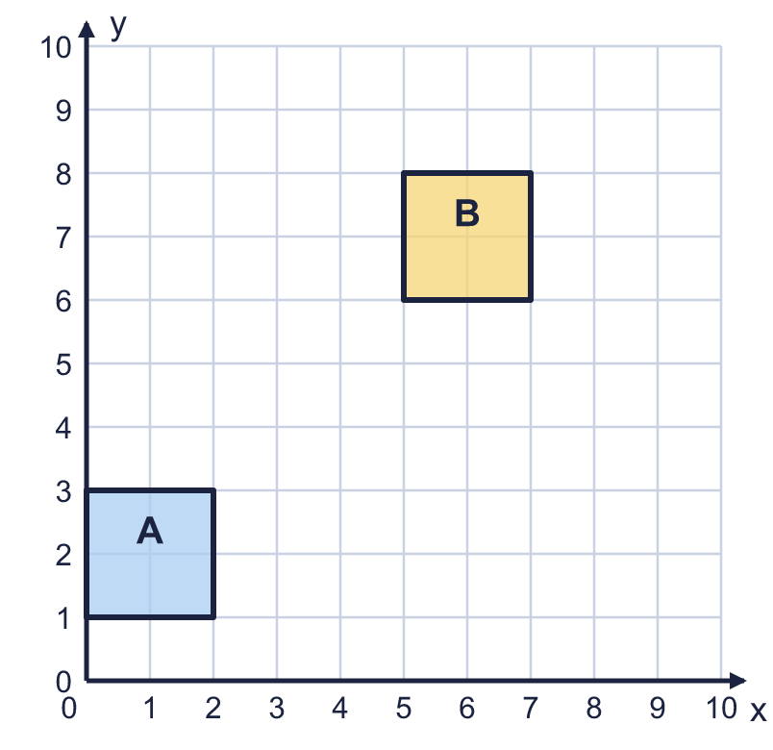  Is Boba correct? Circle yes or no.  Yes / No  Explain how you know.
     | 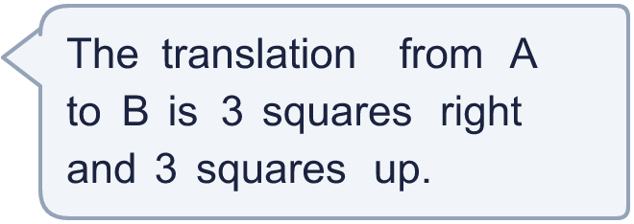
  9 | Square A is translated to square B.  Is Boba correct? Circle yes or no.  Yes / No  Explain how you know.
  10 | A triangle has been translated 40 units left and 20 units down. After the translation its corners are at (−21, −31), (−80, −60), (−60, −50).  Write the coordinates of the corners before the translation.  a) Corner 1  b) Corner 2  c) Corner 3
  10 | A triangle has been translated 40 units left and 20 units down. After the translation its corners are at (−21, −31), (−80, −60), (−60, −50).  Write the coordinates of the corners before the translation.  a) Corner 1  b) Corner 2  c) Corner 3
  11 | A point starts at (−2, −3). It is translated 2 squares right and 4 squares down. Then it is translated 5 squares right and 4 squares down.  a) Where does the point end up? Write the coordinates.  b) What single translation would take the point from the start to the end? Write it like this: 3 left and 4 up.
  11 | A point starts at (−2, −3). It is translated 2 squares right and 4 squares down. Then it is translated 5 squares right and 4 squares down.  a) Where does the point end up? Write the coordinates.  b) What single translation would take the point from the start to the end? Write it like this: 3 left and 4 up.
  12 | A shape has corners at A (1, −3), B (−3, 2), C (3, −1), D (−1, −1). It is translated 3 squares right and 3 squares up.  Which corners are in the top right quadrant after the translation? (Both coordinates must be greater than 0.) Write the letters.
  12 | A shape has corners at A (1, −3), B (−3, 2), C (3, −1), D (−1, −1). It is translated 3 squares right and 3 squares up.  Which corners are in the top right quadrant after the translation? (Both coordinates must be greater than 0.) Write the letters.
  13 | A point is translated 3 squares right and 6 squares down. It ends at (0, −5).  Where did the point start? Write the coordinates.
  13 | A point is translated 3 squares right and 6 squares down. It ends at (0, −5).  Where did the point start? Write the coordinates.
  14 | A triangle has corners at (−3, −4), (−7, −7), (−3, −1). All of its corners are in the bottom left quadrant.  Write a translation that moves the whole triangle into the top right quadrant (all corners must have both coordinates greater than 0). Write it like this: 3 left and 4 up.
  14 | A triangle has corners at (−3, −4), (−7, −7), (−3, −1). All of its corners are in the bottom left quadrant.  Write a translation that moves the whole triangle into the top right quadrant (all corners must have both coordinates greater than 0). Write it like this: 3 left and 4 up.

Year 6 · Position and direction · Step 4
Translations
Answers (teacher copy)

  1 | Four points are plotted on the coordinate grid. Count the squares to describe the translation from P to Q.  a) How many squares left is it from P to Q? 9  b) How many squares up is it from P to Q? 5
  2 | Four points are plotted on the coordinate grid. Count the squares to describe the translation from R to S.  a) How many squares right is it from R to S? 8  b) How many squares down is it from R to S? 3
  3 | Translate triangle ABC 1 square left and 4 squares down. Draw the new triangle in your book. Then write the coordinates of the corners of the new triangle.  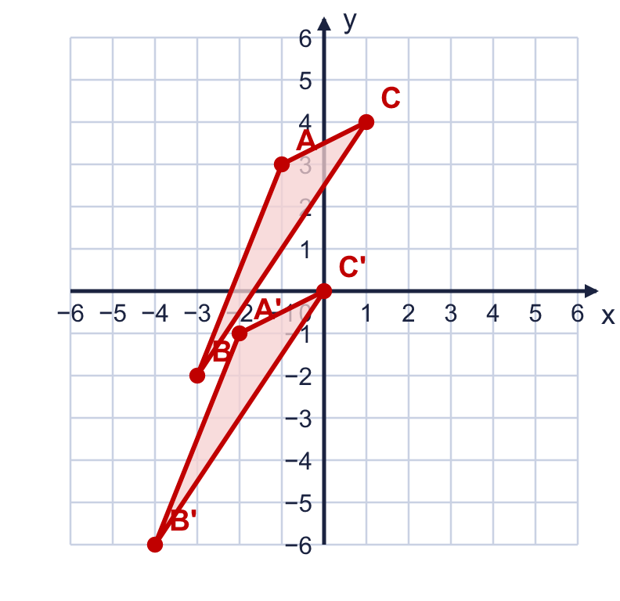  a) Corner A' (−2, −1)  b) Corner B' (−4, −6)  c) Corner C' (0, 0)
  4 | The coordinate grid shows shape A and four other shapes. Some of the shapes are translations of shape A: they have been slid, but not turned or flipped.  Which shapes are translations of A? Write the letters. B, E
  5 | The point (−3, −2) is translated 5 squares left and 3 squares up.  Write the coordinates of the new point. (−8, 1)
  6 | A point moves from (−1, −1) to (−4, 4). Describe the translation. Write it like this: 3 left and 4 up.  The translation is 3 left and 5 up
  7 | Rectangle ABCD is drawn on the coordinate grid. It is translated 2 squares left and 3 squares up.  a) Where does A go? Write the coordinates of A'. (−4, 1)  b) Where does C go? Write the coordinates of C'. (−2, 3)
  8 | The point (2, −4) is translated 4 squares left and 4 squares down. Then it is translated 3 squares right and 1 square down.  Write the coordinates of the point at the end. (1, −9)
  9 | Square A is translated to square B.  Is Boba correct? Circle yes or no.  Yes / No  Explain how you know.  Boba counted from the corner of A that is closest to B to the closest corner of B. You must count from a corner of A to the same corner of B. The bottom left corners are at (0, 1) and (5, 6), so the translation is 5 squares right and 5 squares up.
  10 | A triangle has been translated 40 units left and 20 units down. After the translation its corners are at (−21, −31), (−80, −60), (−60, −50).  Write the coordinates of the corners before the translation.  a) Corner 1 (19, −11)  b) Corner 2 (−40, −40)  c) Corner 3 (−20, −30)
  11 | A point starts at (−2, −3). It is translated 2 squares right and 4 squares down. Then it is translated 5 squares right and 4 squares down.  a) Where does the point end up? Write the coordinates. (5, −11)  b) What single translation would take the point from the start to the end? Write it like this: 3 left and 4 up. 7 right and 8 down
  12 | A shape has corners at A (1, −3), B (−3, 2), C (3, −1), D (−1, −1). It is translated 3 squares right and 3 squares up.  Which corners are in the top right quadrant after the translation? (Both coordinates must be greater than 0.) Write the letters. C, D
  13 | A point is translated 3 squares right and 6 squares down. It ends at (0, −5).  Where did the point start? Write the coordinates. (−3, 1)
  14 | A triangle has corners at (−3, −4), (−7, −7), (−3, −1). All of its corners are in the bottom left quadrant.  Write a translation that moves the whole triangle into the top right quadrant (all corners must have both coordinates greater than 0). Write it like this: 3 left and 4 up.  Any translation with at least 8 right and 8 up, for example 8 right and 8 up or 10 right and 9 up

