  Year 6 · Position and direction · Step 5  Reflections | 
  Year 6 · Position and direction · Step 5
  Reflections
  1 | Write the coordinates of each point after it is reflected in the axis.  a) (2, 2) reflected in the y-axis  b) (−3, 3) reflected in the x-axis
  1 | Write the coordinates of each point after it is reflected in the axis.  a) (2, 2) reflected in the y-axis  b) (−3, 3) reflected in the x-axis
  2 | Reflect triangle ABC in the y-axis. Draw the new triangle in your book. Then write the coordinates of the corners of the new triangle.  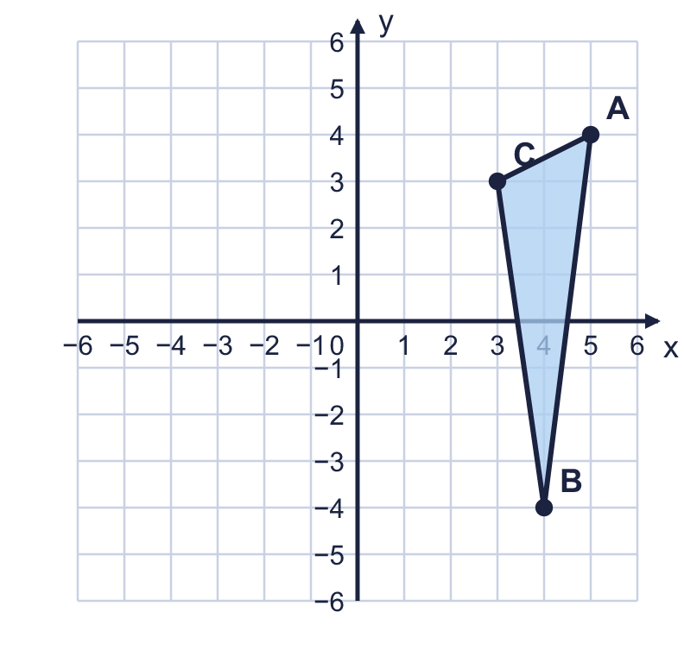  a) Corner A'  b) Corner B'  c) Corner C'
  2 | Reflect triangle ABC in the y-axis. Draw the new triangle in your book. Then write the coordinates of the corners of the new triangle.  a) Corner A'  b) Corner B'  c) Corner C'
  3 | Reflect triangle ABC in the x-axis. Draw the new triangle in your book. Then write the coordinates of the corners of the new triangle.  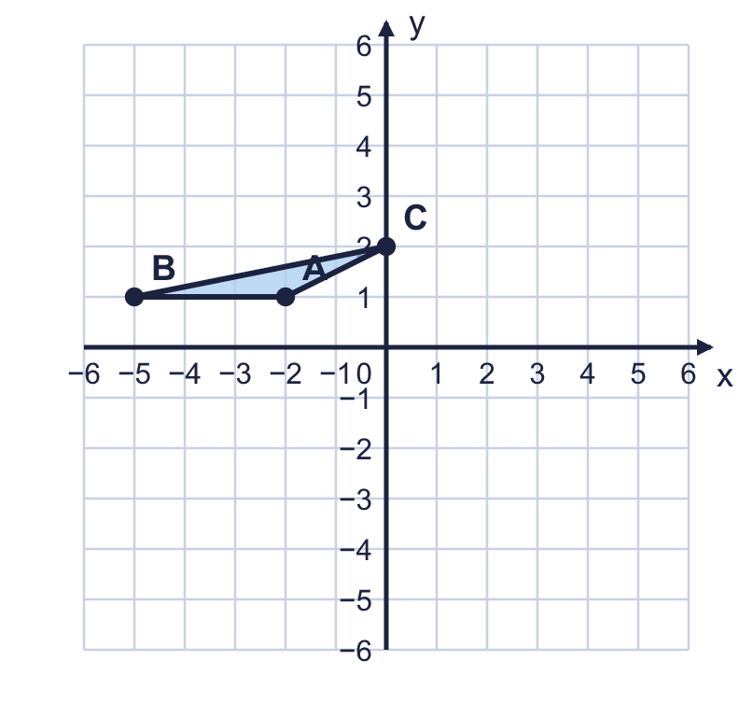  a) Corner A'  b) Corner B'  c) Corner C'
  3 | Reflect triangle ABC in the x-axis. Draw the new triangle in your book. Then write the coordinates of the corners of the new triangle.  a) Corner A'  b) Corner B'  c) Corner C'
  4 | Shape A is on the coordinate grid with three other shapes B, C and D.  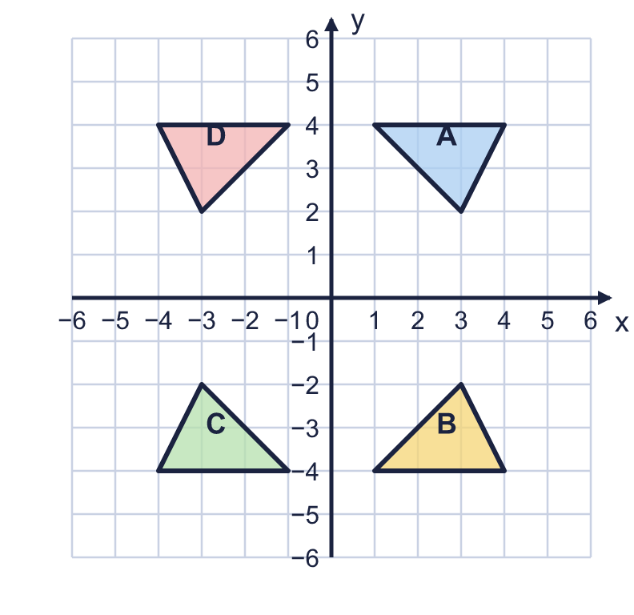  a) Which shape is the reflection of A in the y-axis? Write the letter.  b) Which shape is the reflection of A in the x-axis? Write the letter.
  4 | Shape A is on the coordinate grid with three other shapes B, C and D.  a) Which shape is the reflection of A in the y-axis? Write the letter.  b) Which shape is the reflection of A in the x-axis? Write the letter.
  5 | The point (−1, 2) is reflected in the x-axis. The new point is then reflected in the y-axis.  Write the coordinates of the point at the end.
  5 | The point (−1, 2) is reflected in the x-axis. The new point is then reflected in the y-axis.  Write the coordinates of the point at the end.
  6 | A point at (6, 3) is reflected. Its new position is (6, −3).  In which axis was it reflected? Write the x-axis or the y-axis.
  6 | A point at (6, 3) is reflected. Its new position is (6, −3).  In which axis was it reflected? Write the x-axis or the y-axis.
  7 | Rectangle ABCD is reflected in the y-axis.  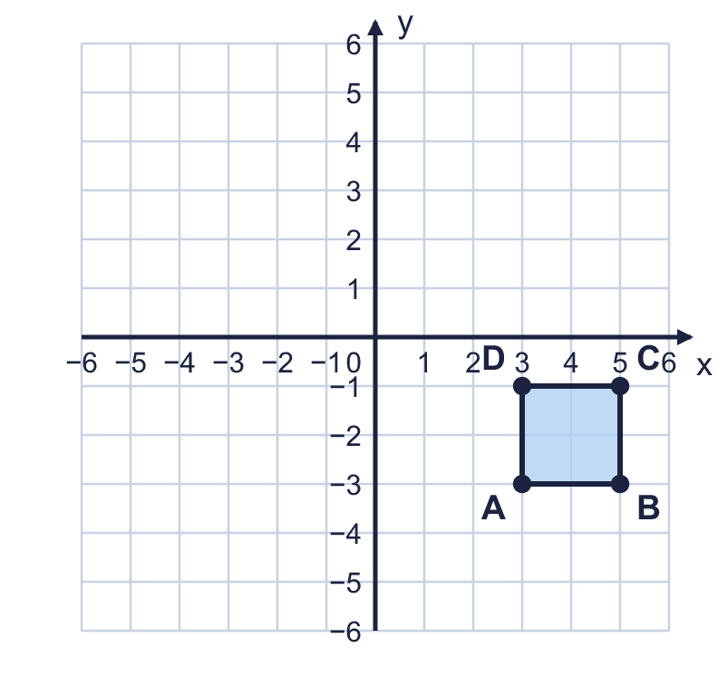  a) Write the coordinates of A'.  b) Write the coordinates of C'.
  7 | Rectangle ABCD is reflected in the y-axis.  a) Write the coordinates of A'.  b) Write the coordinates of C'.
  8 | Triangle ABC is drawn on the coordinate grid. It is reflected in the y-axis.  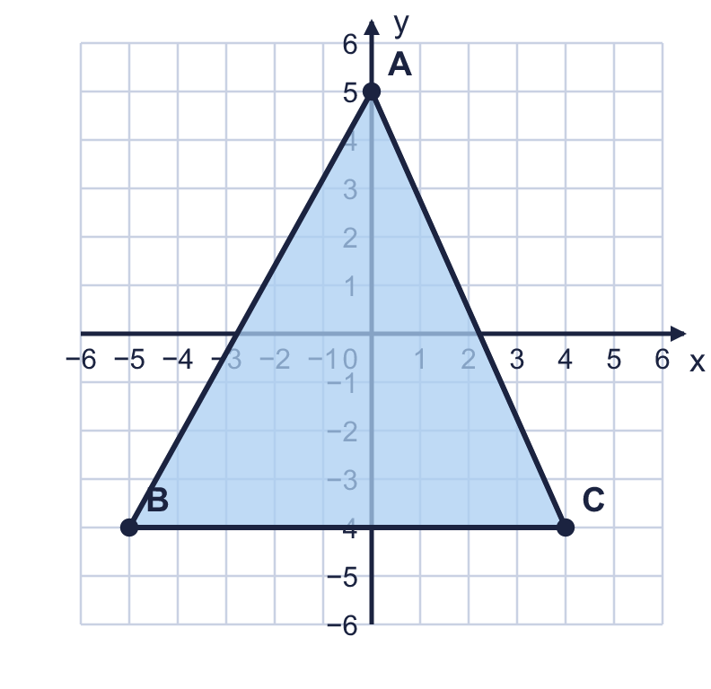  How many corners stay in the same place when the triangle is reflected in the y-axis?
  8 | Triangle ABC is drawn on the coordinate grid. It is reflected in the y-axis.  How many corners stay in the same place when the triangle is reflected in the y-axis?

  9 | Is Boba correct? Circle yes or no.  Yes / No  Explain how you know.
     | 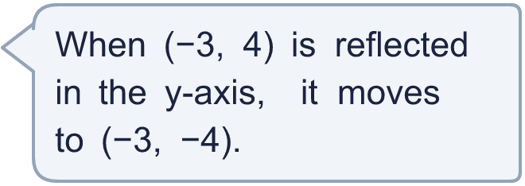
  9 | Is Boba correct? Circle yes or no.  Yes / No  Explain how you know.
  10 | Triangle ABC is reflected in the x-axis. The new triangle is translated 7 squares right and 3 squares up. That triangle is reflected in the x-axis again. Draw each step in your book if it helps. The final triangle has corners A', B' and C'.  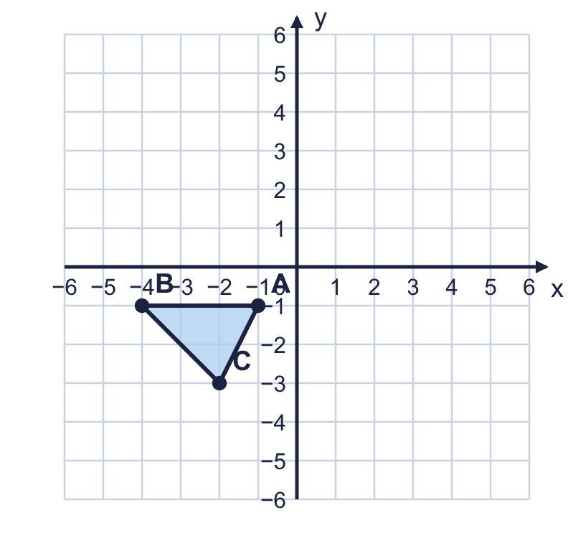  a) Write the coordinates of A'.  b) Write the coordinates of C'.
  10 | Triangle ABC is reflected in the x-axis. The new triangle is translated 7 squares right and 3 squares up. That triangle is reflected in the x-axis again. Draw each step in your book if it helps. The final triangle has corners A', B' and C'.  a) Write the coordinates of A'.  b) Write the coordinates of C'.
  11 | Work out where each point was before it was reflected.  a) After a reflection in the y-axis a point is at (−6, 4). Where was it before?  b) After a reflection in the x-axis a point is at (−3, 5). Where was it before?
  11 | Work out where each point was before it was reflected.  a) After a reflection in the y-axis a point is at (−6, 4). Where was it before?  b) After a reflection in the x-axis a point is at (−3, 5). Where was it before?
  12 | Triangle ABC is reflected in the y-axis.  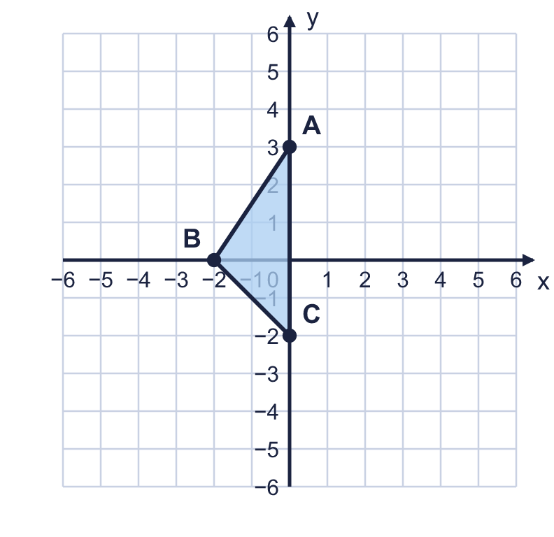  How many of the corners of ABC are in the same place after the reflection?  Explain why those corners do not move.
  12 | Triangle ABC is reflected in the y-axis.  How many of the corners of ABC are in the same place after the reflection?  Explain why those corners do not move.
  13 | A point is reflected in the x-axis. Then it is translated 2 squares right and 2 squares down. It ends at (−1, −1).  Where did the point start? Write the coordinates.
  13 | A point is reflected in the x-axis. Then it is translated 2 squares right and 2 squares down. It ends at (−1, −1).  Where did the point start? Write the coordinates.
  14 | Write three different points that stay in the same place when they are reflected in the y-axis.
  14 | Write three different points that stay in the same place when they are reflected in the y-axis.

Year 6 · Position and direction · Step 5
Reflections
Answers (teacher copy)

  1 | Write the coordinates of each point after it is reflected in the axis.  a) (2, 2) reflected in the y-axis (−2, 2)  b) (−3, 3) reflected in the x-axis (−3, −3)
  2 | Reflect triangle ABC in the y-axis. Draw the new triangle in your book. Then write the coordinates of the corners of the new triangle.  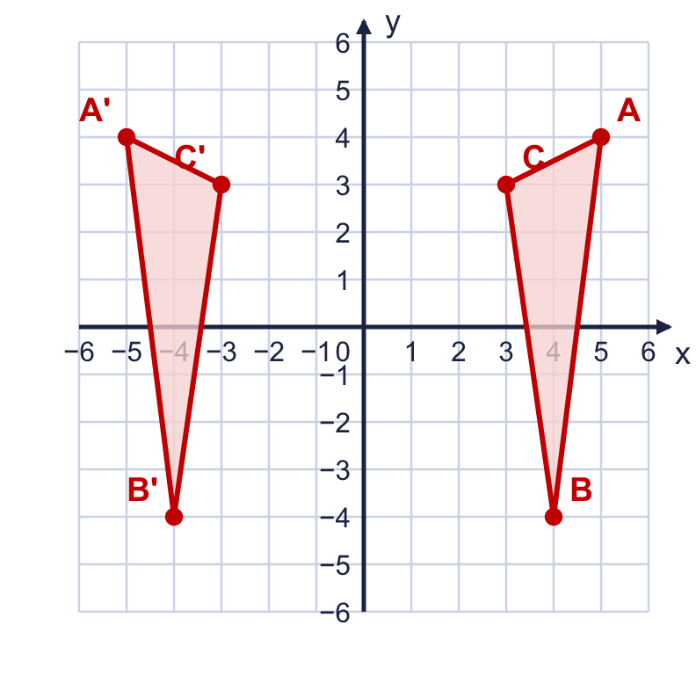  a) Corner A' (−5, 4)  b) Corner B' (−4, −4)  c) Corner C' (−3, 3)
  3 | Reflect triangle ABC in the x-axis. Draw the new triangle in your book. Then write the coordinates of the corners of the new triangle.  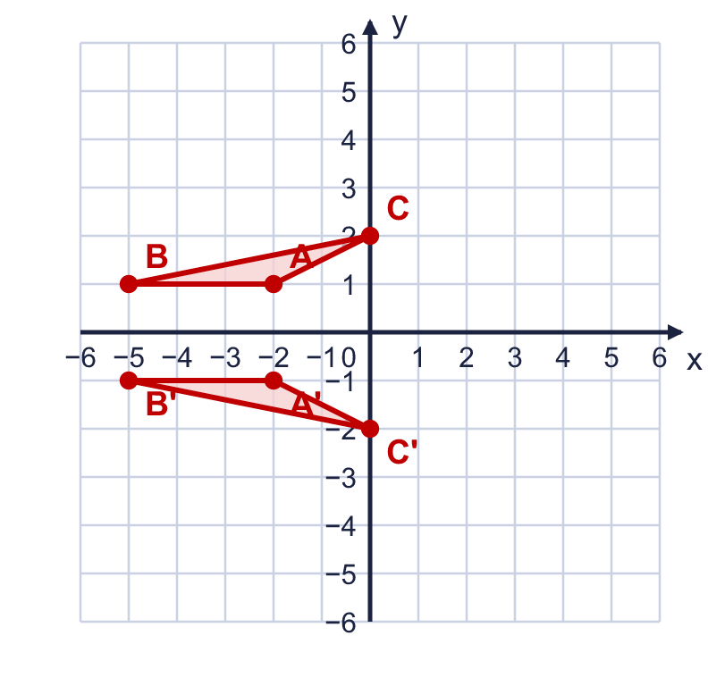  a) Corner A' (−2, −1)  b) Corner B' (−5, −1)  c) Corner C' (0, −2)
  4 | Shape A is on the coordinate grid with three other shapes B, C and D.  a) Which shape is the reflection of A in the y-axis? Write the letter. D  b) Which shape is the reflection of A in the x-axis? Write the letter. B
  5 | The point (−1, 2) is reflected in the x-axis. The new point is then reflected in the y-axis.  Write the coordinates of the point at the end. (1, −2)
  6 | A point at (6, 3) is reflected. Its new position is (6, −3).  In which axis was it reflected? Write the x-axis or the y-axis. x-axis
  7 | Rectangle ABCD is reflected in the y-axis.  a) Write the coordinates of A'. (−3, −3)  b) Write the coordinates of C'. (−5, −1)
  8 | Triangle ABC is drawn on the coordinate grid. It is reflected in the y-axis.  How many corners stay in the same place when the triangle is reflected in the y-axis? 1
  9 | Is Boba correct? Circle yes or no.  Yes / No  Explain how you know.  Reflecting in the y-axis changes the x-coordinate to its opposite and keeps the y-coordinate the same. The new point is (3, 4), not (−3, −4).
  10 | Triangle ABC is reflected in the x-axis. The new triangle is translated 7 squares right and 3 squares up. That triangle is reflected in the x-axis again. Draw each step in your book if it helps. The final triangle has corners A', B' and C'.  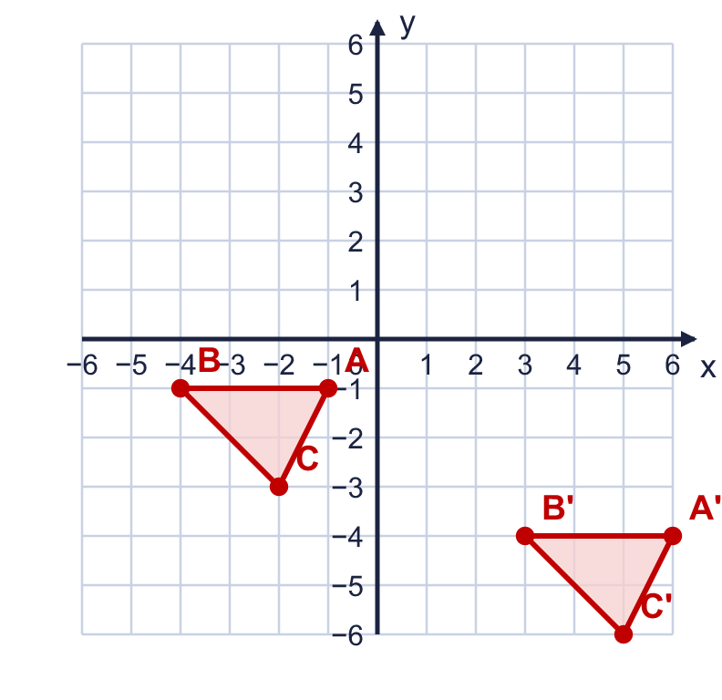  a) Write the coordinates of A'. (6, −4)  b) Write the coordinates of C'. (5, −6)
  11 | Work out where each point was before it was reflected.  a) After a reflection in the y-axis a point is at (−6, 4). Where was it before? (6, 4)  b) After a reflection in the x-axis a point is at (−3, 5). Where was it before? (−3, −5)
  12 | Triangle ABC is reflected in the y-axis.  How many of the corners of ABC are in the same place after the reflection? 2  Explain why those corners do not move.  They are on the y-axis, which is the mirror line. A point on the mirror line is as far from the line as its reflection (no distance), so it stays where it is.
  13 | A point is reflected in the x-axis. Then it is translated 2 squares right and 2 squares down. It ends at (−1, −1).  Where did the point start? Write the coordinates. (−3, −1)
  14 | Write three different points that stay in the same place when they are reflected in the y-axis.  Any three different points on the y-axis, for example (0, 2), (0, −4), (0, 6)

