  Year 6 · Statistics · Step 1  Line graphs | 
  Year 6 · Statistics · Step 1
  Line graphs
  1 | The graph shows the temperature in Kelby on one day.  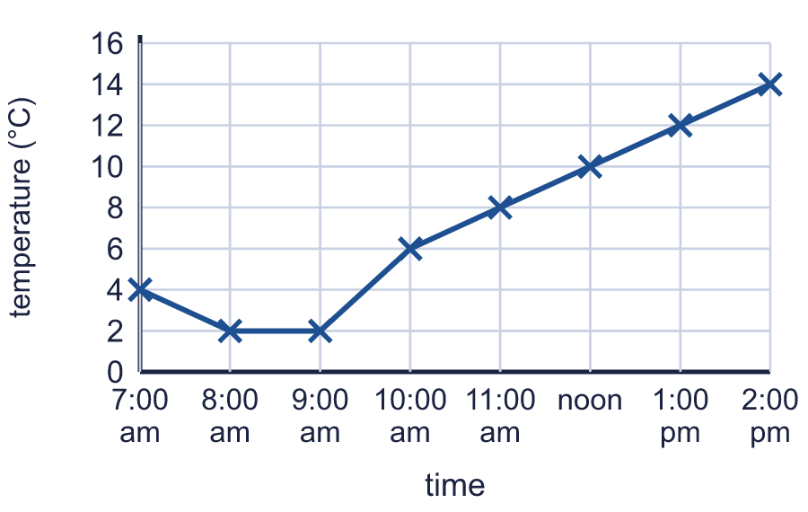  a) What was the temperature at 7:00 am? Write the number of °C.  b) What was the temperature at 11:00 am? Write the number of °C.
  1 | The graph shows the temperature in Kelby on one day.  a) What was the temperature at 7:00 am? Write the number of °C.  b) What was the temperature at 11:00 am? Write the number of °C.
  2 | The graph shows the temperature in Marlow on one day.  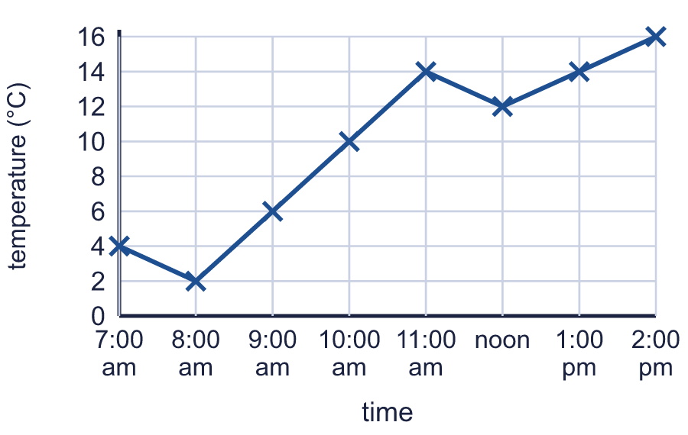  a) What was the difference in temperature between 7:00 am and 8:00 am?  b) By how many °C did the temperature fall between 7:00 am and 8:00 am?
  2 | The graph shows the temperature in Marlow on one day.  a) What was the difference in temperature between 7:00 am and 8:00 am?  b) By how many °C did the temperature fall between 7:00 am and 8:00 am?
  3 | The graph shows the temperature in Tarnley on one day.  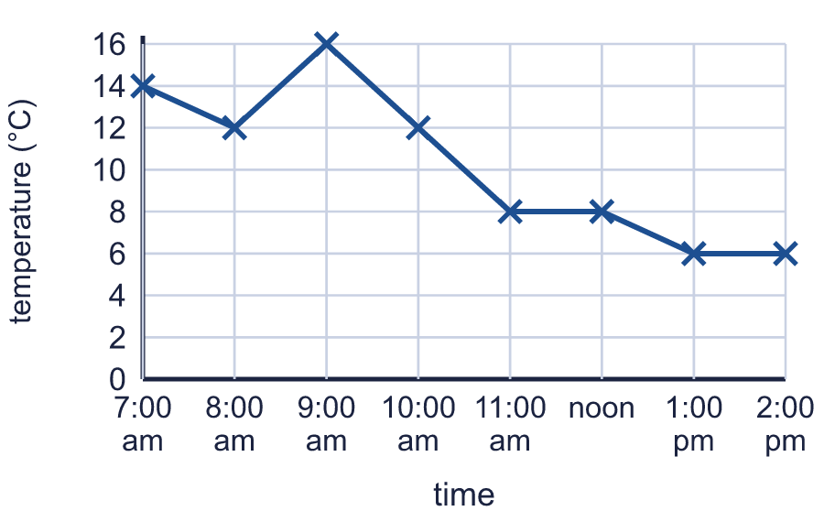  At what time was the temperature 16 °C? Write the time.
  3 | The graph shows the temperature in Tarnley on one day.  At what time was the temperature 16 °C? Write the time.
  4 | The graph shows the temperature in Oakby on one day.  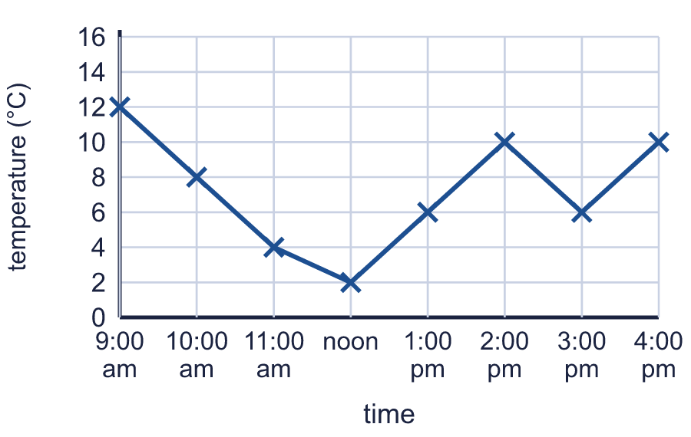  a) At what time was it warmest? Write the time.  b) At what time was it coolest? Write the time.
  4 | The graph shows the temperature in Oakby on one day.  a) At what time was it warmest? Write the time.  b) At what time was it coolest? Write the time.
  5 | The graph shows the temperature in Brindle on one day. A reading was taken every hour.  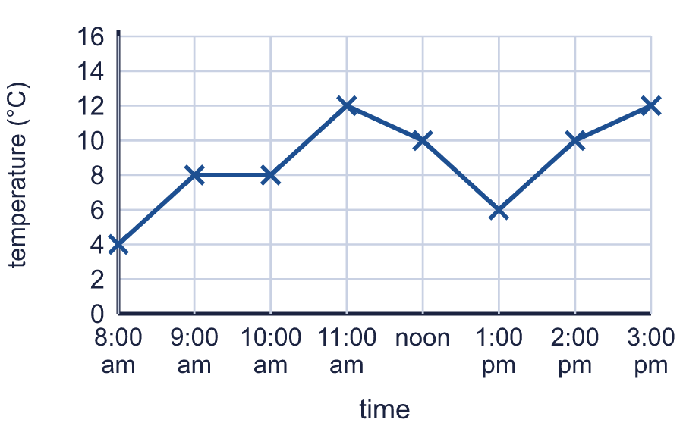  At how many of the readings was the temperature higher than 8 °C?
  5 | The graph shows the temperature in Brindle on one day. A reading was taken every hour.  At how many of the readings was the temperature higher than 8 °C?
  6 | The graph shows the value of two cars over the years.  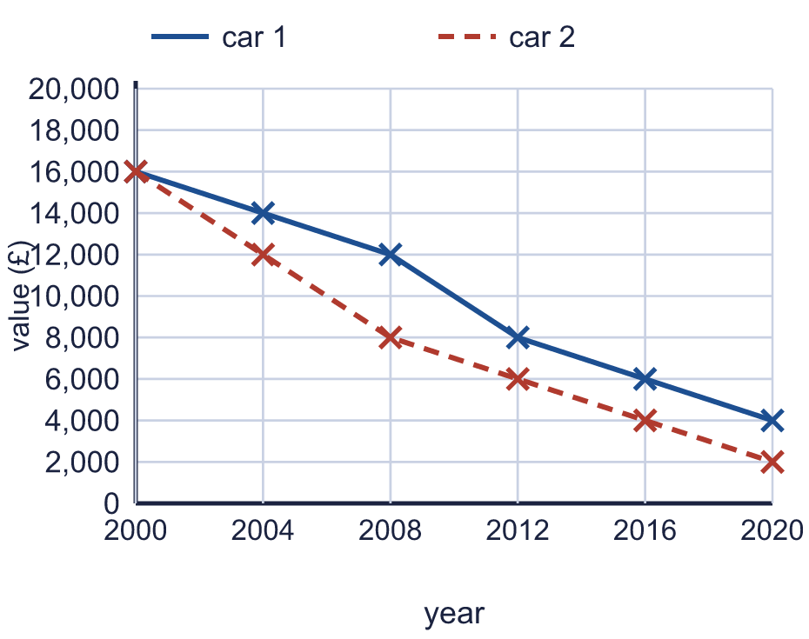  a) In which year were the two cars worth the same? Write the year.  b) What was car 2 worth in 2008? Write the number of pounds.
  6 | The graph shows the value of two cars over the years.  a) In which year were the two cars worth the same? Write the year.  b) What was car 2 worth in 2008? Write the number of pounds.
  7 | The graph shows the value of two cars over the years.  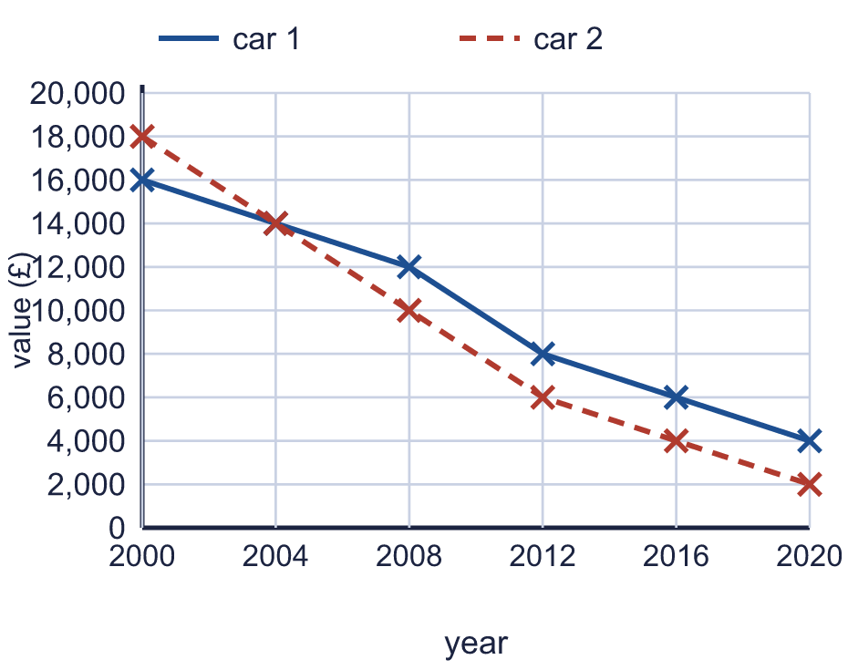  a) Which car was worth more in 2008? Write car 1 or car 2.  b) How many pounds more was it worth?
  7 | The graph shows the value of two cars over the years.  a) Which car was worth more in 2008? Write car 1 or car 2.  b) How many pounds more was it worth?
  8 | The graph shows the value of two cars over the years.  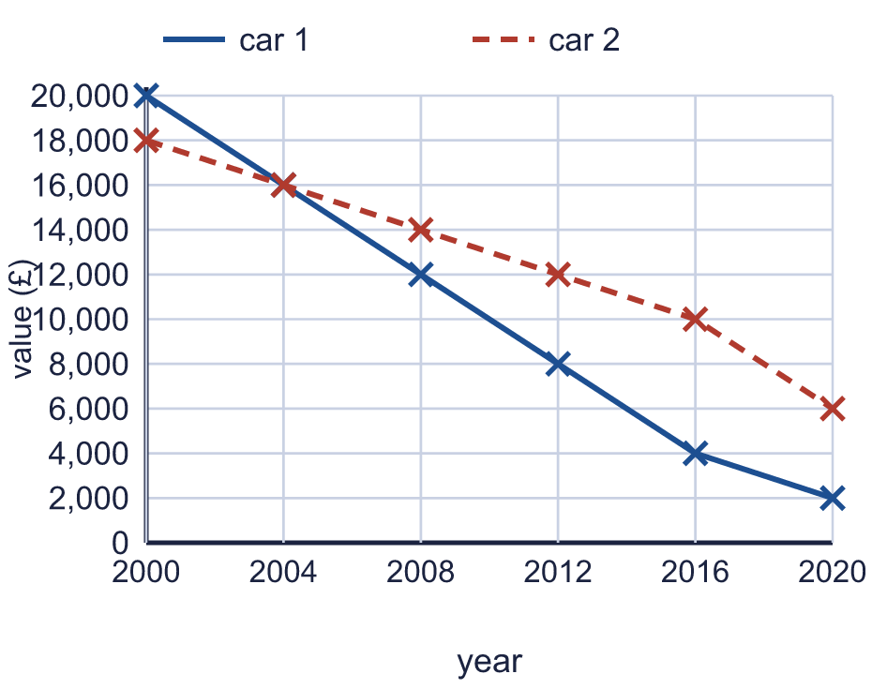  a) How many pounds did car 1 lose in value between 2012 and 2020?  b) How many pounds did car 2 lose in value between 2012 and 2020?
  8 | The graph shows the value of two cars over the years.  a) How many pounds did car 1 lose in value between 2012 and 2020?  b) How many pounds did car 2 lose in value between 2012 and 2020?

  9 | Look at the scale on the side of the graph. Is Boba correct? Circle yes or no.  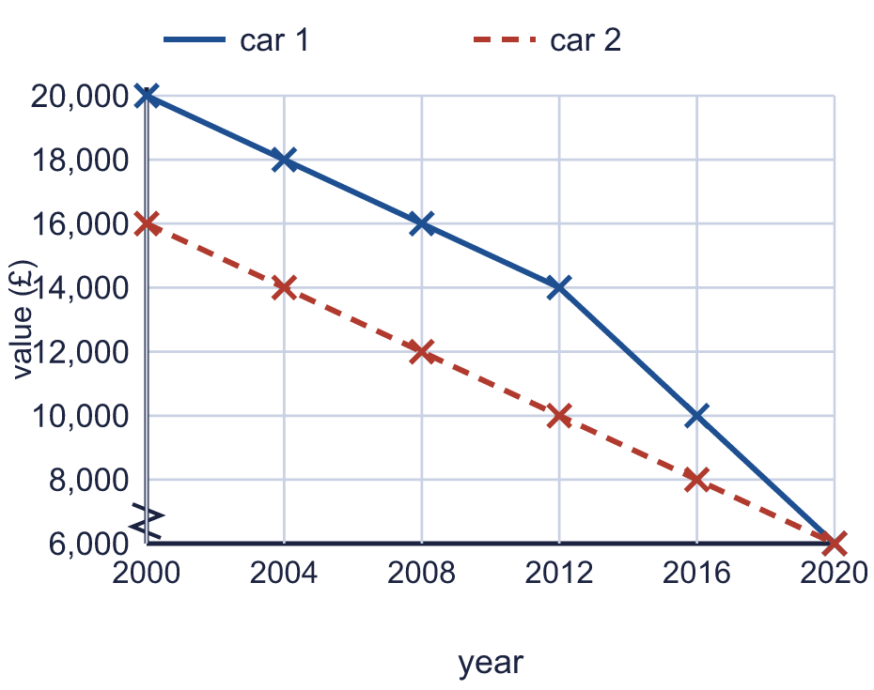  Yes / No  Explain how you know.
     | 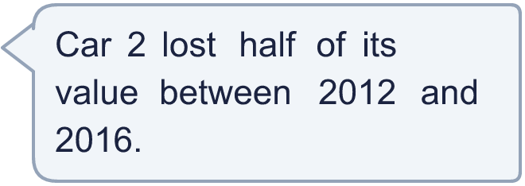
  9 | Look at the scale on the side of the graph. Is Boba correct? Circle yes or no.  Yes / No  Explain how you know.
  10 | A class measures the height of a bean plant each week. The table shows the results. Draw a line graph of the data in your book. Use a ruler and put time (weeks) along the bottom.  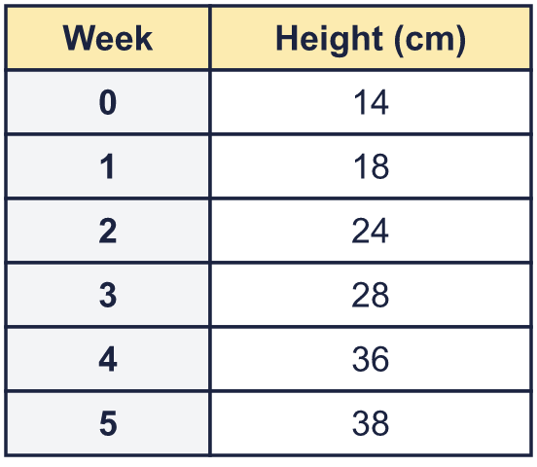  a) Use your graph. What was the biggest increase in height in one week? Write the number of cm.  b) In which week did the plant grow the most? Write the week number.
  10 | A class measures the height of a bean plant each week. The table shows the results. Draw a line graph of the data in your book. Use a ruler and put time (weeks) along the bottom.  a) Use your graph. What was the biggest increase in height in one week? Write the number of cm.  b) In which week did the plant grow the most? Write the week number.
  11 | A drone flies for one hour. The graph shows its height above the ground.  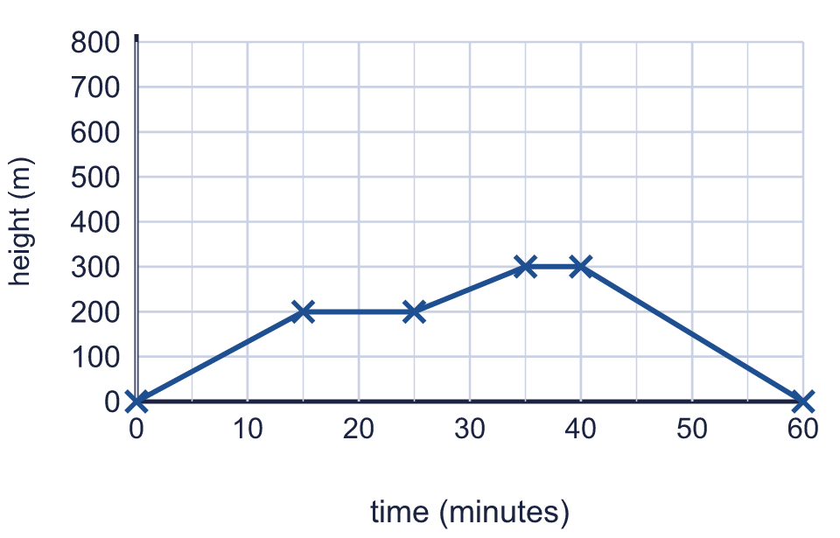  a) What was the greatest height the drone reached? Write the number of metres.  b) For how many minutes in total did the drone stay at the same height?
  11 | A drone flies for one hour. The graph shows its height above the ground.  a) What was the greatest height the drone reached? Write the number of metres.  b) For how many minutes in total did the drone stay at the same height?
  12 | Two tanks are filled and emptied during a night and a day. The graph shows how much water each tank holds.  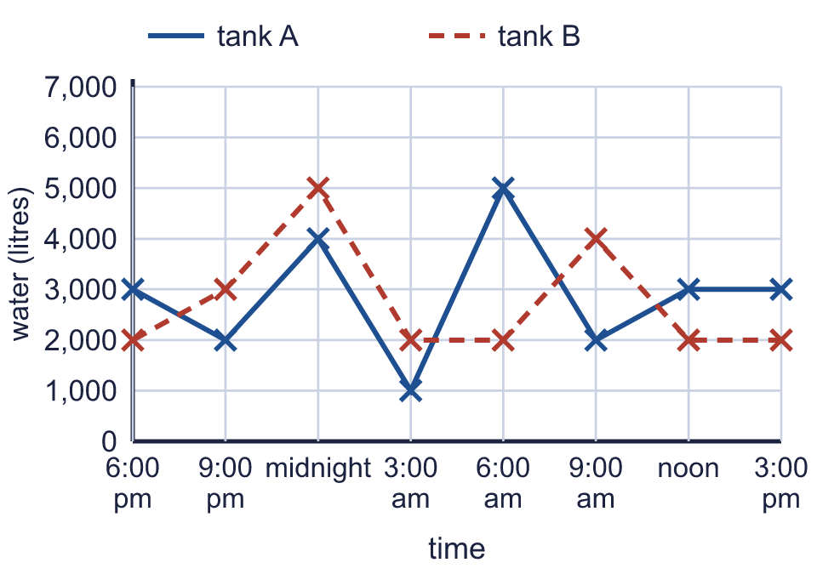  a) At which times did tank B hold more water than tank A? Write the times.  b) What is the difference between the amounts of water in the two tanks at 9:00 am? Write the number of litres.
  12 | Two tanks are filled and emptied during a night and a day. The graph shows how much water each tank holds.  a) At which times did tank B hold more water than tank A? Write the times.  b) What is the difference between the amounts of water in the two tanks at 9:00 am? Write the number of litres.
  13 | This graph is a straight line. You can use it to change kilometres into miles and miles into kilometres.  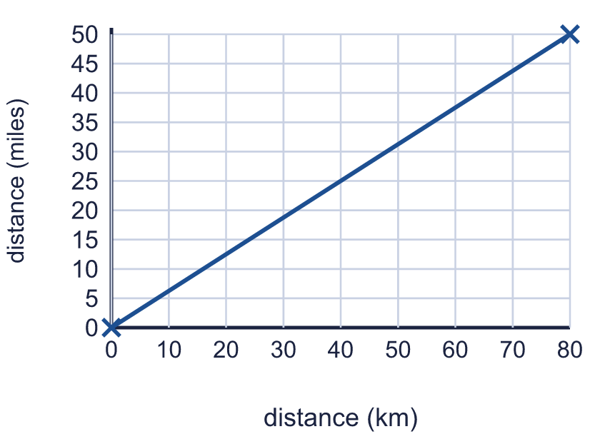  a) About how many miles is 32 km? Write the number of miles.  b) About how many kilometres is 25 miles? Write the number of km.
  13 | This graph is a straight line. You can use it to change kilometres into miles and miles into kilometres.  a) About how many miles is 32 km? Write the number of miles.  b) About how many kilometres is 25 miles? Write the number of km.
  14 | The graph shows the temperature in Stoneleigh. A reading was taken every hour.  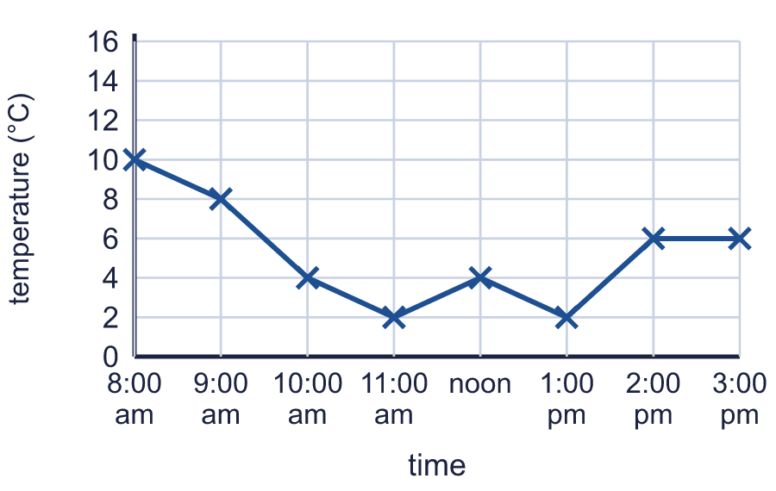  Between two readings, one hour apart, the temperature went up by more than at any other time.  a) At what time was the second of those two readings taken? Write the time.  b) By how many °C did the temperature go up?
  14 | The graph shows the temperature in Stoneleigh. A reading was taken every hour.  Between two readings, one hour apart, the temperature went up by more than at any other time.  a) At what time was the second of those two readings taken? Write the time.  b) By how many °C did the temperature go up?

Year 6 · Statistics · Step 1
Line graphs
Answers (teacher copy)

  1 | The graph shows the temperature in Kelby on one day.  a) What was the temperature at 7:00 am? Write the number of °C. 4  b) What was the temperature at 11:00 am? Write the number of °C. 8
  2 | The graph shows the temperature in Marlow on one day.  a) What was the difference in temperature between 7:00 am and 8:00 am? 2  b) By how many °C did the temperature fall between 7:00 am and 8:00 am? 2
  3 | The graph shows the temperature in Tarnley on one day.  At what time was the temperature 16 °C? Write the time. 9:00 am
  4 | The graph shows the temperature in Oakby on one day.  a) At what time was it warmest? Write the time. 9:00 am  b) At what time was it coolest? Write the time. noon
  5 | The graph shows the temperature in Brindle on one day. A reading was taken every hour.  At how many of the readings was the temperature higher than 8 °C? 4
  6 | The graph shows the value of two cars over the years.  a) In which year were the two cars worth the same? Write the year. 2000  b) What was car 2 worth in 2008? Write the number of pounds. 8,000
  7 | The graph shows the value of two cars over the years.  a) Which car was worth more in 2008? Write car 1 or car 2. car 1  b) How many pounds more was it worth? 2,000
  8 | The graph shows the value of two cars over the years.  a) How many pounds did car 1 lose in value between 2012 and 2020? 6,000  b) How many pounds did car 2 lose in value between 2012 and 2020? 6,000
  9 | Look at the scale on the side of the graph. Is Boba correct? Circle yes or no.  Yes / No  Explain how you know.  Half of £10,000 is £5,000, but car 2 was worth £8,000 in 2016. The scale starts at £6,000, not at £0, so the line seems to fall further than it does.
  10 | A class measures the height of a bean plant each week. The table shows the results. Draw a line graph of the data in your book. Use a ruler and put time (weeks) along the bottom.  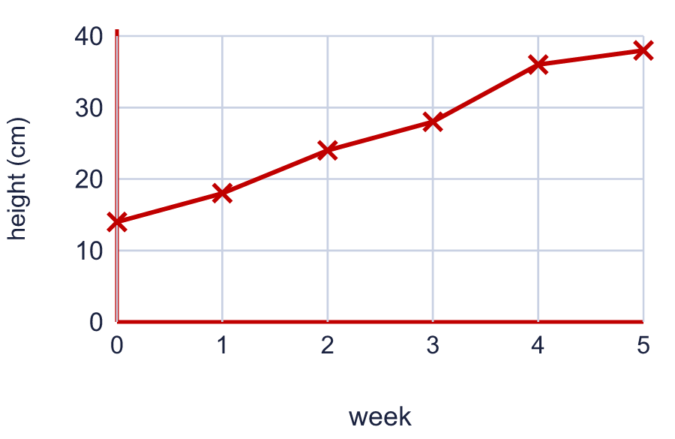  a) Use your graph. What was the biggest increase in height in one week? Write the number of cm. 8  b) In which week did the plant grow the most? Write the week number. 4
  11 | A drone flies for one hour. The graph shows its height above the ground.  a) What was the greatest height the drone reached? Write the number of metres. 300  b) For how many minutes in total did the drone stay at the same height? 15
  12 | Two tanks are filled and emptied during a night and a day. The graph shows how much water each tank holds.  a) At which times did tank B hold more water than tank A? Write the times. 9:00 pm, midnight, 3:00 am, 9:00 am  b) What is the difference between the amounts of water in the two tanks at 9:00 am? Write the number of litres. 2,000
  13 | This graph is a straight line. You can use it to change kilometres into miles and miles into kilometres.  a) About how many miles is 32 km? Write the number of miles. 20  b) About how many kilometres is 25 miles? Write the number of km. 40
  14 | The graph shows the temperature in Stoneleigh. A reading was taken every hour.  Between two readings, one hour apart, the temperature went up by more than at any other time.  a) At what time was the second of those two readings taken? Write the time. 2:00 pm  b) By how many °C did the temperature go up? 4

