  Year 6 · Ratio · Step 7  Similar shapes | 
  Year 6 · Ratio · Step 7
  Similar shapes
  1 | Look at each pair of rectangles. Are they similar? Circle yes or no.  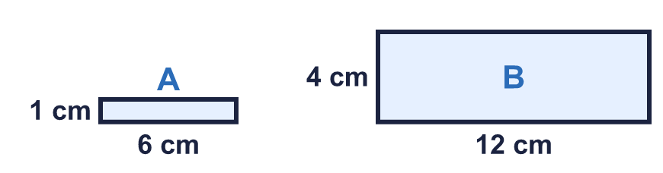  a) Are A and B similar?  Yes / No  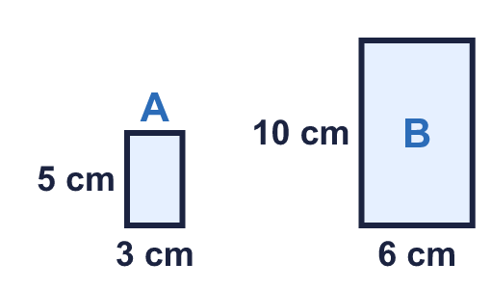  b) Are A and B similar?  Yes / No
  1 | Look at each pair of rectangles. Are they similar? Circle yes or no.  a) Are A and B similar?  Yes / No  b) Are A and B similar?  Yes / No
  2 | The first rectangle is C. Two of the other three rectangles are similar to C. One is not similar.  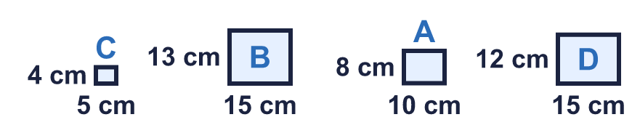  Which rectangle is not similar to C? Write its letter.
  2 | The first rectangle is C. Two of the other three rectangles are similar to C. One is not similar.  Which rectangle is not similar to C? Write its letter.
  3 | Each pair of rectangles is similar. Work out the missing length.  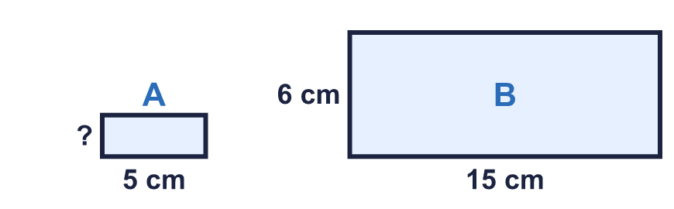  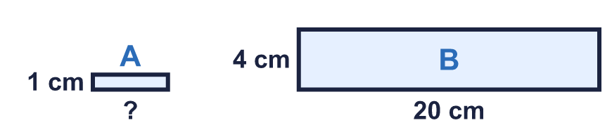  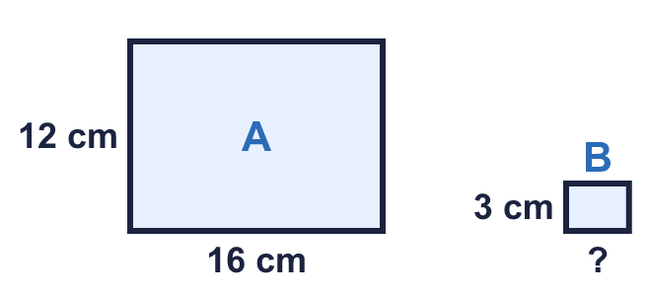
  3 | Each pair of rectangles is similar. Work out the missing length.
  4 | The two rectangles are similar. Work out the missing length.  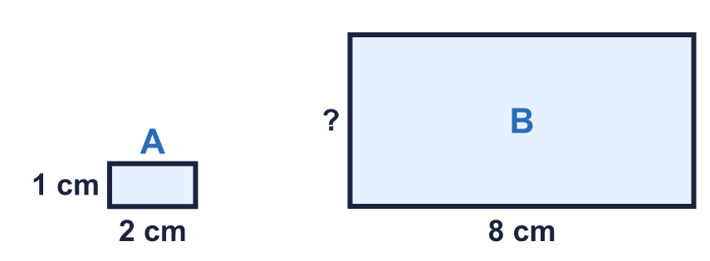
  4 | The two rectangles are similar. Work out the missing length.
  5 | These two rectangles are similar.  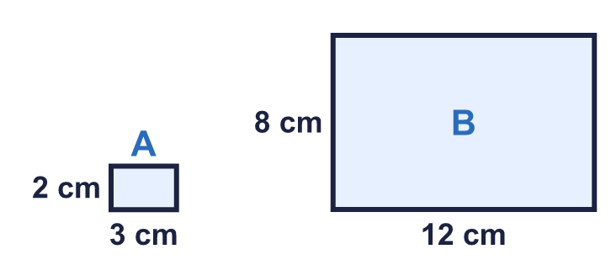
    c) The perimeter of B is
    times the perimeter of A
  5 | These two rectangles are similar.
    c) The perimeter of B is
    times the perimeter of A
  6 | Rectangle E is the first one. Two of the other rectangles are similar to E.  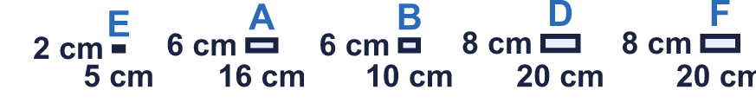  Write the letters of the two rectangles that are similar to E.
  6 | Rectangle E is the first one. Two of the other rectangles are similar to E.  Write the letters of the two rectangles that are similar to E.
  7 | The rectangles in the table are all similar. Write the missing numbers.  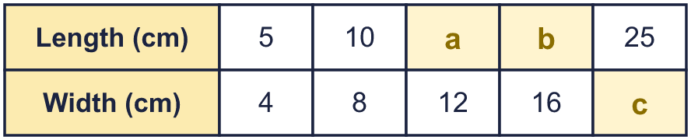
  7 | The rectangles in the table are all similar. Write the missing numbers.
  8 | These two rectangles are similar. Work out the missing length.  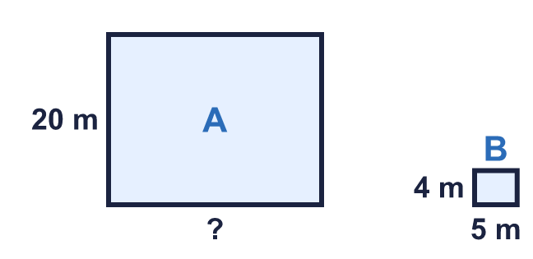
  8 | These two rectangles are similar. Work out the missing length.

  9 | Rectangle A is 5 cm by 2 cm. Rectangle B is 8 cm by 5 cm.  Is B similar to A? Circle yes or no.  Yes / No  Explain how you know.
     | 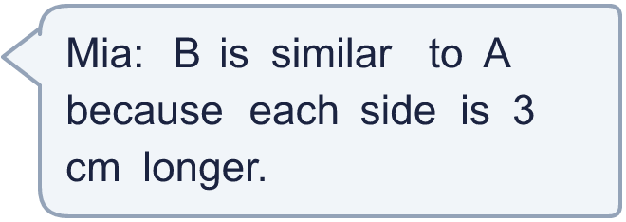
  9 | Rectangle A is 5 cm by 2 cm. Rectangle B is 8 cm by 5 cm.  Is B similar to A? Circle yes or no.  Yes / No  Explain how you know.
  10 | A poster is 7 cm wide and 4 cm high. It is enlarged so that the new poster is similar.  The new poster is 12 cm high. How wide is it?
  10 | A poster is 7 cm wide and 4 cm high. It is enlarged so that the new poster is similar.  The new poster is 12 cm high. How wide is it?
  11 | A flag is 8 cm wide and 6 cm high. A small flag is similar to it.  The small flag is 4 cm wide. How high is it?
  11 | A flag is 8 cm wide and 6 cm high. A small flag is similar to it.  The small flag is 4 cm wide. How high is it?
  12 | Two rectangles are similar. The perimeter of the small rectangle is 20 cm. Each side of the big rectangle is 4 times as long as the matching side of the small one.  a) Perimeter of the big rectangle: cm
  12 | Two rectangles are similar. The perimeter of the small rectangle is 20 cm. Each side of the big rectangle is 4 times as long as the matching side of the small one.  a) Perimeter of the big rectangle: cm
  13 | Three of these four rectangles are similar to each other. One is different.  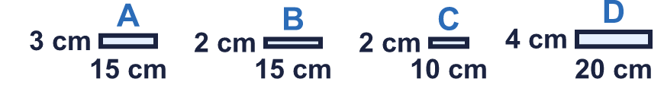  Which rectangle is the odd one out? Write its letter.
  13 | Three of these four rectangles are similar to each other. One is different.  Which rectangle is the odd one out? Write its letter.
  14 | Challenge  A rectangle has a length to width ratio of 3 : 2. Its perimeter is 50 cm.
  14 | Challenge  A rectangle has a length to width ratio of 3 : 2. Its perimeter is 50 cm.

Year 6 · Ratio · Step 7
Similar shapes
Answers (teacher copy)

  1 | Look at each pair of rectangles. Are they similar? Circle yes or no.  a) Are A and B similar?  Yes / No  b) Are A and B similar?  Yes / No
  2 | The first rectangle is C. Two of the other three rectangles are similar to C. One is not similar.  Which rectangle is not similar to C? Write its letter.  B
  3 | Each pair of rectangles is similar. Work out the missing length.  a = 2 cm  b = 5 cm  c = 4 cm
  4 | The two rectangles are similar. Work out the missing length.  Missing length: 4 cm
  5 | These two rectangles are similar.  a) Perimeter of A: 10 cm  b) Perimeter of B: 40 cm  c) The perimeter of B is 4 times the perimeter of A
  6 | Rectangle E is the first one. Two of the other rectangles are similar to E.  Write the letters of the two rectangles that are similar to E.  D, F
  7 | The rectangles in the table are all similar. Write the missing numbers.  a = 15  b = 20  c = 20
  8 | These two rectangles are similar. Work out the missing length.  Missing length: 25 m
  9 | Rectangle A is 5 cm by 2 cm. Rectangle B is 8 cm by 5 cm.  Is B similar to A? Circle yes or no.  Yes / No  Explain how you know.  No. 5 + 3 = 8 and 2 + 3 = 5, but adding does not keep the shape. 8 ÷ 5 is not 5 ÷ 2.
  10 | A poster is 7 cm wide and 4 cm high. It is enlarged so that the new poster is similar.  The new poster is 12 cm high. How wide is it?  21 cm
  11 | A flag is 8 cm wide and 6 cm high. A small flag is similar to it.  The small flag is 4 cm wide. How high is it?  3 cm
  12 | Two rectangles are similar. The perimeter of the small rectangle is 20 cm. Each side of the big rectangle is 4 times as long as the matching side of the small one.  a) Perimeter of the big rectangle: 80 cm  b) How much bigger is it? 60 cm
  13 | Three of these four rectangles are similar to each other. One is different.  Which rectangle is the odd one out? Write its letter.  B
  14 | Challenge  A rectangle has a length to width ratio of 3 : 2. Its perimeter is 50 cm.  Length: 15 cm Width: 10 cm

