The rectangle is 3 squares by 2 squares. 1 square = 2 cm, so the real rectangle is 6 cm by 4 cm:  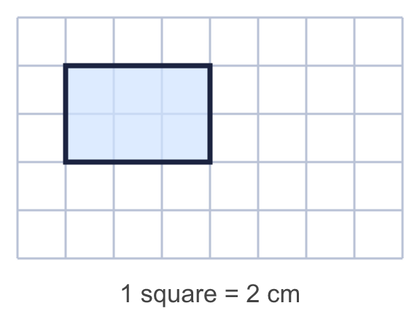 |  | The rectangle is 3 squares by 2 squares. 1 square = 2 cm, so the real rectangle is 6 cm by 4 cm:
  Year 6 · Ratio · Step 5  Scale drawings | 
  Year 6 · Ratio · Step 5
  Scale drawings
  1 | Use each scale to work out the real length.  a) On a map, 1 cm represents 4 m. A fence is 5 cm long on the map.  b) On a map, 1 cm represents 5 km. A road is 8 cm long on the map.  c) On a map, 1 cm represents 10 km. A road is 5 cm long on the map.  Hint: The scale tells you what 1 cm stands for. Multiply by the number of centimetres on the map.
  1 | Use each scale to work out the real length.  a) On a map, 1 cm represents 4 m. A fence is 5 cm long on the map.  b) On a map, 1 cm represents 5 km. A road is 8 cm long on the map.  c) On a map, 1 cm represents 10 km. A road is 5 cm long on the map.  Hint: The scale tells you what 1 cm stands for. Multiply by the number of centimetres on the map.
  2 | Here is a scale drawing of a rectangle. 1 square = 4 cm. What are the real length and width?  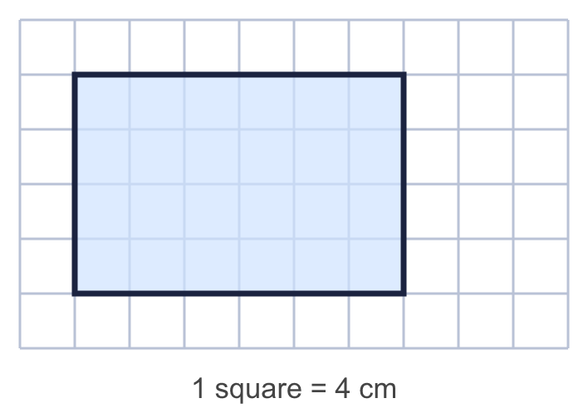  Hint: Count the squares along each side. Each square stands for the length in the scale.
  2 | Here is a scale drawing of a rectangle. 1 square = 4 cm. What are the real length and width?  Hint: Count the squares along each side. Each square stands for the length in the scale.
  3 | Use each scale to work out the length on the map.  a) On a map, 1 cm represents 3 m. A fence is really 18 m long.  b) On a map, 1 cm represents 5 km. A road is really 15 km long.  c) On a map, 1 cm represents 10 km. A road is really 30 km long.  Hint: Divide the real length by the number that 1 cm stands for.
  3 | Use each scale to work out the length on the map.  a) On a map, 1 cm represents 3 m. A fence is really 18 m long.  b) On a map, 1 cm represents 5 km. A road is really 15 km long.  c) On a map, 1 cm represents 10 km. A road is really 30 km long.  Hint: Divide the real length by the number that 1 cm stands for.
  4 | Here is a scale drawing of a rectangle. 1 square = 3 cm.  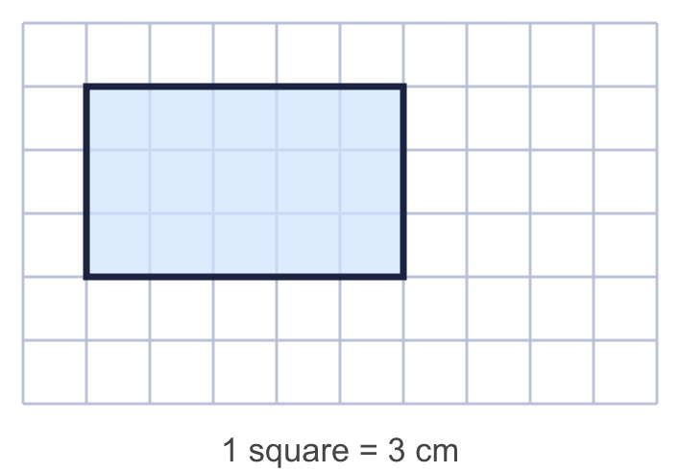  b) Perimeter of the real rectangle: cm  Hint: Add up all four sides of the drawing. For part b, multiply by what each square stands for.
  4 | Here is a scale drawing of a rectangle. 1 square = 3 cm.  b) Perimeter of the real rectangle: cm  Hint: Add up all four sides of the drawing. For part b, multiply by what each square stands for.
  5 | The first rectangle is the original. Only one of the other three rectangles is a scale drawing of it.  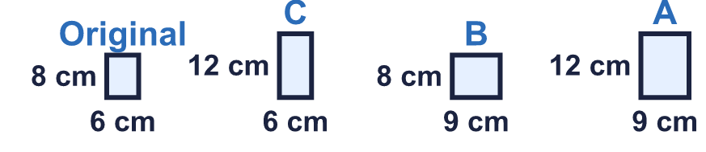  Which one is it? Write its letter.  Hint: In a scale drawing every length is multiplied by the same number. Check the length and the width.
  5 | The first rectangle is the original. Only one of the other three rectangles is a scale drawing of it.  Which one is it? Write its letter.  Hint: In a scale drawing every length is multiplied by the same number. Check the length and the width.
  6 | a) A model car is made to a scale of 1 : 25. The model is 12 cm long.  b) A model boat is made to a scale of 1 : 25. The real boat is 2.25 m long.  Hint: 1 : 50 means every 1 cm on the model is 50 cm in real life. 100 cm = 1 m.
  6 | a) A model car is made to a scale of 1 : 25. The model is 12 cm long.  b) A model boat is made to a scale of 1 : 25. The real boat is 2.25 m long.  Hint: 1 : 50 means every 1 cm on the model is 50 cm in real life. 100 cm = 1 m.
  7 | On a plan, 1 cm represents 3 m. A room is 6 cm by 9 cm on the plan.  Hint: Find the real length and the real width first. Then multiply them to find the area.
  7 | On a plan, 1 cm represents 3 m. A room is 6 cm by 9 cm on the plan.  Hint: Find the real length and the real width first. Then multiply them to find the area.
  8 | Use each scale to work out the missing length.  a) On a map, 1 cm represents 50 m. A fence is really 100 m long.  b) On a map, 1 cm represents 1.5 m. A footpath is 2 cm long on the map.  c) On a map, 1 cm represents 250 m. A footpath is really 2,500 m long.  Hint: Real length = map length × the scale. Map length = real length ÷ the scale.
  8 | Use each scale to work out the missing length.  a) On a map, 1 cm represents 50 m. A fence is really 100 m long.  b) On a map, 1 cm represents 1.5 m. A footpath is 2 cm long on the map.  c) On a map, 1 cm represents 250 m. A footpath is really 2,500 m long.  Hint: Real length = map length × the scale. Map length = real length ÷ the scale.

  9 | On a map, 1 cm represents 5 km.  Is Boba correct? Circle yes or no.  Yes / No  Explain the mistake.  Hint: 1 cm is 5 km. How many centimetres are there? Multiply.
    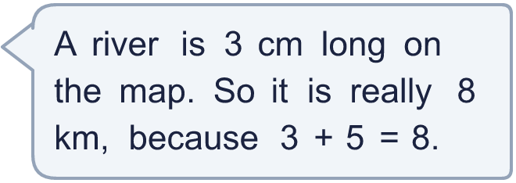
  9 | On a map, 1 cm represents 5 km.  Is Boba correct? Circle yes or no.  Yes / No  Explain the mistake.  Hint: 1 cm is 5 km. How many centimetres are there? Multiply.
  10 | Amir uses map A. On map A, 1 cm represents 6 km. Eva uses map B. On map B, 1 cm represents 3 km.  A real journey is 36 km. Amir and Eva each draw the journey as a straight line on their own map.  Whose line is longer? How many centimetres longer?  Hint: Work out the length of each line in centimetres. Then subtract.
  10 | Amir uses map A. On map A, 1 cm represents 6 km. Eva uses map B. On map B, 1 cm represents 3 km.  A real journey is 36 km. Amir and Eva each draw the journey as a straight line on their own map.  Whose line is longer? How many centimetres longer?  Hint: Work out the length of each line in centimetres. Then subtract.
  11 | On a map, 1 cm represents 250 m. Mia walks from A to B (9 cm on the map) and then from B to C (7 cm on the map).  How far does Mia walk altogether? Give your answer in kilometres.  Hint: Add the two lengths on the map. Multiply by 250 to get metres. Then divide by 1,000 to change metres to kilometres.
  11 | On a map, 1 cm represents 250 m. Mia walks from A to B (9 cm on the map) and then from B to C (7 cm on the map).  How far does Mia walk altogether? Give your answer in kilometres.  Hint: Add the two lengths on the map. Multiply by 250 to get metres. Then divide by 1,000 to change metres to kilometres.
  12 | A garden is 10 m long. It is drawn on a plan as a line 5 cm long.  Hint: Divide 10 by 5 to find how many metres 1 cm stands for. Then change metres to centimetres.
    a) 1 cm on the plan represents
    m
    b) Written as a ratio, the scale is 1 :
  12 | A garden is 10 m long. It is drawn on a plan as a line 5 cm long.  Hint: Divide 10 by 5 to find how many metres 1 cm stands for. Then change metres to centimetres.
    a) 1 cm on the plan represents
    m
    b) Written as a ratio, the scale is 1 :
  13 | A field is 25 m by 15 m. It is drawn with 1 cm = 5 m.  b) Perimeter of the real field: m  Hint: Change each length to centimetres by dividing by 5. Then find the perimeter.
  13 | A field is 25 m by 15 m. It is drawn with 1 cm = 5 m.  b) Perimeter of the real field: m  Hint: Change each length to centimetres by dividing by 5. Then find the perimeter.
  14 | Challenge  On a map, 1 cm represents 2 km. A square lake has sides that are 2 cm long on the map.  What is the real area of the lake?  Hint: First find the real length of one side in km. Then multiply the length by the width to find the area.
  14 | Challenge  On a map, 1 cm represents 2 km. A square lake has sides that are 2 cm long on the map.  What is the real area of the lake?  Hint: First find the real length of one side in km. Then multiply the length by the width to find the area.

Year 6 · Ratio · Step 5
Scale drawings
Answers (teacher copy)

The rectangle is 3 squares by 2 squares. 1 square = 2 cm, so the real rectangle is 6 cm by 4 cm:
  1 | Use each scale to work out the real length.  a) On a map, 1 cm represents 4 m. A fence is 5 cm long on the map.  Real length: 20 m  b) On a map, 1 cm represents 5 km. A road is 8 cm long on the map.  Real length: 40 km  c) On a map, 1 cm represents 10 km. A road is 5 cm long on the map.  Real length: 50 km  Hint: The scale tells you what 1 cm stands for. Multiply by the number of centimetres on the map.
  2 | Here is a scale drawing of a rectangle. 1 square = 4 cm. What are the real length and width?  Length: 24 cm  Width: 16 cm  Hint: Count the squares along each side. Each square stands for the length in the scale.
  3 | Use each scale to work out the length on the map.  a) On a map, 1 cm represents 3 m. A fence is really 18 m long.  Length on the map: 6 cm  b) On a map, 1 cm represents 5 km. A road is really 15 km long.  Length on the map: 3 cm  c) On a map, 1 cm represents 10 km. A road is really 30 km long.  Length on the map: 3 cm  Hint: Divide the real length by the number that 1 cm stands for.
  4 | Here is a scale drawing of a rectangle. 1 square = 3 cm.  a) Perimeter of the drawing: 16 squares  b) Perimeter of the real rectangle: 48 cm  Hint: Add up all four sides of the drawing. For part b, multiply by what each square stands for.
  5 | The first rectangle is the original. Only one of the other three rectangles is a scale drawing of it.  Which one is it? Write its letter.  A  Hint: In a scale drawing every length is multiplied by the same number. Check the length and the width.
  6 | a) A model car is made to a scale of 1 : 25. The model is 12 cm long.  Real car length: 3 m  b) A model boat is made to a scale of 1 : 25. The real boat is 2.25 m long.  Model length: 9 cm  Hint: 1 : 50 means every 1 cm on the model is 50 cm in real life. 100 cm = 1 m.
  7 | On a plan, 1 cm represents 3 m. A room is 6 cm by 9 cm on the plan.  a) Real length: 27 m  b) Real width: 18 m  c) Real area: 486 m²  Hint: Find the real length and the real width first. Then multiply them to find the area.
  8 | Use each scale to work out the missing length.  a) On a map, 1 cm represents 50 m. A fence is really 100 m long.  Length on the map: 2 cm  b) On a map, 1 cm represents 1.5 m. A footpath is 2 cm long on the map.  Real length: 3 m  c) On a map, 1 cm represents 250 m. A footpath is really 2,500 m long.  Length on the map: 10 cm  Hint: Real length = map length × the scale. Map length = real length ÷ the scale.
  9 | On a map, 1 cm represents 5 km.  Is Boba correct? Circle yes or no.  Yes / No  Explain the mistake.  Boba added. Each centimetre stands for 5 km, so 3 cm stands for 3 × 5 = 15 km.  Real length: 15 km  Hint: 1 cm is 5 km. How many centimetres are there? Multiply.
  10 | Amir uses map A. On map A, 1 cm represents 6 km. Eva uses map B. On map B, 1 cm represents 3 km.  A real journey is 36 km. Amir and Eva each draw the journey as a straight line on their own map.  Whose line is longer? How many centimetres longer?  Eva  6 cm  Hint: Work out the length of each line in centimetres. Then subtract.
  11 | On a map, 1 cm represents 250 m. Mia walks from A to B (9 cm on the map) and then from B to C (7 cm on the map).  How far does Mia walk altogether? Give your answer in kilometres.  4 km  Hint: Add the two lengths on the map. Multiply by 250 to get metres. Then divide by 1,000 to change metres to kilometres.
  12 | A garden is 10 m long. It is drawn on a plan as a line 5 cm long.  a) 1 cm on the plan represents 2 m  b) Written as a ratio, the scale is 1 : 200  Hint: Divide 10 by 5 to find how many metres 1 cm stands for. Then change metres to centimetres.
  13 | A field is 25 m by 15 m. It is drawn with 1 cm = 5 m.  a) Perimeter of the drawing: 16 cm  b) Perimeter of the real field: 80 m  Hint: Change each length to centimetres by dividing by 5. Then find the perimeter.
  14 | Challenge  On a map, 1 cm represents 2 km. A square lake has sides that are 2 cm long on the map.  What is the real area of the lake?  16 km²  Hint: First find the real length of one side in km. Then multiply the length by the width to find the area.

