Share 20 in the ratio 2 : 3. There are 5 equal parts, so 1 part is 20 ÷ 5 = 4. A gets 8 and B gets 12:  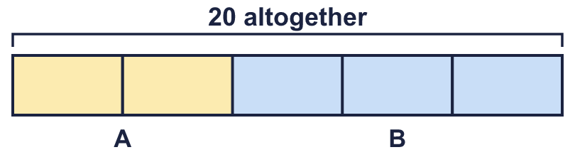 |  | Share 20 in the ratio 2 : 3. There are 5 equal parts, so 1 part is 20 ÷ 5 = 4. A gets 8 and B gets 12:
  Year 6 · Ratio · Step 8  Ratio problems | 
  Year 6 · Ratio · Step 8
  Ratio problems
  1 | The ratio of red to blue is 5 : 2. There are 28 altogether.  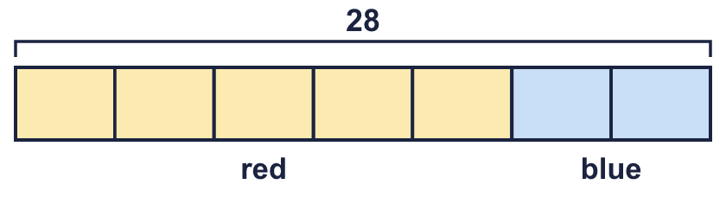  Hint: There are 5 + 2 = 7 equal parts. Divide 28 by 7 to find one part.
  1 | The ratio of red to blue is 5 : 2. There are 28 altogether.  Hint: There are 5 + 2 = 7 equal parts. Divide 28 by 7 to find one part.
  2 | Use the ratio to work out the missing number.  a) The ratio of bikes to scooters is 5 : 3. There are 27 scooters.  b) The ratio of bikes to scooters is 2 : 5. There are 15 scooters.  c) The ratio of cows to sheep is 2 : 5. There are 14 cows.  Hint: Divide to find how many groups there are. Then multiply the other number in the ratio.
  2 | Use the ratio to work out the missing number.  a) The ratio of bikes to scooters is 5 : 3. There are 27 scooters.  b) The ratio of bikes to scooters is 2 : 5. There are 15 scooters.  c) The ratio of cows to sheep is 2 : 5. There are 14 cows.  Hint: Divide to find how many groups there are. Then multiply the other number in the ratio.
  3 | Dora and Tia share 35 stickers in the ratio 3 : 2.  Hint: Add the ratio numbers: 3 + 2 = 5 parts. Divide 35 by 5. Then multiply by 3 and by 2.
    Dora gets |  | and Tia gets
  3 | Dora and Tia share 35 stickers in the ratio 3 : 2.  Hint: Add the ratio numbers: 3 + 2 = 5 parts. Divide 35 by 5. Then multiply by 3 and by 2.
    Dora gets |  | and Tia gets
  4 | Mia and Leo share £175 in the ratio 2 : 3.  Hint: Find one part first: £175 ÷ 5.
    Mia gets |  | and Leo gets
  4 | Mia and Leo share £175 in the ratio 2 : 3.  Hint: Find one part first: £175 ÷ 5.
    Mia gets |  | and Leo gets
  5 | 88 stickers are shared in the ratio 4 : 2 : 5.  Hint: There are 4 + 2 + 5 = 11 equal parts.
    The three shares are
    and
  5 | 88 stickers are shared in the ratio 4 : 2 : 5.  Hint: There are 4 + 2 + 5 = 11 equal parts.
    The three shares are
    and
  6 | The ratio of boys to girls is 7 : 4. There are 21 more boys than girls.  Hint: boys have 3 more parts than girls. The 21 extra things are 3 parts.
  6 | The ratio of boys to girls is 7 : 4. There are 21 more boys than girls.  Hint: boys have 3 more parts than girls. The 21 extra things are 3 parts.
  7 | A money box has 20p coins and 5p coins in the ratio 3 : 5. There are 30 5p coins.  How much money is in the box?  Hint: Find how many groups there are. Work out the value of one group of coins, then multiply.
  7 | A money box has 20p coins and 5p coins in the ratio 3 : 5. There are 30 5p coins.  How much money is in the box?  Hint: Find how many groups there are. Work out the value of one group of coins, then multiply.
  8 | A mix has gravel A and gravel B in the ratio 9 : 2. The mix has a mass of 440 g.  Hint: Divide 440 by 11 to find the mass of one part.
  8 | A mix has gravel A and gravel B in the ratio 9 : 2. The mix has a mass of 440 g.  Hint: Divide 440 by 11 to find the mass of one part.

  9 | Dora shares 36 sweets between two friends in the ratio 5 : 1.  Is Boba correct? Circle yes or no.  Yes / No  Explain the mistake. Then write the correct shares.  Hint: Add the numbers in the ratio. Divide the total by that number to find one part.
    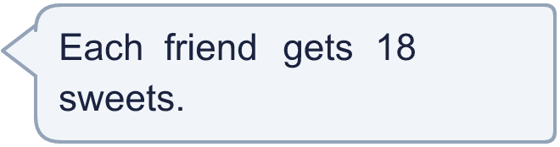
    Shares: |  | and
  9 | Dora shares 36 sweets between two friends in the ratio 5 : 1.  Is Boba correct? Circle yes or no.  Yes / No  Explain the mistake. Then write the correct shares.  Hint: Add the numbers in the ratio. Divide the total by that number to find one part.
    Shares: |  | and
  10 | Eva has a box of counters. For every 5 blue counters there are 2 yellow counters.  Eva takes out 9 blue counters. Now there are the same number of blue and yellow counters in the box.  How many yellow counters are in the box?  Hint: The blue counters have 3 more parts than the yellow. Those extra parts are the 9 counters you take out.
  10 | Eva has a box of counters. For every 5 blue counters there are 2 yellow counters.  Eva takes out 9 blue counters. Now there are the same number of blue and yellow counters in the box.  How many yellow counters are in the box?  Hint: The blue counters have 3 more parts than the yellow. Those extra parts are the 9 counters you take out.
  11 | The ratio of 20p coins to 5p coins in a jar is 6 : 1. There are 24 20p coins.  How much money is in the jar? Write your answer in pounds.  Hint: Find the number of each coin. Then work out the value of each kind. Change pence to pounds at the end.
  11 | The ratio of 20p coins to 5p coins in a jar is 6 : 1. There are 24 20p coins.  How much money is in the jar? Write your answer in pounds.  Hint: Find the number of each coin. Then work out the value of each kind. Change pence to pounds at the end.
  12 | The ratio of adults to children at a club is 6 : 1. There are 15 more adults than children.  How many people are at the club altogether?  Hint: Find how many people one part stands for. Then multiply by the total number of parts.
  12 | The ratio of adults to children at a club is 6 : 1. There are 15 more adults than children.  How many people are at the club altogether?  Hint: Find how many people one part stands for. Then multiply by the total number of parts.
  13 | A bag holds 1 kg of mixed nuts. The ratio of almonds to cashews is 3 : 5.  What is the mass of the almonds in grams?  Hint: Change 1 kg to grams first. Then share it in the ratio.
  13 | A bag holds 1 kg of mixed nuts. The ratio of almonds to cashews is 3 : 5.  What is the mass of the almonds in grams?  Hint: Change 1 kg to grams first. Then share it in the ratio.
  14 | Challenge  A bag has green and yellow counters in the ratio 5 : 6. 2 more green counters are added. Now there are the same number of green and yellow counters.  How many counters are in the bag now?  Hint: The yellow counters have 1 more parts. Those extra parts are the 2 counters added.
  14 | Challenge  A bag has green and yellow counters in the ratio 5 : 6. 2 more green counters are added. Now there are the same number of green and yellow counters.  How many counters are in the bag now?  Hint: The yellow counters have 1 more parts. Those extra parts are the 2 counters added.

Year 6 · Ratio · Step 8
Ratio problems
Answers (teacher copy)

Share 20 in the ratio 2 : 3. There are 5 equal parts, so 1 part is 20 ÷ 5 = 4. A gets 8 and B gets 12:
  1 | The ratio of red to blue is 5 : 2. There are 28 altogether.  One equal part is worth 4  Number of red: 20  Number of blue: 8  Hint: There are 5 + 2 = 7 equal parts. Divide 28 by 7 to find one part.
  2 | Use the ratio to work out the missing number.  a) The ratio of bikes to scooters is 5 : 3. There are 27 scooters.  How many bikes? 45  b) The ratio of bikes to scooters is 2 : 5. There are 15 scooters.  How many bikes? 6  c) The ratio of cows to sheep is 2 : 5. There are 14 cows.  How many sheep? 35  Hint: Divide to find how many groups there are. Then multiply the other number in the ratio.
  3 | Dora and Tia share 35 stickers in the ratio 3 : 2.  Dora gets 21 and Tia gets 14  Hint: Add the ratio numbers: 3 + 2 = 5 parts. Divide 35 by 5. Then multiply by 3 and by 2.
  4 | Mia and Leo share £175 in the ratio 2 : 3.  Mia gets £70 and Leo gets £105  Hint: Find one part first: £175 ÷ 5.
  5 | 88 stickers are shared in the ratio 4 : 2 : 5.  The three shares are 32 16 and 40  Hint: There are 4 + 2 + 5 = 11 equal parts.
  6 | The ratio of boys to girls is 7 : 4. There are 21 more boys than girls.  How many boys? 49  How many girls? 28  Hint: boys have 3 more parts than girls. The 21 extra things are 3 parts.
  7 | A money box has 20p coins and 5p coins in the ratio 3 : 5. There are 30 5p coins.  How much money is in the box?  £5.10  Hint: Find how many groups there are. Work out the value of one group of coins, then multiply.
  8 | A mix has gravel A and gravel B in the ratio 9 : 2. The mix has a mass of 440 g.  Mass of A: 360 g Mass of B: 80 g  Hint: Divide 440 by 11 to find the mass of one part.
  9 | Dora shares 36 sweets between two friends in the ratio 5 : 1.  Is Boba correct? Circle yes or no.  Yes / No  Explain the mistake. Then write the correct shares.  No. Boba shared them equally, but the ratio 5 : 1 is not equal. There are 5 + 1 = 6 parts, so one part is 6.  Shares: 30 and 6  Hint: Add the numbers in the ratio. Divide the total by that number to find one part.
  10 | Eva has a box of counters. For every 5 blue counters there are 2 yellow counters.  Eva takes out 9 blue counters. Now there are the same number of blue and yellow counters in the box.  How many yellow counters are in the box?  6  Hint: The blue counters have 3 more parts than the yellow. Those extra parts are the 9 counters you take out.
  11 | The ratio of 20p coins to 5p coins in a jar is 6 : 1. There are 24 20p coins.  How much money is in the jar? Write your answer in pounds.  £5  Hint: Find the number of each coin. Then work out the value of each kind. Change pence to pounds at the end.
  12 | The ratio of adults to children at a club is 6 : 1. There are 15 more adults than children.  How many people are at the club altogether?  21  Hint: Find how many people one part stands for. Then multiply by the total number of parts.
  13 | A bag holds 1 kg of mixed nuts. The ratio of almonds to cashews is 3 : 5.  What is the mass of the almonds in grams?  375 g  Hint: Change 1 kg to grams first. Then share it in the ratio.
  14 | Challenge  A bag has green and yellow counters in the ratio 5 : 6. 2 more green counters are added. Now there are the same number of green and yellow counters.  How many counters are in the bag now?  24  Hint: The yellow counters have 1 more parts. Those extra parts are the 2 counters added.

