For every 1 red counter there are 2 yellow counters:  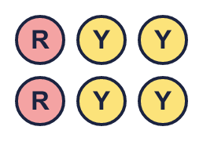 |  | For every 1 red counter there are 2 yellow counters:
  Year 6 · Ratio · Step 2  Ratio language | 
  Year 6 · Ratio · Step 2
  Ratio language
  1 | Complete the sentences about the counters.  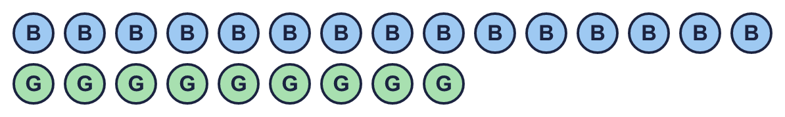  Hint: Count each colour. Then share both numbers out equally into the same number of groups.
    For every 5 blue counters there are
    green counters.
    For every 3 green counters there are
    blue counters.
  1 | Complete the sentences about the counters.  Hint: Count each colour. Then share both numbers out equally into the same number of groups.
    For every 5 blue counters there are
    green counters.
    For every 3 green counters there are
    blue counters.
  2 | Complete each sentence.  A field has 4 boys and 6 girls.  A field has 20 bikes and 8 scooters.  Hint: Divide both numbers by the same number to make smaller numbers.
    For every 2 boys there are
    girls.
    For every 2 scooters there are
    bikes.
  2 | Complete each sentence.  A field has 4 boys and 6 girls.  A field has 20 bikes and 8 scooters.  Hint: Divide both numbers by the same number to make smaller numbers.
    For every 2 boys there are
    girls.
    For every 2 scooters there are
    bikes.
  3 | Use the sentence to work out the missing number.  For every 5 boys there are 3 girls. There are 20 boys.  For every 5 bikes there is 1 scooter. There are 2 scooters.  For every 2 ducks there are 3 geese. There are 12 geese.  Hint: How many groups are there? Multiply the other number by the number of groups.
  3 | Use the sentence to work out the missing number.  For every 5 boys there are 3 girls. There are 20 boys.  For every 5 bikes there is 1 scooter. There are 2 scooters.  For every 2 ducks there are 3 geese. There are 12 geese.  Hint: How many groups are there? Multiply the other number by the number of groups.
  4 | Two of these sentences are true for the shapes.  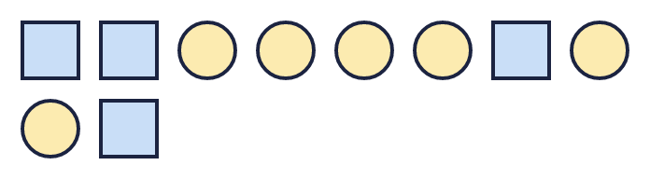  A: For every 4 squares there are 6 circles.  B: For every 2 squares there are 3 circles.  C: For every 3 squares there are 2 circles.  D: For every 2 squares there are 4 circles.  Write the letters of the two true sentences.  Hint: Count each shape. Then check each sentence: could the picture be split into equal groups like that?
  4 | Two of these sentences are true for the shapes.  A: For every 4 squares there are 6 circles.  B: For every 2 squares there are 3 circles.  C: For every 3 squares there are 2 circles.  D: For every 2 squares there are 4 circles.  Write the letters of the two true sentences.  Hint: Count each shape. Then check each sentence: could the picture be split into equal groups like that?
  5 | For every 2 bikes there are 3 scooters. Complete the table.  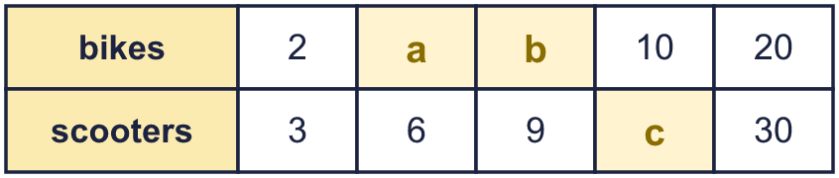  Hint: Look at the first column. Each column is the first column multiplied by the same number.
  5 | For every 2 bikes there are 3 scooters. Complete the table.  Hint: Look at the first column. Each column is the first column multiplied by the same number.
  6 | In a tank, for every 1 red fish there are 4 gold fish. There are at least 36 fish in the tank.  What is the smallest number of fish that could be in the tank?  Hint: Each group has 1 + 4 = 5 fish. Count in 5s until you reach 36 or more.
  6 | In a tank, for every 1 red fish there are 4 gold fish. There are at least 36 fish in the tank.  What is the smallest number of fish that could be in the tank?  Hint: Each group has 1 + 4 = 5 fish. Count in 5s until you reach 36 or more.
  7 | Use the sentence to work out the missing number.  For every 4 apples there are 9 pears. There are 12 apples.  For every 8 roses there are 3 tulips. There are 48 roses.  For every 7 roses there are 9 tulips. There are 28 roses.  Hint: Divide to find how many groups. Then multiply.
  7 | Use the sentence to work out the missing number.  For every 4 apples there are 9 pears. There are 12 apples.  For every 8 roses there are 3 tulips. There are 48 roses.  For every 7 roses there are 9 tulips. There are 28 roses.  Hint: Divide to find how many groups. Then multiply.
  8 | For every 5 apples there are 2 pears. There are 15 apples.  How many are there altogether?  Hint: There are 3 groups. Each group has 5 + 2 things.
  8 | For every 5 apples there are 2 pears. There are 15 apples.  How many are there altogether?  Hint: There are 3 groups. Each group has 5 + 2 things.

  9 | Dora has 10 pencils and 8 rulers.  Boba has made a mistake. What is it?  Hint: Divide both 10 and 8 by 2. The pencils number comes first.
    
    Correct sentence: For every
    pencils there are
    rulers.
  9 | Dora has 10 pencils and 8 rulers.  Boba has made a mistake. What is it?  Hint: Divide both 10 and 8 by 2. The pencils number comes first.
    Correct sentence: For every
    pencils there are
    rulers.
  10 | In some boxes, for every 5 boys there are 2 girls.  A: 15 boys and 6 girls  B: 25 boys and 10 girls  C: 2 boys and 5 girls  D: 8 boys and 20 girls  Which boxes match the rule? Write the letters.  Hint: Divide both numbers in each box by the same number. Do you get 5 and 2?
  10 | In some boxes, for every 5 boys there are 2 girls.  A: 15 boys and 6 girls  B: 25 boys and 10 girls  C: 2 boys and 5 girls  D: 8 boys and 20 girls  Which boxes match the rule? Write the letters.  Hint: Divide both numbers in each box by the same number. Do you get 5 and 2?
  11 | Amir puts boys and girls in a display. For every 3 boys there are 4 girls.  Amir uses 56 items altogether. Is this possible?  Circle yes or no.  Yes / No  Explain how you know.  Hint: How many items are in one group? Is 56 a multiple of that number?
  11 | Amir puts boys and girls in a display. For every 3 boys there are 4 girls.  Amir uses 56 items altogether. Is this possible?  Circle yes or no.  Yes / No  Explain how you know.  Hint: How many items are in one group? Is 56 a multiple of that number?
  12 | For every 6 ducks there are 7 geese.  A pattern has 21 geese.  How many are there altogether?  Hint: Work out how many groups there are. Then find the number of items in one group.
  12 | For every 6 ducks there are 7 geese.  A pattern has 21 geese.  How many are there altogether?  Hint: Work out how many groups there are. Then find the number of items in one group.
  13 | Three of these shelves have cows and sheep in the same ratio. One shelf is different.  A: 10 cows and 6 sheep  B: 17 cows and 9 sheep  C: 20 cows and 12 sheep  D: 25 cows and 15 sheep  Which shelf is the odd one out? Write its letter.  Hint: Write a “for every” sentence for each shelf. Which one does not match the others?
  13 | Three of these shelves have cows and sheep in the same ratio. One shelf is different.  A: 10 cows and 6 sheep  B: 17 cows and 9 sheep  C: 20 cows and 12 sheep  D: 25 cows and 15 sheep  Which shelf is the odd one out? Write its letter.  Hint: Write a “for every” sentence for each shelf. Which one does not match the others?
  14 | Challenge  Eva makes a pattern with tiles. For every 1 blue tile there are 2 orange tiles.  Eva has 6 blue tiles and 12 orange tiles. Eva wants to use all of them.  Is this possible? Circle yes or no.  Yes / No  Explain how you know.  Hint: How many groups can you make with the blue tiles? How many orange tiles do those groups need?
  14 | Challenge  Eva makes a pattern with tiles. For every 1 blue tile there are 2 orange tiles.  Eva has 6 blue tiles and 12 orange tiles. Eva wants to use all of them.  Is this possible? Circle yes or no.  Yes / No  Explain how you know.  Hint: How many groups can you make with the blue tiles? How many orange tiles do those groups need?

Year 6 · Ratio · Step 2
Ratio language
Answers (teacher copy)

For every 1 red counter there are 2 yellow counters:
  1 | Complete the sentences about the counters.  For every 5 blue counters there are 3 green counters.  For every 3 green counters there are 5 blue counters.  Hint: Count each colour. Then share both numbers out equally into the same number of groups.
  2 | Complete each sentence.  A field has 4 boys and 6 girls.  For every 2 boys there are 3 girls.  A field has 20 bikes and 8 scooters.  For every 2 scooters there are 5 bikes.  Hint: Divide both numbers by the same number to make smaller numbers.
  3 | Use the sentence to work out the missing number.  For every 5 boys there are 3 girls. There are 20 boys.  a) How many girls? 12  For every 5 bikes there is 1 scooter. There are 2 scooters.  b) How many bikes? 10  For every 2 ducks there are 3 geese. There are 12 geese.  c) How many ducks? 8  Hint: How many groups are there? Multiply the other number by the number of groups.
  4 | Two of these sentences are true for the shapes.  A: For every 4 squares there are 6 circles.  B: For every 2 squares there are 3 circles.  C: For every 3 squares there are 2 circles.  D: For every 2 squares there are 4 circles.  Write the letters of the two true sentences.  A, B  Hint: Count each shape. Then check each sentence: could the picture be split into equal groups like that?
  5 | For every 2 bikes there are 3 scooters. Complete the table.  a = 4  b = 6  c = 15  Hint: Look at the first column. Each column is the first column multiplied by the same number.
  6 | In a tank, for every 1 red fish there are 4 gold fish. There are at least 36 fish in the tank.  What is the smallest number of fish that could be in the tank?  40 fish  Hint: Each group has 1 + 4 = 5 fish. Count in 5s until you reach 36 or more.
  7 | Use the sentence to work out the missing number.  For every 4 apples there are 9 pears. There are 12 apples.  a) How many pears? 27  For every 8 roses there are 3 tulips. There are 48 roses.  b) How many tulips? 18  For every 7 roses there are 9 tulips. There are 28 roses.  c) How many tulips? 36  Hint: Divide to find how many groups. Then multiply.
  8 | For every 5 apples there are 2 pears. There are 15 apples.  How many pears are there? 6  How many are there altogether? 21  Hint: There are 3 groups. Each group has 5 + 2 things.
  9 | Dora has 10 pencils and 8 rulers.  Boba has made a mistake. What is it?  The numbers are the wrong way round. Dora has 10 pencils, so for every 5 pencils there are 4 rulers.  Correct sentence: For every 5 pencils there are 4 rulers.  Hint: Divide both 10 and 8 by 2. The pencils number comes first.
  10 | In some boxes, for every 5 boys there are 2 girls.  A: 15 boys and 6 girls  B: 25 boys and 10 girls  C: 2 boys and 5 girls  D: 8 boys and 20 girls  Which boxes match the rule? Write the letters.  A, B  Hint: Divide both numbers in each box by the same number. Do you get 5 and 2?
  11 | Amir puts boys and girls in a display. For every 3 boys there are 4 girls.  Amir uses 56 items altogether. Is this possible?  Circle yes or no.  Yes / No  Explain how you know.  Yes. Each group has 3 + 4 = 7 items and 56 ÷ 7 = 8, so there are 8 whole groups.  Hint: How many items are in one group? Is 56 a multiple of that number?
  12 | For every 6 ducks there are 7 geese.  A pattern has 21 geese.  How many are there altogether?  39  Hint: Work out how many groups there are. Then find the number of items in one group.
  13 | Three of these shelves have cows and sheep in the same ratio. One shelf is different.  A: 10 cows and 6 sheep  B: 17 cows and 9 sheep  C: 20 cows and 12 sheep  D: 25 cows and 15 sheep  Which shelf is the odd one out? Write its letter.  B  Hint: Write a “for every” sentence for each shelf. Which one does not match the others?
  14 | Challenge  Eva makes a pattern with tiles. For every 1 blue tile there are 2 orange tiles.  Eva has 6 blue tiles and 12 orange tiles. Eva wants to use all of them.  Is this possible? Circle yes or no.  Yes / No  Explain how you know.  Yes. 6 blue tiles make 6 groups, and 6 groups need 12 orange tiles. Eva has exactly 12.  Hint: How many groups can you make with the blue tiles? How many orange tiles do those groups need?

