The ratio of red to blue is 2 : 3. Red is 2/5 of the bar. Blue is 3/5 of the bar:  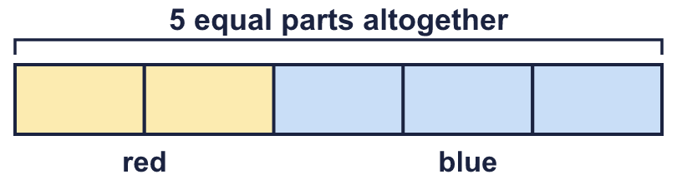 |  | The ratio of red to blue is 2 : 3. Red is 2/5 of the bar. Blue is 3/5 of the bar:
  Year 6 · Ratio · Step 4  Ratio and fractions | 
  Year 6 · Ratio · Step 4
  Ratio and fractions
  1 | Look at the counters.    What fraction of the counters are yellow?  What fraction of the counters are green?  Hint: Count each colour. The fraction is the number of that colour over the number of counters altogether.
    The ratio of green to yellow is
    :
  1 | Look at the counters.  What fraction of the counters are yellow?  What fraction of the counters are green?  Hint: Count each colour. The fraction is the number of that colour over the number of counters altogether.
    The ratio of green to yellow is
    :
  2 | Here are some shapes. Write each fraction in its simplest form.  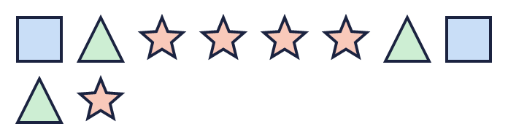  a) What fraction are squares?  b) What fraction are triangles?  Hint: Count all the shapes first. Then count each kind. Simplify the fraction if you can.
  2 | Here are some shapes. Write each fraction in its simplest form.  a) What fraction are squares?  b) What fraction are triangles?  Hint: Count all the shapes first. Then count each kind. Simplify the fraction if you can.
  3 | a) The ratio of red to blue is 7 : 2.  b) The ratio of pens to pencils is 3 : 2.  Hint: Add the numbers in the ratio to find the number of equal parts altogether. That is the bottom number of each fraction.
  3 | a) The ratio of red to blue is 7 : 2.  b) The ratio of pens to pencils is 3 : 2.  Hint: Add the numbers in the ratio to find the number of equal parts altogether. That is the bottom number of each fraction.
  4 | The bar shows the ratio 2 : 4 : 2.  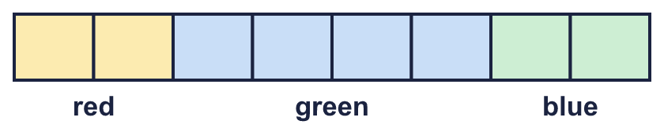  a) What fraction of the bar is red?  b) What fraction of the bar is green?  c) What fraction of the bar is blue?  Hint: Count all the equal parts. Then write each colour’s parts over the total. Simplify.
  4 | The bar shows the ratio 2 : 4 : 2.  a) What fraction of the bar is red?  b) What fraction of the bar is green?  c) What fraction of the bar is blue?  Hint: Count all the equal parts. Then write each colour’s parts over the total. Simplify.
  5 | Here are some counters. Write each fraction in its simplest form.    b) What fraction are not green?  Hint: “Not” means all the other colours. Count them together.
  5 | Here are some counters. Write each fraction in its simplest form.  b) What fraction are not green?  Hint: “Not” means all the other colours. Count them together.
  6 | a) A pencil case has some rulers and some other things. ¹⁄₁₂ of the things are rulers.  b) A pencil case has some pens and some other things. ¹⁄₅ of the things are pens.  Hint: The fraction tells you the parts that are one kind. The rest of the parts are the other kind.
    Ratio of the other things to rulers:
    :
    Ratio of pens to the other things:
    :
  6 | a) A pencil case has some rulers and some other things. ¹⁄₁₂ of the things are rulers.  b) A pencil case has some pens and some other things. ¹⁄₅ of the things are pens.  Hint: The fraction tells you the parts that are one kind. The rest of the parts are the other kind.
    Ratio of the other things to rulers:
    :
    Ratio of pens to the other things:
    :
  7 | a) A bar is split into 5 equal parts. 60% of the bar is shaded.  b) A bar is split into 5 equal parts. 80% of the bar is shaded.  Hint: Work out how many parts are shaded. 50% is half and 25% is a quarter.
    Ratio of shaded to not shaded parts (simplest form):
    :
    Ratio of shaded to not shaded parts (simplest form):
    :
  7 | a) A bar is split into 5 equal parts. 60% of the bar is shaded.  b) A bar is split into 5 equal parts. 80% of the bar is shaded.  Hint: Work out how many parts are shaded. 50% is half and 25% is a quarter.
    Ratio of shaded to not shaded parts (simplest form):
    :
    Ratio of shaded to not shaded parts (simplest form):
    :
  8 | The ratio of pens to pencils to rulers is 1 : 4 : 1.  b) What fraction are pencils?  Hint: Add the three numbers. Write each number over the total and simplify.
  8 | The ratio of pens to pencils to rulers is 1 : 4 : 1.  b) What fraction are pencils?  Hint: Add the three numbers. Write each number over the total and simplify.

  9 | The ratio of brown cubes to yellow cubes is 4 : 3.  Who is correct? Write Zach or Tia.  Explain how you know.  Hint: The bottom number of the fraction is the total number of parts: add the numbers in the ratio.
     | 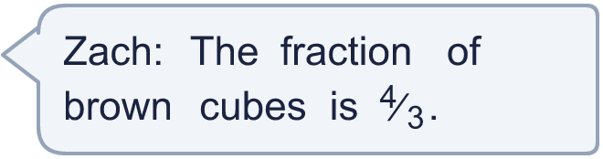
     | 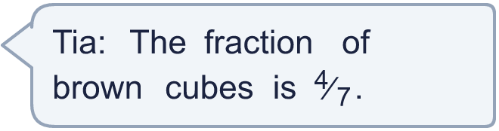
  9 | The ratio of brown cubes to yellow cubes is 4 : 3.  Who is correct? Write Zach or Tia.  Explain how you know.  Hint: The bottom number of the fraction is the total number of parts: add the numbers in the ratio.
  10 | Amir has some apples and some pears. The ratio of apples to pears is 7 : 1.  a) What fraction of the fruit is apples?  b) What fraction of the fruit is pears?  c) How do you know that Amir has more apples than pears?  Hint: Compare the two numbers in the ratio. Compare the two fractions.
  10 | Amir has some apples and some pears. The ratio of apples to pears is 7 : 1.  a) What fraction of the fruit is apples?  b) What fraction of the fruit is pears?  c) How do you know that Amir has more apples than pears?  Hint: Compare the two numbers in the ratio. Compare the two fractions.
  11 | The ratio of boys to girls in a bag is 2 : 1. There are 21 things in the bag altogether.  How many girls are there?  Hint: ²⁄₃ of the bag are boys. Divide 21 by 3 to find one part.
  11 | The ratio of boys to girls in a bag is 2 : 1. There are 21 things in the bag altogether.  How many girls are there?  Hint: ²⁄₃ of the bag are boys. Divide 21 by 3 to find one part.
  12 | The ratio of red to blue is 1 : 3.  What percentage of the whole is red? What percentage is blue?  Hint: Add the ratio numbers. Work out what fraction each part is. Then change the fraction to a percentage out of 100.
    red: |  | % | blue: |  | %
  12 | The ratio of red to blue is 1 : 3.  What percentage of the whole is red? What percentage is blue?  Hint: Add the ratio numbers. Work out what fraction each part is. Then change the fraction to a percentage out of 100.
    red: |  | % | blue: |  | %
  13 | Three of these sentences describe the same bar. One is different.  A: ³⁄₄ of the bar is shaded.  B: ⁶⁄₈ of the bar is shaded.  C: 75% of the bar is shaded.  D: The ratio of shaded to not shaded is 2 : 2.  Which sentence is the odd one out? Write its letter.  Hint: Change each sentence to a fraction in its simplest form. Which one does not match the others?
  13 | Three of these sentences describe the same bar. One is different.  A: ³⁄₄ of the bar is shaded.  B: ⁶⁄₈ of the bar is shaded.  C: 75% of the bar is shaded.  D: The ratio of shaded to not shaded is 2 : 2.  Which sentence is the odd one out? Write its letter.  Hint: Change each sentence to a fraction in its simplest form. Which one does not match the others?
  14 | Challenge  In a bag, ³⁄₁₀ of the counters are pens and ⁴⁄₁₀ are pencils. The rest are rulers.  Hint: Work out how many parts are rulers. Then write the three numbers as a ratio and simplify.
    Write the ratio of pens to pencils to rulers in its simplest form:
     | : |  | :
  14 | Challenge  In a bag, ³⁄₁₀ of the counters are pens and ⁴⁄₁₀ are pencils. The rest are rulers.  Hint: Work out how many parts are rulers. Then write the three numbers as a ratio and simplify.
    Write the ratio of pens to pencils to rulers in its simplest form:
     | : |  | :

Year 6 · Ratio · Step 4
Ratio and fractions
Answers (teacher copy)

The ratio of red to blue is 2 : 3. Red is 2/5 of the bar. Blue is 3/5 of the bar:
  1 | Look at the counters.  The ratio of green to yellow is 1 : 2 :  What fraction of the counters are yellow? ²⁄₃  What fraction of the counters are green? ¹⁄₃  Hint: Count each colour. The fraction is the number of that colour over the number of counters altogether.
  2 | Here are some shapes. Write each fraction in its simplest form.  a) What fraction are squares? ¹⁄₅  b) What fraction are triangles? ³⁄₁₀  c) What fraction are stars? ¹⁄₂  Hint: Count all the shapes first. Then count each kind. Simplify the fraction if you can.
  3 | a) The ratio of red to blue is 7 : 2.  What fraction are red? ⁷⁄₉  What fraction are blue? ²⁄₉  b) The ratio of pens to pencils is 3 : 2.  What fraction are pens? ³⁄₅  What fraction are pencils? ²⁄₅  Hint: Add the numbers in the ratio to find the number of equal parts altogether. That is the bottom number of each fraction.
  4 | The bar shows the ratio 2 : 4 : 2.  a) What fraction of the bar is red? ¹⁄₄  b) What fraction of the bar is green? ¹⁄₂  c) What fraction of the bar is blue? ¹⁄₄  Hint: Count all the equal parts. Then write each colour’s parts over the total. Simplify.
  5 | Here are some counters. Write each fraction in its simplest form.  a) What fraction are blue? ¹⁄₆  b) What fraction are not green? ²⁄₃  Hint: “Not” means all the other colours. Count them together.
  6 | a) A pencil case has some rulers and some other things. ¹⁄₁₂ of the things are rulers.  Ratio of the other things to rulers: 11 : 1 :  b) A pencil case has some pens and some other things. ¹⁄₅ of the things are pens.  Ratio of pens to the other things: 1 : 4 :  Hint: The fraction tells you the parts that are one kind. The rest of the parts are the other kind.
  7 | a) A bar is split into 5 equal parts. 60% of the bar is shaded.  Ratio of shaded to not shaded parts (simplest form): 3 : 2 :  b) A bar is split into 5 equal parts. 80% of the bar is shaded.  Ratio of shaded to not shaded parts (simplest form): 4 : 1 :  Hint: Work out how many parts are shaded. 50% is half and 25% is a quarter.
  8 | The ratio of pens to pencils to rulers is 1 : 4 : 1.  a) What fraction are pens? ¹⁄₆  b) What fraction are pencils? ²⁄₃  c) What fraction are rulers? ¹⁄₆  Hint: Add the three numbers. Write each number over the total and simplify.
  9 | The ratio of brown cubes to yellow cubes is 4 : 3.  Who is correct? Write Zach or Tia.  Tia  Explain how you know.  Tia is correct. There are 4 + 3 = 7 equal parts altogether and 4 of them are brown, so the fraction is ⁴⁄₇.  Hint: The bottom number of the fraction is the total number of parts: add the numbers in the ratio.
  10 | Amir has some apples and some pears. The ratio of apples to pears is 7 : 1.  a) What fraction of the fruit is apples? ⁷⁄₈  b) What fraction of the fruit is pears? ¹⁄₈  c) How do you know that Amir has more apples than pears?  The ratio has a bigger number for apples (7) than for pears (1), so there are more apples. Also ⁷⁄₈ is bigger than ¹⁄₈.  Hint: Compare the two numbers in the ratio. Compare the two fractions.
  11 | The ratio of boys to girls in a bag is 2 : 1. There are 21 things in the bag altogether.  How many girls are there?  7  Hint: ²⁄₃ of the bag are boys. Divide 21 by 3 to find one part.
  12 | The ratio of red to blue is 1 : 3.  What percentage of the whole is red? What percentage is blue?  red: 25 % blue: 75 %  Hint: Add the ratio numbers. Work out what fraction each part is. Then change the fraction to a percentage out of 100.
  13 | Three of these sentences describe the same bar. One is different.  A: ³⁄₄ of the bar is shaded.  B: ⁶⁄₈ of the bar is shaded.  C: 75% of the bar is shaded.  D: The ratio of shaded to not shaded is 2 : 2.  Which sentence is the odd one out? Write its letter.  D  Hint: Change each sentence to a fraction in its simplest form. Which one does not match the others?
  14 | Challenge  In a bag, ³⁄₁₀ of the counters are pens and ⁴⁄₁₀ are pencils. The rest are rulers.  Write the ratio of pens to pencils to rulers in its simplest form: 3 : 4 : 3 : :  Hint: Work out how many parts are rulers. Then write the three numbers as a ratio and simplify.

