  Year 6 · Ratio · Step 9  Proportion problems | 
  Year 6 · Ratio · Step 9
  Proportion problems
  1 | One pen costs 40p. Write the missing numbers on the double number line.  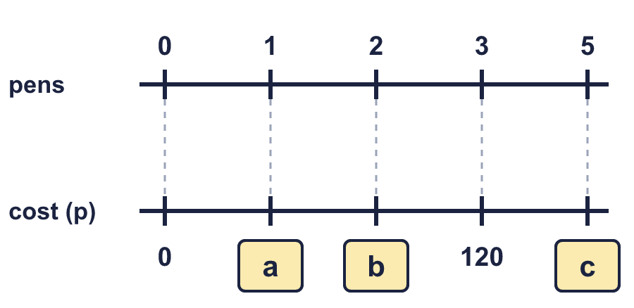
  1 | One pen costs 40p. Write the missing numbers on the double number line.
  2 | Work out the cost. First find the cost of one.  a) 3 rulers cost £1.35. How much do 6 rulers cost?  b) 6 notebooks cost 90p. How much do 12 notebooks cost?  c) 2 pencils cost 30p. How much do 6 pencils cost?
  2 | Work out the cost. First find the cost of one.  a) 3 rulers cost £1.35. How much do 6 rulers cost?  b) 6 notebooks cost 90p. How much do 12 notebooks cost?  c) 2 pencils cost 30p. How much do 6 pencils cost?
  3 | 8 rulers cost £2.  a) 16 rulers:  b) 40 rulers:
  3 | 8 rulers cost £2.  a) 16 rulers:  b) 40 rulers:
  4 | 4 erasers cost £3. How many erasers can you buy for £4.50?
  4 | 4 erasers cost £3. How many erasers can you buy for £4.50?
  5 | A machine makes 95 biscuits in 5 minutes.  a) 15 minutes: biscuits  b) 50 minutes: biscuits
  5 | A machine makes 95 biscuits in 5 minutes.  a) 15 minutes: biscuits  b) 50 minutes: biscuits
  6 | 2 boxes of rulers contain 68 rulers altogether.  a) How many rulers in 6 boxes?  b) How many rulers in 10 boxes?  c) How many boxes hold 680 rulers?
  6 | 2 boxes of rulers contain 68 rulers altogether.  a) How many rulers in 6 boxes?  b) How many rulers in 10 boxes?  c) How many boxes hold 680 rulers?
  7 | A car travels at a steady speed. It goes 20 miles in 20 minutes. How far will it go in 1 hour?
  7 | A car travels at a steady speed. It goes 20 miles in 20 minutes. How far will it go in 1 hour?
  8 | 8 litres of petrol cost £14.80. How much do 11 litres of petrol cost?
  8 | 8 litres of petrol cost £14.80. How much do 11 litres of petrol cost?

  9 | 2 folders cost £6.  Is Boba’s answer correct? Circle yes or no.  Yes / No  Explain the mistake.
     | 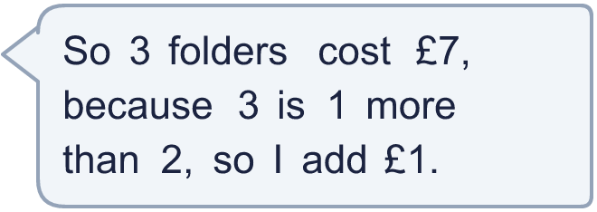
  9 | 2 folders cost £6.  Is Boba’s answer correct? Circle yes or no.  Yes / No  Explain the mistake.
  10 | Shop X sells 5 pencils for £1.50. Shop Y sells 15 pencils for £5.25.
  10 | Shop X sells 5 pencils for £1.50. Shop Y sells 15 pencils for £5.25.
  11 | It costs £2.40 to make 25 key rings. Key rings are sold in boxes of 250 for £75.  It costs £2 to make 10 bangles. Bangles are sold in boxes of 500 for £120.  Profit = selling price − cost to make. How much more profit is made on a box of key rings than on a box of bangles?
  11 | It costs £2.40 to make 25 key rings. Key rings are sold in boxes of 250 for £75.  It costs £2 to make 10 bangles. Bangles are sold in boxes of 500 for £120.  Profit = selling price − cost to make. How much more profit is made on a box of key rings than on a box of bangles?
  12 | A pump fills 6 litres in 15 seconds.  a) Litres in 1 minute:  b) Seconds to fill 60 litres:
  12 | A pump fills 6 litres in 15 seconds.  a) Litres in 1 minute:  b) Seconds to fill 60 litres:
  13 | Dora cycles 15 km in 45 minutes at a steady speed.  How far does Dora cycle in 2 hours?
  13 | Dora cycles 15 km in 45 minutes at a steady speed.  How far does Dora cycle in 2 hours?
  14 | Challenge  A shop sells apples in three different packs.  A: 10 apples for £4.20  B: 5 apples for £1.60  C: 3 apples for £1.14  Which pack is the best value? How much would 60 apples cost at the best value price?
  14 | Challenge  A shop sells apples in three different packs.  A: 10 apples for £4.20  B: 5 apples for £1.60  C: 3 apples for £1.14  Which pack is the best value? How much would 60 apples cost at the best value price?

Year 6 · Ratio · Step 9
Proportion problems
Answers (teacher copy)

  1 | One pen costs 40p. Write the missing numbers on the double number line.  a = 40  b = 80  c = 200
  2 | Work out the cost. First find the cost of one.  a) 3 rulers cost £1.35. How much do 6 rulers cost?  Cost: £2.70  b) 6 notebooks cost 90p. How much do 12 notebooks cost?  Cost: £1.80  c) 2 pencils cost 30p. How much do 6 pencils cost?  Cost: 90p
  3 | 8 rulers cost £2.  a) 16 rulers: £4  b) 40 rulers: £10
  4 | 4 erasers cost £3. How many erasers can you buy for £4.50?  6 erasers
  5 | A machine makes 95 biscuits in 5 minutes.  a) 15 minutes: 285 biscuits  b) 50 minutes: 950 biscuits
  6 | 2 boxes of rulers contain 68 rulers altogether.  a) How many rulers in 6 boxes? 204  b) How many rulers in 10 boxes? 340  c) How many boxes hold 680 rulers? 20
  7 | A car travels at a steady speed. It goes 20 miles in 20 minutes. How far will it go in 1 hour?  60 miles
  8 | 8 litres of petrol cost £14.80. How much do 11 litres of petrol cost?  £20.35
  9 | 2 folders cost £6.  Is Boba’s answer correct? Circle yes or no.  Yes / No  Explain the mistake.  Boba added. The number of folders is 1.5 times as many, so the cost is 1.5 times as much: £6 × 1.5 = £9.  Correct cost: £9
  10 | Shop X sells 5 pencils for £1.50. Shop Y sells 15 pencils for £5.25.  Cost of one in shop X: 30 p  Cost of one in shop Y: 35 p  Better value: X
  11 | It costs £2.40 to make 25 key rings. Key rings are sold in boxes of 250 for £75.  It costs £2 to make 10 bangles. Bangles are sold in boxes of 500 for £120.  Profit = selling price − cost to make. How much more profit is made on a box of key rings than on a box of bangles?  £31
  12 | A pump fills 6 litres in 15 seconds.  a) Litres in 1 minute: 24  b) Seconds to fill 60 litres: 150
  13 | Dora cycles 15 km in 45 minutes at a steady speed.  How far does Dora cycle in 2 hours?  40 km
  14 | Challenge  A shop sells apples in three different packs.  A: 10 apples for £4.20  B: 5 apples for £1.60  C: 3 apples for £1.14  Which pack is the best value? How much would 60 apples cost at the best value price?  B  £19.20

