Per cent means out of 100. 38 squares out of 100 are shaded, so 38% of the square is shaded:  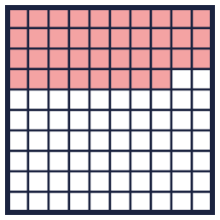 |  | Per cent means out of 100. 38 squares out of 100 are shaded, so 38% of the square is shaded:
  Year 6 · Fractions, decimals and percentages · Step 3  Understanding percentages | 
  Year 6 · Fractions, decimals and percentages · Step 3
  Understanding percentages
  1 | Complete the sentences for each hundred square.  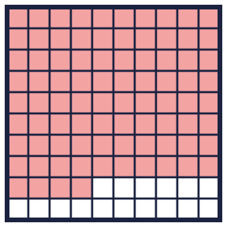  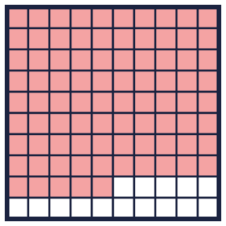  Hint: Count the shaded squares. Out of 100 squares, this number is the percentage.
    a) There are
    parts out of a hundred shaded. This is
    %.
    b) There are
    parts out of a hundred shaded. This is
    %.
  1 | Complete the sentences for each hundred square.  Hint: Count the shaded squares. Out of 100 squares, this number is the percentage.
    a) There are
    parts out of a hundred shaded. This is
    %.
    b) There are
    parts out of a hundred shaded. This is
    %.
  2 | Write the percentage of each hundred square that is shaded.  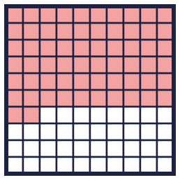  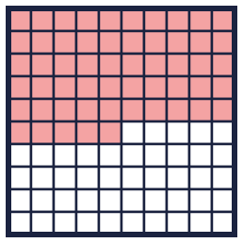  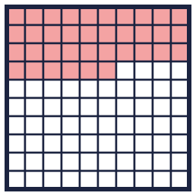  Hint: The number of shaded squares is the percentage.
    a) |  | %
    b) |  | %
    c) |  | %
  2 | Write the percentage of each hundred square that is shaded.  Hint: The number of shaded squares is the percentage.
    a) |  | %
    b) |  | %
    c) |  | %
  3 | The hundred square has 20% shaded pink and 26% shaded yellow.  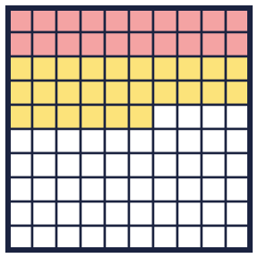  Hint: Add 20% and 26%. Take the total away from 100%.
    What percentage is not shaded?
    %
  3 | The hundred square has 20% shaded pink and 26% shaded yellow.  Hint: Add 20% and 26%. Take the total away from 100%.
    What percentage is not shaded?
    %
  4 | What percentage of each bar is shaded?  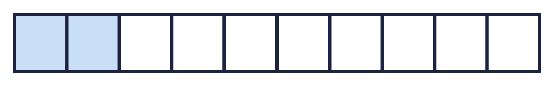  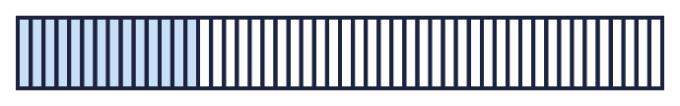    Hint: Each bar is 100%. Divide 100 by the number of parts to find what one part is worth.
    a) |  | %
    b) |  | %
    c) |  | %
  4 | What percentage of each bar is shaded?  Hint: Each bar is 100%. Divide 100 by the number of parts to find what one part is worth.
    a) |  | %
    b) |  | %
    c) |  | %
  5 | A bar is split into 100 equal parts. 46% of the bar is shaded.  Hint: The whole bar is 100%. Take away 46%.
    What percentage is not shaded?
    %
  5 | A bar is split into 100 equal parts. 46% of the bar is shaded.  Hint: The whole bar is 100%. Take away 46%.
    What percentage is not shaded?
    %
  6 | Ron, Alex and Amir are exploring how to make 75%.  Ron: 75% = 50% + 25%  Alex: 75% = 2 × 25%  Amir: 75% = 3 × 25%  Who is correct? Write the names, or All of them, or None.  Hint: Work out each method. Does it make the target percentage?
  6 | Ron, Alex and Amir are exploring how to make 75%.  Ron: 75% = 50% + 25%  Alex: 75% = 2 × 25%  Amir: 75% = 3 × 25%  Who is correct? Write the names, or All of them, or None.  Hint: Work out each method. Does it make the target percentage?
  7 | Find three different ways to make 45%.  Hint: You can add, multiply or take away from 100%. For example 45% = 100% − 55%.
  7 | Find three different ways to make 45%.  Hint: You can add, multiply or take away from 100%. For example 45% = 100% − 55%.
  8 | Some of the hundred square is shaded pink and some is shaded yellow.  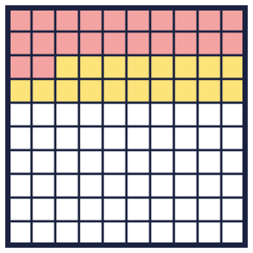  Hint: Count each colour. The unshaded squares are the rest of the 100.
    Pink: |  | % Yellow:
     | % Not shaded: |  | %
  8 | Some of the hundred square is shaded pink and some is shaded yellow.  Hint: Count each colour. The unshaded squares are the rest of the 100.
    Pink: |  | % Yellow:
     | % Not shaded: |  | %

  9 | Work out the percentage of each grid that is shaded.  Hint: Change to out of 100. How many times does the total fit into 100?
    a) 24 out of 25 squares are shaded:
    %
    b) 13 out of 20 squares are shaded:
    %
    c) 6 out of 20 squares are shaded:
    %
  9 | Work out the percentage of each grid that is shaded.  Hint: Change to out of 100. How many times does the total fit into 100?
    a) 24 out of 25 squares are shaded:
    %
    b) 13 out of 20 squares are shaded:
    %
    c) 6 out of 20 squares are shaded:
    %
  10 | Leo says that 10% of this bar is shaded.  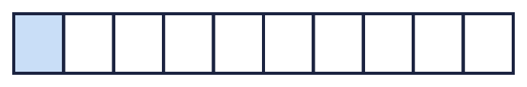  Is Leo correct? Circle yes or no.  Yes / No  Explain how you know.  Hint: The whole bar is 100%. How much is each equal part worth?
  10 | Leo says that 10% of this bar is shaded.  Is Leo correct? Circle yes or no.  Yes / No  Explain how you know.  Hint: The whole bar is 100%. How much is each equal part worth?
  11 | A bag has red, blue and green counters. 30% are red. 10% are blue. The rest are green.  Hint: Add the red and blue percentages. Take them away from 100%.
    What percentage are green? |  | %
  11 | A bag has red, blue and green counters. 30% are red. 10% are blue. The rest are green.  Hint: Add the red and blue percentages. Take them away from 100%.
    What percentage are green? |  | %
  12 | Work out the percentage for each.  Hint: Each part is worth 100 ÷ the number of parts.
    a) 6 out of 10 equal parts: |  | %
    b) 3 out of 4 equal parts: |  | %
  12 | Work out the percentage for each.  Hint: Each part is worth 100 ÷ the number of parts.
    a) 6 out of 10 equal parts: |  | %
    b) 3 out of 4 equal parts: |  | %
  13 | Find three different ways to make 55%.  Hint: Try adding two percentages, or take a percentage away from 100%.
  13 | Find three different ways to make 55%.  Hint: Try adding two percentages, or take a percentage away from 100%.
  14 | Challenge  Find three different ways to make 99%.  Hint: 99% is 1% less than 100%.
  14 | Challenge  Find three different ways to make 99%.  Hint: 99% is 1% less than 100%.

Year 6 · Fractions, decimals and percentages · Step 3
Understanding percentages
Answers (teacher copy)

Per cent means out of 100. 38 squares out of 100 are shaded, so 38% of the square is shaded:
  1 | Complete the sentences for each hundred square.  a) There are 84 parts out of a hundred shaded. This is 84 %.  b) There are 85 parts out of a hundred shaded. This is 85 %.  Hint: Count the shaded squares. Out of 100 squares, this number is the percentage.
  2 | Write the percentage of each hundred square that is shaded.  a) 62 %  b) 55 %  c) 36 %  Hint: The number of shaded squares is the percentage.
  3 | The hundred square has 20% shaded pink and 26% shaded yellow.  What percentage is not shaded? 54 %  Hint: Add 20% and 26%. Take the total away from 100%.
  4 | What percentage of each bar is shaded?  a) 20 %  b) 28 %  c) 80 %  Hint: Each bar is 100%. Divide 100 by the number of parts to find what one part is worth.
  5 | A bar is split into 100 equal parts. 46% of the bar is shaded.  What percentage is not shaded? 54 %  Hint: The whole bar is 100%. Take away 46%.
  6 | Ron, Alex and Amir are exploring how to make 75%.  Ron: 75% = 50% + 25%  Alex: 75% = 2 × 25%  Amir: 75% = 3 × 25%  Who is correct? Write the names, or All of them, or None.  Ron, Amir  Hint: Work out each method. Does it make the target percentage?
  7 | Find three different ways to make 45%.  25% + 20%, 35% + 10%, 100% − 55%  Hint: You can add, multiply or take away from 100%. For example 45% = 100% − 55%.
  8 | Some of the hundred square is shaded pink and some is shaded yellow.  Pink: 22 % Yellow: 18 % Not shaded: 60 %  Hint: Count each colour. The unshaded squares are the rest of the 100.
  9 | Work out the percentage of each grid that is shaded.  a) 24 out of 25 squares are shaded: 96 %  b) 13 out of 20 squares are shaded: 65 %  c) 6 out of 20 squares are shaded: 30 %  Hint: Change to out of 100. How many times does the total fit into 100?
  10 | Leo says that 10% of this bar is shaded.  Is Leo correct? Circle yes or no.  Yes / No  Explain how you know.  Yes. The bar has 10 equal parts, so each part is 10%. One part is shaded, so 10% is shaded.  Hint: The whole bar is 100%. How much is each equal part worth?
  11 | A bag has red, blue and green counters. 30% are red. 10% are blue. The rest are green.  What percentage are green? 60 %  Hint: Add the red and blue percentages. Take them away from 100%.
  12 | Work out the percentage for each.  a) 6 out of 10 equal parts: 60 %  b) 3 out of 4 equal parts: 75 %  Hint: Each part is worth 100 ÷ the number of parts.
  13 | Find three different ways to make 55%.  45% + 10%, 50% + 5%, 100% − 45%  Hint: Try adding two percentages, or take a percentage away from 100%.
  14 | Challenge  Find three different ways to make 99%.  100% − 1%, 90% + 9%, 50% + 49%  Hint: 99% is 1% less than 100%.

