  Year 6 · Fractions, decimals and percentages · Step 3  Understanding percentages | 
  Year 6 · Fractions, decimals and percentages · Step 3
  Understanding percentages
  1 | Complete the sentences for each hundred square.  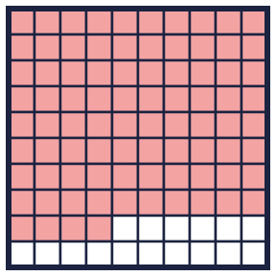  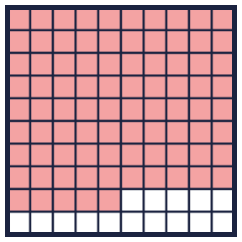
    a) There are
    parts out of a hundred shaded. This is
    %.
    b) There are
    parts out of a hundred shaded. This is
    %.
  1 | Complete the sentences for each hundred square.
    a) There are
    parts out of a hundred shaded. This is
    %.
    b) There are
    parts out of a hundred shaded. This is
    %.
  2 | Write the percentage of each hundred square that is shaded.  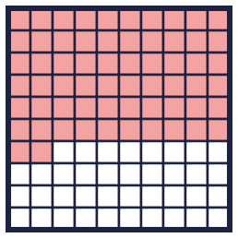  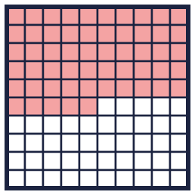  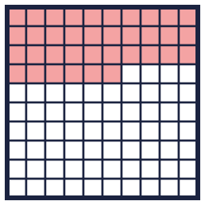
    a) |  | %
    b) |  | %
    c) |  | %
  2 | Write the percentage of each hundred square that is shaded.
    a) |  | %
    b) |  | %
    c) |  | %
  3 | The hundred square has 20% shaded pink and 26% shaded yellow.  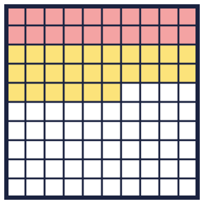
    What percentage is not shaded?
    %
  3 | The hundred square has 20% shaded pink and 26% shaded yellow.
    What percentage is not shaded?
    %
  4 | What percentage of each bar is shaded?  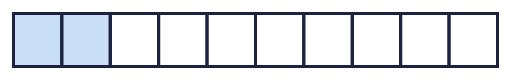  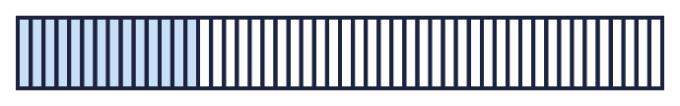  
    a) |  | %
    b) |  | %
    c) |  | %
  4 | What percentage of each bar is shaded?
    a) |  | %
    b) |  | %
    c) |  | %
  5 | A bar is split into 100 equal parts. 46% of the bar is shaded.
    What percentage is not shaded?
    %
  5 | A bar is split into 100 equal parts. 46% of the bar is shaded.
    What percentage is not shaded?
    %
  6 | Ron, Alex and Amir are exploring how to make 75%.  Ron: 75% = 50% + 25%  Alex: 75% = 2 × 25%  Amir: 75% = 3 × 25%  Who is correct? Write the names, or All of them, or None.
  6 | Ron, Alex and Amir are exploring how to make 75%.  Ron: 75% = 50% + 25%  Alex: 75% = 2 × 25%  Amir: 75% = 3 × 25%  Who is correct? Write the names, or All of them, or None.
  7 | Find three different ways to make 45%.
  7 | Find three different ways to make 45%.
  8 | Some of the hundred square is shaded pink and some is shaded yellow.  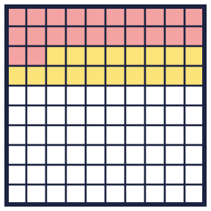
    Pink: |  | % Yellow:
     | % Not shaded: |  | %
  8 | Some of the hundred square is shaded pink and some is shaded yellow.
    Pink: |  | % Yellow:
     | % Not shaded: |  | %

  9 | Work out the percentage of each grid that is shaded.
    a) 24 out of 25 squares are shaded:
    %
    b) 13 out of 20 squares are shaded:
    %
    c) 6 out of 20 squares are shaded:
    %
  9 | Work out the percentage of each grid that is shaded.
    a) 24 out of 25 squares are shaded:
    %
    b) 13 out of 20 squares are shaded:
    %
    c) 6 out of 20 squares are shaded:
    %
  10 | Leo says that 10% of this bar is shaded.  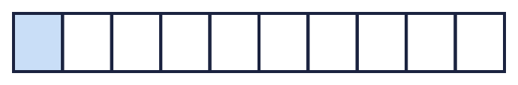  Is Leo correct? Circle yes or no.  Yes / No  Explain how you know.
  10 | Leo says that 10% of this bar is shaded.  Is Leo correct? Circle yes or no.  Yes / No  Explain how you know.
  11 | A bag has red, blue and green counters. 30% are red. 10% are blue. The rest are green.
    What percentage are green? |  | %
  11 | A bag has red, blue and green counters. 30% are red. 10% are blue. The rest are green.
    What percentage are green? |  | %
  12 | Work out the percentage for each.
    a) 6 out of 10 equal parts: |  | %
    b) 3 out of 4 equal parts: |  | %
  12 | Work out the percentage for each.
    a) 6 out of 10 equal parts: |  | %
    b) 3 out of 4 equal parts: |  | %
  13 | Find three different ways to make 55%.
  13 | Find three different ways to make 55%.
  14 | Challenge  Find three different ways to make 99%.
  14 | Challenge  Find three different ways to make 99%.

Year 6 · Fractions, decimals and percentages · Step 3
Understanding percentages
Answers (teacher copy)

  1 | Complete the sentences for each hundred square.  a) There are 84 parts out of a hundred shaded. This is 84 %.  b) There are 85 parts out of a hundred shaded. This is 85 %.
  2 | Write the percentage of each hundred square that is shaded.  a) 62 %  b) 55 %  c) 36 %
  3 | The hundred square has 20% shaded pink and 26% shaded yellow.  What percentage is not shaded? 54 %
  4 | What percentage of each bar is shaded?  a) 20 %  b) 28 %  c) 80 %
  5 | A bar is split into 100 equal parts. 46% of the bar is shaded.  What percentage is not shaded? 54 %
  6 | Ron, Alex and Amir are exploring how to make 75%.  Ron: 75% = 50% + 25%  Alex: 75% = 2 × 25%  Amir: 75% = 3 × 25%  Who is correct? Write the names, or All of them, or None.  Ron, Amir
  7 | Find three different ways to make 45%.  25% + 20%, 35% + 10%, 100% − 55%
  8 | Some of the hundred square is shaded pink and some is shaded yellow.  Pink: 22 % Yellow: 18 % Not shaded: 60 %
  9 | Work out the percentage of each grid that is shaded.  a) 24 out of 25 squares are shaded: 96 %  b) 13 out of 20 squares are shaded: 65 %  c) 6 out of 20 squares are shaded: 30 %
  10 | Leo says that 10% of this bar is shaded.  Is Leo correct? Circle yes or no.  Yes / No  Explain how you know.  Yes. The bar has 10 equal parts, so each part is 10%. One part is shaded, so 10% is shaded.
  11 | A bag has red, blue and green counters. 30% are red. 10% are blue. The rest are green.  What percentage are green? 60 %
  12 | Work out the percentage for each.  a) 6 out of 10 equal parts: 60 %  b) 3 out of 4 equal parts: 75 %
  13 | Find three different ways to make 55%.  45% + 10%, 50% + 5%, 100% − 45%
  14 | Challenge  Find three different ways to make 99%.  100% − 1%, 90% + 9%, 50% + 49%

