10% is 40. 10% is 1/10 of the whole, so the whole is 10 × 40 = 400. Work backwards:  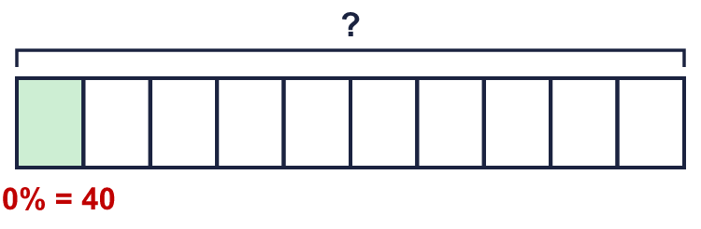 |  | 10% is 40. 10% is 1/10 of the whole, so the whole is 10 × 40 = 400. Work backwards:
  Year 6 · Fractions, decimals and percentages · Step 9  Percentages with missing values | 
  Year 6 · Fractions, decimals and percentages · Step 9
  Percentages with missing values
  1 | Work out the missing whole number in each calculation.  Hint: Find 1 part first. Then multiply to find the whole (100%).
    a) 25% of |  | = 180
    b) 10% of |  | = 180
    c) 50% of |  | = 180
    d) 75% of |  | = 180
  1 | Work out the missing whole number in each calculation.  Hint: Find 1 part first. Then multiply to find the whole (100%).
    a) 25% of |  | = 180
    b) 10% of |  | = 180
    c) 50% of |  | = 180
    d) 75% of |  | = 180
  2 | Ron is finding the missing number in 10% of ? = 200.  Is Boba correct? Circle yes or no.  Yes / No  Explain the mistake. Then write the correct answer.  Hint: The whole is bigger than the part.
    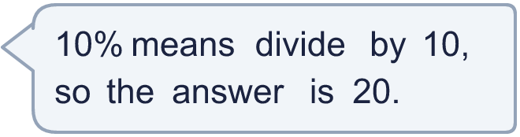
  2 | Ron is finding the missing number in 10% of ? = 200.  Is Boba correct? Circle yes or no.  Yes / No  Explain the mistake. Then write the correct answer.  Hint: The whole is bigger than the part.
  3 | 40% of the children in a school are boys. There are 90 boys in total. The rest are girls.  Hint: Find 1% or 10% first. Then work out 100%.
    a) How many children are there altogether?
    b) How many girls are there?
  3 | 40% of the children in a school are boys. There are 90 boys in total. The rest are girls.  Hint: Find 1% or 10% first. Then work out 100%.
    a) How many children are there altogether?
    b) How many girls are there?
  4 | Work out the missing whole number.  Hint: Find 10% first, or 1%. Then multiply.
    a) 20% of |  | = 90
    b) 10% of |  | = 20
    c) 80% of |  | = 24
  4 | Work out the missing whole number.  Hint: Find 10% first, or 1%. Then multiply.
    a) 20% of |  | = 90
    b) 10% of |  | = 20
    c) 80% of |  | = 24
  5 | Work out the missing percentage.  Hint: Write the part over the whole as a fraction. Change it to a percentage.
    a) |  | % of 400 = 100
    b) |  | % of 300 = 225
    c) |  | % of 80 = 20
  5 | Work out the missing percentage.  Hint: Write the part over the whole as a fraction. Change it to a percentage.
    a) |  | % of 400 = 100
    b) |  | % of 300 = 225
    c) |  | % of 80 = 20
  6 | 2,240 people visited a cinema over four days. On Thursday 10% of them visited. On Saturday 45% of them visited.  Hint: Find 10% of 2,240. Then use it.
    a) How many visited on Thursday?
    b) How many visited on Saturday?
  6 | 2,240 people visited a cinema over four days. On Thursday 10% of them visited. On Saturday 45% of them visited.  Hint: Find 10% of 2,240. Then use it.
    a) How many visited on Thursday?
    b) How many visited on Saturday?
  7 | 2,240 people visited a cinema over four days. 448 of them visited on Friday.  Hint: Write 448 out of 2,240 as a fraction. Change it to a percentage.
    What percentage of the visitors came on Friday?
    %
  7 | 2,240 people visited a cinema over four days. 448 of them visited on Friday.  Hint: Write 448 out of 2,240 as a fraction. Change it to a percentage.
    What percentage of the visitors came on Friday?
    %
  8 | Work out the missing whole number.  Hint: Find 5% or 10% first.
    a) 15% of |  | = 45
    b) 5% of |  | = 12
    c) 30% of |  | = 150
  8 | Work out the missing whole number.  Hint: Find 5% or 10% first.
    a) 15% of |  | = 45
    b) 5% of |  | = 12
    c) 30% of |  | = 150

  9 | Work out the missing whole number.  Hint: Work out what 1% is. Then find 100%.
    a) 5% of |  | = 40
    b) 20% of |  | = 60
  9 | Work out the missing whole number.  Hint: Work out what 1% is. Then find 100%.
    a) 5% of |  | = 40
    b) 20% of |  | = 60
  10 | 60% of the people at a match are adults. There are 84 adults. The rest are children.  Hint: Work out the total first. Then take away the adults.
    How many children are at the match?
  10 | 60% of the people at a match are adults. There are 84 adults. The rest are children.  Hint: Work out the total first. Then take away the adults.
    How many children are at the match?
  11 | Work out the missing percentage.  Hint: Write the part over the whole. Make the bottom number 100.
    a) |  | % of 80 = 20
    b) |  | % of 60 = 15
    c) |  | % of 36 = 27
  11 | Work out the missing percentage.  Hint: Write the part over the whole. Make the bottom number 100.
    a) |  | % of 80 = 20
    b) |  | % of 60 = 15
    c) |  | % of 36 = 27
  12 | 2,240 people visited a cinema. 60% of the visitors were children.  How many children went to the cinema?  Hint: Find 10%. Then find 60%.
  12 | 2,240 people visited a cinema. 60% of the visitors were children.  How many children went to the cinema?  Hint: Find 10%. Then find 60%.
  13 | 2,240 people visited a cinema over four days. 45% visited on Saturday and 25% visited on Sunday.  How many more people went on Saturday than Sunday?  Hint: Find the difference in percentages. Then find that percentage of the total.
  13 | 2,240 people visited a cinema over four days. 45% visited on Saturday and 25% visited on Sunday.  How many more people went on Saturday than Sunday?  Hint: Find the difference in percentages. Then find that percentage of the total.
  14 | Challenge  12.5% of a number is 15.  Hint: 12.5% is ¹⁄₈. How many eighths make the whole?
  14 | Challenge  12.5% of a number is 15.  Hint: 12.5% is ¹⁄₈. How many eighths make the whole?

Year 6 · Fractions, decimals and percentages · Step 9
Percentages with missing values
Answers (teacher copy)

10% is 40. 10% is 1/10 of the whole, so the whole is 10 × 40 = 400. Work backwards:
  1 | Work out the missing whole number in each calculation.  a) 25% of 720 = 180  b) 10% of 1,800 = 180  c) 50% of 360 = 180  d) 75% of 240 = 180  Hint: Find 1 part first. Then multiply to find the whole (100%).
  2 | Ron is finding the missing number in 10% of ? = 200.  Is Boba correct? Circle yes or no.  Yes / No  Explain the mistake. Then write the correct answer.  No. 200 is 10% of the whole, so the whole is 10 times bigger: 200 × 10 = 2,000.  2,000  Hint: The whole is bigger than the part.
  3 | 40% of the children in a school are boys. There are 90 boys in total. The rest are girls.  a) How many children are there altogether? 225  b) How many girls are there? 135  Hint: Find 1% or 10% first. Then work out 100%.
  4 | Work out the missing whole number.  a) 20% of 450 = 90  b) 10% of 200 = 20  c) 80% of 30 = 24  Hint: Find 10% first, or 1%. Then multiply.
  5 | Work out the missing percentage.  a) 25 % of 400 = 100  b) 75 % of 300 = 225  c) 25 % of 80 = 20  Hint: Write the part over the whole as a fraction. Change it to a percentage.
  6 | 2,240 people visited a cinema over four days. On Thursday 10% of them visited. On Saturday 45% of them visited.  a) How many visited on Thursday? 224  b) How many visited on Saturday? 1,008  Hint: Find 10% of 2,240. Then use it.
  7 | 2,240 people visited a cinema over four days. 448 of them visited on Friday.  What percentage of the visitors came on Friday? 20 %  Hint: Write 448 out of 2,240 as a fraction. Change it to a percentage.
  8 | Work out the missing whole number.  a) 15% of 300 = 45  b) 5% of 240 = 12  c) 30% of 500 = 150  Hint: Find 5% or 10% first.
  9 | Work out the missing whole number.  a) 5% of 800 = 40  b) 20% of 300 = 60  Hint: Work out what 1% is. Then find 100%.
  10 | 60% of the people at a match are adults. There are 84 adults. The rest are children.  How many children are at the match? 56  Hint: Work out the total first. Then take away the adults.
  11 | Work out the missing percentage.  a) 25 % of 80 = 20  b) 25 % of 60 = 15  c) 75 % of 36 = 27  Hint: Write the part over the whole. Make the bottom number 100.
  12 | 2,240 people visited a cinema. 60% of the visitors were children.  How many children went to the cinema? 1,344  Hint: Find 10%. Then find 60%.
  13 | 2,240 people visited a cinema over four days. 45% visited on Saturday and 25% visited on Sunday.  How many more people went on Saturday than Sunday? 448  Hint: Find the difference in percentages. Then find that percentage of the total.
  14 | Challenge  12.5% of a number is 15.  What is the number? 120  Hint: 12.5% is ¹⁄₈. How many eighths make the whole?

