1 ten, 6 ones, 0 tenths, 5 hundredths and 2 thousandths make 16.052:  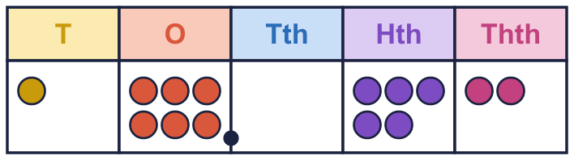 |  | 1 ten, 6 ones, 0 tenths, 5 hundredths and 2 thousandths make 16.052:
  Year 6 · Decimals · Step 2  Place value with whole numbers and decimals | 
  Year 6 · Decimals · Step 2
  Place value with whole numbers and decimals
  1 | Write the number shown on each place value chart.  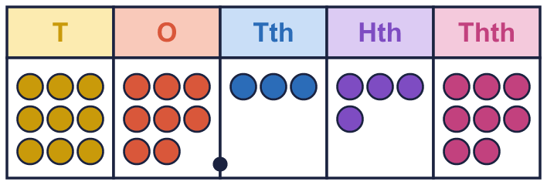  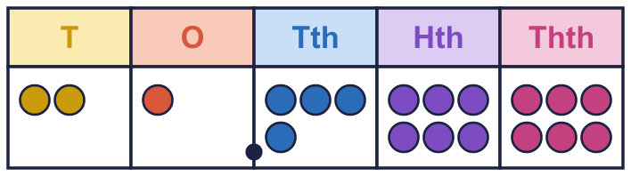  Hint: Write the tens, ones, tenths, hundredths and thousandths in order. Put the decimal point after the ones.
    a) The number is
    b) The number is
  1 | Write the number shown on each place value chart.  Hint: Write the tens, ones, tenths, hundredths and thousandths in order. Put the decimal point after the ones.
    a) The number is
    b) The number is
  2 | Use counters to make each number. Write how many counters go in each column.  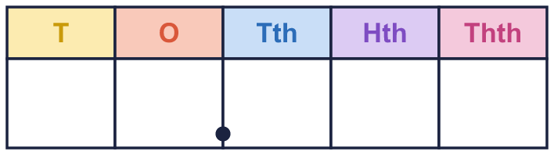  Hint: Write the columns T, O, tenths, hundredths, thousandths. A zero means the column is empty.
    a) 70.479:
    b) 42.582:
  2 | Use counters to make each number. Write how many counters go in each column.  Hint: Write the columns T, O, tenths, hundredths, thousandths. A zero means the column is empty.
    a) 70.479:
    b) 42.582:
  3 | Write the value of the digit in each number.  Hint: Which column is the digit in? Tens, ones, tenths, hundredths or thousandths?
    a) the 5 in 56.417:
    b) the 6 in 58.602:
    c) the 8 in 12.896:
    d) the 7 in 13.274:
  3 | Write the value of the digit in each number.  Hint: Which column is the digit in? Tens, ones, tenths, hundredths or thousandths?
    a) the 5 in 56.417:
    b) the 6 in 58.602:
    c) the 8 in 12.896:
    d) the 7 in 13.274:
  4 | Write the missing number.  Hint: Split the number into tens, ones, tenths, hundredths and thousandths.
    a) 65.147 = 60 + 5 +
    + 0.04 + 0.007
    b) 31.745 = 30 +
    + 0.7 + 0.04 + 0.005
    c) 72.311 = 70 +
    + 0.3 + 0.01 + 0.001
  4 | Write the missing number.  Hint: Split the number into tens, ones, tenths, hundredths and thousandths.
    a) 65.147 = 60 + 5 +
    + 0.04 + 0.007
    b) 31.745 = 30 +
    + 0.7 + 0.04 + 0.005
    c) 72.311 = 70 +
    + 0.3 + 0.01 + 0.001
  5 | Write the missing number.  Hint: Which part is missing: tens, ones, tenths …?
    a) 41.777 = 40 +
    + 0.7 + 0.07 + 0.007
    b) 79.383 = 70 +
    + 0.3 + 0.08 + 0.003
    c) 31.728 = 30 +
    + 0.7 + 0.02 + 0.008
  5 | Write the missing number.  Hint: Which part is missing: tens, ones, tenths …?
    a) 41.777 = 40 +
    + 0.7 + 0.07 + 0.007
    b) 79.383 = 70 +
    + 0.3 + 0.08 + 0.003
    c) 31.728 = 30 +
    + 0.7 + 0.02 + 0.008
  6 | Write the missing number. The tenths change each time.  Hint: Take the whole number, the tenths and the thousandths away from the total.
    a) 4.785 = 4 + 0.7 +
    + 0.005
    b) 4.785 = 4 + 0.6 +
    + 0.005
    c) 4.785 = 4 + 0.5 +
    + 0.005
    d) 4.785 = 4 + 0.4 +
    + 0.005
  6 | Write the missing number. The tenths change each time.  Hint: Take the whole number, the tenths and the thousandths away from the total.
    a) 4.785 = 4 + 0.7 +
    + 0.005
    b) 4.785 = 4 + 0.6 +
    + 0.005
    c) 4.785 = 4 + 0.5 +
    + 0.005
    d) 4.785 = 4 + 0.4 +
    + 0.005
  7 | Write <, > or = in each box.  Hint: Compare the tens, then the ones, then the tenths, then the hundredths.
    a) 24.251 |  | 24.351
    b) 27.63 |  | 27.62
    c) 28.2 |  | 28.19
    d) 7.8 |  | 7.799
  7 | Write <, > or = in each box.  Hint: Compare the tens, then the ones, then the tenths, then the hundredths.
    a) 24.251 |  | 24.351
    b) 27.63 |  | 27.62
    c) 28.2 |  | 28.19
    d) 7.8 |  | 7.799
  8 | Write these numbers in order, starting with the greatest.  3.36 3.11 3.87 3.91  Hint: The whole numbers are the same. Compare the tenths, then the hundredths.
  8 | Write these numbers in order, starting with the greatest.  3.36 3.11 3.87 3.91  Hint: The whole numbers are the same. Compare the tenths, then the hundredths.

  9 | Is Mia correct? Circle yes or no.  Yes / No  Explain how you know.  Hint: Find the digit. Which column is it in? Count from the decimal point.
     | 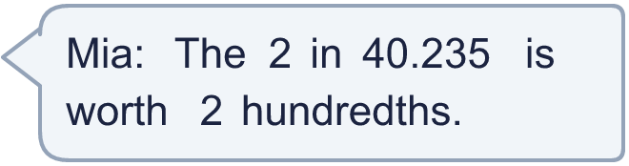
  9 | Is Mia correct? Circle yes or no.  Yes / No  Explain how you know.  Hint: Find the digit. Which column is it in? Count from the decimal point.
  10 | Which of these are equal to 93.142? Write the letters.  A: 93.242  B: 93.1420  C: 93 + 0.142  D: 90 + 3 + 0.1 + 0.04 + 0.002  Hint: Work out the value of each one.
  10 | Which of these are equal to 93.142? Write the letters.  A: 93.242  B: 93.1420  C: 93 + 0.142  D: 90 + 3 + 0.1 + 0.04 + 0.002  Hint: Work out the value of each one.
  11 | Here are four digit cards: 2 8 9 5.  Use each card once to make the smallest number of the form __.__ (two digits, a decimal point, two digits).  Hint: Put the smallest digit in the tens column, the next in the ones, and so on.
  11 | Here are four digit cards: 2 8 9 5.  Use each card once to make the smallest number of the form __.__ (two digits, a decimal point, two digits).  Hint: Put the smallest digit in the tens column, the next in the ones, and so on.
  12 | Work out each answer.  Hint: Which column does the change affect?
    a) 18.937 + 0.001 =
    b) 18.937 − 0.01 =
    c) 18.937 + 0.1 =
  12 | Work out each answer.  Hint: Which column does the change affect?
    a) 18.937 + 0.001 =
    b) 18.937 − 0.01 =
    c) 18.937 + 0.1 =
  13 | Write a decimal that is between 2.6 and 2.7.  Hint: Write both numbers with two decimal places, then pick one in the middle.
  13 | Write a decimal that is between 2.6 and 2.7.  Hint: Write both numbers with two decimal places, then pick one in the middle.
  14 | Challenge  Work out 5 × 10 + 1 + 4 ÷ 100.  Hint: 5 tens is 50. 4 hundredths is 0.04.
  14 | Challenge  Work out 5 × 10 + 1 + 4 ÷ 100.  Hint: 5 tens is 50. 4 hundredths is 0.04.

Year 6 · Decimals · Step 2
Place value with whole numbers and decimals
Answers (teacher copy)

1 ten, 6 ones, 0 tenths, 5 hundredths and 2 thousandths make 16.052:
  1 | Write the number shown on each place value chart.  a) The number is 98.348  b) The number is 21.466  Hint: Write the tens, ones, tenths, hundredths and thousandths in order. Put the decimal point after the ones.
  2 | Use counters to make each number. Write how many counters go in each column.  a) 70.479: 7 0 4 7 9  b) 42.582: 4 2 5 8 2  Hint: Write the columns T, O, tenths, hundredths, thousandths. A zero means the column is empty.
  3 | Write the value of the digit in each number.  a) the 5 in 56.417: 50  b) the 6 in 58.602: 0.6  c) the 8 in 12.896: 0.8  d) the 7 in 13.274: 0.07  Hint: Which column is the digit in? Tens, ones, tenths, hundredths or thousandths?
  4 | Write the missing number.  a) 65.147 = 60 + 5 + 0.1 + 0.04 + 0.007  b) 31.745 = 30 + 1 + 0.7 + 0.04 + 0.005  c) 72.311 = 70 + 2 + 0.3 + 0.01 + 0.001  Hint: Split the number into tens, ones, tenths, hundredths and thousandths.
  5 | Write the missing number.  a) 41.777 = 40 + 1 + 0.7 + 0.07 + 0.007  b) 79.383 = 70 + 9 + 0.3 + 0.08 + 0.003  c) 31.728 = 30 + 1 + 0.7 + 0.02 + 0.008  Hint: Which part is missing: tens, ones, tenths …?
  6 | Write the missing number. The tenths change each time.  a) 4.785 = 4 + 0.7 + 0.08 + 0.005  b) 4.785 = 4 + 0.6 + 0.18 + 0.005  c) 4.785 = 4 + 0.5 + 0.28 + 0.005  d) 4.785 = 4 + 0.4 + 0.38 + 0.005  Hint: Take the whole number, the tenths and the thousandths away from the total.
  7 | Write <, > or = in each box.  a) 24.251 < 24.351  b) 27.63 > 27.62  c) 28.2 > 28.19  d) 7.8 > 7.799  Hint: Compare the tens, then the ones, then the tenths, then the hundredths.
  8 | Write these numbers in order, starting with the greatest.  3.36 3.11 3.87 3.91  3.91, 3.87, 3.36, 3.11  Hint: The whole numbers are the same. Compare the tenths, then the hundredths.
  9 | Is Mia correct? Circle yes or no.  Yes / No  Explain how you know.  No. In 40.235 the 2 is in the tenths column, so it is worth 2 tenths.  Hint: Find the digit. Which column is it in? Count from the decimal point.
  10 | Which of these are equal to 93.142? Write the letters.  A: 93.242  B: 93.1420  C: 93 + 0.142  D: 90 + 3 + 0.1 + 0.04 + 0.002  B, C, D  Hint: Work out the value of each one.
  11 | Here are four digit cards: 2 8 9 5.  Use each card once to make the smallest number of the form __.__ (two digits, a decimal point, two digits).  25.89  Hint: Put the smallest digit in the tens column, the next in the ones, and so on.
  12 | Work out each answer.  a) 18.937 + 0.001 = 18.938  b) 18.937 − 0.01 = 18.927  c) 18.937 + 0.1 = 19.037  Hint: Which column does the change affect?
  13 | Write a decimal that is between 2.6 and 2.7.  2.65  Hint: Write both numbers with two decimal places, then pick one in the middle.
  14 | Challenge  Work out 5 × 10 + 1 + 4 ÷ 100.  51.04  Hint: 5 tens is 50. 4 hundredths is 0.04.

