0 ones, 3 tenths, 2 hundredths and 5 thousandths make 0.325:  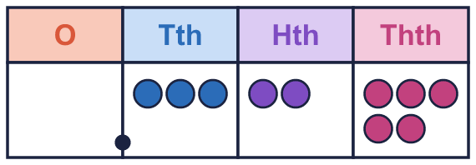 |  | 0 ones, 3 tenths, 2 hundredths and 5 thousandths make 0.325:
  Year 6 · Decimals · Step 1  Decimals within 1 | 
  Year 6 · Decimals · Step 1
  Decimals within 1
  1 | Write the number shown on each place value chart.  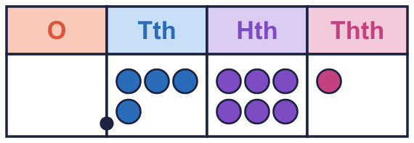  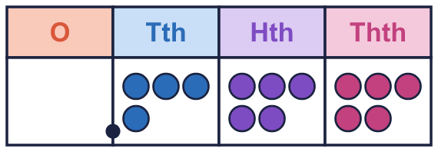  Hint: Say how many tenths, hundredths and thousandths there are. Write the digits in the columns.
    a) The number is
    b) The number is
  1 | Write the number shown on each place value chart.  Hint: Say how many tenths, hundredths and thousandths there are. Write the digits in the columns.
    a) The number is
    b) The number is
  2 | Use counters to make each number. Write how many counters go in each column.  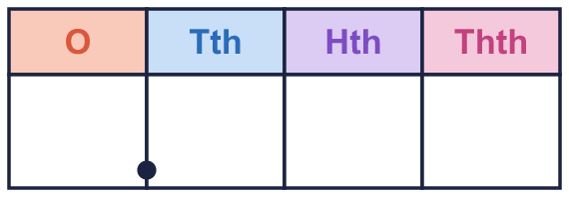  Hint: A zero means the column is empty. Write O, tenths, hundredths, thousandths in order.
    a) 0.441:
    b) 0.262:
  2 | Use counters to make each number. Write how many counters go in each column.  Hint: A zero means the column is empty. Write O, tenths, hundredths, thousandths in order.
    a) 0.441:
    b) 0.262:
  3 | Write the missing number in each partition.  Hint: Split the decimal into tenths, hundredths and thousandths.
    a) |  | + 0.04 + 0.002 = 0.842
    b) |  | + 0.03 + 0.004 = 0.134
    c) 0.4 + 0.08 + |  | = 0.487
  3 | Write the missing number in each partition.  Hint: Split the decimal into tenths, hundredths and thousandths.
    a) |  | + 0.04 + 0.002 = 0.842
    b) |  | + 0.03 + 0.004 = 0.134
    c) 0.4 + 0.08 + |  | = 0.487
  4 | Add the parts to make one decimal.  Hint: Write the tenths first, then the hundredths, then the thousandths.
    a) 0.09 + 0.1 + 0.009 =
    b) 0.001 + 0.01 + 0.9 =
    c) 0.8 + 0.03 + 0.002 =
  4 | Add the parts to make one decimal.  Hint: Write the tenths first, then the hundredths, then the thousandths.
    a) 0.09 + 0.1 + 0.009 =
    b) 0.001 + 0.01 + 0.9 =
    c) 0.8 + 0.03 + 0.002 =
  5 | The number line is split into 10 equal steps. Write the decimal that each arrow points to.  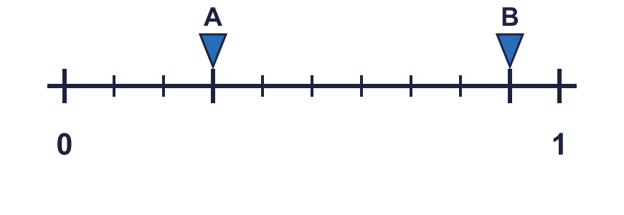  Hint: Each step is one tenth, 0.1. Count the steps from 0.
    A = |  | B =
  5 | The number line is split into 10 equal steps. Write the decimal that each arrow points to.  Hint: Each step is one tenth, 0.1. Count the steps from 0.
    A = |  | B =
  6 | Write <, > or = in each box.  Hint: Compare the tenths first. If they are the same, compare the hundredths.
    a) 0.78 |  | 0.1
    b) 0.85 |  | 0.85
    c) 0.25 |  | 0.393
    d) 0.37 |  | 0.599
  6 | Write <, > or = in each box.  Hint: Compare the tenths first. If they are the same, compare the hundredths.
    a) 0.78 |  | 0.1
    b) 0.85 |  | 0.85
    c) 0.25 |  | 0.393
    d) 0.37 |  | 0.599
  7 | Write these decimals in order, starting with the smallest.  0.455 0.757 0.563 0.797  Hint: Compare the tenths. Then the hundredths. Then the thousandths.
  7 | Write these decimals in order, starting with the smallest.  0.455 0.757 0.563 0.797  Hint: Compare the tenths. Then the hundredths. Then the thousandths.
  8 | Work out each answer.  Hint: 0.001 is one thousandth. 0.01 is one hundredth. Which column changes?
    a) 0.391 + 0.001 =
    b) 0.391 − 0.001 =
    c) 0.391 + 0.01 =
    d) 0.391 − 0.01 =
  8 | Work out each answer.  Hint: 0.001 is one thousandth. 0.01 is one hundredth. Which column changes?
    a) 0.391 + 0.001 =
    b) 0.391 − 0.001 =
    c) 0.391 + 0.01 =
    d) 0.391 − 0.01 =

  9 | Is Zach correct? Circle yes or no.  Yes / No  Explain how you know.  Hint: Add up the parts. Is the total the same as the decimal?
     | 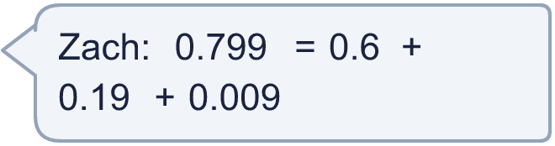
  9 | Is Zach correct? Circle yes or no.  Yes / No  Explain how you know.  Hint: Add up the parts. Is the total the same as the decimal?
  10 | Here are three digit cards: 2 6 8.  Use each card once to make the largest decimal of the form 0.___.  Hint: For the largest number put the biggest card in the tenths column.
  10 | Here are three digit cards: 2 6 8.  Use each card once to make the largest decimal of the form 0.___.  Hint: For the largest number put the biggest card in the tenths column.
  11 | Which of these are equal to 0.6? Write the letters.  A: 0.60  B: 0.06 × 10  C: 0.5 + 0.1  D: 0.06  Hint: Work out each one. 0.50 and 0.5 are the same size.
  11 | Which of these are equal to 0.6? Write the letters.  A: 0.60  B: 0.06 × 10  C: 0.5 + 0.1  D: 0.06  Hint: Work out each one. 0.50 and 0.5 are the same size.
  12 | Write the missing number.  Hint: Take the tenths and the thousandths away from the total.
    0.7 + |  | + 0.008 = 0.778
  12 | Write the missing number.  Hint: Take the tenths and the thousandths away from the total.
    0.7 + |  | + 0.008 = 0.778
  13 | Write a decimal that is between 0.1 and 0.11.  Hint: Write both numbers with three decimal places. Then find a number between them.
  13 | Write a decimal that is between 0.1 and 0.11.  Hint: Write both numbers with three decimal places. Then find a number between them.
  14 | Challenge  How many thousandths (0.001) make 0.5?  Hint: 1 tenth is 100 thousandths. 1 hundredth is 10 thousandths.
  14 | Challenge  How many thousandths (0.001) make 0.5?  Hint: 1 tenth is 100 thousandths. 1 hundredth is 10 thousandths.

Year 6 · Decimals · Step 1
Decimals within 1
Answers (teacher copy)

0 ones, 3 tenths, 2 hundredths and 5 thousandths make 0.325:
  1 | Write the number shown on each place value chart.  a) The number is 0.461  b) The number is 0.455  Hint: Say how many tenths, hundredths and thousandths there are. Write the digits in the columns.
  2 | Use counters to make each number. Write how many counters go in each column.  a) 0.441: 0 4 4 1  b) 0.262: 0 2 6 2  Hint: A zero means the column is empty. Write O, tenths, hundredths, thousandths in order.
  3 | Write the missing number in each partition.  a) 0.8 + 0.04 + 0.002 = 0.842  b) 0.1 + 0.03 + 0.004 = 0.134  c) 0.4 + 0.08 + 0.007 = 0.487  Hint: Split the decimal into tenths, hundredths and thousandths.
  4 | Add the parts to make one decimal.  a) 0.09 + 0.1 + 0.009 = 0.199  b) 0.001 + 0.01 + 0.9 = 0.911  c) 0.8 + 0.03 + 0.002 = 0.832  Hint: Write the tenths first, then the hundredths, then the thousandths.
  5 | The number line is split into 10 equal steps. Write the decimal that each arrow points to.  A = 0.3 B = 0.9  Hint: Each step is one tenth, 0.1. Count the steps from 0.
  6 | Write <, > or = in each box.  a) 0.78 > 0.1  b) 0.85 = 0.85  c) 0.25 < 0.393  d) 0.37 < 0.599  Hint: Compare the tenths first. If they are the same, compare the hundredths.
  7 | Write these decimals in order, starting with the smallest.  0.455 0.757 0.563 0.797  0.455, 0.563, 0.757, 0.797  Hint: Compare the tenths. Then the hundredths. Then the thousandths.
  8 | Work out each answer.  a) 0.391 + 0.001 = 0.392  b) 0.391 − 0.001 = 0.39  c) 0.391 + 0.01 = 0.401  d) 0.391 − 0.01 = 0.381  Hint: 0.001 is one thousandth. 0.01 is one hundredth. Which column changes?
  9 | Is Zach correct? Circle yes or no.  Yes / No  Explain how you know.  Yes. 0.6 + 0.19 + 0.009 = 0.799, which is the same as 0.799.  Hint: Add up the parts. Is the total the same as the decimal?
  10 | Here are three digit cards: 2 6 8.  Use each card once to make the largest decimal of the form 0.___.  0.862  Hint: For the largest number put the biggest card in the tenths column.
  11 | Which of these are equal to 0.6? Write the letters.  A: 0.60  B: 0.06 × 10  C: 0.5 + 0.1  D: 0.06  A, B, C  Hint: Work out each one. 0.50 and 0.5 are the same size.
  12 | Write the missing number.  0.7 + 0.07 + 0.008 = 0.778  Hint: Take the tenths and the thousandths away from the total.
  13 | Write a decimal that is between 0.1 and 0.11.  0.105  Hint: Write both numbers with three decimal places. Then find a number between them.
  14 | Challenge  How many thousandths (0.001) make 0.5?  500  Hint: 1 tenth is 100 thousandths. 1 hundredth is 10 thousandths.

