  Year 6 · Area, perimeter, volume · Step 1  Shapes with the same area | 
  Year 6 · Area, perimeter, volume · Step 1
  Shapes with the same area
  1 | Use the diagram to complete the sentences.  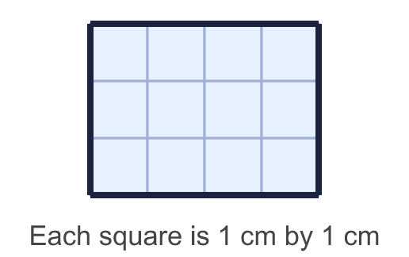
    Length = |  | cm.
    Width = |  | cm.
    Number of squares =
    Area = |  | cm²
  1 | Use the diagram to complete the sentences.
    Length = |  | cm.
    Width = |  | cm.
    Number of squares =
    Area = |  | cm²
  2 | Work out the area of each shape.  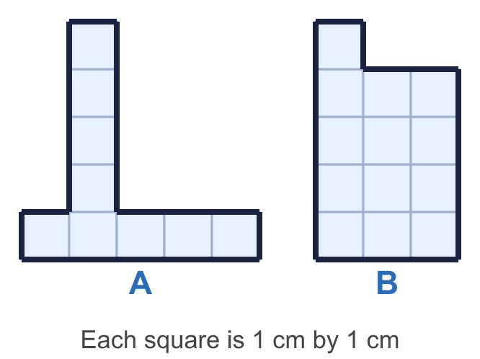
    a) Shape A: |  | cm²
    b) Shape B: |  | cm²
  2 | Work out the area of each shape.
    a) Shape A: |  | cm²
    b) Shape B: |  | cm²
  3 | Work out the area of each rectangle.  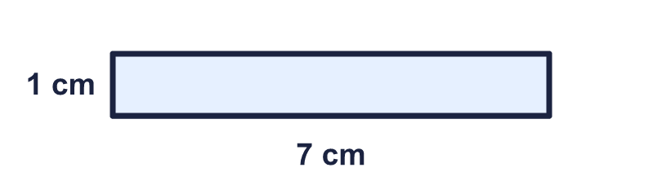  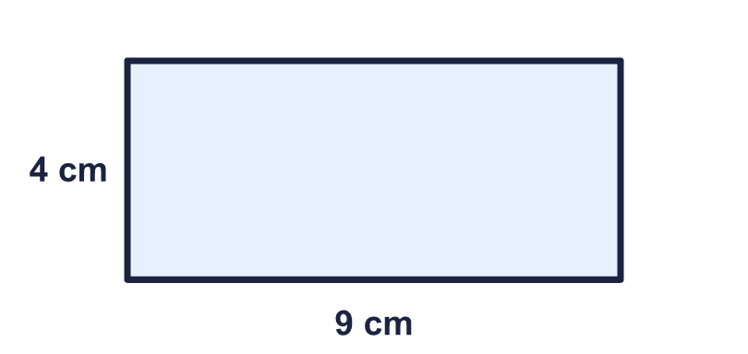
    a) |  | cm²
    b) |  | cm²
  3 | Work out the area of each rectangle.
    a) |  | cm²
    b) |  | cm²
  4 | Write all the factors of 24.
  4 | Write all the factors of 24.
  5 | Which shapes have an area of 20 cm²? Write the letters.  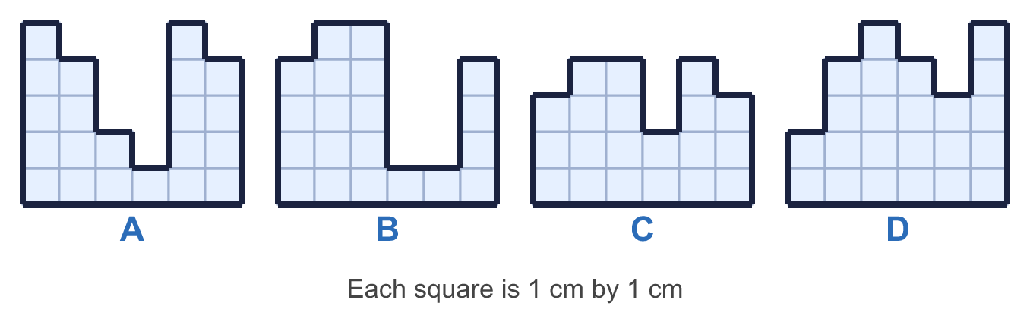
  5 | Which shapes have an area of 20 cm²? Write the letters.
  6 | This rectangle has an area of 30 cm². Find the missing length.  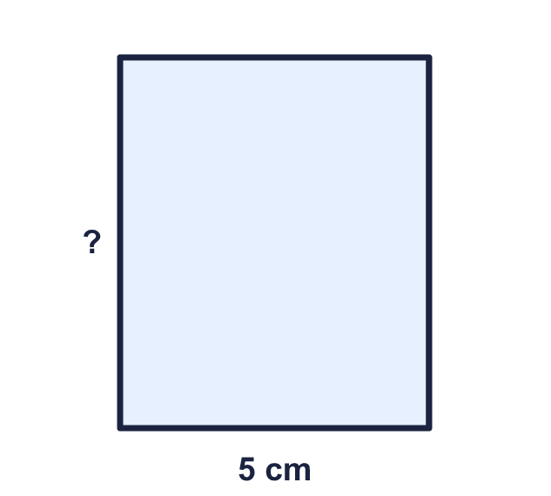
    Missing length in cm:
  6 | This rectangle has an area of 30 cm². Find the missing length.
    Missing length in cm:
  7 | Zach's rectangle is 8 cm long and 5 cm wide. Dora's rectangle is 12 cm long and 3 cm wide.  Whose rectangle has the greater area?
    How much greater is it? |  | cm²
  7 | Zach's rectangle is 8 cm long and 5 cm wide. Dora's rectangle is 12 cm long and 3 cm wide.  Whose rectangle has the greater area?
    How much greater is it? |  | cm²
  8 | A school field is a rectangle 12 m long and 9 m wide.
    Area of the field: |  | m²
  8 | A school field is a rectangle 12 m long and 9 m wide.
    Area of the field: |  | m²

  9 | Eva is finding the area of this shape. "I can multiply 9 by 8, so the area must be 72 cm²."  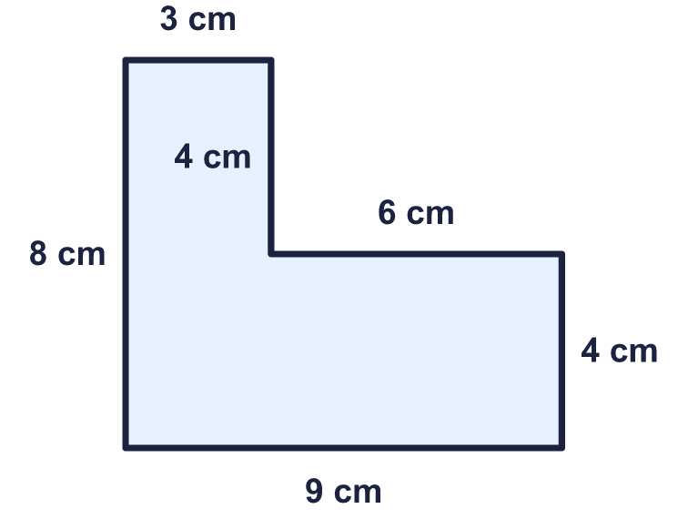  Do you agree with Eva? Circle yes or no.  Yes / No  Explain your answer.
  9 | Eva is finding the area of this shape. "I can multiply 9 by 8, so the area must be 72 cm²."  Do you agree with Eva? Circle yes or no.  Yes / No  Explain your answer.
  10 | Rectangles have sides that are whole numbers of centimetres. A 3 cm by 8 cm rectangle is the same as an 8 cm by 3 cm rectangle.  How many different rectangles have an area of 30 cm²?
    rectangles
  10 | Rectangles have sides that are whole numbers of centimetres. A 3 cm by 8 cm rectangle is the same as an 8 cm by 3 cm rectangle.  How many different rectangles have an area of 30 cm²?
    rectangles
  11 | A rectangle is 8 cm long and 3 cm wide. Which of these rectangles have the same area? Write the letters.  A: 12 cm by 2 cm  B: 3 cm by 8 cm  C: 8 cm by 2 cm  D: 9 cm by 3 cm
  11 | A rectangle is 8 cm long and 3 cm wide. Which of these rectangles have the same area? Write the letters.  A: 12 cm by 2 cm  B: 3 cm by 8 cm  C: 8 cm by 2 cm  D: 9 cm by 3 cm
  12 | Amir says: "If two shapes have the same area they must have the same perimeter."  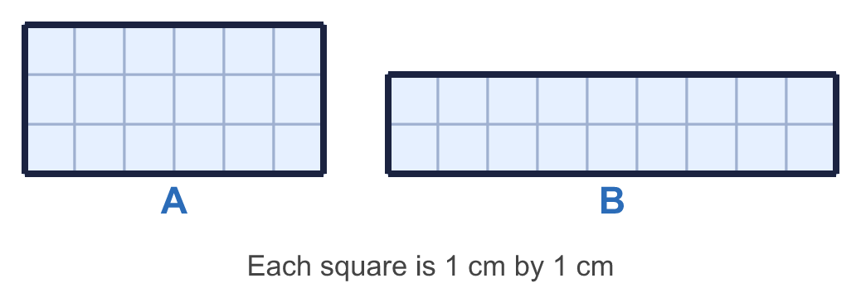  Is Amir correct? Circle yes or no.  Yes / No  Explain how you know.
  12 | Amir says: "If two shapes have the same area they must have the same perimeter."  Is Amir correct? Circle yes or no.  Yes / No  Explain how you know.
  13 | A rectangular poster has an area of 36 cm². Its length is 4 times its width.
    Width = |  | cm.
    Length = |  | cm.
  13 | A rectangular poster has an area of 36 cm². Its length is 4 times its width.
    Width = |  | cm.
    Length = |  | cm.
  14 | Challenge  A rectangle has an area of 54 cm². Its length is 3 cm more than its width. Both are whole numbers.
    Length = |  | cm.
    Width = |  | cm.
  14 | Challenge  A rectangle has an area of 54 cm². Its length is 3 cm more than its width. Both are whole numbers.
    Length = |  | cm.
    Width = |  | cm.

Year 6 · Area, perimeter, volume · Step 1
Shapes with the same area
Answers (teacher copy)

  1 | Use the diagram to complete the sentences.  Length = 4 cm.  Width = 3 cm.  Number of squares = 12  Area = 12 cm²
  2 | Work out the area of each shape.  a) Shape A: 9 cm²  b) Shape B: 13 cm²
  3 | Work out the area of each rectangle.  a) 7 cm²  b) 36 cm²
  4 | Write all the factors of 24.  1, 2, 3, 4, 6, 8, 12, 24
  5 | Which shapes have an area of 20 cm²? Write the letters.  B, C
  6 | This rectangle has an area of 30 cm². Find the missing length.  Missing length in cm: 6
  7 | Zach's rectangle is 8 cm long and 5 cm wide. Dora's rectangle is 12 cm long and 3 cm wide.  Whose rectangle has the greater area? Zach  How much greater is it? 4 cm²
  8 | A school field is a rectangle 12 m long and 9 m wide.  Area of the field: 108 m²
  9 | Eva is finding the area of this shape. "I can multiply 9 by 8, so the area must be 72 cm²."  Do you agree with Eva? Circle yes or no.  Yes / No  Explain your answer.  No. The shape is not a rectangle: 9 × 8 = 72 cm² is the area with the corner filled in. Take away the missing 6 × 4 = 24 cm² to get 48 cm².
  10 | Rectangles have sides that are whole numbers of centimetres. A 3 cm by 8 cm rectangle is the same as an 8 cm by 3 cm rectangle.  How many different rectangles have an area of 30 cm²?  4 rectangles
  11 | A rectangle is 8 cm long and 3 cm wide. Which of these rectangles have the same area? Write the letters.  A: 12 cm by 2 cm  B: 3 cm by 8 cm  C: 8 cm by 2 cm  D: 9 cm by 3 cm  A, B
  12 | Amir says: "If two shapes have the same area they must have the same perimeter."  Is Amir correct? Circle yes or no.  Yes / No  Explain how you know.  No. Both shapes have an area of 18 cm². Shape A has a perimeter of 18 cm and shape B has a perimeter of 22 cm.
  13 | A rectangular poster has an area of 36 cm². Its length is 4 times its width.  Width = 3 cm.  Length = 12 cm.
  14 | Challenge  A rectangle has an area of 54 cm². Its length is 3 cm more than its width. Both are whole numbers.  Length = 9 cm.  Width = 6 cm.

