  Year 6 · Area, perimeter, volume · Step 4  Area of a right-angled triangle | 
  Year 6 · Area, perimeter, volume · Step 4
  Area of a right-angled triangle
  1 | The rectangle is cut into two identical right-angled triangles.  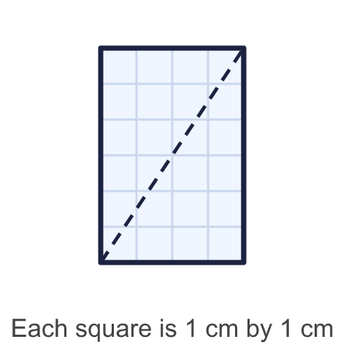
    Area of the rectangle = |  | cm²
    Area of one triangle = |  | cm²
  1 | The rectangle is cut into two identical right-angled triangles.
    Area of the rectangle = |  | cm²
    Area of one triangle = |  | cm²
  2 | Work out the area of the triangle.  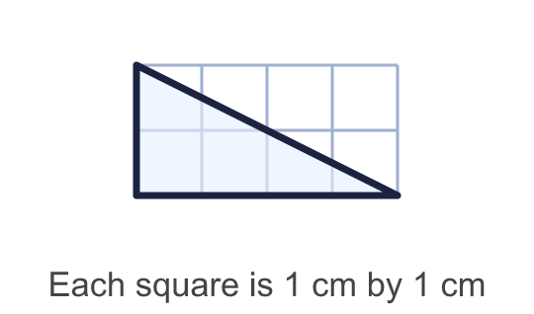
    Area = |  | cm²
  2 | Work out the area of the triangle.
    Area = |  | cm²
  3 | Work out the area of the triangle.  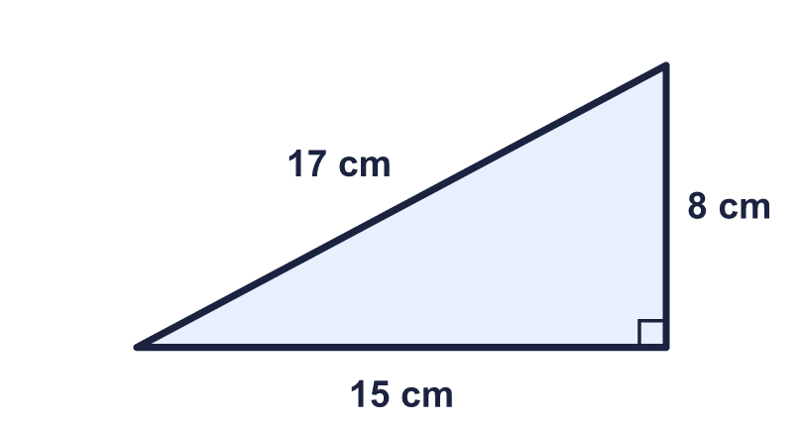
    Area = |  | cm²
  3 | Work out the area of the triangle.
    Area = |  | cm²
  4 | Put the numbers into the formula to find the area of the triangle.  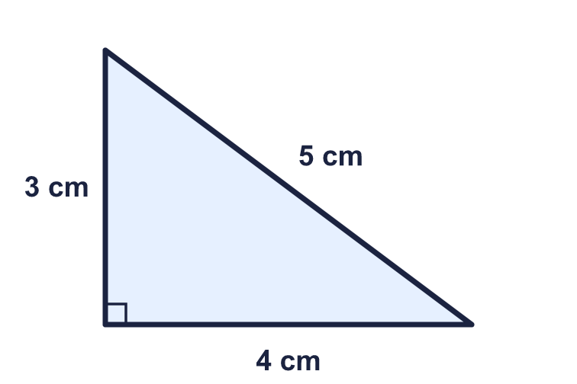  The first number is the base. The second number is the height.
    ¹⁄₂ × |  | × |  | = |  | cm²
  4 | Put the numbers into the formula to find the area of the triangle.  The first number is the base. The second number is the height.
    ¹⁄₂ × |  | × |  | = |  | cm²
  5 | Work out the area of the triangle.  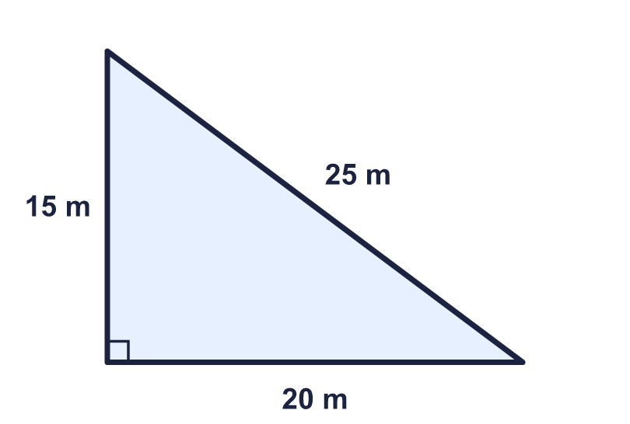
    Area = |  | m²
  5 | Work out the area of the triangle.
    Area = |  | m²
  6 | A right-angled triangle has a base of 14 m and a height of 3 m.
    Area = |  | m²
  6 | A right-angled triangle has a base of 14 m and a height of 3 m.
    Area = |  | m²
  7 | The area of this triangle is 60 cm². Find the height.  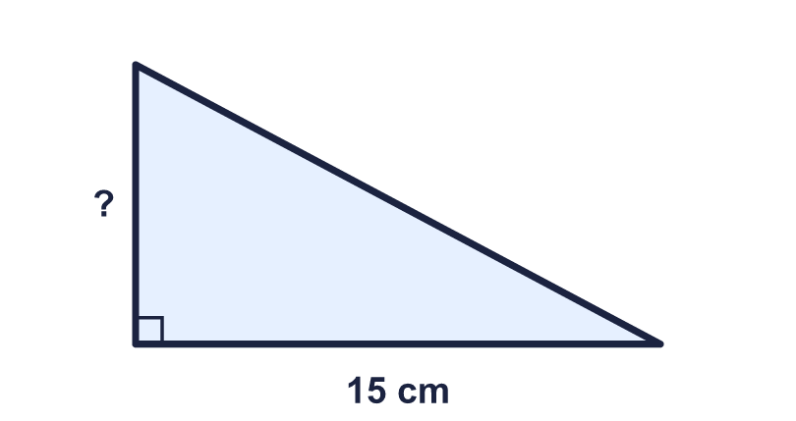
    Height = |  | cm.
  7 | The area of this triangle is 60 cm². Find the height.
    Height = |  | cm.
  8 | Which triangle has the greater area? How much greater?  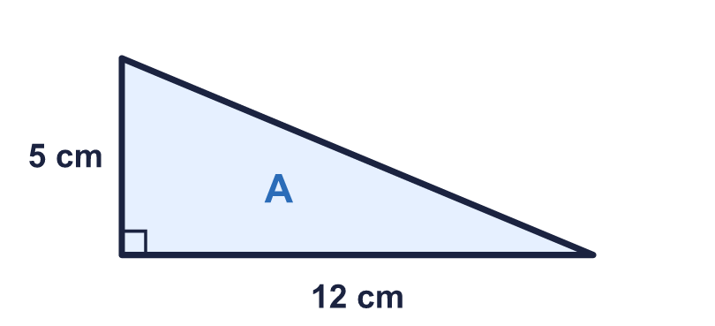  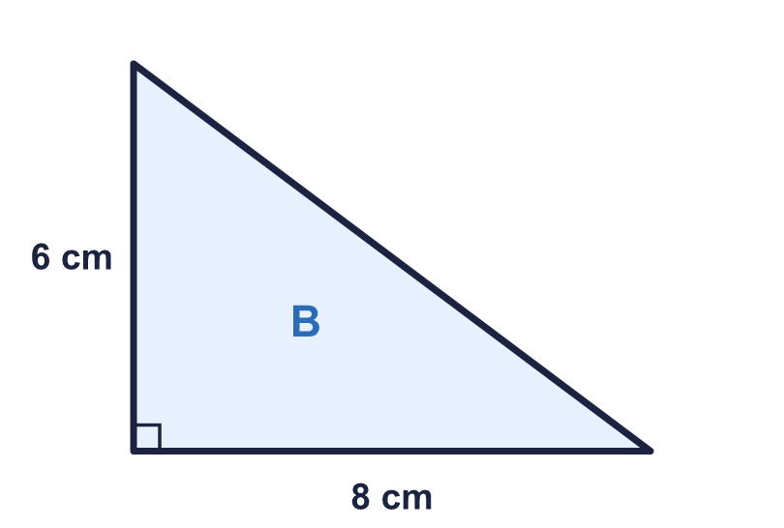
    Greater area: triangle
    It is greater by |  | cm²
  8 | Which triangle has the greater area? How much greater?
    Greater area: triangle
    It is greater by |  | cm²

  9 | Sam uses ½ × 5 × 12 to work out the area. "I can ignore the 13 cm side because it is not the base or the perpendicular height."  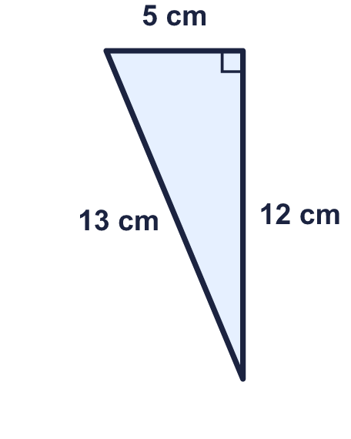  Do you agree with Sam? Circle yes or no.  Yes / No  Explain your answer.
  9 | Sam uses ½ × 5 × 12 to work out the area. "I can ignore the 13 cm side because it is not the base or the perpendicular height."  Do you agree with Sam? Circle yes or no.  Yes / No  Explain your answer.
  10 | Work out the perimeter and the area of the triangle.  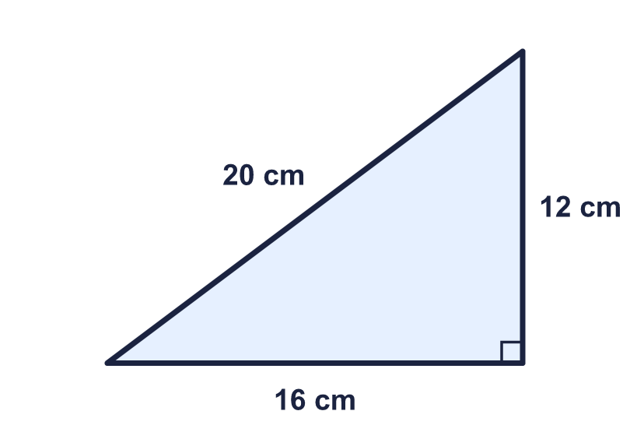
    Perimeter = |  | cm.
    Area = |  | cm²
  10 | Work out the perimeter and the area of the triangle.
    Perimeter = |  | cm.
    Area = |  | cm²
  11 | The shape is made from a rectangle and a right-angled triangle. Work out its area.  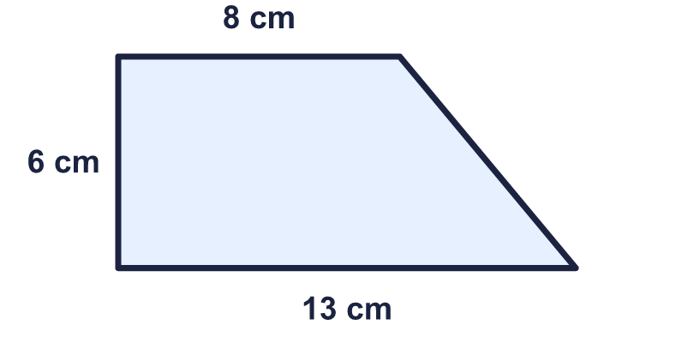
    Area = |  | cm²
  11 | The shape is made from a rectangle and a right-angled triangle. Work out its area.
    Area = |  | cm²
  12 | A sail is a right-angled triangle. Its base is 10 m and its height is 12 m. Sail cloth costs £8 for each square metre.
    Cost of the cloth = £
  12 | A sail is a right-angled triangle. Its base is 10 m and its height is 12 m. Sail cloth costs £8 for each square metre.
    Cost of the cloth = £
  13 | A right-angled triangle has an area of 54 cm². Its base is 3 times as long as its height.
    Base = |  | cm.
    Height = |  | cm.
  13 | A right-angled triangle has an area of 54 cm². Its base is 3 times as long as its height.
    Base = |  | cm.
    Height = |  | cm.
  14 | Challenge  A right-angled triangle has an area of 44 cm². Its two short sides add up to 19 cm. They are whole numbers of centimetres.
    Shorter side = |  | cm.
    Longer side = |  | cm.
  14 | Challenge  A right-angled triangle has an area of 44 cm². Its two short sides add up to 19 cm. They are whole numbers of centimetres.
    Shorter side = |  | cm.
    Longer side = |  | cm.

Year 6 · Area, perimeter, volume · Step 4
Area of a right-angled triangle
Answers (teacher copy)

  1 | The rectangle is cut into two identical right-angled triangles.  Area of the rectangle = 24 cm²  Area of one triangle = 12 cm²
  2 | Work out the area of the triangle.  Area = 4 cm²
  3 | Work out the area of the triangle.  Area = 60 cm²
  4 | Put the numbers into the formula to find the area of the triangle.  ¹⁄₂ × 3 × 4 = 6 cm²  The first number is the base. The second number is the height.
  5 | Work out the area of the triangle.  Area = 150 m²
  6 | A right-angled triangle has a base of 14 m and a height of 3 m.  Area = 21 m²
  7 | The area of this triangle is 60 cm². Find the height.  Height = 8 cm.
  8 | Which triangle has the greater area? How much greater?  Greater area: triangle A  It is greater by 6 cm²
  9 | Sam uses ½ × 5 × 12 to work out the area. "I can ignore the 13 cm side because it is not the base or the perpendicular height."  Do you agree with Sam? Circle yes or no.  Yes / No  Explain your answer.  Yes. The 13 cm side is the slanting side, so it is not needed. The area is ½ × 5 × 12 = 30 cm².
  10 | Work out the perimeter and the area of the triangle.  Perimeter = 48 cm.  Area = 96 cm²
  11 | The shape is made from a rectangle and a right-angled triangle. Work out its area.  Area = 63 cm²
  12 | A sail is a right-angled triangle. Its base is 10 m and its height is 12 m. Sail cloth costs £8 for each square metre.  Cost of the cloth = £ 480
  13 | A right-angled triangle has an area of 54 cm². Its base is 3 times as long as its height.  Base = 18 cm.  Height = 6 cm.
  14 | Challenge  A right-angled triangle has an area of 44 cm². Its two short sides add up to 19 cm. They are whole numbers of centimetres.  Shorter side = 8 cm.  Longer side = 11 cm.

