Do the first operation, then the second. 4 × 3 = 12, then 12 + 2 = 14. To go backwards, undo the second operation first:  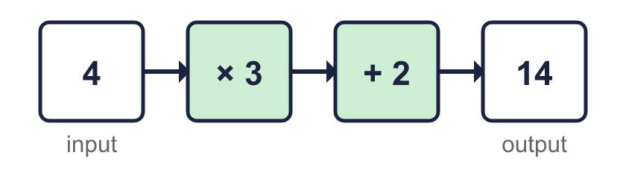 |  | Do the first operation, then the second. 4 × 3 = 12, then 12 + 2 = 14. To go backwards, undo the second operation first:
  Year 6 · Algebra · Step 2  Two-step function machines | 
  Year 6 · Algebra · Step 2
  Two-step function machines
  1 | Use the function machine to complete the table. Write the missing outputs.  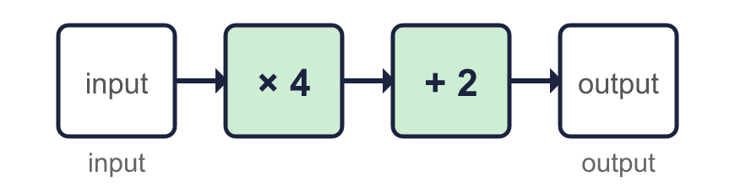  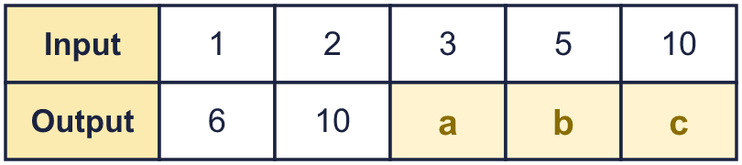  Hint: Do × 4 first. Then do + 2 to your answer.
  1 | Use the function machine to complete the table. Write the missing outputs.  Hint: Do × 4 first. Then do + 2 to your answer.
  2 | This machine does the same two steps in the other order. Complete the table.  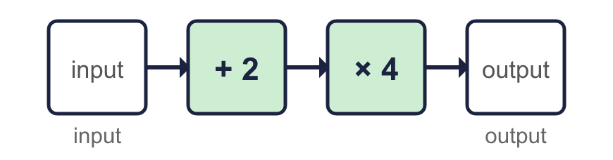  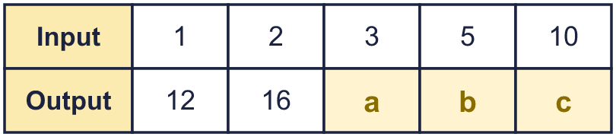  Hint: Do + 2 first. Then do × 4 to your answer.
  2 | This machine does the same two steps in the other order. Complete the table.  Hint: Do + 2 first. Then do × 4 to your answer.
  3 | Work out the output of each machine.  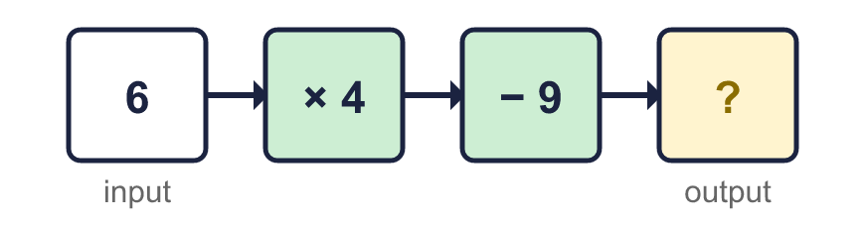  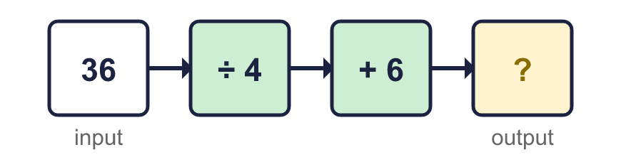  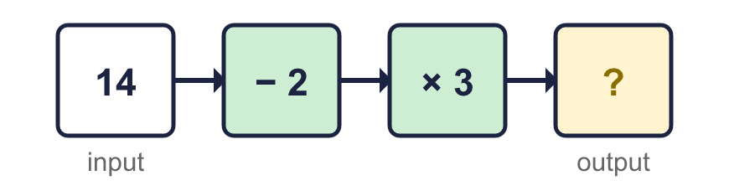  Hint: Do the first operation, then the second.
  3 | Work out the output of each machine.  Hint: Do the first operation, then the second.
  4 | Work out the input of each machine. Start with the output and use the opposite operations.  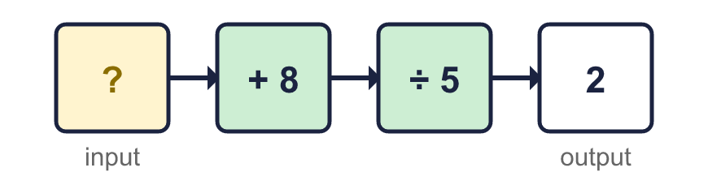  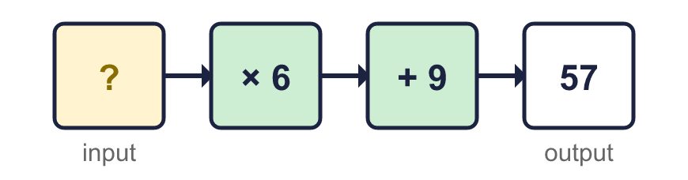  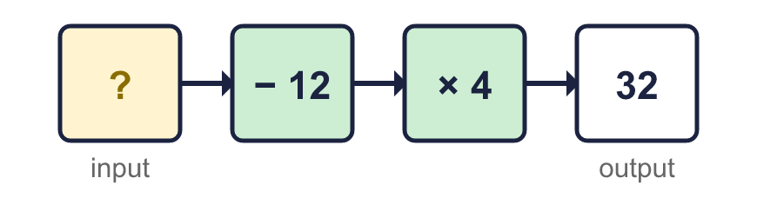  Hint: Undo the last operation first. Then undo the first operation.
  4 | Work out the input of each machine. Start with the output and use the opposite operations.  Hint: Undo the last operation first. Then undo the first operation.
  5 | Each pair of machines is made of the same two steps. Which pairs give the same output for every input? Write the letters.  A: + 7, then + 9 and + 9, then + 7  B: + 4, then + 6 and + 6, then + 4  C: + 9, then × 2 and × 2, then + 9  Hint: Try the same input in both machines. Try more than one input.
  5 | Each pair of machines is made of the same two steps. Which pairs give the same output for every input? Write the letters.  A: + 7, then + 9 and + 9, then + 7  B: + 4, then + 6 and + 6, then + 4  C: + 9, then × 2 and × 2, then + 9  Hint: Try the same input in both machines. Try more than one input.
  6 | Use the function machine to complete the table. Some missing numbers are inputs and some are outputs.  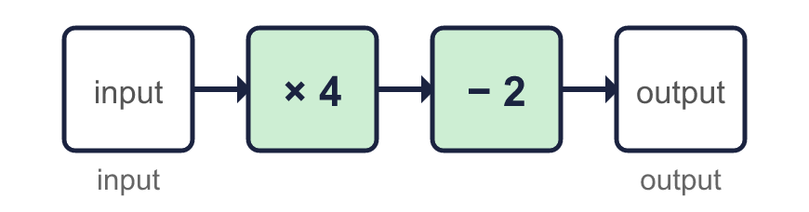  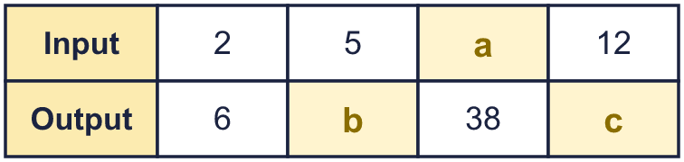  Hint: For a missing output do the two steps. For a missing input work backwards.
  6 | Use the function machine to complete the table. Some missing numbers are inputs and some are outputs.  Hint: For a missing output do the two steps. For a missing input work backwards.
  7 | A shop prints photos online. Photos cost 25p each. There is a delivery charge of £1.75 for every order.  How much does an order of 18 photos cost?  Hint: Cost of the photos: 18 × 25p. Then add the delivery.
  7 | A shop prints photos online. Photos cost 25p each. There is a delivery charge of £1.75 for every order.  How much does an order of 18 photos cost?  Hint: Cost of the photos: 18 × 25p. Then add the delivery.
  8 | Write one machine that does the same job as each pair of machines.  Hint: Try some inputs, such as 10. What single operation gives the same output?
    a) × 3, then × 5:
    b) − 5, then + 14:
    c) ÷ 4, then × 16:
  8 | Write one machine that does the same job as each pair of machines.  Hint: Try some inputs, such as 10. What single operation gives the same output?
    a) × 3, then × 5:
    b) − 5, then + 14:
    c) ÷ 4, then × 16:

  9 | Machine A: + 6, then + 2.  Machine B: + 2, then + 6.  Is Jack correct? Circle yes or no.  Yes / No  Explain. Use the input 2 to help.  Hint: Put 2 into each machine. Compare the two outputs.
     | 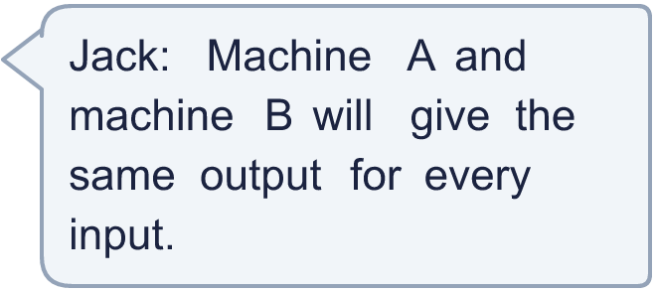
  9 | Machine A: + 6, then + 2.  Machine B: + 2, then + 6.  Is Jack correct? Circle yes or no.  Yes / No  Explain. Use the input 2 to help.  Hint: Put 2 into each machine. Compare the two outputs.
  10 | Dora puts a number into this machine and the number that comes out is the same as the number that went in.  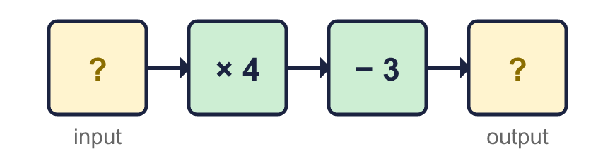  Hint: Try some numbers: 1, 2, 3 … Which one comes out the same?
  10 | Dora puts a number into this machine and the number that comes out is the same as the number that went in.  Hint: Try some numbers: 1, 2, 3 … Which one comes out the same?
  11 | Photos cost 30p each. Delivery is £1.50 for the whole order. Eva pays £9.30.  How many photos did Eva order?  Hint: Take the delivery charge off first. Then divide by the cost of one photo.
  11 | Photos cost 30p each. Delivery is £1.50 for the whole order. Eva pays £9.30.  How many photos did Eva order?  Hint: Take the delivery charge off first. Then divide by the cost of one photo.
  12 | Tables are joined end to end in a row. 1 table seats 8 people. 2 tables seat 10 people. 3 tables seat 12 people.  a) How many people can sit at 9 tables?  b) A party has 70 people. How many tables do they need?  Hint: Find how many more people each new table adds. Then find the number for 0 tables and use both numbers.
  12 | Tables are joined end to end in a row. 1 table seats 8 people. 2 tables seat 10 people. 3 tables seat 12 people.  a) How many people can sit at 9 tables?  b) A party has 70 people. How many tables do they need?  Hint: Find how many more people each new table adds. Then find the number for 0 tables and use both numbers.
  13 | A function machine turns these inputs into these outputs.  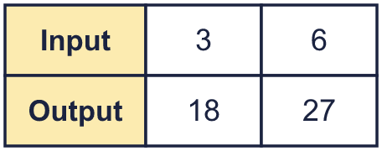  Which machine is it? Write its letter.  A: × 2, then + 4  B: + 2, then × 5  C: + 3, then × 3  Hint: Try the first input in each machine. Cross out the machines that give the wrong output.
  13 | A function machine turns these inputs into these outputs.  Which machine is it? Write its letter.  A: × 2, then + 4  B: + 2, then × 5  C: + 3, then × 3  Hint: Try the first input in each machine. Cross out the machines that give the wrong output.
  14 | Challenge  A two-step machine multiplies by a number and then adds or subtracts a number.  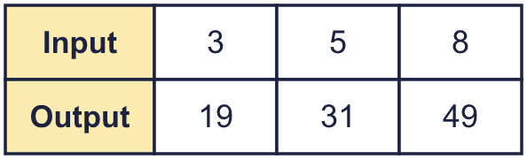  Hint: Find how much the output goes up when the input goes up by 1. That is the number you multiply by.
  14 | Challenge  A two-step machine multiplies by a number and then adds or subtracts a number.  Hint: Find how much the output goes up when the input goes up by 1. That is the number you multiply by.

Year 6 · Algebra · Step 2
Two-step function machines
Answers (teacher copy)

Do the first operation, then the second. 4 × 3 = 12, then 12 + 2 = 14. To go backwards, undo the second operation first:
  1 | Use the function machine to complete the table. Write the missing outputs.  a = 14  b = 22  c = 42  Hint: Do × 4 first. Then do + 2 to your answer.
  2 | This machine does the same two steps in the other order. Complete the table.  a = 20  b = 28  c = 48  Hint: Do + 2 first. Then do × 4 to your answer.
  3 | Work out the output of each machine.  a) 15  b) 15  c) 36  Hint: Do the first operation, then the second.
  4 | Work out the input of each machine. Start with the output and use the opposite operations.  a) 2  b) 8  c) 20  Hint: Undo the last operation first. Then undo the first operation.
  5 | Each pair of machines is made of the same two steps. Which pairs give the same output for every input? Write the letters.  A: + 7, then + 9 and + 9, then + 7  B: + 4, then + 6 and + 6, then + 4  C: + 9, then × 2 and × 2, then + 9  A, B  Hint: Try the same input in both machines. Try more than one input.
  6 | Use the function machine to complete the table. Some missing numbers are inputs and some are outputs.  a = 10  b = 18  c = 46  Hint: For a missing output do the two steps. For a missing input work backwards.
  7 | A shop prints photos online. Photos cost 25p each. There is a delivery charge of £1.75 for every order.  How much does an order of 18 photos cost? £6.25  Hint: Cost of the photos: 18 × 25p. Then add the delivery.
  8 | Write one machine that does the same job as each pair of machines.  a) × 3, then × 5: × 15  b) − 5, then + 14: + 9  c) ÷ 4, then × 16: × 4  Hint: Try some inputs, such as 10. What single operation gives the same output?
  9 | Machine A: + 6, then + 2.  Machine B: + 2, then + 6.  Is Jack correct? Circle yes or no.  Yes / No  Explain. Use the input 2 to help.  Yes. With input 2, machine A gives 10 and machine B gives 10.  Hint: Put 2 into each machine. Compare the two outputs.
  10 | Dora puts a number into this machine and the number that comes out is the same as the number that went in.  Dora’s number: 1  Hint: Try some numbers: 1, 2, 3 … Which one comes out the same?
  11 | Photos cost 30p each. Delivery is £1.50 for the whole order. Eva pays £9.30.  How many photos did Eva order? 26  Hint: Take the delivery charge off first. Then divide by the cost of one photo.
  12 | Tables are joined end to end in a row. 1 table seats 8 people. 2 tables seat 10 people. 3 tables seat 12 people.  a) How many people can sit at 9 tables? 24  b) A party has 70 people. How many tables do they need? 32  Hint: Find how many more people each new table adds. Then find the number for 0 tables and use both numbers.
  13 | A function machine turns these inputs into these outputs.  Which machine is it? Write its letter.  A: × 2, then + 4  B: + 2, then × 5  C: + 3, then × 3  C  Hint: Try the first input in each machine. Cross out the machines that give the wrong output.
  14 | Challenge  A two-step machine multiplies by a number and then adds or subtracts a number.  The two steps are × 6, + 1  Hint: Find how much the output goes up when the input goes up by 1. That is the number you multiply by.

