Undo the adding or taking away first. Then undo the multiplying:  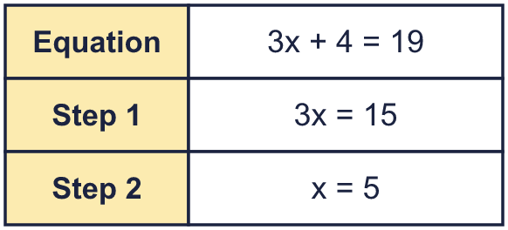 |  | Undo the adding or taking away first. Then undo the multiplying:
  Year 6 · Algebra · Step 8  Solving two-step equations | 
  Year 6 · Algebra · Step 8
  Solving two-step equations
  1 | The part-whole model is an equation. Work out the value of y.  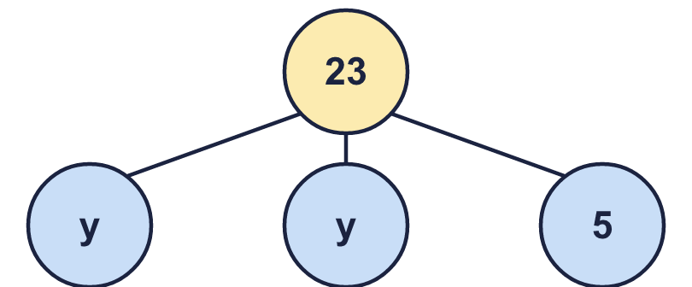  Hint: Take the number part away from the whole. Then share what is left between the y parts.
    y =
  1 | The part-whole model is an equation. Work out the value of y.  Hint: Take the number part away from the whole. Then share what is left between the y parts.
    y =
  2 | Solve each equation. Do two steps.  Hint: Undo the + or − first. Then divide.
    a) 10t − 9 = 81 | t =
    b) 2 + 10t = 42 | t =
    c) 10 + 5x = 45 | x =
    d) 120 = 10p + 10 | p =
  2 | Solve each equation. Do two steps.  Hint: Undo the + or − first. Then divide.
    a) 10t − 9 = 81 | t =
    b) 2 + 10t = 42 | t =
    c) 10 + 5x = 45 | x =
    d) 120 = 10p + 10 | p =
  3 | There is the same number of counters (y) under each cup. Some counters are loose.  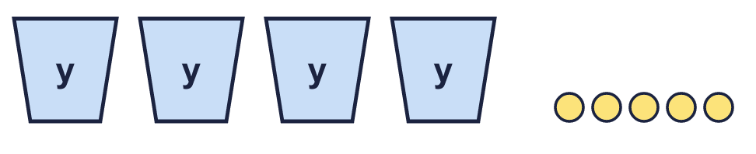  There are 29 counters altogether.  Hint: Take the loose counters away from the total. Then share between the cups.
    b) y =
  3 | There is the same number of counters (y) under each cup. Some counters are loose.  There are 29 counters altogether.  Hint: Take the loose counters away from the total. Then share between the cups.
    b) y =
  4 | Work out the value of the letter in each bar model.  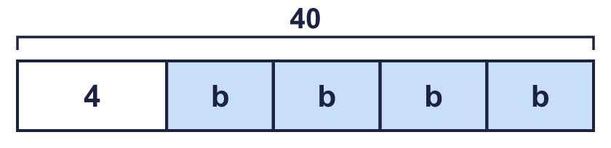  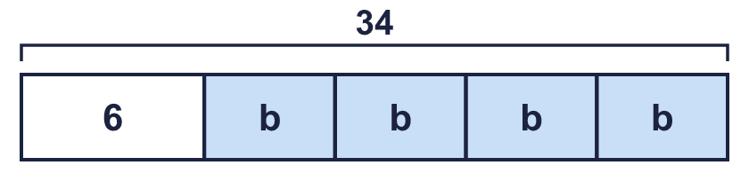  Hint: Take the number away from the total first.
    a) b =
    b) b =
  4 | Work out the value of the letter in each bar model.  Hint: Take the number away from the total first.
    a) b =
    b) b =
  5 | Solve each story.  a) Call my number y. I double my number and add 4. The answer is 22.  b) Call my number g. I multiply my number by 4 and then subtract 2. The answer is 38.  Hint: Work backwards through the steps.
    y =
    g =
  5 | Solve each story.  a) Call my number y. I double my number and add 4. The answer is 22.  b) Call my number g. I multiply my number by 4 and then subtract 2. The answer is 38.  Hint: Work backwards through the steps.
    y =
    g =
  6 | The perimeter of the rectangle is 46 cm.  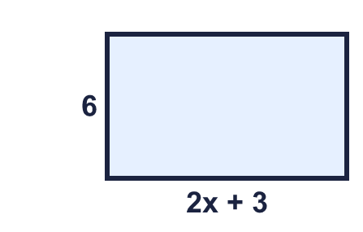  Hint: Add the four sides to make an equation. Solve it. Then find the length and multiply.
    a) x =
  6 | The perimeter of the rectangle is 46 cm.  Hint: Add the four sides to make an equation. Solve it. Then find the length and multiply.
    a) x =
  7 | Alex is y years old. Brett is 5 years older than Alex. Their ages add up to 23. (Write the equation 2y + 5 = 23 and solve it.)  Hint: Find Alex’s age first. Then add to find Brett’s.
  7 | Alex is y years old. Brett is 5 years older than Alex. Their ages add up to 23. (Write the equation 2y + 5 = 23 and solve it.)  Hint: Find Alex’s age first. Then add to find Brett’s.
  8 | Solve each equation.  Hint: Check each answer by putting it back into the equation.
    a) 2p − 5 = 35 | p =
    b) 95 = 7n + 11 | n =
    c) 7m − 10 = 102 | m =
    d) 41 = 5x + 1 | x =
  8 | Solve each equation.  Hint: Check each answer by putting it back into the equation.
    a) 2p − 5 = 35 | p =
    b) 95 = 7n + 11 | n =
    c) 7m − 10 = 102 | m =
    d) 41 = 5x + 1 | x =

  9 | Solve 5x + 2 = 42.  Is Boba correct? Circle yes or no.  Yes / No  Explain the mistake. Then write the correct answer.  Hint: 5x means 5 × x. What is the opposite of × 5?
     | 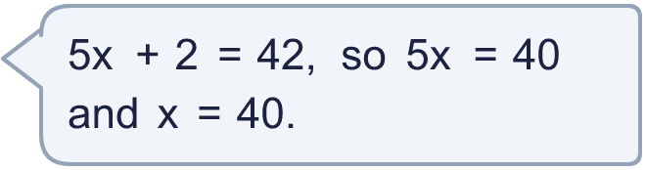
    x =
  9 | Solve 5x + 2 = 42.  Is Boba correct? Circle yes or no.  Yes / No  Explain the mistake. Then write the correct answer.  Hint: 5x means 5 × x. What is the opposite of × 5?
    x =
  10 | Which of these equations have the solution n = 4? Write the letters.  A: 3n − 5 = 7  B: 3n + 5 = 18  C: 17 = 3n + 5  D: n ÷ 2 + 5 = 8  Hint: Put 4 in for n in each equation.
  10 | Which of these equations have the solution n = 4? Write the letters.  A: 3n − 5 = 7  B: 3n + 5 = 18  C: 17 = 3n + 5  D: n ÷ 2 + 5 = 8  Hint: Put 4 in for n in each equation.
  11 | Call my number m. I multiply my number by 5 and then subtract 3. The answer is 27.  Hint: Add the number back on. Then divide.
    m =
  11 | Call my number m. I multiply my number by 5 and then subtract 3. The answer is 27.  Hint: Add the number back on. Then divide.
    m =
  12 | Cinema tickets cost £3 each. There is a booking fee of £1 for the whole order. A family pays £13.  How many tickets did they buy?  Hint: Take the booking fee off first. Then divide by the cost of one ticket.
  12 | Cinema tickets cost £3 each. There is a booking fee of £1 for the whole order. A family pays £13.  How many tickets did they buy?  Hint: Take the booking fee off first. Then divide by the cost of one ticket.
  13 | The perimeter of the triangle is 19 cm. Work out n.  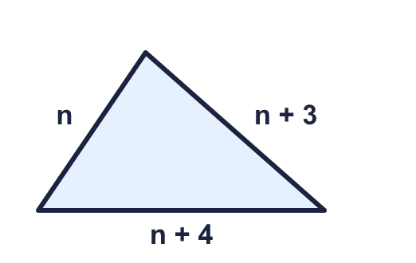  Hint: Write an equation for the perimeter. Then solve it.
    n =
  13 | The perimeter of the triangle is 19 cm. Work out n.  Hint: Write an equation for the perimeter. Then solve it.
    n =
  14 | Challenge  3x + 3 = 9. Then y = 2x − 2.  Hint: Solve for x first. Then put it in the equation for y.
    x = |  | y =
  14 | Challenge  3x + 3 = 9. Then y = 2x − 2.  Hint: Solve for x first. Then put it in the equation for y.
    x = |  | y =

Year 6 · Algebra · Step 8
Solving two-step equations
Answers (teacher copy)

Undo the adding or taking away first. Then undo the multiplying:
  1 | The part-whole model is an equation. Work out the value of y.  y = 9  Hint: Take the number part away from the whole. Then share what is left between the y parts.
  2 | Solve each equation. Do two steps.  a) 10t − 9 = 81 t = 9  b) 2 + 10t = 42 t = 4  c) 10 + 5x = 45 x = 7  d) 120 = 10p + 10 p = 11  Hint: Undo the + or − first. Then divide.
  3 | There is the same number of counters (y) under each cup. Some counters are loose.  There are 29 counters altogether.  a) Write an equation: 4y + 5 = 29  b) y = 6  Hint: Take the loose counters away from the total. Then share between the cups.
  4 | Work out the value of the letter in each bar model.  a) b = 9  b) b = 7  Hint: Take the number away from the total first.
  5 | Solve each story.  a) Call my number y. I double my number and add 4. The answer is 22.  y = 9  b) Call my number g. I multiply my number by 4 and then subtract 2. The answer is 38.  g = 10  Hint: Work backwards through the steps.
  6 | The perimeter of the rectangle is 46 cm.  a) x = 7  b) The area: 102 cm²  Hint: Add the four sides to make an equation. Solve it. Then find the length and multiply.
  7 | Alex is y years old. Brett is 5 years older than Alex. Their ages add up to 23. (Write the equation 2y + 5 = 23 and solve it.)  Alex is 9  Brett is 14  Hint: Find Alex’s age first. Then add to find Brett’s.
  8 | Solve each equation.  a) 2p − 5 = 35 p = 20  b) 95 = 7n + 11 n = 12  c) 7m − 10 = 102 m = 16  d) 41 = 5x + 1 x = 8  Hint: Check each answer by putting it back into the equation.
  9 | Solve 5x + 2 = 42.  Is Boba correct? Circle yes or no.  Yes / No  Explain the mistake. Then write the correct answer.  No. 5x = 40, so x must be 40 ÷ 5 = 8.  x = 8  Hint: 5x means 5 × x. What is the opposite of × 5?
  10 | Which of these equations have the solution n = 4? Write the letters.  A: 3n − 5 = 7  B: 3n + 5 = 18  C: 17 = 3n + 5  D: n ÷ 2 + 5 = 8  A, C  Hint: Put 4 in for n in each equation.
  11 | Call my number m. I multiply my number by 5 and then subtract 3. The answer is 27.  m = 6  Hint: Add the number back on. Then divide.
  12 | Cinema tickets cost £3 each. There is a booking fee of £1 for the whole order. A family pays £13.  How many tickets did they buy? 4  Hint: Take the booking fee off first. Then divide by the cost of one ticket.
  13 | The perimeter of the triangle is 19 cm. Work out n.  n = 4  Hint: Write an equation for the perimeter. Then solve it.
  14 | Challenge  3x + 3 = 9. Then y = 2x − 2.  x = 2 y = 2  Hint: Solve for x first. Then put it in the equation for y.

