  Year 6 · Algebra · Step 8  Solving two-step equations | 
  Year 6 · Algebra · Step 8
  Solving two-step equations
  1 | The part-whole model is an equation. Work out the value of y.  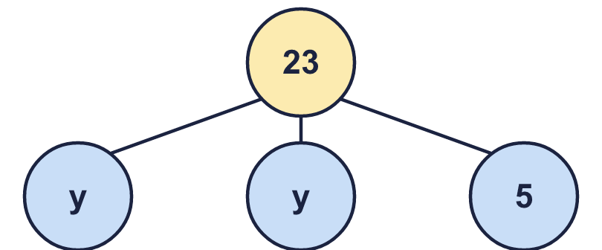
    y =
  1 | The part-whole model is an equation. Work out the value of y.
    y =
  2 | Solve each equation. Do two steps.
    a) 10t − 9 = 81 | t =
    b) 2 + 10t = 42 | t =
    c) 10 + 5x = 45 | x =
    d) 120 = 10p + 10 | p =
  2 | Solve each equation. Do two steps.
    a) 10t − 9 = 81 | t =
    b) 2 + 10t = 42 | t =
    c) 10 + 5x = 45 | x =
    d) 120 = 10p + 10 | p =
  3 | There is the same number of counters (y) under each cup. Some counters are loose.  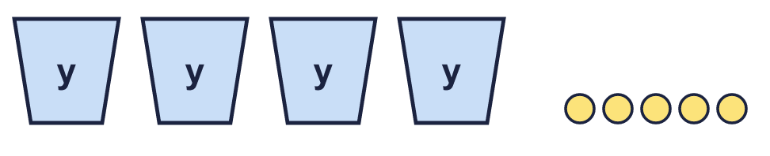  There are 29 counters altogether.
    b) y =
  3 | There is the same number of counters (y) under each cup. Some counters are loose.  There are 29 counters altogether.
    b) y =
  4 | Work out the value of the letter in each bar model.  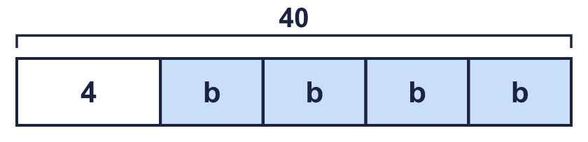  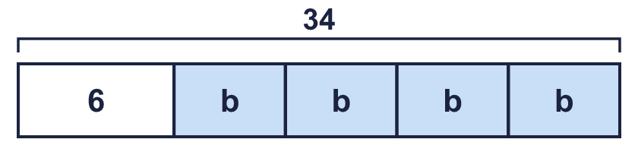
    a) b =
    b) b =
  4 | Work out the value of the letter in each bar model.
    a) b =
    b) b =
  5 | Solve each story.  a) Call my number y. I double my number and add 4. The answer is 22.  b) Call my number g. I multiply my number by 4 and then subtract 2. The answer is 38.
    y =
    g =
  5 | Solve each story.  a) Call my number y. I double my number and add 4. The answer is 22.  b) Call my number g. I multiply my number by 4 and then subtract 2. The answer is 38.
    y =
    g =
  6 | The perimeter of the rectangle is 46 cm.  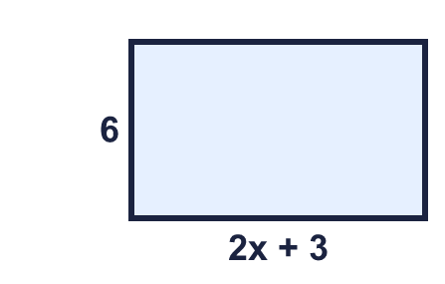
    a) x =
  6 | The perimeter of the rectangle is 46 cm.
    a) x =
  7 | Alex is y years old. Brett is 5 years older than Alex. Their ages add up to 23. (Write the equation 2y + 5 = 23 and solve it.)
  7 | Alex is y years old. Brett is 5 years older than Alex. Their ages add up to 23. (Write the equation 2y + 5 = 23 and solve it.)
  8 | Solve each equation.
    a) 2p − 5 = 35 | p =
    b) 95 = 7n + 11 | n =
    c) 7m − 10 = 102 | m =
    d) 41 = 5x + 1 | x =
  8 | Solve each equation.
    a) 2p − 5 = 35 | p =
    b) 95 = 7n + 11 | n =
    c) 7m − 10 = 102 | m =
    d) 41 = 5x + 1 | x =

  9 | Solve 5x + 2 = 42.  Is Boba correct? Circle yes or no.  Yes / No  Explain the mistake. Then write the correct answer.
     | 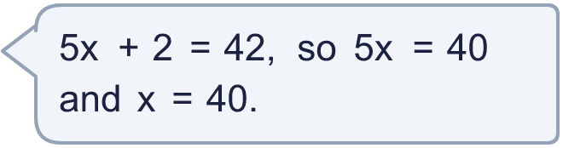
    x =
  9 | Solve 5x + 2 = 42.  Is Boba correct? Circle yes or no.  Yes / No  Explain the mistake. Then write the correct answer.
    x =
  10 | Which of these equations have the solution n = 4? Write the letters.  A: 3n − 5 = 7  B: 3n + 5 = 18  C: 17 = 3n + 5  D: n ÷ 2 + 5 = 8
  10 | Which of these equations have the solution n = 4? Write the letters.  A: 3n − 5 = 7  B: 3n + 5 = 18  C: 17 = 3n + 5  D: n ÷ 2 + 5 = 8
  11 | Call my number m. I multiply my number by 5 and then subtract 3. The answer is 27.
    m =
  11 | Call my number m. I multiply my number by 5 and then subtract 3. The answer is 27.
    m =
  12 | Cinema tickets cost £3 each. There is a booking fee of £1 for the whole order. A family pays £13.  How many tickets did they buy?
  12 | Cinema tickets cost £3 each. There is a booking fee of £1 for the whole order. A family pays £13.  How many tickets did they buy?
  13 | The perimeter of the triangle is 19 cm. Work out n.  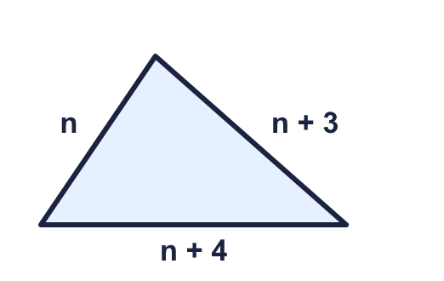
    n =
  13 | The perimeter of the triangle is 19 cm. Work out n.
    n =
  14 | Challenge  3x + 3 = 9. Then y = 2x − 2.
    x = |  | y =
  14 | Challenge  3x + 3 = 9. Then y = 2x − 2.
    x = |  | y =

Year 6 · Algebra · Step 8
Solving two-step equations
Answers (teacher copy)

  1 | The part-whole model is an equation. Work out the value of y.  y = 9
  2 | Solve each equation. Do two steps.  a) 10t − 9 = 81 t = 9  b) 2 + 10t = 42 t = 4  c) 10 + 5x = 45 x = 7  d) 120 = 10p + 10 p = 11
  3 | There is the same number of counters (y) under each cup. Some counters are loose.  There are 29 counters altogether.  a) Write an equation: 4y + 5 = 29  b) y = 6
  4 | Work out the value of the letter in each bar model.  a) b = 9  b) b = 7
  5 | Solve each story.  a) Call my number y. I double my number and add 4. The answer is 22.  y = 9  b) Call my number g. I multiply my number by 4 and then subtract 2. The answer is 38.  g = 10
  6 | The perimeter of the rectangle is 46 cm.  a) x = 7  b) The area: 102 cm²
  7 | Alex is y years old. Brett is 5 years older than Alex. Their ages add up to 23. (Write the equation 2y + 5 = 23 and solve it.)  Alex is 9  Brett is 14
  8 | Solve each equation.  a) 2p − 5 = 35 p = 20  b) 95 = 7n + 11 n = 12  c) 7m − 10 = 102 m = 16  d) 41 = 5x + 1 x = 8
  9 | Solve 5x + 2 = 42.  Is Boba correct? Circle yes or no.  Yes / No  Explain the mistake. Then write the correct answer.  No. 5x = 40, so x must be 40 ÷ 5 = 8.  x = 8
  10 | Which of these equations have the solution n = 4? Write the letters.  A: 3n − 5 = 7  B: 3n + 5 = 18  C: 17 = 3n + 5  D: n ÷ 2 + 5 = 8  A, C
  11 | Call my number m. I multiply my number by 5 and then subtract 3. The answer is 27.  m = 6
  12 | Cinema tickets cost £3 each. There is a booking fee of £1 for the whole order. A family pays £13.  How many tickets did they buy? 4
  13 | The perimeter of the triangle is 19 cm. Work out n.  n = 4
  14 | Challenge  3x + 3 = 9. Then y = 2x − 2.  x = 2 y = 2

