The sum is 20 and a is 4 more than b. Take away the 4, then share what is left: b = 8 and a = 12:  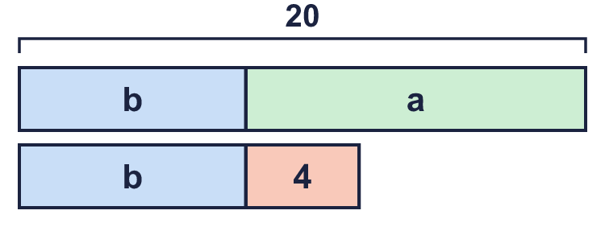 |  | The sum is 20 and a is 4 more than b. Take away the 4, then share what is left: b = 8 and a = 12:
  Year 6 · Algebra · Step 10  Problems with two unknowns | 
  Year 6 · Algebra · Step 10
  Problems with two unknowns
  1 | The sum of two numbers, a and b, is 31. a is 9 more than b.  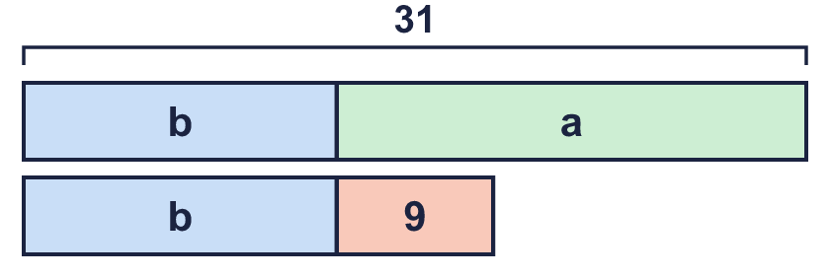  Hint: Take away the 9 from 31. Share what is left between the two equal parts.
    a = |  | b =
  1 | The sum of two numbers, a and b, is 31. a is 9 more than b.  Hint: Take away the 9 from 31. Share what is left between the two equal parts.
    a = |  | b =
  2 | The sum of two numbers, c and d, is 24. d is 8 less than c.  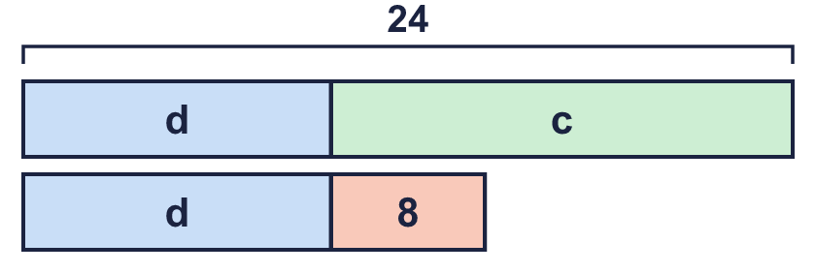  Hint: c is the bigger number. Take 8 away from the sum, share it, then add 8 back on for c.
    c = |  | d =
  2 | The sum of two numbers, c and d, is 24. d is 8 less than c.  Hint: c is the bigger number. Take 8 away from the sum, share it, then add 8 back on for c.
    c = |  | d =
  3 | The sum of p and q is 24. q is 3 times p.  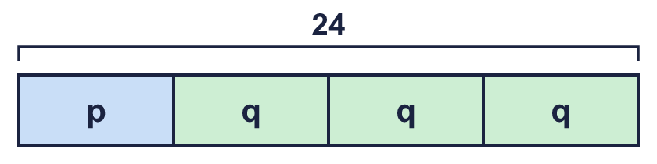  Hint: There are 4 equal parts altogether. Divide 24 by 4.
    p = |  | q =
  3 | The sum of p and q is 24. q is 3 times p.  Hint: There are 4 equal parts altogether. Divide 24 by 4.
    p = |  | q =
  4 | The sum of r and s is 9. s is half of r.  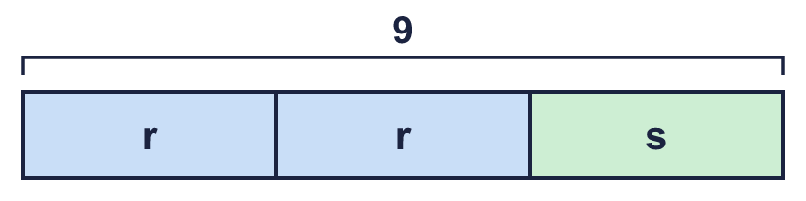  Hint: r is 2 parts and s is 1 part. Divide 9 by 3 to find one part.
    r = |  | s =
  4 | The sum of r and s is 9. s is half of r.  Hint: r is 2 parts and s is 1 part. Divide 9 by 3 to find one part.
    r = |  | s =
  5 | The difference between v and w is 120. v is one-third of w.  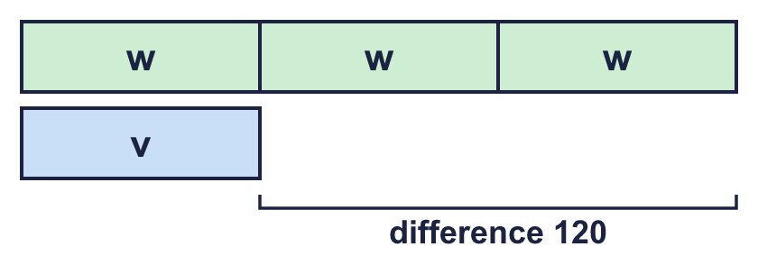  Hint: w is 3 parts and v is 1 part. The difference is 2 parts.
    v = |  | w =
  5 | The difference between v and w is 120. v is one-third of w.  Hint: w is 3 parts and v is 1 part. The difference is 2 parts.
    v = |  | w =
  6 | The total cost of one apple and one pear is £1.40. A pear costs 20p more than an apple.  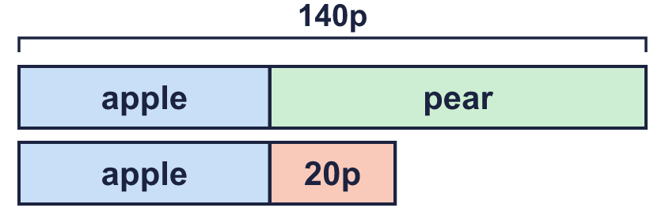  Hint: Change £1.40 to 140p. Take away the 20p, then share.
  6 | The total cost of one apple and one pear is £1.40. A pear costs 20p more than an apple.  Hint: Change £1.40 to 140p. Take away the 20p, then share.
  7 | The mass of a bag is 3 times the mass of a box. The bag is 150 g heavier than the box.  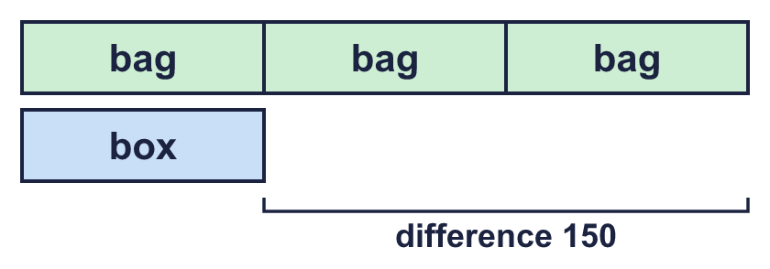  What is the total mass of the bag and the box? g  Hint: Find the mass of the box first. Then find the bag. Add them.
  7 | The mass of a bag is 3 times the mass of a box. The bag is 150 g heavier than the box.  What is the total mass of the bag and the box? g  Hint: Find the mass of the box first. Then find the bag. Add them.
  8 | x + y = 122  x − y = 4  Work out the values of x and y.  Hint: x is the bigger number. Add the two equations, or use a bar model: the sum is 122 and the difference is 4.
    x = |  | y =
  8 | x + y = 122  x − y = 4  Work out the values of x and y.  Hint: x is the bigger number. Add the two equations, or use a bar model: the sum is 122 and the difference is 4.
    x = |  | y =

  9 | a + b = 30  a = b + 10  Is Nina correct? Circle yes or no.  Yes / No  Explain how you know.  Hint: Put the numbers into both equations. Both must be true.
     | 
  9 | a + b = 30  a = b + 10  Is Nina correct? Circle yes or no.  Yes / No  Explain how you know.  Hint: Put the numbers into both equations. Both must be true.
  10 | Dad and Ravi have ages that add up to 24. Dad is 3 times as old as Ravi.  Hint: Ravi is 1 part and Dad is 3 parts. How many parts altogether?
  10 | Dad and Ravi have ages that add up to 24. Dad is 3 times as old as Ravi.  Hint: Ravi is 1 part and Dad is 3 parts. How many parts altogether?
  11 | A purse has 6 coins. Each coin is a 5p or a 20p. The coins are worth 75p altogether.  How many 5p coins? How many 20p coins?  Hint: Try 6 coins of 5p, then swap some for 20p coins. How much does each swap add?
  11 | A purse has 6 coins. Each coin is a 5p or a 20p. The coins are worth 75p altogether.  How many 5p coins? How many 20p coins?  Hint: Try 6 coins of 5p, then swap some for 20p coins. How much does each swap add?
  12 | t and c are numbers.  t + t + c = 22  t + c = 13  Hint: Compare the two equations. What is the difference between them?
    t = |  | c =
  12 | t and c are numbers.  t + t + c = 22  t + c = 13  Hint: Compare the two equations. What is the difference between them?
    t = |  | c =
  13 | The sum of two numbers is 28. Their difference is 6.  Hint: Find the two numbers first. Then multiply them.
  13 | The sum of two numbers is 28. Their difference is 6.  Hint: Find the two numbers first. Then multiply them.
  14 | Challenge  The sum of three consecutive whole numbers is 81. (Consecutive numbers follow each other, like 7, 8, 9.)  Hint: The middle number is the mean of the three. Divide the sum by 3.
    The numbers are |  |  | and
  14 | Challenge  The sum of three consecutive whole numbers is 81. (Consecutive numbers follow each other, like 7, 8, 9.)  Hint: The middle number is the mean of the three. Divide the sum by 3.
    The numbers are |  |  | and

Year 6 · Algebra · Step 10
Problems with two unknowns
Answers (teacher copy)

The sum is 20 and a is 4 more than b. Take away the 4, then share what is left: b = 8 and a = 12:
  1 | The sum of two numbers, a and b, is 31. a is 9 more than b.  a = 20 b = 11  Hint: Take away the 9 from 31. Share what is left between the two equal parts.
  2 | The sum of two numbers, c and d, is 24. d is 8 less than c.  c = 16 d = 8  Hint: c is the bigger number. Take 8 away from the sum, share it, then add 8 back on for c.
  3 | The sum of p and q is 24. q is 3 times p.  p = 6 q = 18  Hint: There are 4 equal parts altogether. Divide 24 by 4.
  4 | The sum of r and s is 9. s is half of r.  r = 6 s = 3  Hint: r is 2 parts and s is 1 part. Divide 9 by 3 to find one part.
  5 | The difference between v and w is 120. v is one-third of w.  v = 60 w = 180  Hint: w is 3 parts and v is 1 part. The difference is 2 parts.
  6 | The total cost of one apple and one pear is £1.40. A pear costs 20p more than an apple.  Apple: 60 p Pear: 80 p  Hint: Change £1.40 to 140p. Take away the 20p, then share.
  7 | The mass of a bag is 3 times the mass of a box. The bag is 150 g heavier than the box.  What is the total mass of the bag and the box? 300 g  Hint: Find the mass of the box first. Then find the bag. Add them.
  8 | x + y = 122  x − y = 4  Work out the values of x and y.  x = 63 y = 59  Hint: x is the bigger number. Add the two equations, or use a bar model: the sum is 122 and the difference is 4.
  9 | a + b = 30  a = b + 10  Is Nina correct? Circle yes or no.  Yes / No  Explain how you know.  No. 21 + 9 = 30, but 9 + 10 = 19, not 21.  Hint: Put the numbers into both equations. Both must be true.
  10 | Dad and Ravi have ages that add up to 24. Dad is 3 times as old as Ravi.  Ravi: 6 Dad: 18  Hint: Ravi is 1 part and Dad is 3 parts. How many parts altogether?
  11 | A purse has 6 coins. Each coin is a 5p or a 20p. The coins are worth 75p altogether.  How many 5p coins? 3 How many 20p coins? 3  Hint: Try 6 coins of 5p, then swap some for 20p coins. How much does each swap add?
  12 | t and c are numbers.  t + t + c = 22  t + c = 13  t = 9 c = 4  Hint: Compare the two equations. What is the difference between them?
  13 | The sum of two numbers is 28. Their difference is 6.  What is their product? 187  Hint: Find the two numbers first. Then multiply them.
  14 | Challenge  The sum of three consecutive whole numbers is 81. (Consecutive numbers follow each other, like 7, 8, 9.)  The numbers are 26 27 and 28  Hint: The middle number is the mean of the three. Divide the sum by 3.

