  Year 6 · Algebra · Step 10  Problems with two unknowns | 
  Year 6 · Algebra · Step 10
  Problems with two unknowns
  1 | The sum of two numbers, a and b, is 31. a is 9 more than b.  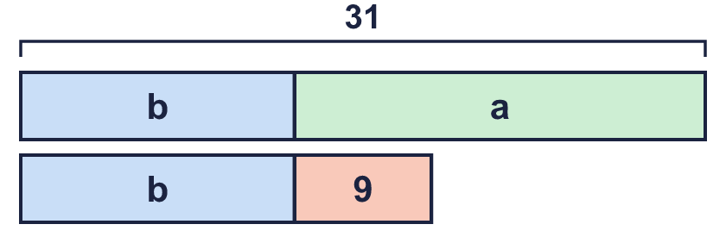
    a = |  | b =
  1 | The sum of two numbers, a and b, is 31. a is 9 more than b.
    a = |  | b =
  2 | The sum of two numbers, c and d, is 24. d is 8 less than c.  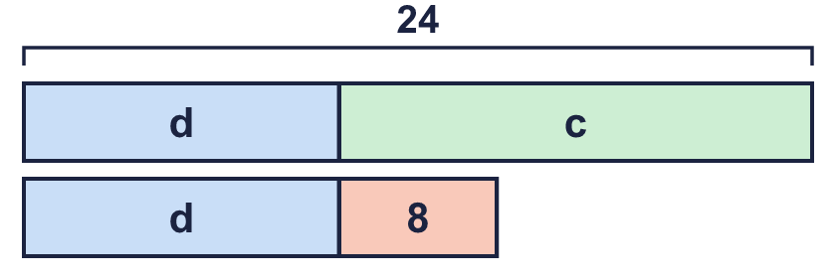
    c = |  | d =
  2 | The sum of two numbers, c and d, is 24. d is 8 less than c.
    c = |  | d =
  3 | The sum of p and q is 24. q is 3 times p.  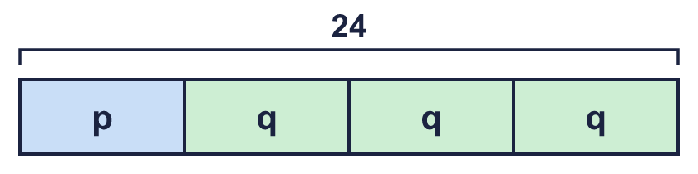
    p = |  | q =
  3 | The sum of p and q is 24. q is 3 times p.
    p = |  | q =
  4 | The sum of r and s is 9. s is half of r.  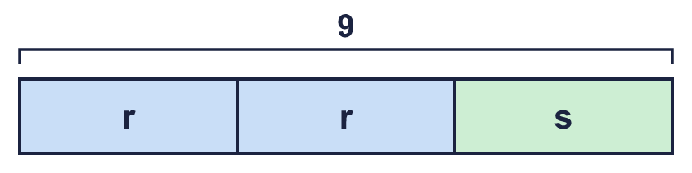
    r = |  | s =
  4 | The sum of r and s is 9. s is half of r.
    r = |  | s =
  5 | The difference between v and w is 120. v is one-third of w.  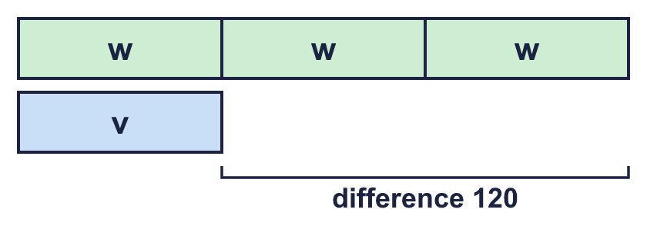
    v = |  | w =
  5 | The difference between v and w is 120. v is one-third of w.
    v = |  | w =
  6 | The total cost of one apple and one pear is £1.40. A pear costs 20p more than an apple.  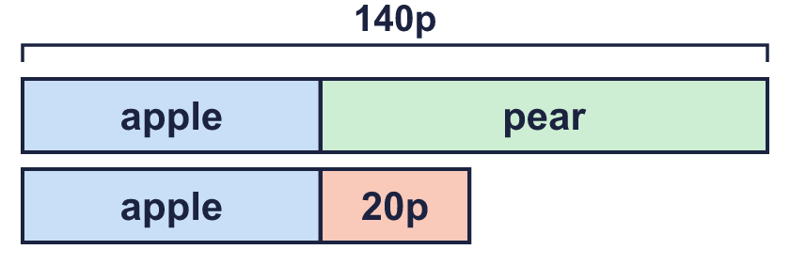
  6 | The total cost of one apple and one pear is £1.40. A pear costs 20p more than an apple.
  7 | The mass of a bag is 3 times the mass of a box. The bag is 150 g heavier than the box.  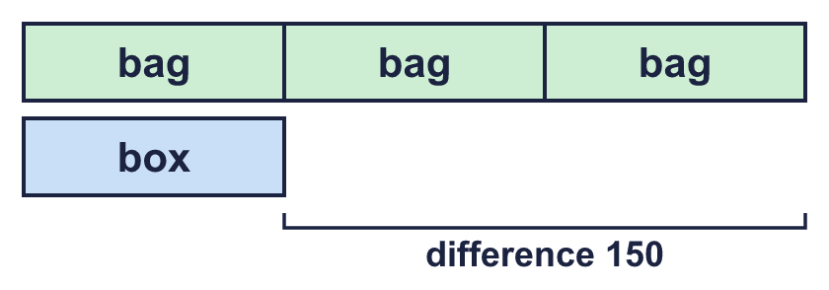  What is the total mass of the bag and the box? g
  7 | The mass of a bag is 3 times the mass of a box. The bag is 150 g heavier than the box.  What is the total mass of the bag and the box? g
  8 | x + y = 122  x − y = 4  Work out the values of x and y.
    x = |  | y =
  8 | x + y = 122  x − y = 4  Work out the values of x and y.
    x = |  | y =

  9 | a + b = 30  a = b + 10  Is Nina correct? Circle yes or no.  Yes / No  Explain how you know.
     | 
  9 | a + b = 30  a = b + 10  Is Nina correct? Circle yes or no.  Yes / No  Explain how you know.
  10 | Dad and Ravi have ages that add up to 24. Dad is 3 times as old as Ravi.
  10 | Dad and Ravi have ages that add up to 24. Dad is 3 times as old as Ravi.
  11 | A purse has 6 coins. Each coin is a 5p or a 20p. The coins are worth 75p altogether.  How many 5p coins? How many 20p coins?
  11 | A purse has 6 coins. Each coin is a 5p or a 20p. The coins are worth 75p altogether.  How many 5p coins? How many 20p coins?
  12 | t and c are numbers.  t + t + c = 22  t + c = 13
    t = |  | c =
  12 | t and c are numbers.  t + t + c = 22  t + c = 13
    t = |  | c =
  13 | The sum of two numbers is 28. Their difference is 6.
  13 | The sum of two numbers is 28. Their difference is 6.
  14 | Challenge  The sum of three consecutive whole numbers is 81. (Consecutive numbers follow each other, like 7, 8, 9.)
    The numbers are |  |  | and
  14 | Challenge  The sum of three consecutive whole numbers is 81. (Consecutive numbers follow each other, like 7, 8, 9.)
    The numbers are |  |  | and

Year 6 · Algebra · Step 10
Problems with two unknowns
Answers (teacher copy)

  1 | The sum of two numbers, a and b, is 31. a is 9 more than b.  a = 20 b = 11
  2 | The sum of two numbers, c and d, is 24. d is 8 less than c.  c = 16 d = 8
  3 | The sum of p and q is 24. q is 3 times p.  p = 6 q = 18
  4 | The sum of r and s is 9. s is half of r.  r = 6 s = 3
  5 | The difference between v and w is 120. v is one-third of w.  v = 60 w = 180
  6 | The total cost of one apple and one pear is £1.40. A pear costs 20p more than an apple.  Apple: 60 p Pear: 80 p
  7 | The mass of a bag is 3 times the mass of a box. The bag is 150 g heavier than the box.  What is the total mass of the bag and the box? 300 g
  8 | x + y = 122  x − y = 4  Work out the values of x and y.  x = 63 y = 59
  9 | a + b = 30  a = b + 10  Is Nina correct? Circle yes or no.  Yes / No  Explain how you know.  No. 21 + 9 = 30, but 9 + 10 = 19, not 21.
  10 | Dad and Ravi have ages that add up to 24. Dad is 3 times as old as Ravi.  Ravi: 6 Dad: 18
  11 | A purse has 6 coins. Each coin is a 5p or a 20p. The coins are worth 75p altogether.  How many 5p coins? 3 How many 20p coins? 3
  12 | t and c are numbers.  t + t + c = 22  t + c = 13  t = 9 c = 4
  13 | The sum of two numbers is 28. Their difference is 6.  What is their product? 187
  14 | Challenge  The sum of three consecutive whole numbers is 81. (Consecutive numbers follow each other, like 7, 8, 9.)  The numbers are 26 27 and 28

