A function machine does the same thing to every input. Here the rule is + 5, so 3 goes in and 8 comes out:  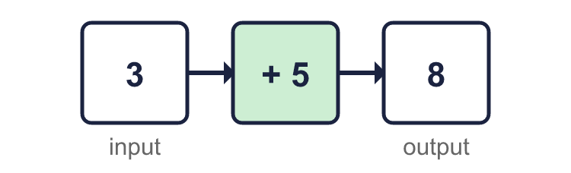 |  | A function machine does the same thing to every input. Here the rule is + 5, so 3 goes in and 8 comes out:
  Year 6 · Algebra · Step 1  One-step function machines | 
  Year 6 · Algebra · Step 1
  One-step function machines
  1 | Use the function machine to complete the table. Write the missing outputs.    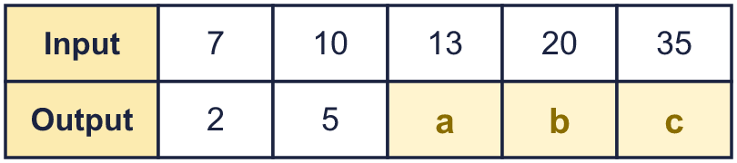  Hint: Do − 5 to each input to find the output.
  1 | Use the function machine to complete the table. Write the missing outputs.  Hint: Do − 5 to each input to find the output.
  2 | Use the function machine to complete the table. Write the missing inputs. Work backwards from the outputs.    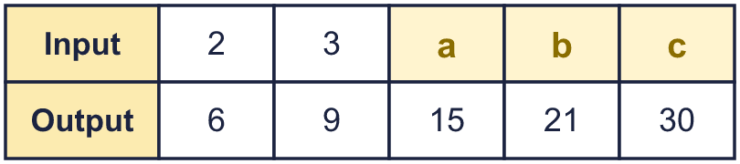  Hint: The machine does × 3. Do the opposite to each output.
  2 | Use the function machine to complete the table. Write the missing inputs. Work backwards from the outputs.  Hint: The machine does × 3. Do the opposite to each output.
  3 | Work out the output of each function machine.        Hint: Do the operation shown in the green box to the input.
  3 | Work out the output of each function machine.  Hint: Do the operation shown in the green box to the input.
  4 | Work out the input of each function machine. Work backwards.        Hint: Use the opposite operation: the opposite of + is −, and the opposite of × is ÷.
  4 | Work out the input of each function machine. Work backwards.  Hint: Use the opposite operation: the opposite of + is −, and the opposite of × is ÷.
  5 | The function machine has a missing operation. Use the table to find it.    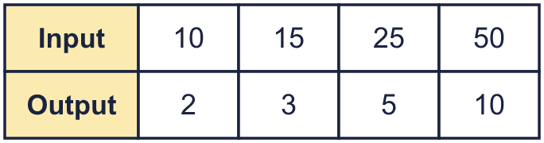  Hint: Compare an input with its output. Did the number get bigger or smaller? By how much, or how many times?
  5 | The function machine has a missing operation. Use the table to find it.  Hint: Compare an input with its output. Did the number get bigger or smaller? By how much, or how many times?
  6 | Here is a pattern of squares made from lolly sticks. Complete the table.    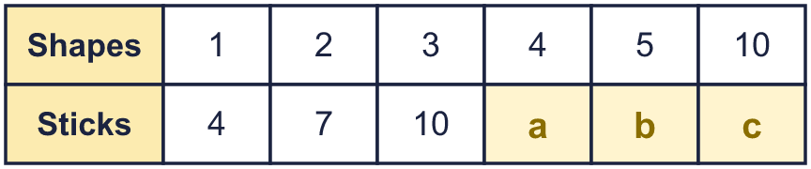  Hint: Count the sticks for 1, 2 and 3 shapes. How many more sticks does each new shape need?
  6 | Here is a pattern of squares made from lolly sticks. Complete the table.  Hint: Count the sticks for 1, 2 and 3 shapes. How many more sticks does each new shape need?
  7 | Each of the cars has the same number of wheels. Complete the table.  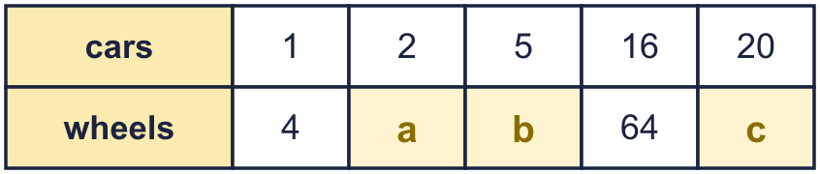  Hint: Look at the column for 1. Multiply the number of cars by that.
  7 | Each of the cars has the same number of wheels. Complete the table.  Hint: Look at the column for 1. Multiply the number of cars by that.
  8 | Look at the table. A function machine does the same thing to every input.  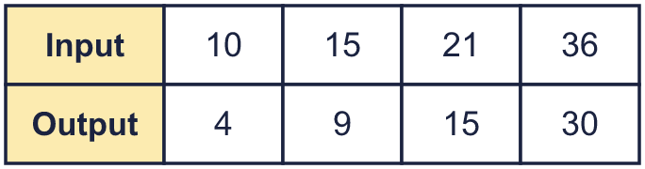  a) What is the rule of the machine?  b) The output when the input is 56:  Hint: Find the rule from the first column. Check it with the other columns.
  8 | Look at the table. A function machine does the same thing to every input.  a) What is the rule of the machine?  b) The output when the input is 56:  Hint: Find the rule from the first column. Check it with the other columns.

  9 | Here is a function machine.    a) The input is 0. The output is  b) The output is 0. The input is  c) The input is 0.5. The output is  d) The output is 1,000. The input is  Hint: The machine multiplies by 2. To go backwards, divide by 2.
  9 | Here is a function machine.  a) The input is 0. The output is  b) The output is 0. The input is  c) The input is 0.5. The output is  d) The output is 1,000. The input is  Hint: The machine multiplies by 2. To go backwards, divide by 2.
  10 | Here is a table from a function machine with a missing rule.  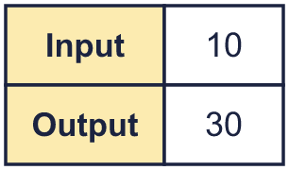  Dora says: “The rule is add 20.”  Dexter says: “The rule is multiply by 3.”  Who is correct? Write Dora, Dexter or Both.  Explain how you know.  Hint: Try each rule on the input. Does it give the output? Try it on every column.
  10 | Here is a table from a function machine with a missing rule.  Dora says: “The rule is add 20.”  Dexter says: “The rule is multiply by 3.”  Who is correct? Write Dora, Dexter or Both.  Explain how you know.  Hint: Try each rule on the input. Does it give the output? Try it on every column.
  11 | Sam wants a function machine that turns 3 into 15.  Write two different one-step machines that do this.  Machine 1: Machine 2:  Hint: One machine adds. How much do you add to 3 to get 15? Another machine multiplies.
  11 | Sam wants a function machine that turns 3 into 15.  Write two different one-step machines that do this.  Machine 1: Machine 2:  Hint: One machine adds. How much do you add to 3 to get 15? Another machine multiplies.
  12 | Each ticket costs £6. This machine works out the cost.    a) Cost of 8 tickets:  b) Number of tickets for £90:  Hint: The machine multiplies the number of tickets by 6. To work backwards, divide.
  12 | Each ticket costs £6. This machine works out the cost.  a) Cost of 8 tickets:  b) Number of tickets for £90:  Hint: The machine multiplies the number of tickets by 6. To work backwards, divide.
  13 | Here is a pattern of squares made from lolly sticks.    a) How many sticks for 15 squares?  b) A pattern uses 121 sticks. How many squares?  Hint: Work out the rule: how many sticks for each shape, and how many extra? Use it forwards for a), backwards for b).
  13 | Here is a pattern of squares made from lolly sticks.  a) How many sticks for 15 squares?  b) A pattern uses 121 sticks. How many squares?  Hint: Work out the rule: how many sticks for each shape, and how many extra? Use it forwards for a), backwards for b).
  14 | Challenge  Two machines are joined together.  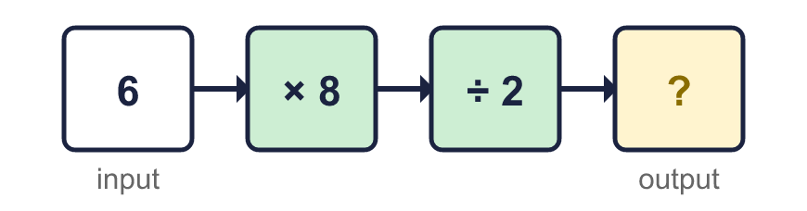  b) One machine that does the same job as both:  Hint: Try some other inputs, such as 1 or 10. What happens each time?
  14 | Challenge  Two machines are joined together.  b) One machine that does the same job as both:  Hint: Try some other inputs, such as 1 or 10. What happens each time?

Year 6 · Algebra · Step 1
One-step function machines
Answers (teacher copy)

A function machine does the same thing to every input. Here the rule is + 5, so 3 goes in and 8 comes out:
  1 | Use the function machine to complete the table. Write the missing outputs.  a = 8  b = 15  c = 30  Hint: Do − 5 to each input to find the output.
  2 | Use the function machine to complete the table. Write the missing inputs. Work backwards from the outputs.  a = 5  b = 7  c = 10  Hint: The machine does × 3. Do the opposite to each output.
  3 | Work out the output of each function machine.  a) 8  b) 43  c) 12  Hint: Do the operation shown in the green box to the input.
  4 | Work out the input of each function machine. Work backwards.  a) 12  b) 48  c) 30  Hint: Use the opposite operation: the opposite of + is −, and the opposite of × is ÷.
  5 | The function machine has a missing operation. Use the table to find it.  Missing operation: ÷ 5  Hint: Compare an input with its output. Did the number get bigger or smaller? By how much, or how many times?
  6 | Here is a pattern of squares made from lolly sticks. Complete the table.  a = 13  b = 16  c = 31  Hint: Count the sticks for 1, 2 and 3 shapes. How many more sticks does each new shape need?
  7 | Each of the cars has the same number of wheels. Complete the table.  a = 8  b = 20  c = 80  Hint: Look at the column for 1. Multiply the number of cars by that.
  8 | Look at the table. A function machine does the same thing to every input.  a) What is the rule of the machine? − 6  b) The output when the input is 56: 50  Hint: Find the rule from the first column. Check it with the other columns.
  9 | Here is a function machine.  a) The input is 0. The output is 0  b) The output is 0. The input is 0  c) The input is 0.5. The output is 1  d) The output is 1,000. The input is 500  Hint: The machine multiplies by 2. To go backwards, divide by 2.
  10 | Here is a table from a function machine with a missing rule.  Dora says: “The rule is add 20.”  Dexter says: “The rule is multiply by 3.”  Who is correct? Write Dora, Dexter or Both.  Both  Explain how you know.  10 + 20 = 30; 10 × 3 = 30. Both rules give the same output for this input.  Hint: Try each rule on the input. Does it give the output? Try it on every column.
  11 | Sam wants a function machine that turns 3 into 15.  Write two different one-step machines that do this.  Machine 1: + 12 Machine 2: × 5  Hint: One machine adds. How much do you add to 3 to get 15? Another machine multiplies.
  12 | Each ticket costs £6. This machine works out the cost.  a) Cost of 8 tickets: £48  b) Number of tickets for £90: 15  Hint: The machine multiplies the number of tickets by 6. To work backwards, divide.
  13 | Here is a pattern of squares made from lolly sticks.  a) How many sticks for 15 squares? 46  b) A pattern uses 121 sticks. How many squares? 40  Hint: Work out the rule: how many sticks for each shape, and how many extra? Use it forwards for a), backwards for b).
  14 | Challenge  Two machines are joined together.  a) The output is 24  b) One machine that does the same job as both: × 4  Hint: Try some other inputs, such as 1 or 10. What happens each time?

