  Year 6 · Algebra · Step 1  One-step function machines | 
  Year 6 · Algebra · Step 1
  One-step function machines
  1 | Use the function machine to complete the table. Write the missing outputs.    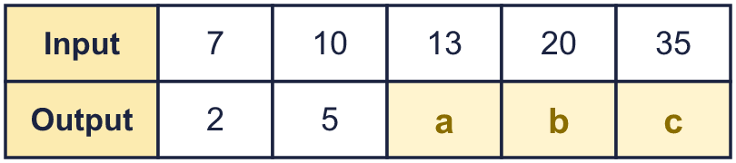
  1 | Use the function machine to complete the table. Write the missing outputs.
  2 | Use the function machine to complete the table. Write the missing inputs. Work backwards from the outputs.    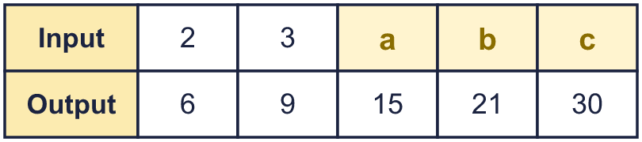
  2 | Use the function machine to complete the table. Write the missing inputs. Work backwards from the outputs.
  3 | Work out the output of each function machine.      
  3 | Work out the output of each function machine.
  4 | Work out the input of each function machine. Work backwards.      
  4 | Work out the input of each function machine. Work backwards.
  5 | The function machine has a missing operation. Use the table to find it.    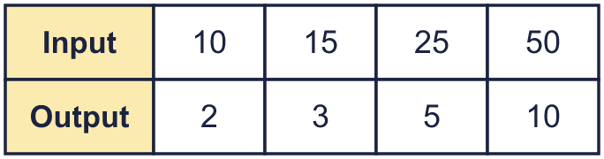
  5 | The function machine has a missing operation. Use the table to find it.
  6 | Here is a pattern of squares made from lolly sticks. Complete the table.    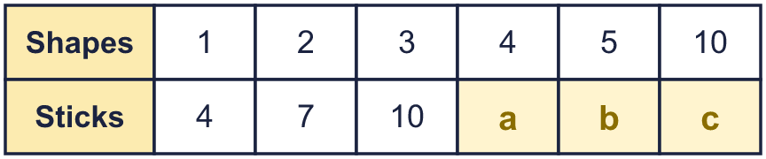
  6 | Here is a pattern of squares made from lolly sticks. Complete the table.
  7 | Each of the cars has the same number of wheels. Complete the table.  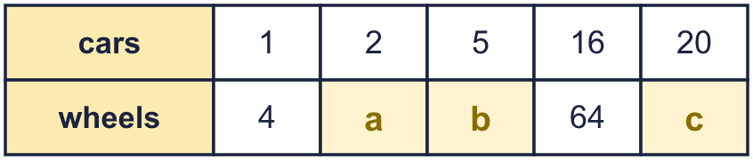
  7 | Each of the cars has the same number of wheels. Complete the table.
  8 | Look at the table. A function machine does the same thing to every input.  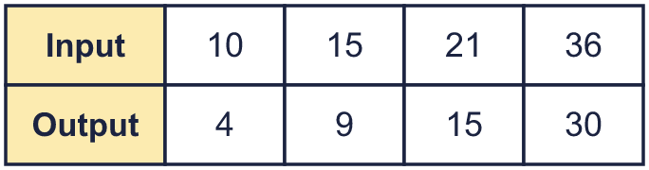  a) What is the rule of the machine?  b) The output when the input is 56:
  8 | Look at the table. A function machine does the same thing to every input.  a) What is the rule of the machine?  b) The output when the input is 56:

  9 | Here is a function machine.    a) The input is 0. The output is  b) The output is 0. The input is  c) The input is 0.5. The output is  d) The output is 1,000. The input is
  9 | Here is a function machine.  a) The input is 0. The output is  b) The output is 0. The input is  c) The input is 0.5. The output is  d) The output is 1,000. The input is
  10 | Here is a table from a function machine with a missing rule.  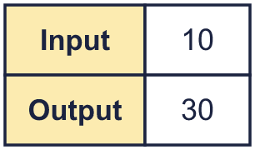  Dora says: “The rule is add 20.”  Dexter says: “The rule is multiply by 3.”  Who is correct? Write Dora, Dexter or Both.  Explain how you know.
  10 | Here is a table from a function machine with a missing rule.  Dora says: “The rule is add 20.”  Dexter says: “The rule is multiply by 3.”  Who is correct? Write Dora, Dexter or Both.  Explain how you know.
  11 | Sam wants a function machine that turns 3 into 15.  Write two different one-step machines that do this.  Machine 1: Machine 2:
  11 | Sam wants a function machine that turns 3 into 15.  Write two different one-step machines that do this.  Machine 1: Machine 2:
  12 | Each ticket costs £6. This machine works out the cost.    a) Cost of 8 tickets:  b) Number of tickets for £90:
  12 | Each ticket costs £6. This machine works out the cost.  a) Cost of 8 tickets:  b) Number of tickets for £90:
  13 | Here is a pattern of squares made from lolly sticks.    a) How many sticks for 15 squares?  b) A pattern uses 121 sticks. How many squares?
  13 | Here is a pattern of squares made from lolly sticks.  a) How many sticks for 15 squares?  b) A pattern uses 121 sticks. How many squares?
  14 | Challenge  Two machines are joined together.  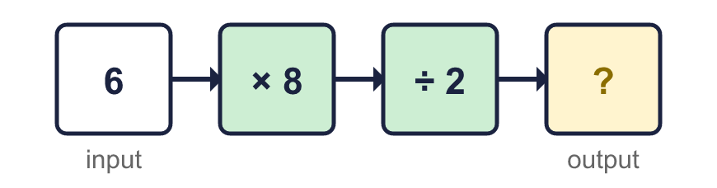  b) One machine that does the same job as both:
  14 | Challenge  Two machines are joined together.  b) One machine that does the same job as both:

Year 6 · Algebra · Step 1
One-step function machines
Answers (teacher copy)

  1 | Use the function machine to complete the table. Write the missing outputs.  a = 8  b = 15  c = 30
  2 | Use the function machine to complete the table. Write the missing inputs. Work backwards from the outputs.  a = 5  b = 7  c = 10
  3 | Work out the output of each function machine.  a) 8  b) 43  c) 12
  4 | Work out the input of each function machine. Work backwards.  a) 12  b) 48  c) 30
  5 | The function machine has a missing operation. Use the table to find it.  Missing operation: ÷ 5
  6 | Here is a pattern of squares made from lolly sticks. Complete the table.  a = 13  b = 16  c = 31
  7 | Each of the cars has the same number of wheels. Complete the table.  a = 8  b = 20  c = 80
  8 | Look at the table. A function machine does the same thing to every input.  a) What is the rule of the machine? − 6  b) The output when the input is 56: 50
  9 | Here is a function machine.  a) The input is 0. The output is 0  b) The output is 0. The input is 0  c) The input is 0.5. The output is 1  d) The output is 1,000. The input is 500
  10 | Here is a table from a function machine with a missing rule.  Dora says: “The rule is add 20.”  Dexter says: “The rule is multiply by 3.”  Who is correct? Write Dora, Dexter or Both.  Both  Explain how you know.  10 + 20 = 30; 10 × 3 = 30. Both rules give the same output for this input.
  11 | Sam wants a function machine that turns 3 into 15.  Write two different one-step machines that do this.  Machine 1: + 12 Machine 2: × 5
  12 | Each ticket costs £6. This machine works out the cost.  a) Cost of 8 tickets: £48  b) Number of tickets for £90: 15
  13 | Here is a pattern of squares made from lolly sticks.  a) How many sticks for 15 squares? 46  b) A pattern uses 121 sticks. How many squares? 40
  14 | Challenge  Two machines are joined together.  a) The output is 24  b) One machine that does the same job as both: × 4

