An equation says that two things are equal. This bar model is a + a + 5 = 17, which is written 2a + 5 = 17:  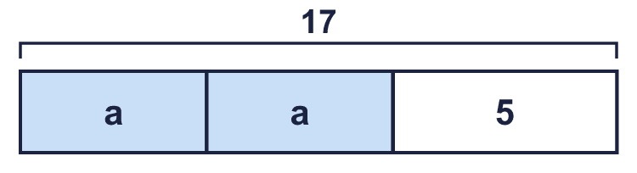 |  | An equation says that two things are equal. This bar model is a + a + 5 = 17, which is written 2a + 5 = 17:
  Year 6 · Algebra · Step 6  Forming equations | 
  Year 6 · Algebra · Step 6
  Forming equations
  1 | Write the equation that each part-whole model shows.  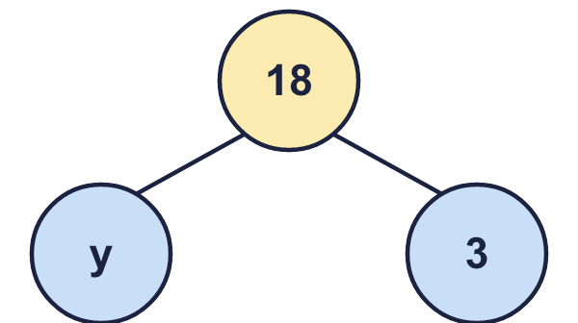  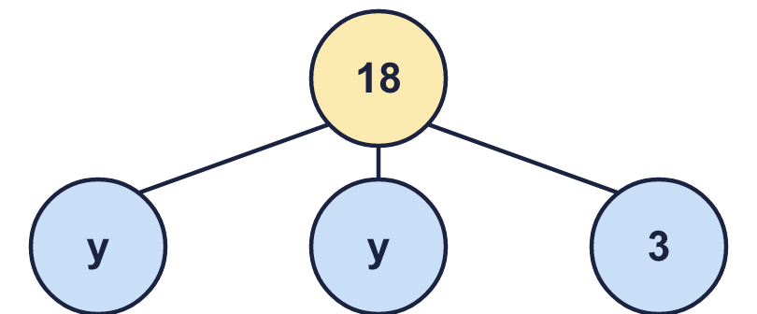  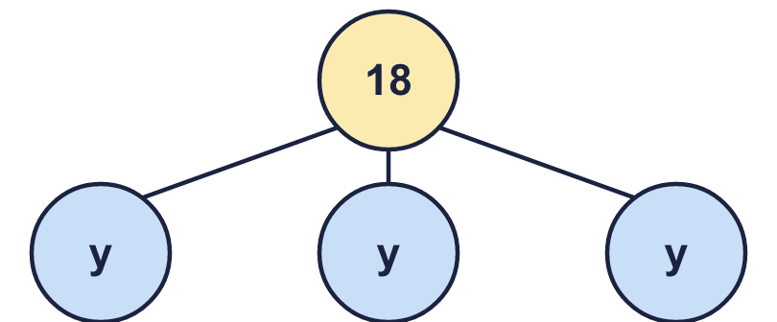  Hint: Add the parts. The total of the parts is the whole.
  1 | Write the equation that each part-whole model shows.  Hint: Add the parts. The total of the parts is the whole.
  2 | Write an equation for each sentence.  Hint: “Less than” means take away from the letter. “Lots of” means multiply.
    a) 5 more than p is equal to 28:
    b) 9 less than y is equal to 11:
    c) 9 lots of x is equal to 34:
    d) 3 lots of n is equal to 17:
  2 | Write an equation for each sentence.  Hint: “Less than” means take away from the letter. “Lots of” means multiply.
    a) 5 more than p is equal to 28:
    b) 9 less than y is equal to 11:
    c) 9 lots of x is equal to 34:
    d) 3 lots of n is equal to 17:
  3 | Write an equation for each bar model.  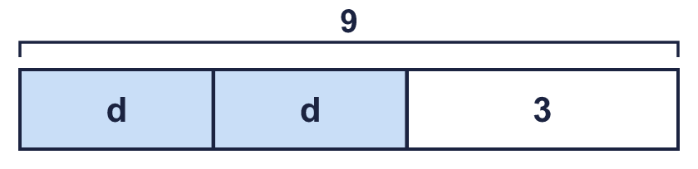  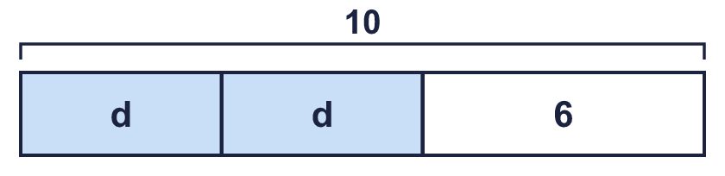  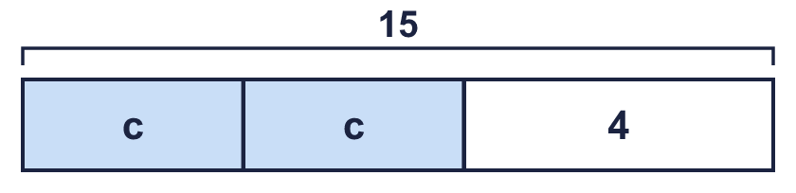  Hint: The parts added together equal the total at the top.
  3 | Write an equation for each bar model.  Hint: The parts added together equal the total at the top.
  4 | A shop sells these things. A jumper costs £s. A book costs £b. A hat costs £5. A box of marbles costs £m.  Write an equation for each sentence.  a) The total cost of a book and a box of marbles is £38.  b) The total cost of a box of marbles and 3 jumpers is £38.  c) The total cost of a jumper and 2 boxes of marbles is £20.  Hint: Write a letter or number for each thing. Add them up and make it equal to the total.
  4 | A shop sells these things. A jumper costs £s. A book costs £b. A hat costs £5. A box of marbles costs £m.  Write an equation for each sentence.  a) The total cost of a book and a box of marbles is £38.  b) The total cost of a box of marbles and 3 jumpers is £38.  c) The total cost of a jumper and 2 boxes of marbles is £20.  Hint: Write a letter or number for each thing. Add them up and make it equal to the total.
  5 | Write an equation for each story.  a) Call my number n. I subtract 8 from my number. The answer is 14.  b) Call my number p. I double my number and add 4. The answer is 19.  Hint: Use the letter for my number. Then follow the steps in the story.
  5 | Write an equation for each story.  a) Call my number n. I subtract 8 from my number. The answer is 14.  b) Call my number p. I double my number and add 4. The answer is 19.  Hint: Use the letter for my number. Then follow the steps in the story.
  6 | Write an equation for each bar model.  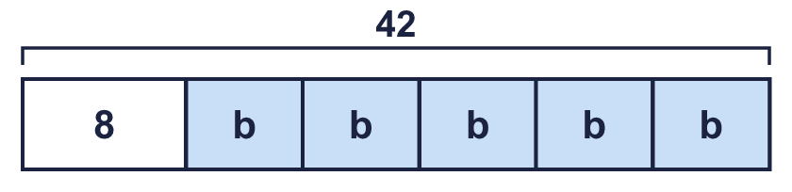  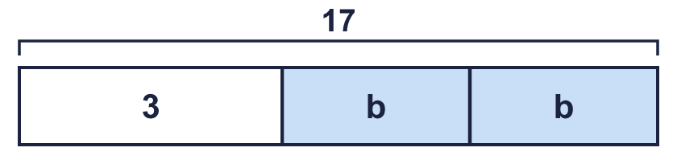  Hint: Write the letters together first, then the number.
  6 | Write an equation for each bar model.  Hint: Write the letters together first, then the number.
  7 | Write an equation for each sentence.  Hint: Work out what the letter is multiplied by first. Then take away or add.
    a) One less than 4 lots of y is equal to 20:
    b) 8 less than 4 lots of p is equal to 50:
    c) 4 lots of n is equal to 50:
    d) 3 less than 4 lots of y is equal to 34:
  7 | Write an equation for each sentence.  Hint: Work out what the letter is multiplied by first. Then take away or add.
    a) One less than 4 lots of y is equal to 20:
    b) 8 less than 4 lots of p is equal to 50:
    c) 4 lots of n is equal to 50:
    d) 3 less than 4 lots of y is equal to 34:
  8 | Write an equation for each story.  a) Alex is y years old. Brett is 4 years older than Alex. Their ages add up to 28.  b) Call my number y. I multiply my number by 2 and then subtract 2. The answer is 28.  c) Call my number y. I double my number and add 8. The answer is 15.  Hint: For ages, both people are described using the same letter.
  8 | Write an equation for each story.  a) Alex is y years old. Brett is 4 years older than Alex. Their ages add up to 28.  b) Call my number y. I multiply my number by 2 and then subtract 2. The answer is 28.  c) Call my number y. I double my number and add 8. The answer is 15.  Hint: For ages, both people are described using the same letter.

  9 | Call my number m. I multiply my number by 2 and then subtract 6. The answer is 15.  Which equation matches the story? Write the letter.  A: 2m + 6 = 15  B: 2m − 6 = 15  C: 8m = 15  D: 2m − 7 = 15  Hint: Follow the story step by step. Write each step using the letter.
  9 | Call my number m. I multiply my number by 2 and then subtract 6. The answer is 15.  Which equation matches the story? Write the letter.  A: 2m + 6 = 15  B: 2m − 6 = 15  C: 8m = 15  D: 2m − 7 = 15  Hint: Follow the story step by step. Write each step using the letter.
  10 | Dora writes an equation for this sentence: “6 less than n is equal to 39”.  Is Dora correct? Circle yes or no.  Yes / No  Explain the mistake. Then write the correct equation.  Hint: Which number is being made smaller?
     | 
  10 | Dora writes an equation for this sentence: “6 less than n is equal to 39”.  Is Dora correct? Circle yes or no.  Yes / No  Explain the mistake. Then write the correct equation.  Hint: Which number is being made smaller?
  11 | A packet of balloons costs £s. A hat costs £5.  The total cost of 2 packets of balloons and a hat is £18.  Write an equation.  Hint: 2 packets cost 2 × s. Add the hat.
  11 | A packet of balloons costs £s. A hat costs £5.  The total cost of 2 packets of balloons and a hat is £18.  Write an equation.  Hint: 2 packets cost 2 × s. Add the hat.
  12 | Rosie and Tommy each think of a number. Write an equation for each problem.  Rosie: Call my number p. I subtract 2 from my number. The answer is 16.  Tommy: Call my number m. I double my number and add 5. The answer is 22.  Hint: Use the letter given for each number.
  12 | Rosie and Tommy each think of a number. Write an equation for each problem.  Rosie: Call my number p. I subtract 2 from my number. The answer is 16.  Tommy: Call my number m. I double my number and add 5. The answer is 22.  Hint: Use the letter given for each number.
  13 | A rectangle has a perimeter of 20 cm.  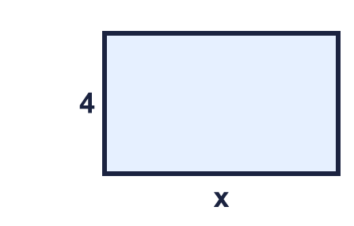  Write an equation for the perimeter.  Hint: Add all four sides. Opposite sides are equal.
  13 | A rectangle has a perimeter of 20 cm.  Write an equation for the perimeter.  Hint: Add all four sides. Opposite sides are equal.
  14 | Challenge  A triangle has a perimeter of 26 cm.  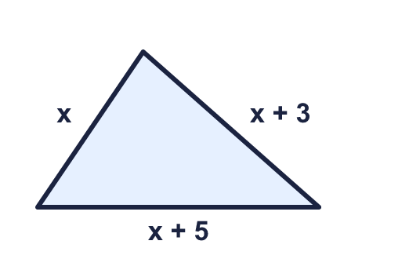  Write an equation for the perimeter.  Hint: Add the three sides. Collect the letters, then the numbers.
  14 | Challenge  A triangle has a perimeter of 26 cm.  Write an equation for the perimeter.  Hint: Add the three sides. Collect the letters, then the numbers.

Year 6 · Algebra · Step 6
Forming equations
Answers (teacher copy)

An equation says that two things are equal. This bar model is a + a + 5 = 17, which is written 2a + 5 = 17:
  1 | Write the equation that each part-whole model shows.  a) y + 3 = 18  b) 2y + 3 = 18  c) 3y = 18  Hint: Add the parts. The total of the parts is the whole.
  2 | Write an equation for each sentence.  a) 5 more than p is equal to 28: p + 5 = 28  b) 9 less than y is equal to 11: y − 9 = 11  c) 9 lots of x is equal to 34: 9x = 34  d) 3 lots of n is equal to 17: 3n = 17  Hint: “Less than” means take away from the letter. “Lots of” means multiply.
  3 | Write an equation for each bar model.  a) 2d + 3 = 9  b) 2d + 6 = 10  c) 2c + 4 = 15  Hint: The parts added together equal the total at the top.
  4 | A shop sells these things. A jumper costs £s. A book costs £b. A hat costs £5. A box of marbles costs £m.  Write an equation for each sentence.  a) The total cost of a book and a box of marbles is £38.  b + m = 38  b) The total cost of a box of marbles and 3 jumpers is £38.  m + 3s = 38  c) The total cost of a jumper and 2 boxes of marbles is £20.  2m + s = 20  Hint: Write a letter or number for each thing. Add them up and make it equal to the total.
  5 | Write an equation for each story.  a) Call my number n. I subtract 8 from my number. The answer is 14.  n − 8 = 14  b) Call my number p. I double my number and add 4. The answer is 19.  2p + 4 = 19  Hint: Use the letter for my number. Then follow the steps in the story.
  6 | Write an equation for each bar model.  a) 5b + 8 = 42  b) 2b + 3 = 17  Hint: Write the letters together first, then the number.
  7 | Write an equation for each sentence.  a) One less than 4 lots of y is equal to 20: 4y − 1 = 20  b) 8 less than 4 lots of p is equal to 50: 4p − 8 = 50  c) 4 lots of n is equal to 50: 4n = 50  d) 3 less than 4 lots of y is equal to 34: 4y − 3 = 34  Hint: Work out what the letter is multiplied by first. Then take away or add.
  8 | Write an equation for each story.  a) Alex is y years old. Brett is 4 years older than Alex. Their ages add up to 28.  2y + 4 = 28  b) Call my number y. I multiply my number by 2 and then subtract 2. The answer is 28.  2y − 2 = 28  c) Call my number y. I double my number and add 8. The answer is 15.  2y + 8 = 15  Hint: For ages, both people are described using the same letter.
  9 | Call my number m. I multiply my number by 2 and then subtract 6. The answer is 15.  Which equation matches the story? Write the letter.  A: 2m + 6 = 15  B: 2m − 6 = 15  C: 8m = 15  D: 2m − 7 = 15  B  Hint: Follow the story step by step. Write each step using the letter.
  10 | Dora writes an equation for this sentence: “6 less than n is equal to 39”.  Is Dora correct? Circle yes or no.  Yes / No  Explain the mistake. Then write the correct equation.  No. “6 less than n” means n take away 6, so it is n − 6.  n − 6 = 39  Hint: Which number is being made smaller?
  11 | A packet of balloons costs £s. A hat costs £5.  The total cost of 2 packets of balloons and a hat is £18.  Write an equation.  2s + 5 = 18  Hint: 2 packets cost 2 × s. Add the hat.
  12 | Rosie and Tommy each think of a number. Write an equation for each problem.  Rosie: Call my number p. I subtract 2 from my number. The answer is 16.  p − 2 = 16  Tommy: Call my number m. I double my number and add 5. The answer is 22.  2m + 5 = 22  Hint: Use the letter given for each number.
  13 | A rectangle has a perimeter of 20 cm.  Write an equation for the perimeter.  2x + 8 = 20  Hint: Add all four sides. Opposite sides are equal.
  14 | Challenge  A triangle has a perimeter of 26 cm.  Write an equation for the perimeter.  3x + 8 = 26  Hint: Add the three sides. Collect the letters, then the numbers.

