Place value chart to help you:  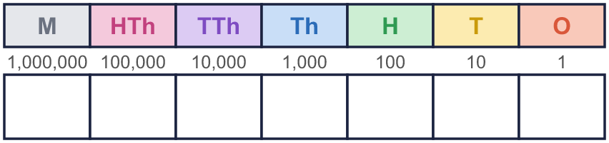 |  | Place value chart to help you:
  Year 6 · Place value · Step 4  Powers of 10 | 
  Year 6 · Place value · Step 4
  Powers of 10
  1 | The place value chart shows a number. What is 10 times the number?  Hint: Move every counter ONE column to the left. Then read the new number. The empty column on the right is a zero.  Draw the new counters here:
    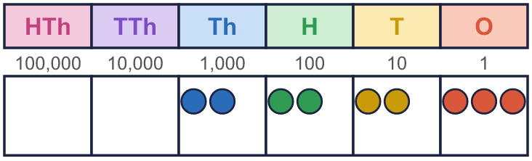
  1 | The place value chart shows a number. What is 10 times the number?  Hint: Move every counter ONE column to the left. Then read the new number. The empty column on the right is a zero.  Draw the new counters here:
  2 | Work out the multiplications.  a) 6 × 10 =  b) 17 × 1,000 =  c) 130 × 100 =  Hint: Multiply by 10: every digit moves ONE column to the LEFT. Divide by 10: every digit moves ONE column to the RIGHT. A zero fills the empty place.
  2 | Work out the multiplications.  a) 6 × 10 =  b) 17 × 1,000 =  c) 130 × 100 =  Hint: Multiply by 10: every digit moves ONE column to the LEFT. Divide by 10: every digit moves ONE column to the RIGHT. A zero fills the empty place.
  3 | Work out the divisions.  a) 7,000 ÷ 10 =  b) 8,900 ÷ 100 =  c) 73,000 ÷ 1,000 =  Hint: Multiply by 10: every digit moves ONE column to the LEFT. Divide by 10: every digit moves ONE column to the RIGHT. A zero fills the empty place.
  3 | Work out the divisions.  a) 7,000 ÷ 10 =  b) 8,900 ÷ 100 =  c) 73,000 ÷ 1,000 =  Hint: Multiply by 10: every digit moves ONE column to the LEFT. Divide by 10: every digit moves ONE column to the RIGHT. A zero fills the empty place.
  4 | Write the missing number.  c) 6,400 × 100 =  Hint: a) How many columns did each digit move? b) Undo the ÷: multiply instead. c) Multiply, moving the digits left.
    a) | 200 × |  | = 2,000
    b) |  | ÷ 10 = 4,000
  4 | Write the missing number.  c) 6,400 × 100 =  Hint: a) How many columns did each digit move? b) Undo the ÷: multiply instead. c) Multiply, moving the digits left.
    a) | 200 × |  | = 2,000
    b) |  | ÷ 10 = 4,000
  5 | How many thousands are there in each number?  Hint: 1,000 is one thousand. Divide the number by 1,000, or ask: which column is the thousands column, and what is to its left?
    a) | 90,000 | = |  | thousands
    b) | 600,000 | = |  | thousands
    c) | 660,000 | = |  | thousands
    d) | 7,600,000 | = |  | thousands
  5 | How many thousands are there in each number?  Hint: 1,000 is one thousand. Divide the number by 1,000, or ask: which column is the thousands column, and what is to its left?
    a) | 90,000 | = |  | thousands
    b) | 600,000 | = |  | thousands
    c) | 660,000 | = |  | thousands
    d) | 7,600,000 | = |  | thousands
  6 | Complete the sentences.  a) 84,000 is 10 times the size of  b) 84,000 is one-tenth the size of  Hint: 10 times bigger: the digits move one column to the left. One-tenth: one column to the right.
    c)
    is 100 times the size of 84,000
    d)
    is one-hundredth the size of 84,000
  6 | Complete the sentences.  a) 84,000 is 10 times the size of  b) 84,000 is one-tenth the size of  Hint: 10 times bigger: the digits move one column to the left. One-tenth: one column to the right.
    c)
    is 100 times the size of 84,000
    d)
    is one-hundredth the size of 84,000
  7 | Each number is made from the one before it. Complete the pattern.  Hint: Do the same thing each time. Use the answer you just found as the next start.
    a) | × 10 each time:
    9 | → |  | → |  | →
    b) | × 100 each time:
    5 | → |  | →
  7 | Each number is made from the one before it. Complete the pattern.  Hint: Do the same thing each time. Use the answer you just found as the next start.
    a) | × 10 each time:
    9 | → |  | → |  | →
    b) | × 100 each time:
    5 | → |  | →
  8 | Work out the two-step calculations. Do them from left to right.  a) 90 × 100 ÷ 10 =  b) 60,000 ÷ 10 × 1,000 =  Hint: Do the first step. Write the answer. Then do the second step with that answer.
  8 | Work out the two-step calculations. Do them from left to right.  a) 90 × 100 ÷ 10 =  b) 60,000 ÷ 10 × 1,000 =  Hint: Do the first step. Write the answer. Then do the second step with that answer.

  9 | 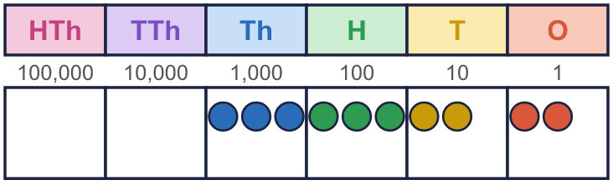  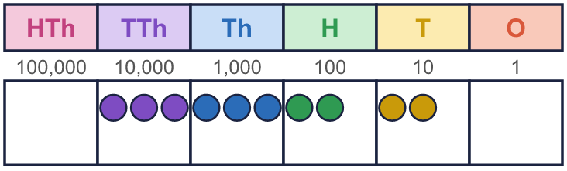  What is the same? What is different?  Hint: Look at the pattern of counters, then at which columns they are in. Read both numbers.
    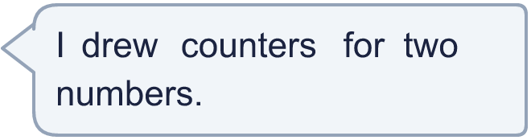
  9 | What is the same? What is different?  Hint: Look at the pattern of counters, then at which columns they are in. Read both numbers.
  10 | Is Boba correct? Circle yes or no.  Yes / No  Explain how you know.  Hint: Divide by 100: how many columns do the digits move to the right?
     | 
  10 | Is Boba correct? Circle yes or no.  Yes / No  Explain how you know.  Hint: Divide by 100: how many columns do the digits move to the right?
  11 | There are 800 pencils in one box.  a) How many pencils are in 10 boxes?  b) How many pencils are in 100 boxes?  c) The school has 54,000 pencils. How many boxes of 1,000 can they fill?  Hint: a) and b): multiply, so the digits move left. c) Divide by 1,000: the digits move three columns to the right.
     | 
  11 | There are 800 pencils in one box.  a) How many pencils are in 10 boxes?  b) How many pencils are in 100 boxes?  c) The school has 54,000 pencils. How many boxes of 1,000 can they fill?  Hint: a) and b): multiply, so the digits move left. c) Divide by 1,000: the digits move three columns to the right.
  12 | a) What is my number?  b) What do I get if I multiply my number by 10?  Hint: a) Undo the division by multiplying. b) Use your answer to a).
     | 
  12 | a) What is my number?  b) What do I get if I multiply my number by 10?  Hint: a) Undo the division by multiplying. b) Use your answer to a).
  13 | Which calculations have the same answer as 4,200 × 10? Write the letters.  a) 420,000 ÷ 10  b) 42,000 × 10  c) 42 × 1,000  d) 4,200 × 100  Answer:  Hint: First work out 4,200 × 10. Then work out each calculation and match the answers.
  13 | Which calculations have the same answer as 4,200 × 10? Write the letters.  a) 420,000 ÷ 10  b) 42,000 × 10  c) 42 × 1,000  d) 4,200 × 100  Answer:  Hint: First work out 4,200 × 10. Then work out each calculation and match the answers.
  14 | Write three different calculations that all have the answer 2,000. Use × or ÷ and 10, 100 or 1,000.  Hint: Work backwards: which number × 10 makes it? Which number ÷ 10?
  14 | Write three different calculations that all have the answer 2,000. Use × or ÷ and 10, 100 or 1,000.  Hint: Work backwards: which number × 10 makes it? Which number ÷ 10?

Year 6 · Place value · Step 4
Powers of 10
Answers (teacher copy)

Place value chart to help you:
  1 | The place value chart shows a number. What is 10 times the number?  Hint: Move every counter ONE column to the left. Then read the new number. The empty column on the right is a zero.  Draw the new counters here:
    22,230
  2 | Work out the multiplications.  a) 6 × 10 = 60  b) 17 × 1,000 = 17,000  c) 130 × 100 = 13,000  Hint: Multiply by 10: every digit moves ONE column to the LEFT. Divide by 10: every digit moves ONE column to the RIGHT. A zero fills the empty place.
  3 | Work out the divisions.  a) 7,000 ÷ 10 = 700  b) 8,900 ÷ 100 = 89  c) 73,000 ÷ 1,000 = 73  Hint: Multiply by 10: every digit moves ONE column to the LEFT. Divide by 10: every digit moves ONE column to the RIGHT. A zero fills the empty place.
  4 | Write the missing number.  a) 200 × 10 = 2,000  b) 40,000 ÷ 10 = 4,000  c) 6,400 × 100 = 640,000  Hint: a) How many columns did each digit move? b) Undo the ÷: multiply instead. c) Multiply, moving the digits left.
  5 | How many thousands are there in each number?  a) 90,000 = 90 thousands  b) 600,000 = 600 thousands  c) 660,000 = 660 thousands  d) 7,600,000 = 7,600 thousands  Hint: 1,000 is one thousand. Divide the number by 1,000, or ask: which column is the thousands column, and what is to its left?
  6 | Complete the sentences.  a) 84,000 is 10 times the size of 8,400  b) 84,000 is one-tenth the size of 840,000  c) 8,400,000 is 100 times the size of 84,000  d) 840 is one-hundredth the size of 84,000  Hint: 10 times bigger: the digits move one column to the left. One-tenth: one column to the right.
  7 | Each number is made from the one before it. Complete the pattern.  a) × 10 each time: 9 → 90 → 900 → 9,000  b) × 100 each time: 5 → 500 → 50,000  Hint: Do the same thing each time. Use the answer you just found as the next start.
  8 | Work out the two-step calculations. Do them from left to right.  a) 90 × 100 ÷ 10 = 900  b) 60,000 ÷ 10 × 1,000 = 6,000,000  Hint: Do the first step. Write the answer. Then do the second step with that answer.
  9 | What is the same? What is different?  The counters make the same pattern, but every counter in the second chart is one column to the left. The second number, 33,220, is 10 times the first number, 3,322.  Hint: Look at the pattern of counters, then at which columns they are in. Read both numbers.
  10 | Is Boba correct? Circle yes or no.  Yes / No  Explain how you know.  80,000 ÷ 100 = 800. Dividing by 100 moves the digits two columns to the right. Boba moved them three columns, which is dividing by 1,000.  Hint: Divide by 100: how many columns do the digits move to the right?
  11 | There are 800 pencils in one box.  a) How many pencils are in 10 boxes? 8,000  b) How many pencils are in 100 boxes? 80,000  c) The school has 54,000 pencils. How many boxes of 1,000 can they fill? 54  Hint: a) and b): multiply, so the digits move left. c) Divide by 1,000: the digits move three columns to the right.
  12 | a) What is my number? 74,000  b) What do I get if I multiply my number by 10? 740,000  Hint: a) Undo the division by multiplying. b) Use your answer to a).
  13 | Which calculations have the same answer as 4,200 × 10? Write the letters.  a) 420,000 ÷ 10  b) 42,000 × 10  c) 42 × 1,000  d) 4,200 × 100  Answer: a and c  Hint: First work out 4,200 × 10. Then work out each calculation and match the answers.
  14 | Write three different calculations that all have the answer 2,000. Use × or ÷ and 10, 100 or 1,000.  Any three correct calculations, for example 200 × 10, 20 × 100, 20,000 ÷ 10  Hint: Work backwards: which number × 10 makes it? Which number ÷ 10?

