Place value chart to help you:  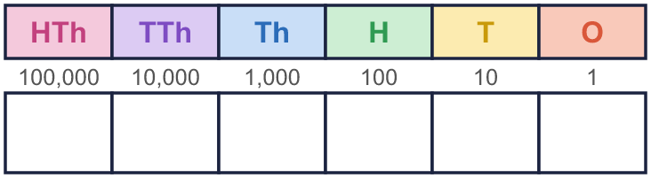 |  | Place value chart to help you:
  Year 6 · Place value · Step 1  Numbers up to 1,000,000 | 
  Year 6 · Place value · Step 1
  Numbers up to 1,000,000
  1 | What number is shown in the place value chart?  Hint: Count the counters in each column. Write the digits in order.
    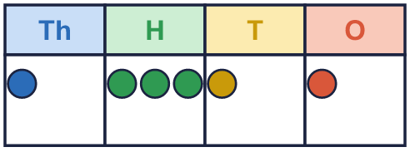
  1 | What number is shown in the place value chart?  Hint: Count the counters in each column. Write the digits in order.
  2 | What number is shown in the place value chart?  Hint: An empty column means a zero. Use a 0 to hold the place.
    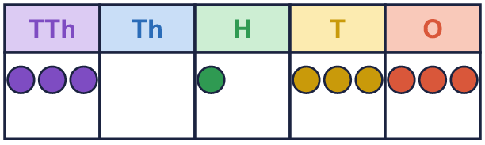
  2 | What number is shown in the place value chart?  Hint: An empty column means a zero. Use a 0 to hold the place.
  3 | What number is shown in the place value chart?  Hint: Read the thousands first, then the ones. Say it out loud.
    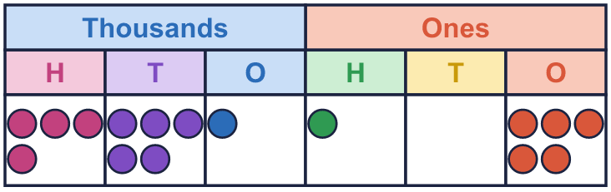
  3 | What number is shown in the place value chart?  Hint: Read the thousands first, then the ones. Say it out loud.
  4 | Write this number in digits.  five hundred and nine thousand one hundred and thirty  Hint: Split it at the word “thousand”. Write the thousands part, then the rest.
  4 | Write this number in digits.  five hundred and nine thousand one hundred and thirty  Hint: Split it at the word “thousand”. Write the thousands part, then the rest.
  5 | Partition the number. Fill in the missing parts.  Hint: Look at the chart. 1 counter in the hundreds column is worth 100. 8 counters in the tens column are worth 80.  The number in a place value chart:  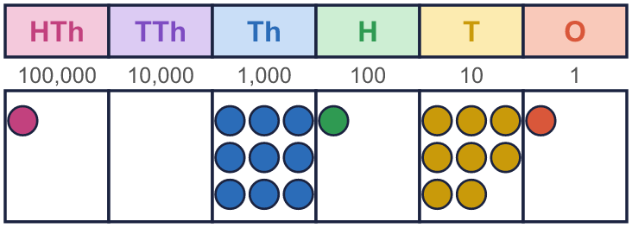
    109,181 = | 100,000 | + | 9,000 | +
     | + |  | + | 1
  5 | Partition the number. Fill in the missing parts.  Hint: Look at the chart. 1 counter in the hundreds column is worth 100. 8 counters in the tens column are worth 80.  The number in a place value chart:
    109,181 = | 100,000 | + | 9,000 | +
     | + |  | + | 1

  6 | Write the value of the digit in the box.  a) 49,221 =  b) 135,967 =  Hint: Find the column of the digit in the box. Then say how much it is worth there.  a)  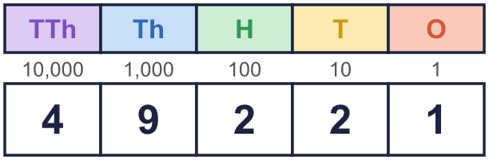  b)  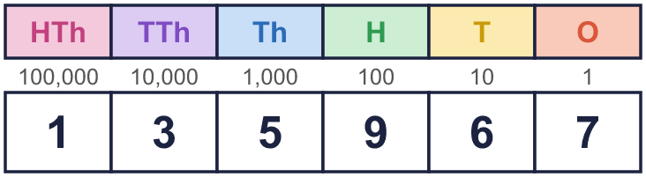
  6 | Write the value of the digit in the box.  a) 49,221 =  b) 135,967 =  Hint: Find the column of the digit in the box. Then say how much it is worth there.  a)  b)
  7 | Work out the missing numbers.  a) 10,000 more than 84,772 =  b) 1,000 less than 80,599 =  c) 100 less than 466,047 =  Hint: Only one column changes. a) Add 1 to the ten thousands digit. b) Take 1 from the thousands digit. c) Take 1 from the hundreds digit: it is 0, so exchange 1 from the thousands first.
  7 | Work out the missing numbers.  a) 10,000 more than 84,772 =  b) 1,000 less than 80,599 =  c) 100 less than 466,047 =  Hint: Only one column changes. a) Add 1 to the ten thousands digit. b) Take 1 from the thousands digit. c) Take 1 from the hundreds digit: it is 0, so exchange 1 from the thousands first.
  8 | Write <, > or = in each box.  Hint: Line the digits up. Compare from the left: the biggest column first. Then the crocodile eats the bigger number.  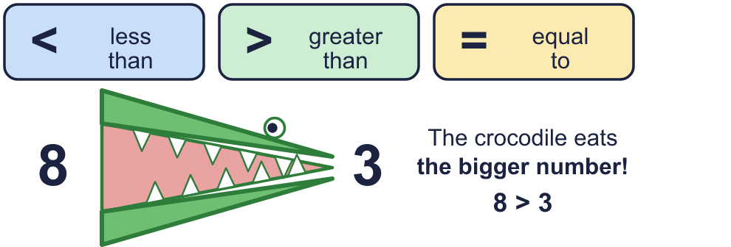
    a) | 37,496 |  | 37,469
    b) | 3,622 |  | 30,622
    c) | 600,000 + 70,000 + 25
    670,025
  8 | Write <, > or = in each box.  Hint: Line the digits up. Compare from the left: the biggest column first. Then the crocodile eats the bigger number.
    a) | 37,496 |  | 37,469
    b) | 3,622 |  | 30,622
    c) | 600,000 + 70,000 + 25
    670,025

  9 | The numbers: 8,181 68,798 348,364  Is Boba correct? Circle yes or no.  Yes / No  Explain how you know.  Hint: Find the column of the digit in each number.
    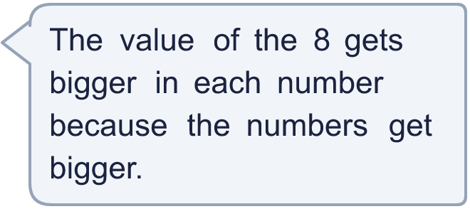
  9 | The numbers: 8,181 68,798 348,364  Is Boba correct? Circle yes or no.  Yes / No  Explain how you know.  Hint: Find the column of the digit in each number.
  10 | Complete the part-whole models.  Hint: A part-whole model: the two parts add to make the whole. Part + part = whole.
    a)  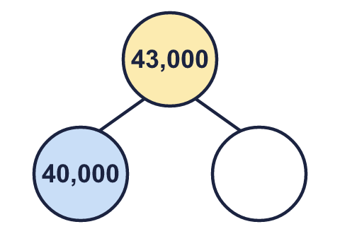 | b)  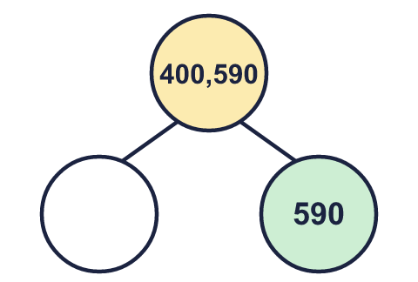 | c)  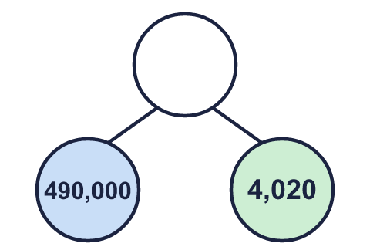
  10 | Complete the part-whole models.  Hint: A part-whole model: the two parts add to make the whole. Part + part = whole.
    a) | b) | c)

  11 | 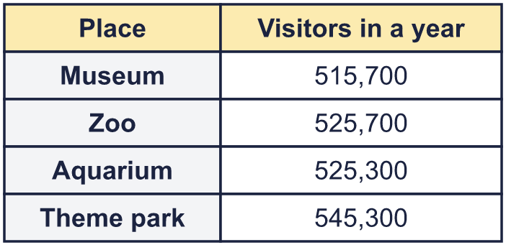  a) Write the places in order, smallest number of visitors first.  b) Which place had 10,000 more visitors than the Museum?  c) What is the value of the digit in the box in the Aquarium number: 525,300?  Hint: For a), compare the hundred thousands first, then the ten thousands.
     | 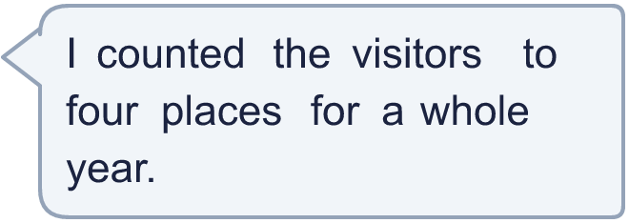
  11 | a) Write the places in order, smallest number of visitors first.  b) Which place had 10,000 more visitors than the Museum?  c) What is the value of the digit in the box in the Aquarium number: 525,300?  Hint: For a), compare the hundred thousands first, then the ten thousands.
  12 | 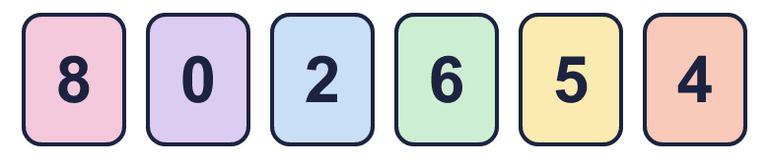  a) Make the smallest number.  b) Make the largest even number.  c) Make the number closest to 500,000.  Hint: a) Put the smallest digit first (not 0). b) Even means the last digit is even. c) Start with the digit nearest to 5.
     | 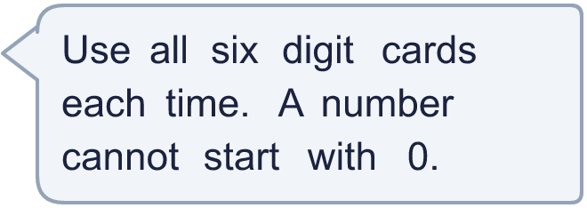
  12 | a) Make the smallest number.  b) Make the largest even number.  c) Make the number closest to 500,000.  Hint: a) Put the smallest digit first (not 0). b) Even means the last digit is even. c) Start with the digit nearest to 5.

  13 | • The hundreds digit is double the ones digit.  • The ten thousands digit is double the ones digit.  • The digits add up to 45.  • The tens digit is 7.  What is my number?  Hint: Start with the clue that tells you a digit exactly. Write it in the chart, then use the next clue.
     | 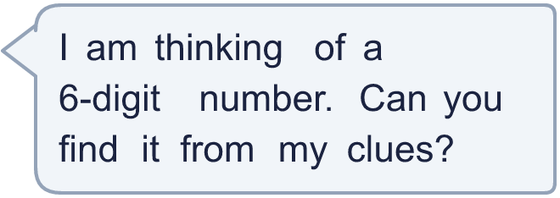
  13 | • The hundreds digit is double the ones digit.  • The ten thousands digit is double the ones digit.  • The digits add up to 45.  • The tens digit is 7.  What is my number?  Hint: Start with the clue that tells you a digit exactly. Write it in the chart, then use the next clue.
  14 | Write three different numbers in which the digit 7 is worth 700.  Hint: Which column makes the digit worth that much? Put your digit there, then choose the other digits.
  14 | Write three different numbers in which the digit 7 is worth 700.  Hint: Which column makes the digit worth that much? Put your digit there, then choose the other digits.

Year 6 · Place value · Step 1
Numbers up to 1,000,000
Answers (teacher copy)

Place value chart to help you:
  1 | What number is shown in the place value chart?  Hint: Count the counters in each column. Write the digits in order.
    1,311
  2 | What number is shown in the place value chart?  Hint: An empty column means a zero. Use a 0 to hold the place.
    30,133
  3 | What number is shown in the place value chart?  Hint: Read the thousands first, then the ones. Say it out loud.
    451,105
  4 | Write this number in digits.  five hundred and nine thousand one hundred and thirty  509,130  Hint: Split it at the word “thousand”. Write the thousands part, then the rest.
  5 | Partition the number. Fill in the missing parts.  109,181 = 100,000 + 9,000 + 100 + 80 + 1  Hint: Look at the chart. 1 counter in the hundreds column is worth 100. 8 counters in the tens column are worth 80.  The number in a place value chart:
  6 | Write the value of the digit in the box.  a) 49,221 = 1  b) 135,967 = 30,000  Hint: Find the column of the digit in the box. Then say how much it is worth there.  a)  b)
  7 | Work out the missing numbers.  a) 10,000 more than 84,772 = 94,772  b) 1,000 less than 80,599 = 79,599  c) 100 less than 466,047 = 465,947  Hint: Only one column changes. a) Add 1 to the ten thousands digit. b) Take 1 from the thousands digit. c) Take 1 from the hundreds digit: it is 0, so exchange 1 from the thousands first.
  8 | Write <, > or = in each box.  a) 37,496 > 37,469  b) 3,622 < 30,622  c) 600,000 + 70,000 + 25 = 670,025  Hint: Line the digits up. Compare from the left: the biggest column first. Then the crocodile eats the bigger number.
  9 | The numbers: 8,181 68,798 348,364  Is Boba correct? Circle yes or no.  Yes / No  Explain how you know.  The 8 is in the thousands column in all three numbers, so it is worth 8,000 every time.  Hint: Find the column of the digit in each number.
  10 | Complete the part-whole models.  a) 3,000 b) 400,000 c) 494,020  Hint: A part-whole model: the two parts add to make the whole. Part + part = whole.
    a)  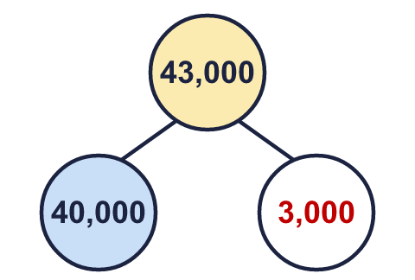 | b)  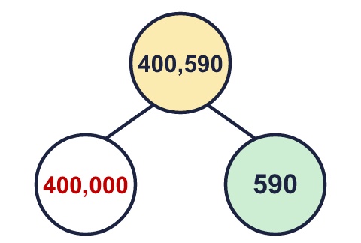 | c)  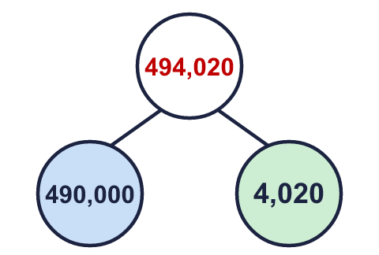
  11 | a) Write the places in order, smallest number of visitors first. Museum, Aquarium, Zoo, Theme park  b) Which place had 10,000 more visitors than the Museum? Zoo  c) What is the value of the digit in the box in the Aquarium number: 525,300? 20,000  Hint: For a), compare the hundred thousands first, then the ten thousands.
  12 | a) Make the smallest number. 204,568  b) Make the largest even number. 865,420  c) Make the number closest to 500,000. 502,468  Hint: a) Put the smallest digit first (not 0). b) Even means the last digit is even. c) Start with the digit nearest to 5.
  13 | • The hundreds digit is double the ones digit.  • The ten thousands digit is double the ones digit.  • The digits add up to 45.  • The tens digit is 7.  What is my number?  989,874  Hint: Start with the clue that tells you a digit exactly. Write it in the chart, then use the next clue.
  14 | Write three different numbers in which the digit 7 is worth 700.  Any numbers with the 7 in the hundreds column, for example 750, 2,705, 3,700  Hint: Which column makes the digit worth that much? Put your digit there, then choose the other digits.

