  Year 6 · Place value · Step 1  Numbers up to 1,000,000 | 
  Year 6 · Place value · Step 1
  Numbers up to 1,000,000
  1 | What number is shown in the place value chart?
    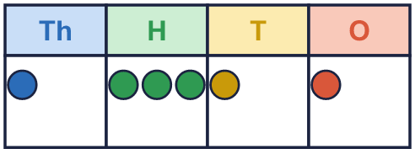
  1 | What number is shown in the place value chart?
  2 | What number is shown in the place value chart?
    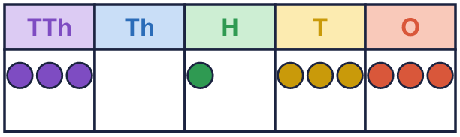
  2 | What number is shown in the place value chart?
  3 | What number is shown in the place value chart?
    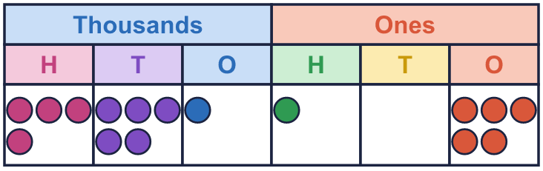
  3 | What number is shown in the place value chart?
  4 | Write this number in digits.  five hundred and nine thousand one hundred and thirty
  4 | Write this number in digits.  five hundred and nine thousand one hundred and thirty
  5 | Partition the number. Fill in the missing parts.
    109,181 = | 100,000 | + | 9,000 | +
     | + |  | + | 1
  5 | Partition the number. Fill in the missing parts.
    109,181 = | 100,000 | + | 9,000 | +
     | + |  | + | 1
  6 | Write the value of the digit in the box.  a) 49,221 =  b) 135,967 =
  6 | Write the value of the digit in the box.  a) 49,221 =  b) 135,967 =
  7 | Work out the missing numbers.  a) 10,000 more than 84,772 =  b) 1,000 less than 80,599 =  c) 100 less than 466,047 =
  7 | Work out the missing numbers.  a) 10,000 more than 84,772 =  b) 1,000 less than 80,599 =  c) 100 less than 466,047 =
  8 | Write <, > or = in each box.
    a) | 37,496 |  | 37,469
    b) | 3,622 |  | 30,622
    c) | 600,000 + 70,000 + 25
    670,025
  8 | Write <, > or = in each box.
    a) | 37,496 |  | 37,469
    b) | 3,622 |  | 30,622
    c) | 600,000 + 70,000 + 25
    670,025

  9 | The numbers: 8,181 68,798 348,364  Is Boba correct? Circle yes or no.  Yes / No  Explain how you know.
    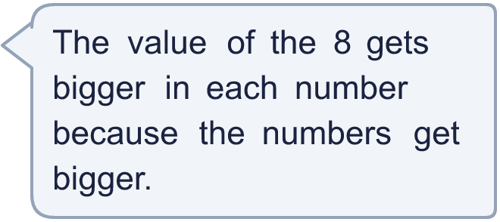
  9 | The numbers: 8,181 68,798 348,364  Is Boba correct? Circle yes or no.  Yes / No  Explain how you know.
  10 | Complete the part-whole models.
    a)  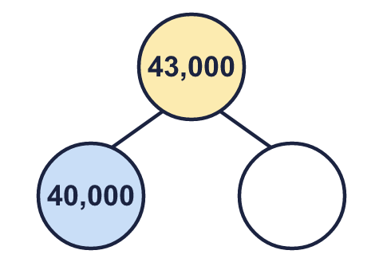 | b)  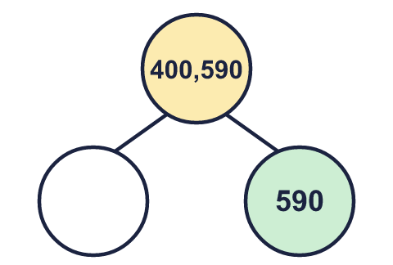 | c)  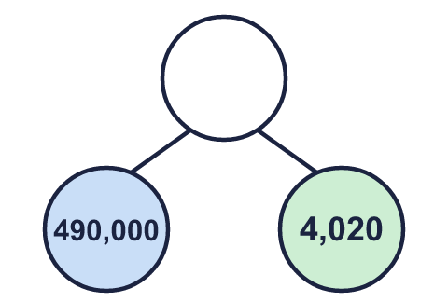
  10 | Complete the part-whole models.
    a) | b) | c)
  11 | 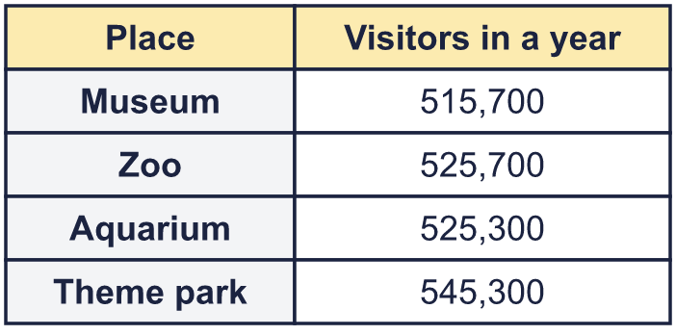  a) Write the places in order, smallest number of visitors first.  b) Which place had 10,000 more visitors than the Museum?  c) What is the value of the digit in the box in the Aquarium number: 525,300?
     | 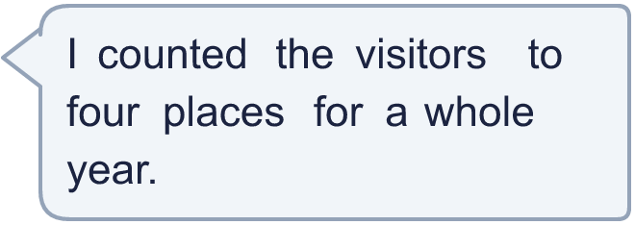
  11 | a) Write the places in order, smallest number of visitors first.  b) Which place had 10,000 more visitors than the Museum?  c) What is the value of the digit in the box in the Aquarium number: 525,300?
  12 | 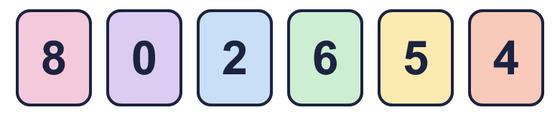  a) Make the smallest number.  b) Make the largest even number.  c) Make the number closest to 500,000.
     | 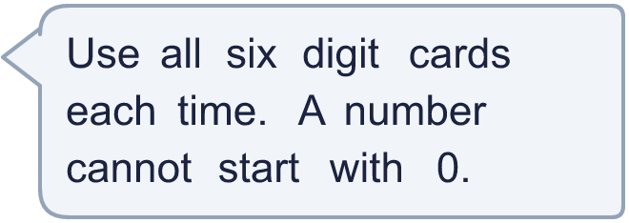
  12 | a) Make the smallest number.  b) Make the largest even number.  c) Make the number closest to 500,000.

  13 | • The hundreds digit is double the ones digit.  • The ten thousands digit is double the ones digit.  • The digits add up to 45.  • The tens digit is 7.  What is my number?
     | 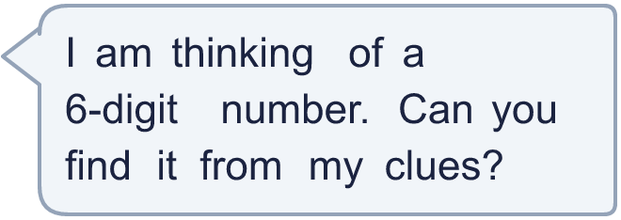
  13 | • The hundreds digit is double the ones digit.  • The ten thousands digit is double the ones digit.  • The digits add up to 45.  • The tens digit is 7.  What is my number?
  14 | Write three different numbers in which the digit 7 is worth 700.
  14 | Write three different numbers in which the digit 7 is worth 700.

Year 6 · Place value · Step 1
Numbers up to 1,000,000
Answers (teacher copy)

  1 | What number is shown in the place value chart?
    1,311
  2 | What number is shown in the place value chart?
    30,133
  3 | What number is shown in the place value chart?
    451,105
  4 | Write this number in digits.  five hundred and nine thousand one hundred and thirty  509,130
  5 | Partition the number. Fill in the missing parts.  109,181 = 100,000 + 9,000 + 100 + 80 + 1
  6 | Write the value of the digit in the box.  a) 49,221 = 1  b) 135,967 = 30,000
  7 | Work out the missing numbers.  a) 10,000 more than 84,772 = 94,772  b) 1,000 less than 80,599 = 79,599  c) 100 less than 466,047 = 465,947
  8 | Write <, > or = in each box.  a) 37,496 > 37,469  b) 3,622 < 30,622  c) 600,000 + 70,000 + 25 = 670,025
  9 | The numbers: 8,181 68,798 348,364  Is Boba correct? Circle yes or no.  Yes / No  Explain how you know.  The 8 is in the thousands column in all three numbers, so it is worth 8,000 every time.
  10 | Complete the part-whole models.  a) 3,000 b) 400,000 c) 494,020
    a)  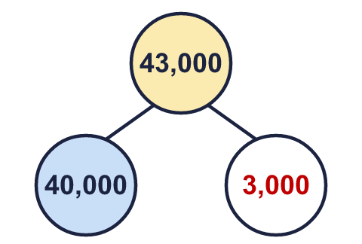 | b)  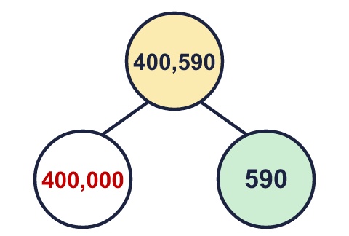 | c)  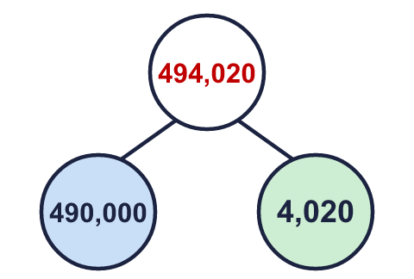
  11 | a) Write the places in order, smallest number of visitors first. Museum, Aquarium, Zoo, Theme park  b) Which place had 10,000 more visitors than the Museum? Zoo  c) What is the value of the digit in the box in the Aquarium number: 525,300? 20,000
  12 | a) Make the smallest number. 204,568  b) Make the largest even number. 865,420  c) Make the number closest to 500,000. 502,468
  13 | • The hundreds digit is double the ones digit.  • The ten thousands digit is double the ones digit.  • The digits add up to 45.  • The tens digit is 7.  What is my number?  989,874
  14 | Write three different numbers in which the digit 7 is worth 700.  Any numbers with the 7 in the hundreds column, for example 750, 2,705, 3,700

