Fraction wall to help you:  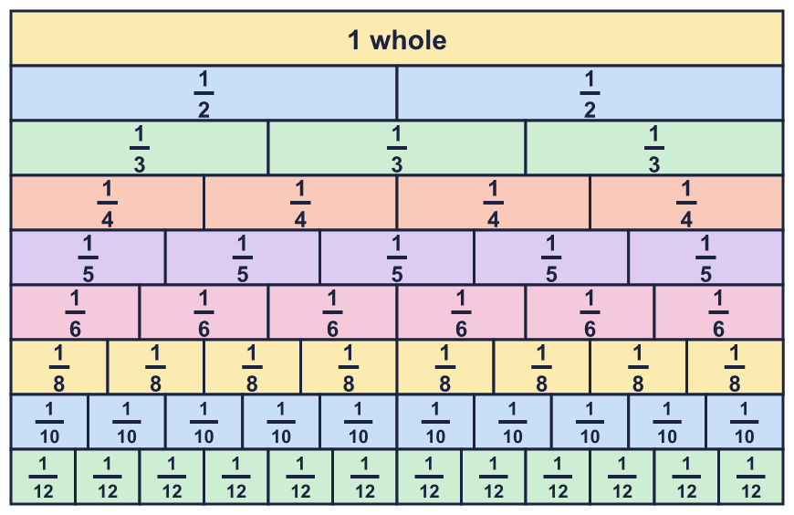 |  | Fraction wall to help you:
  Year 6 · Fractions B · Step 1  Multiplying fractions by whole numbers | 
  Year 6 · Fractions B · Step 1
  Multiplying fractions by whole numbers
  1 | Work out each addition. Write each answer in its simplest form. Adding the same fraction again and again is the same as multiplying.  a) ⁴⁄₇ + ⁴⁄₇ =  b) ³⁄₅ + ³⁄₅ + ³⁄₅ + ³⁄₅ =  Hint: Add the numerators. The denominator stays the same. Then simplify.
  1 | Work out each addition. Write each answer in its simplest form. Adding the same fraction again and again is the same as multiplying.  a) ⁴⁄₇ + ⁴⁄₇ =  b) ³⁄₅ + ³⁄₅ + ³⁄₅ + ³⁄₅ =  Hint: Add the numerators. The denominator stays the same. Then simplify.
  2 | Work out each multiplication. Write each answer in its simplest form.  a) ¹⁄₉ × 5 =  b) ¹⁄₁₀ × 6 =  c) ¹⁄₇ × 5 =  d) ¹⁄₇ × 6 =  Hint: Multiply the numerator by the whole number. Keep the denominator. Then simplify if you can.
  2 | Work out each multiplication. Write each answer in its simplest form.  a) ¹⁄₉ × 5 =  b) ¹⁄₁₀ × 6 =  c) ¹⁄₇ × 5 =  d) ¹⁄₇ × 6 =  Hint: Multiply the numerator by the whole number. Keep the denominator. Then simplify if you can.
  3 | Work out each multiplication. Write each answer in its simplest form.  a) ³⁄₇ × 2 =  b) ²⁄₁₁ × 4 =  c) ²⁄₇ × 3 =  d) ²⁄₇ × 2 =  Hint: Multiply the numerator by the whole number. Keep the denominator the same.
  3 | Work out each multiplication. Write each answer in its simplest form.  a) ³⁄₇ × 2 =  b) ²⁄₁₁ × 4 =  c) ²⁄₇ × 3 =  d) ²⁄₇ × 2 =  Hint: Multiply the numerator by the whole number. Keep the denominator the same.
  4 | Work out each multiplication. Write each answer as a mixed number in its simplest form.  a) 7 × ¹⁄₆ =  b) 3 × ³⁄₄ =  c) 2 × ¹⁄₃ =  Hint: Whole number × fraction is the same as fraction × whole number. Multiply the numerator, then change an improper fraction to a mixed number.
  4 | Work out each multiplication. Write each answer as a mixed number in its simplest form.  a) 7 × ¹⁄₆ =  b) 3 × ³⁄₄ =  c) 2 × ¹⁄₃ =  Hint: Whole number × fraction is the same as fraction × whole number. Multiply the numerator, then change an improper fraction to a mixed number.
  5 | Work out each multiplication. Write each answer as a mixed number in its simplest form.  a) ³⁄₄ × 6 =  b) ⁷⁄₁₀ × 4 =  c) ⁴⁄₅ × 5 =  Hint: Multiply the numerator. Then find how many wholes are in the improper fraction.
  5 | Work out each multiplication. Write each answer as a mixed number in its simplest form.  a) ³⁄₄ × 6 =  b) ⁷⁄₁₀ × 4 =  c) ⁴⁄₅ × 5 =  Hint: Multiply the numerator. Then find how many wholes are in the improper fraction.
  6 | Work out each multiplication. Look for a way to simplify first. Write each answer as a mixed number in its simplest form.  a) ³⁄₈ × 4 =  b) ¹⁷⁄₂₀ × 5 =  c) ¹⁄₁₂ × 6 =  Hint: The whole number and the denominator share a factor. Divide both by that factor before you multiply.
  6 | Work out each multiplication. Look for a way to simplify first. Write each answer as a mixed number in its simplest form.  a) ³⁄₈ × 4 =  b) ¹⁷⁄₂₀ × 5 =  c) ¹⁄₁₂ × 6 =  Hint: The whole number and the denominator share a factor. Divide both by that factor before you multiply.
  7 | Write the missing whole number in each multiplication.  a) ? × ⁷⁄₁₀ = 2 ¹⁄₁₀  b) ? × ¹⁄₄ = 1  Hint: Use the opposite operation. Divide the answer by the fraction, or work out what you multiplied the numerator by.
  7 | Write the missing whole number in each multiplication.  a) ? × ⁷⁄₁₀ = 2 ¹⁄₁₀  b) ? × ¹⁄₄ = 1  Hint: Use the opposite operation. Divide the answer by the fraction, or work out what you multiplied the numerator by.
  8 | Work out each multiplication. Look at your answers. What pattern do you notice?  a) ¹⁄₃ × 4 =  b) ¹⁄₃ × 5 =  c) ¹⁄₃ × 6 =  d) ¹⁄₃ × 7 =  Hint: Each answer is ¹⁄₃ more than the one before.
  8 | Work out each multiplication. Look at your answers. What pattern do you notice?  a) ¹⁄₃ × 4 =  b) ¹⁄₃ × 5 =  c) ¹⁄₃ × 6 =  d) ¹⁄₃ × 7 =  Hint: Each answer is ¹⁄₃ more than the one before.

  9 | Is Zach correct? Circle yes or no.  Yes / No  Explain the mistake and give the correct answer.  Hint: Think of the fraction as a number of equal parts. Multiplying makes more parts, but the parts stay the same size.
     | 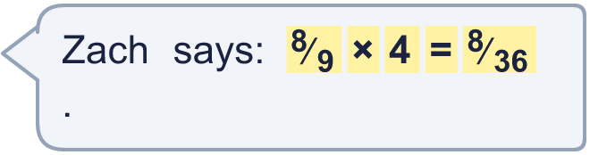
  9 | Is Zach correct? Circle yes or no.  Yes / No  Explain the mistake and give the correct answer.  Hint: Think of the fraction as a number of equal parts. Multiplying makes more parts, but the parts stay the same size.
  10 | A runner drinks ¹⁄₄ of a litre of water each hour.  How much water does the runner drink in 7 hours? Write the answer as a mixed number in its simplest form.  Hint: Multiply the fraction by the number of days (or hours). Change an improper fraction to a mixed number.
  10 | A runner drinks ¹⁄₄ of a litre of water each hour.  How much water does the runner drink in 7 hours? Write the answer as a mixed number in its simplest form.  Hint: Multiply the fraction by the number of days (or hours). Change an improper fraction to a mixed number.
  11 | Three of these calculations have the same answer, 1 ²⁄₃. Write the calculation that does not.  ¹⁄₃ × 5 ⁵⁄₆ × 2 ¹⁄₆ × 2 ⁵⁄₉ × 3  Hint: Work out all four answers. Which one is different?
  11 | Three of these calculations have the same answer, 1 ²⁄₃. Write the calculation that does not.  ¹⁄₃ × 5 ⁵⁄₆ × 2 ¹⁄₆ × 2 ⁵⁄₉ × 3  Hint: Work out all four answers. Which one is different?
  12 | Write the missing fraction in its simplest form.  ? × 4 = ¹⁶⁄₅  Hint: Use the opposite operation. Divide ¹⁶⁄₅ by 4.
  12 | Write the missing fraction in its simplest form.  ? × 4 = ¹⁶⁄₅  Hint: Use the opposite operation. Divide ¹⁶⁄₅ by 4.
  13 | Each pencil is ¹⁄₆ of a foot long.  A tower of 8 pencils is laid end to end. How long is it? Write the answer as a mixed number.  Hint: Multiply the fraction by the number of items.
  13 | Each pencil is ¹⁄₆ of a foot long.  A tower of 8 pencils is laid end to end. How long is it? Write the answer as a mixed number.  Hint: Multiply the fraction by the number of items.
  14 | Challenge  Amir has 4 bags. Each bag holds 3 ³⁄₄ kg of flour.  How much flour is there altogether? Write the answer as a mixed number in its simplest form.  Hint: Change the mixed number to an improper fraction first. Then multiply.
  14 | Challenge  Amir has 4 bags. Each bag holds 3 ³⁄₄ kg of flour.  How much flour is there altogether? Write the answer as a mixed number in its simplest form.  Hint: Change the mixed number to an improper fraction first. Then multiply.

Year 6 · Fractions B · Step 1
Multiplying fractions by whole numbers
Answers (teacher copy)

Fraction wall to help you:
  1 | Work out each addition. Write each answer in its simplest form. Adding the same fraction again and again is the same as multiplying.  a) ⁴⁄₇ + ⁴⁄₇ = ⁸⁄₇  b) ³⁄₅ + ³⁄₅ + ³⁄₅ + ³⁄₅ = ¹²⁄₅  Hint: Add the numerators. The denominator stays the same. Then simplify.
  2 | Work out each multiplication. Write each answer in its simplest form.  a) ¹⁄₉ × 5 = ⁵⁄₉  b) ¹⁄₁₀ × 6 = ³⁄₅  c) ¹⁄₇ × 5 = ⁵⁄₇  d) ¹⁄₇ × 6 = ⁶⁄₇  Hint: Multiply the numerator by the whole number. Keep the denominator. Then simplify if you can.
  3 | Work out each multiplication. Write each answer in its simplest form.  a) ³⁄₇ × 2 = ⁶⁄₇  b) ²⁄₁₁ × 4 = ⁸⁄₁₁  c) ²⁄₇ × 3 = ⁶⁄₇  d) ²⁄₇ × 2 = ⁴⁄₇  Hint: Multiply the numerator by the whole number. Keep the denominator the same.
  4 | Work out each multiplication. Write each answer as a mixed number in its simplest form.  a) 7 × ¹⁄₆ = 1 ¹⁄₆  b) 3 × ³⁄₄ = 2 ¹⁄₄  c) 2 × ¹⁄₃ = ²⁄₃  Hint: Whole number × fraction is the same as fraction × whole number. Multiply the numerator, then change an improper fraction to a mixed number.
  5 | Work out each multiplication. Write each answer as a mixed number in its simplest form.  a) ³⁄₄ × 6 = 4 ¹⁄₂  b) ⁷⁄₁₀ × 4 = 2 ⁴⁄₅  c) ⁴⁄₅ × 5 = 4  Hint: Multiply the numerator. Then find how many wholes are in the improper fraction.
  6 | Work out each multiplication. Look for a way to simplify first. Write each answer as a mixed number in its simplest form.  a) ³⁄₈ × 4 = 1 ¹⁄₂  b) ¹⁷⁄₂₀ × 5 = 4 ¹⁄₄  c) ¹⁄₁₂ × 6 = ¹⁄₂  Hint: The whole number and the denominator share a factor. Divide both by that factor before you multiply.
  7 | Write the missing whole number in each multiplication.  a) ? × ⁷⁄₁₀ = 2 ¹⁄₁₀ 3  b) ? × ¹⁄₄ = 1 4  Hint: Use the opposite operation. Divide the answer by the fraction, or work out what you multiplied the numerator by.
  8 | Work out each multiplication. Look at your answers. What pattern do you notice?  a) ¹⁄₃ × 4 = 1 ¹⁄₃  b) ¹⁄₃ × 5 = 1 ²⁄₃  c) ¹⁄₃ × 6 = 2  d) ¹⁄₃ × 7 = 2 ¹⁄₃  Hint: Each answer is ¹⁄₃ more than the one before.
  9 | Is Zach correct? Circle yes or no.  Yes / No  Explain the mistake and give the correct answer.  No. Zach multiplied the denominator. When you multiply a fraction by a whole number you multiply the numerator only. ⁸⁄₉ × 4 = ³²⁄₉.  Hint: Think of the fraction as a number of equal parts. Multiplying makes more parts, but the parts stay the same size.
  10 | A runner drinks ¹⁄₄ of a litre of water each hour.  How much water does the runner drink in 7 hours? Write the answer as a mixed number in its simplest form.  1 ³⁄₄ litres  Hint: Multiply the fraction by the number of days (or hours). Change an improper fraction to a mixed number.
  11 | Three of these calculations have the same answer, 1 ²⁄₃. Write the calculation that does not.  ¹⁄₃ × 5 ⁵⁄₆ × 2 ¹⁄₆ × 2 ⁵⁄₉ × 3  ¹⁄₆ × 2  Hint: Work out all four answers. Which one is different?
  12 | Write the missing fraction in its simplest form.  ? × 4 = ¹⁶⁄₅ ⁴⁄₅  Hint: Use the opposite operation. Divide ¹⁶⁄₅ by 4.
  13 | Each pencil is ¹⁄₆ of a foot long.  A tower of 8 pencils is laid end to end. How long is it? Write the answer as a mixed number.  1 ¹⁄₃ feet  Hint: Multiply the fraction by the number of items.
  14 | Challenge  Amir has 4 bags. Each bag holds 3 ³⁄₄ kg of flour.  How much flour is there altogether? Write the answer as a mixed number in its simplest form.  15 kg  Hint: Change the mixed number to an improper fraction first. Then multiply.

