An area grid shows 3/4 × 2/3 = 6/12:  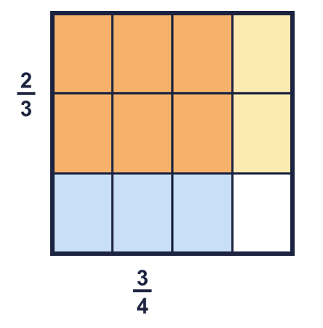 |  | An area grid shows 3/4 × 2/3 = 6/12:
  Year 6 · Fractions B · Step 2  Multiplying fractions by fractions | 
  Year 6 · Fractions B · Step 2
  Multiplying fractions by fractions
  1 | The grid shows two fractions multiplied together. Work out the multiplication. Write the answer in its simplest form.  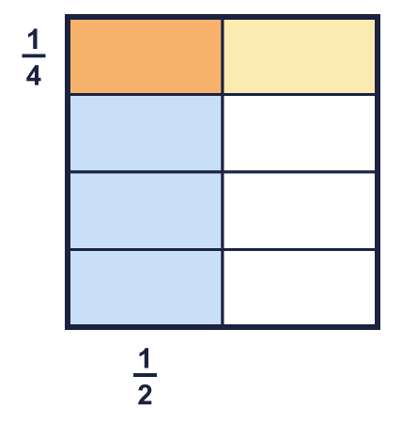  ¹⁄₂ × ¹⁄₄ =  Hint: Count the squares that are shaded both colours (the overlap). Count all the small squares. Write overlap over total, then simplify.
  1 | The grid shows two fractions multiplied together. Work out the multiplication. Write the answer in its simplest form.  ¹⁄₂ × ¹⁄₄ =  Hint: Count the squares that are shaded both colours (the overlap). Count all the small squares. Write overlap over total, then simplify.
  2 | Work out each multiplication.  a) ¹⁄₆ × ¹⁄₄ =  b) ¹⁄₂ × ¹⁄₈ =  c) ¹⁄₃ × ¹⁄₆ =  Hint: Multiply the numerators. Multiply the denominators.
  2 | Work out each multiplication.  a) ¹⁄₆ × ¹⁄₄ =  b) ¹⁄₂ × ¹⁄₈ =  c) ¹⁄₃ × ¹⁄₆ =  Hint: Multiply the numerators. Multiply the denominators.
  3 | Work out each multiplication.  a) ⁵⁄₈ × ¹⁄₇ =  b) ¹⁄₄ × ¹⁄₄ =  c) ¹⁄₆ × ⁷⁄₈ =  d) ³⁄₈ × ⁵⁄₇ =  Hint: Multiply the numerators. Multiply the denominators.
  3 | Work out each multiplication.  a) ⁵⁄₈ × ¹⁄₇ =  b) ¹⁄₄ × ¹⁄₄ =  c) ¹⁄₆ × ⁷⁄₈ =  d) ³⁄₈ × ⁵⁄₇ =  Hint: Multiply the numerators. Multiply the denominators.
  4 | Work out each multiplication. Write each answer in its simplest form.  a) ⁵⁄₆ × ³⁄₄ =  b) ¹⁴⁄₁₅ × ¹⁄₈ =  c) ³⁄₈ × ²⁄₉ =  Hint: You can simplify before you multiply: divide a numerator and a denominator by the same number.
  4 | Work out each multiplication. Write each answer in its simplest form.  a) ⁵⁄₆ × ³⁄₄ =  b) ¹⁴⁄₁₅ × ¹⁄₈ =  c) ³⁄₈ × ²⁄₉ =  Hint: You can simplify before you multiply: divide a numerator and a denominator by the same number.
  5 | 'Of' means multiply. Work out each answer in its simplest form.  a) ¹⁄₈ of ¹⁄₅ =  b) ³⁄₄ of ³⁄₄ =  c) ¹⁄₃ of ¹⁄₃ =  Hint: A fraction of a fraction: multiply the two fractions.
  5 | 'Of' means multiply. Work out each answer in its simplest form.  a) ¹⁄₈ of ¹⁄₅ =  b) ³⁄₄ of ³⁄₄ =  c) ¹⁄₃ of ¹⁄₃ =  Hint: A fraction of a fraction: multiply the two fractions.
  6 | Write the missing fraction in each multiplication. Write it in its simplest form.  a) ²⁄₅ × ? = ¹⁄₃  b) ? × ⁵⁄₈ = ⁵⁄₁₄  Hint: Use the opposite operation. Think about what you multiplied the numerator and the denominator by.
  6 | Write the missing fraction in each multiplication. Write it in its simplest form.  a) ²⁄₅ × ? = ¹⁄₃  b) ? × ⁵⁄₈ = ⁵⁄₁₄  Hint: Use the opposite operation. Think about what you multiplied the numerator and the denominator by.
  7 | Work out each multiplication. Write each answer in its simplest form.  a) ¹⁄₆ × ⁴⁄₅ × ³⁄₄ =  b) ⁵⁄₆ × ²⁄₃ × ⁵⁄₆ =  Hint: Multiply all the numerators. Multiply all the denominators. Cancel before you multiply if you can.
  7 | Work out each multiplication. Write each answer in its simplest form.  a) ¹⁄₆ × ⁴⁄₅ × ³⁄₄ =  b) ⁵⁄₆ × ²⁄₃ × ⁵⁄₆ =  Hint: Multiply all the numerators. Multiply all the denominators. Cancel before you multiply if you can.
  8 | Write <, > or = in each box. Work out both sides first.  Hint: Multiply each pair of fractions. Then compare the two answers.
    a) | ¹⁄₆ × ¹⁄₂ |  | ¹⁄₄ × ³⁄₅
    b) | ¹⁄₆ × ¹⁄₄ |  | ²⁄₃ × ¹⁄₂
    c) | ¹⁄₂ × ²⁄₃ |  | ²⁄₃ × ⁵⁄₆
  8 | Write <, > or = in each box. Work out both sides first.  Hint: Multiply each pair of fractions. Then compare the two answers.
    a) | ¹⁄₆ × ¹⁄₂ |  | ¹⁄₄ × ³⁄₅
    b) | ¹⁄₆ × ¹⁄₄ |  | ²⁄₃ × ¹⁄₂
    c) | ¹⁄₂ × ²⁄₃ |  | ²⁄₃ × ⁵⁄₆

  9 | Whitney uses this grid to work out ¹⁄₂ × ¹⁄₃.  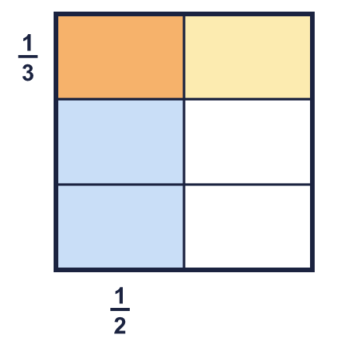  Explain how the grid shows that ¹⁄₂ × ¹⁄₃ = ¹⁄₆.  Hint: Count all the small squares. Count the squares where both colours overlap.
  9 | Whitney uses this grid to work out ¹⁄₂ × ¹⁄₃.  Explain how the grid shows that ¹⁄₂ × ¹⁄₃ = ¹⁄₆.  Hint: Count all the small squares. Count the squares where both colours overlap.
  10 | Ron says: ²⁄₃ × ²⁄₃ = ⁴⁄₆.  Is Ron correct? Circle yes or no.  Yes / No  Explain how you know.  Hint: Multiply the numerators. Multiply the denominators. Then simplify.
  10 | Ron says: ²⁄₃ × ²⁄₃ = ⁴⁄₆.  Is Ron correct? Circle yes or no.  Yes / No  Explain how you know.  Hint: Multiply the numerators. Multiply the denominators. Then simplify.
  11 | Leanna says: ³⁄₄ × ⁴⁄₅ is greater than ³⁄₄, because multiplying always makes a number bigger.  Is Leanna correct? Circle yes or no.  Yes / No  Explain your answer.  Hint: Think of the fraction as 'part of' the first number. Is part of something more or less than the whole?
  11 | Leanna says: ³⁄₄ × ⁴⁄₅ is greater than ³⁄₄, because multiplying always makes a number bigger.  Is Leanna correct? Circle yes or no.  Yes / No  Explain your answer.  Hint: Think of the fraction as 'part of' the first number. Is part of something more or less than the whole?
  12 | ¹⁄₃ of the pupils in a class are girls. ¹⁄₂ of the girls wear glasses.  What fraction of the whole class are girls who wear glasses? Write the answer in its simplest form.  Hint: Find a fraction of a fraction. Multiply.
  12 | ¹⁄₃ of the pupils in a class are girls. ¹⁄₂ of the girls wear glasses.  What fraction of the whole class are girls who wear glasses? Write the answer in its simplest form.  Hint: Find a fraction of a fraction. Multiply.
  13 | A rectangle is ³⁄₄ m long and ⁷⁄₁₀ m wide.  What is its area? Write the answer in its simplest form.  Hint: Area = length × width.
  13 | A rectangle is ³⁄₄ m long and ⁷⁄₁₀ m wide.  What is its area? Write the answer in its simplest form.  Hint: Area = length × width.
  14 | Write two different pairs of fractions that multiply to make ⁴⁄₁₅.  Hint: Split the numerator and the denominator between the two fractions. Try the factors of the denominator.
  14 | Write two different pairs of fractions that multiply to make ⁴⁄₁₅.  Hint: Split the numerator and the denominator between the two fractions. Try the factors of the denominator.

Year 6 · Fractions B · Step 2
Multiplying fractions by fractions
Answers (teacher copy)

An area grid shows 3/4 × 2/3 = 6/12:
  1 | The grid shows two fractions multiplied together. Work out the multiplication. Write the answer in its simplest form.  ¹⁄₂ × ¹⁄₄ = ¹⁄₈  Hint: Count the squares that are shaded both colours (the overlap). Count all the small squares. Write overlap over total, then simplify.
  2 | Work out each multiplication.  a) ¹⁄₆ × ¹⁄₄ = ¹⁄₂₄  b) ¹⁄₂ × ¹⁄₈ = ¹⁄₁₆  c) ¹⁄₃ × ¹⁄₆ = ¹⁄₁₈  Hint: Multiply the numerators. Multiply the denominators.
  3 | Work out each multiplication.  a) ⁵⁄₈ × ¹⁄₇ = ⁵⁄₅₆  b) ¹⁄₄ × ¹⁄₄ = ¹⁄₁₆  c) ¹⁄₆ × ⁷⁄₈ = ⁷⁄₄₈  d) ³⁄₈ × ⁵⁄₇ = ¹⁵⁄₅₆  Hint: Multiply the numerators. Multiply the denominators.
  4 | Work out each multiplication. Write each answer in its simplest form.  a) ⁵⁄₆ × ³⁄₄ = ⁵⁄₈  b) ¹⁴⁄₁₅ × ¹⁄₈ = ⁷⁄₆₀  c) ³⁄₈ × ²⁄₉ = ¹⁄₁₂  Hint: You can simplify before you multiply: divide a numerator and a denominator by the same number.
  5 | 'Of' means multiply. Work out each answer in its simplest form.  a) ¹⁄₈ of ¹⁄₅ = ¹⁄₄₀  b) ³⁄₄ of ³⁄₄ = ⁹⁄₁₆  c) ¹⁄₃ of ¹⁄₃ = ¹⁄₉  Hint: A fraction of a fraction: multiply the two fractions.
  6 | Write the missing fraction in each multiplication. Write it in its simplest form.  a) ²⁄₅ × ? = ¹⁄₃ ⁵⁄₆  b) ? × ⁵⁄₈ = ⁵⁄₁₄ ⁴⁄₇  Hint: Use the opposite operation. Think about what you multiplied the numerator and the denominator by.
  7 | Work out each multiplication. Write each answer in its simplest form.  a) ¹⁄₆ × ⁴⁄₅ × ³⁄₄ = ¹⁄₁₀  b) ⁵⁄₆ × ²⁄₃ × ⁵⁄₆ = ²⁵⁄₅₄  Hint: Multiply all the numerators. Multiply all the denominators. Cancel before you multiply if you can.
  8 | Write <, > or = in each box. Work out both sides first.  a) ¹⁄₆ × ¹⁄₂ < ¹⁄₄ × ³⁄₅  b) ¹⁄₆ × ¹⁄₄ < ²⁄₃ × ¹⁄₂  c) ¹⁄₂ × ²⁄₃ < ²⁄₃ × ⁵⁄₆  Hint: Multiply each pair of fractions. Then compare the two answers.
  9 | Whitney uses this grid to work out ¹⁄₂ × ¹⁄₃.  Explain how the grid shows that ¹⁄₂ × ¹⁄₃ = ¹⁄₆.  The square is split into 6 equal parts. 1 of them is shaded both colours. So ¹⁄₂ × ¹⁄₃ = ¹⁄₆.  Hint: Count all the small squares. Count the squares where both colours overlap.
  10 | Ron says: ²⁄₃ × ²⁄₃ = ⁴⁄₆.  Is Ron correct? Circle yes or no.  Yes / No  Explain how you know.  No. ²⁄₃ × ²⁄₃ = ⁴⁄₉. Ron added the numerators and the denominators. To multiply fractions you multiply the numerators and multiply the denominators.  Hint: Multiply the numerators. Multiply the denominators. Then simplify.
  11 | Leanna says: ³⁄₄ × ⁴⁄₅ is greater than ³⁄₄, because multiplying always makes a number bigger.  Is Leanna correct? Circle yes or no.  Yes / No  Explain your answer.  No. ³⁄₄ × ⁴⁄₅ = ³⁄₅, which is smaller than ³⁄₄. When you multiply by a fraction less than 1, the answer is smaller.  Hint: Think of the fraction as 'part of' the first number. Is part of something more or less than the whole?
  12 | ¹⁄₃ of the pupils in a class are girls. ¹⁄₂ of the girls wear glasses.  What fraction of the whole class are girls who wear glasses? Write the answer in its simplest form.  ¹⁄₆  Hint: Find a fraction of a fraction. Multiply.
  13 | A rectangle is ³⁄₄ m long and ⁷⁄₁₀ m wide.  What is its area? Write the answer in its simplest form.  ²¹⁄₄₀ m²  Hint: Area = length × width.
  14 | Write two different pairs of fractions that multiply to make ⁴⁄₁₅.  for example ²⁄₃ × ²⁄₅, ⁴⁄₅ × ¹⁄₃  Hint: Split the numerator and the denominator between the two fractions. Try the factors of the denominator.

