  Year 6 · Fractions B · Step 2  Multiplying fractions by fractions | 
  Year 6 · Fractions B · Step 2
  Multiplying fractions by fractions
  1 | The grid shows two fractions multiplied together. Work out the multiplication. Write the answer in its simplest form.  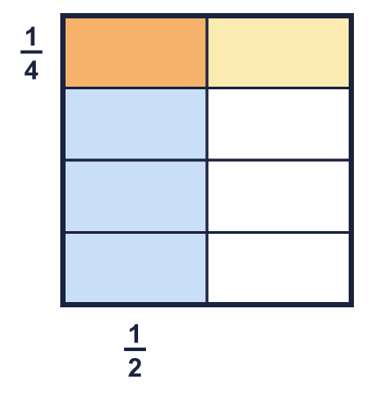  ¹⁄₂ × ¹⁄₄ =
  1 | The grid shows two fractions multiplied together. Work out the multiplication. Write the answer in its simplest form.  ¹⁄₂ × ¹⁄₄ =
  2 | Work out each multiplication.  a) ¹⁄₆ × ¹⁄₄ =  b) ¹⁄₂ × ¹⁄₈ =  c) ¹⁄₃ × ¹⁄₆ =
  2 | Work out each multiplication.  a) ¹⁄₆ × ¹⁄₄ =  b) ¹⁄₂ × ¹⁄₈ =  c) ¹⁄₃ × ¹⁄₆ =
  3 | Work out each multiplication.  a) ⁵⁄₈ × ¹⁄₇ =  b) ¹⁄₄ × ¹⁄₄ =  c) ¹⁄₆ × ⁷⁄₈ =  d) ³⁄₈ × ⁵⁄₇ =
  3 | Work out each multiplication.  a) ⁵⁄₈ × ¹⁄₇ =  b) ¹⁄₄ × ¹⁄₄ =  c) ¹⁄₆ × ⁷⁄₈ =  d) ³⁄₈ × ⁵⁄₇ =
  4 | Work out each multiplication. Write each answer in its simplest form.  a) ⁵⁄₆ × ³⁄₄ =  b) ¹⁴⁄₁₅ × ¹⁄₈ =  c) ³⁄₈ × ²⁄₉ =
  4 | Work out each multiplication. Write each answer in its simplest form.  a) ⁵⁄₆ × ³⁄₄ =  b) ¹⁴⁄₁₅ × ¹⁄₈ =  c) ³⁄₈ × ²⁄₉ =
  5 | 'Of' means multiply. Work out each answer in its simplest form.  a) ¹⁄₈ of ¹⁄₅ =  b) ³⁄₄ of ³⁄₄ =  c) ¹⁄₃ of ¹⁄₃ =
  5 | 'Of' means multiply. Work out each answer in its simplest form.  a) ¹⁄₈ of ¹⁄₅ =  b) ³⁄₄ of ³⁄₄ =  c) ¹⁄₃ of ¹⁄₃ =
  6 | Write the missing fraction in each multiplication. Write it in its simplest form.  a) ²⁄₅ × ? = ¹⁄₃  b) ? × ⁵⁄₈ = ⁵⁄₁₄
  6 | Write the missing fraction in each multiplication. Write it in its simplest form.  a) ²⁄₅ × ? = ¹⁄₃  b) ? × ⁵⁄₈ = ⁵⁄₁₄
  7 | Work out each multiplication. Write each answer in its simplest form.  a) ¹⁄₆ × ⁴⁄₅ × ³⁄₄ =  b) ⁵⁄₆ × ²⁄₃ × ⁵⁄₆ =
  7 | Work out each multiplication. Write each answer in its simplest form.  a) ¹⁄₆ × ⁴⁄₅ × ³⁄₄ =  b) ⁵⁄₆ × ²⁄₃ × ⁵⁄₆ =
  8 | Write <, > or = in each box. Work out both sides first.
    a) | ¹⁄₆ × ¹⁄₂ |  | ¹⁄₄ × ³⁄₅
    b) | ¹⁄₆ × ¹⁄₄ |  | ²⁄₃ × ¹⁄₂
    c) | ¹⁄₂ × ²⁄₃ |  | ²⁄₃ × ⁵⁄₆
  8 | Write <, > or = in each box. Work out both sides first.
    a) | ¹⁄₆ × ¹⁄₂ |  | ¹⁄₄ × ³⁄₅
    b) | ¹⁄₆ × ¹⁄₄ |  | ²⁄₃ × ¹⁄₂
    c) | ¹⁄₂ × ²⁄₃ |  | ²⁄₃ × ⁵⁄₆

  9 | Whitney uses this grid to work out ¹⁄₂ × ¹⁄₃.  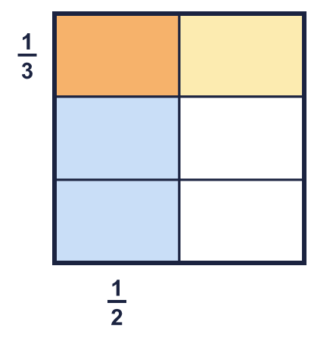  Explain how the grid shows that ¹⁄₂ × ¹⁄₃ = ¹⁄₆.
  9 | Whitney uses this grid to work out ¹⁄₂ × ¹⁄₃.  Explain how the grid shows that ¹⁄₂ × ¹⁄₃ = ¹⁄₆.
  10 | Ron says: ²⁄₃ × ²⁄₃ = ⁴⁄₆.  Is Ron correct? Circle yes or no.  Yes / No  Explain how you know.
  10 | Ron says: ²⁄₃ × ²⁄₃ = ⁴⁄₆.  Is Ron correct? Circle yes or no.  Yes / No  Explain how you know.
  11 | Leanna says: ³⁄₄ × ⁴⁄₅ is greater than ³⁄₄, because multiplying always makes a number bigger.  Is Leanna correct? Circle yes or no.  Yes / No  Explain your answer.
  11 | Leanna says: ³⁄₄ × ⁴⁄₅ is greater than ³⁄₄, because multiplying always makes a number bigger.  Is Leanna correct? Circle yes or no.  Yes / No  Explain your answer.
  12 | ¹⁄₃ of the pupils in a class are girls. ¹⁄₂ of the girls wear glasses.  What fraction of the whole class are girls who wear glasses? Write the answer in its simplest form.
  12 | ¹⁄₃ of the pupils in a class are girls. ¹⁄₂ of the girls wear glasses.  What fraction of the whole class are girls who wear glasses? Write the answer in its simplest form.
  13 | A rectangle is ³⁄₄ m long and ⁷⁄₁₀ m wide.  What is its area? Write the answer in its simplest form.
  13 | A rectangle is ³⁄₄ m long and ⁷⁄₁₀ m wide.  What is its area? Write the answer in its simplest form.
  14 | Write two different pairs of fractions that multiply to make ⁴⁄₁₅.
  14 | Write two different pairs of fractions that multiply to make ⁴⁄₁₅.

Year 6 · Fractions B · Step 2
Multiplying fractions by fractions
Answers (teacher copy)

  1 | The grid shows two fractions multiplied together. Work out the multiplication. Write the answer in its simplest form.  ¹⁄₂ × ¹⁄₄ = ¹⁄₈
  2 | Work out each multiplication.  a) ¹⁄₆ × ¹⁄₄ = ¹⁄₂₄  b) ¹⁄₂ × ¹⁄₈ = ¹⁄₁₆  c) ¹⁄₃ × ¹⁄₆ = ¹⁄₁₈
  3 | Work out each multiplication.  a) ⁵⁄₈ × ¹⁄₇ = ⁵⁄₅₆  b) ¹⁄₄ × ¹⁄₄ = ¹⁄₁₆  c) ¹⁄₆ × ⁷⁄₈ = ⁷⁄₄₈  d) ³⁄₈ × ⁵⁄₇ = ¹⁵⁄₅₆
  4 | Work out each multiplication. Write each answer in its simplest form.  a) ⁵⁄₆ × ³⁄₄ = ⁵⁄₈  b) ¹⁴⁄₁₅ × ¹⁄₈ = ⁷⁄₆₀  c) ³⁄₈ × ²⁄₉ = ¹⁄₁₂
  5 | 'Of' means multiply. Work out each answer in its simplest form.  a) ¹⁄₈ of ¹⁄₅ = ¹⁄₄₀  b) ³⁄₄ of ³⁄₄ = ⁹⁄₁₆  c) ¹⁄₃ of ¹⁄₃ = ¹⁄₉
  6 | Write the missing fraction in each multiplication. Write it in its simplest form.  a) ²⁄₅ × ? = ¹⁄₃ ⁵⁄₆  b) ? × ⁵⁄₈ = ⁵⁄₁₄ ⁴⁄₇
  7 | Work out each multiplication. Write each answer in its simplest form.  a) ¹⁄₆ × ⁴⁄₅ × ³⁄₄ = ¹⁄₁₀  b) ⁵⁄₆ × ²⁄₃ × ⁵⁄₆ = ²⁵⁄₅₄
  8 | Write <, > or = in each box. Work out both sides first.  a) ¹⁄₆ × ¹⁄₂ < ¹⁄₄ × ³⁄₅  b) ¹⁄₆ × ¹⁄₄ < ²⁄₃ × ¹⁄₂  c) ¹⁄₂ × ²⁄₃ < ²⁄₃ × ⁵⁄₆
  9 | Whitney uses this grid to work out ¹⁄₂ × ¹⁄₃.  Explain how the grid shows that ¹⁄₂ × ¹⁄₃ = ¹⁄₆.  The square is split into 6 equal parts. 1 of them is shaded both colours. So ¹⁄₂ × ¹⁄₃ = ¹⁄₆.
  10 | Ron says: ²⁄₃ × ²⁄₃ = ⁴⁄₆.  Is Ron correct? Circle yes or no.  Yes / No  Explain how you know.  No. ²⁄₃ × ²⁄₃ = ⁴⁄₉. Ron added the numerators and the denominators. To multiply fractions you multiply the numerators and multiply the denominators.
  11 | Leanna says: ³⁄₄ × ⁴⁄₅ is greater than ³⁄₄, because multiplying always makes a number bigger.  Is Leanna correct? Circle yes or no.  Yes / No  Explain your answer.  No. ³⁄₄ × ⁴⁄₅ = ³⁄₅, which is smaller than ³⁄₄. When you multiply by a fraction less than 1, the answer is smaller.
  12 | ¹⁄₃ of the pupils in a class are girls. ¹⁄₂ of the girls wear glasses.  What fraction of the whole class are girls who wear glasses? Write the answer in its simplest form.  ¹⁄₆
  13 | A rectangle is ³⁄₄ m long and ⁷⁄₁₀ m wide.  What is its area? Write the answer in its simplest form.  ²¹⁄₄₀ m²
  14 | Write two different pairs of fractions that multiply to make ⁴⁄₁₅.  for example ²⁄₃ × ²⁄₅, ⁴⁄₅ × ¹⁄₃

