Fraction wall to help you:  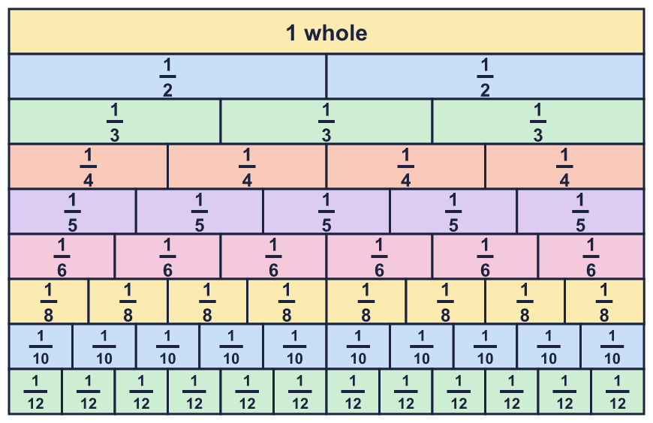 |  | Fraction wall to help you:
  Year 6 · Fractions B · Step 5  Mixed questions with fractions | 
  Year 6 · Fractions B · Step 5
  Mixed questions with fractions
  1 | Work out each calculation. Write each answer as a mixed number in its simplest form. Look carefully at the brackets.  a) (¹⁄₅ + ¹⁄₅) × 5 =  b) (¹⁄₅ + ¹⁄₅) ÷ 5 =  c) ¹⁄₅ + ¹⁄₅ × 5 =  d) ¹⁄₅ + ¹⁄₅ ÷ 5 =  Hint: Brackets first. Then multiplication and division. Then addition and subtraction.
  1 | Work out each calculation. Write each answer as a mixed number in its simplest form. Look carefully at the brackets.  a) (¹⁄₅ + ¹⁄₅) × 5 =  b) (¹⁄₅ + ¹⁄₅) ÷ 5 =  c) ¹⁄₅ + ¹⁄₅ × 5 =  d) ¹⁄₅ + ¹⁄₅ ÷ 5 =  Hint: Brackets first. Then multiplication and division. Then addition and subtraction.
  2 | Work out each calculation. Write each answer in its simplest form. Do multiplication before addition or subtraction.  a) ⁵⁄₆ + ¹⁄₂ × ¹⁄₅ =  b) ¹⁄₂ + ³⁄₄ × ¹⁄₅ =  c) ¹⁄₃ + ¹⁄₃ × ¹⁄₂ =  Hint: Work out the multiplication first. Then add or subtract.
  2 | Work out each calculation. Write each answer in its simplest form. Do multiplication before addition or subtraction.  a) ⁵⁄₆ + ¹⁄₂ × ¹⁄₅ =  b) ¹⁄₂ + ³⁄₄ × ¹⁄₅ =  c) ¹⁄₃ + ¹⁄₃ × ¹⁄₂ =  Hint: Work out the multiplication first. Then add or subtract.
  3 | Jack mixes ¹⁄₅ of a litre of orange juice with ³⁄₄ of a litre of lemonade.  Jack pours the mixture equally into 2 glasses. How much is in each? Write the answer as a fraction of a litre.  Hint: Add the two amounts first. Then divide by the number of containers.
  3 | Jack mixes ¹⁄₅ of a litre of orange juice with ³⁄₄ of a litre of lemonade.  Jack pours the mixture equally into 2 glasses. How much is in each? Write the answer as a fraction of a litre.  Hint: Add the two amounts first. Then divide by the number of containers.
  4 | A rectangle is 1 ³⁄₄ m long and 2 ¹⁄₄ m wide.  What is its perimeter? Write the answer as a mixed number in its simplest form.  Hint: The perimeter is all the way round. Add the length and the width, then double the answer.
  4 | A rectangle is 1 ³⁄₄ m long and 2 ¹⁄₄ m wide.  What is its perimeter? Write the answer as a mixed number in its simplest form.  Hint: The perimeter is all the way round. Add the length and the width, then double the answer.
  5 | A rectangle is ¹⁄₃ m long and ⁴⁄₅ m wide.  What is its area? Write the answer in its simplest form.  Hint: Area = length × width.
  5 | A rectangle is ¹⁄₃ m long and ⁴⁄₅ m wide.  What is its area? Write the answer in its simplest form.  Hint: Area = length × width.
  6 | Write +, −, × or ÷ in each box to make the calculation correct.  Hint: Try each operation. Which one gives the answer on the right?
    a) | ¹⁄₂ |  | ⁵⁄₆ = ³⁄₅
    b) | ⁵⁄₆ |  | ¹⁄₄ = ⁵⁄₂₄
    c) | ¹⁄₂ |  | ³⁄₅ = ¹¹⁄₁₀
  6 | Write +, −, × or ÷ in each box to make the calculation correct.  Hint: Try each operation. Which one gives the answer on the right?
    a) | ¹⁄₂ |  | ⁵⁄₆ = ³⁄₅
    b) | ⁵⁄₆ |  | ¹⁄₄ = ⁵⁄₂₄
    c) | ¹⁄₂ |  | ³⁄₅ = ¹¹⁄₁₀
  7 | Work out each calculation. Write each answer in its simplest form. ('Of' means multiply.)  a) ²⁄₃ × ³⁄₄ + ¹⁄₃ =  b) ²⁄₃ × ³⁄₄ + ³⁄₄ =  Hint: Work out each 'of' or multiplication first. Then add.
  7 | Work out each calculation. Write each answer in its simplest form. ('Of' means multiply.)  a) ²⁄₃ × ³⁄₄ + ¹⁄₃ =  b) ²⁄₃ × ³⁄₄ + ³⁄₄ =  Hint: Work out each 'of' or multiplication first. Then add.
  8 | Work out each calculation. Write each answer in its simplest form.  a) (³⁄₄ − ¹⁄₄) ÷ 4 =  b) (1 − ³⁄₄) × ³⁄₄ =  c) (³⁄₄ − ¹⁄₂) ÷ 4 =  Hint: Do the calculation in the brackets first.
  8 | Work out each calculation. Write each answer in its simplest form.  a) (³⁄₄ − ¹⁄₄) ÷ 4 =  b) (1 − ³⁄₄) × ³⁄₄ =  c) (³⁄₄ − ¹⁄₂) ÷ 4 =  Hint: Do the calculation in the brackets first.

  9 | In a class, ³⁄₁₀ of the pupils are boys and the rest are girls.  ¹⁄₃ of the girls wear glasses. ⁵⁄₈ of the boys wear glasses.  Do more boys or more girls wear glasses? Write boys or girls and explain your reasoning.  Hint: The rest are girls: take the fraction of boys away from 1. Then find a fraction of a fraction for each group.
  9 | In a class, ³⁄₁₀ of the pupils are boys and the rest are girls.  ¹⁄₃ of the girls wear glasses. ⁵⁄₈ of the boys wear glasses.  Do more boys or more girls wear glasses? Write boys or girls and explain your reasoning.  Hint: The rest are girls: take the fraction of boys away from 1. Then find a fraction of a fraction for each group.
  10 | Which statements are true and which are false? Use what you know about fractions to explain, prove or disprove.  A: ¹⁄₂ × ¹⁄₂ × ¹⁄₂ = ¹⁄₈  B: ¹⁄₄ × ¹⁄₂ + ¹⁄₂ × ¹⁄₄ = ¹⁄₄  C: ¹⁄₂ + ¹⁄₂ × ¹⁄₂ = ¹⁄₂  Hint: Work out each calculation. Remember the order of operations.
  10 | Which statements are true and which are false? Use what you know about fractions to explain, prove or disprove.  A: ¹⁄₂ × ¹⁄₂ × ¹⁄₂ = ¹⁄₈  B: ¹⁄₄ × ¹⁄₂ + ¹⁄₂ × ¹⁄₄ = ¹⁄₄  C: ¹⁄₂ + ¹⁄₂ × ¹⁄₂ = ¹⁄₂  Hint: Work out each calculation. Remember the order of operations.
  11 | Is Ron correct? Circle yes or no.  Yes / No  Explain the mistake and give the correct answer.  Hint: Which operation must be done first when there are no brackets?
     | 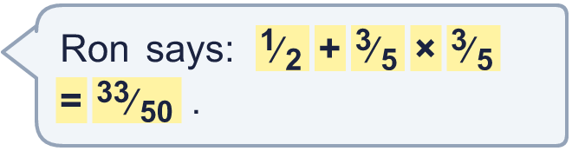
  11 | Is Ron correct? Circle yes or no.  Yes / No  Explain the mistake and give the correct answer.  Hint: Which operation must be done first when there are no brackets?
  12 | A square has sides of ²⁄₃ m. A rectangle has the same area as the square. The rectangle is ²⁄₅ m wide.  How tall is the rectangle? Write the answer in its simplest form.  Hint: Find the area of the square. Then work out what to multiply the width by to get that area.
  12 | A square has sides of ²⁄₃ m. A rectangle has the same area as the square. The rectangle is ²⁄₅ m wide.  How tall is the rectangle? Write the answer in its simplest form.  Hint: Find the area of the square. Then work out what to multiply the width by to get that area.
  13 | Ben has 3 ¹⁄₆ litres of juice. Ben pours ³⁄₄ of a litre into a bottle. Ben shares the juice that is left equally between 2 glasses.  How much juice is in each glass? Write the answer as a mixed number or fraction of a litre in its simplest form.  Hint: First find how much juice is left. Then divide by the number of glasses.
  13 | Ben has 3 ¹⁄₆ litres of juice. Ben pours ³⁄₄ of a litre into a bottle. Ben shares the juice that is left equally between 2 glasses.  How much juice is in each glass? Write the answer as a mixed number or fraction of a litre in its simplest form.  Hint: First find how much juice is left. Then divide by the number of glasses.
  14 | Two of these fractions multiply to make ¹⁄₂. Which two?  ²⁄₃ ¹⁄₃ ³⁄₄ ⁴⁄₅ ¹⁄₂  Hint: Try the pairs. Multiply the numerators and the denominators and simplify. Which pair gives ¹⁄_{2?}
  14 | Two of these fractions multiply to make ¹⁄₂. Which two?  ²⁄₃ ¹⁄₃ ³⁄₄ ⁴⁄₅ ¹⁄₂  Hint: Try the pairs. Multiply the numerators and the denominators and simplify. Which pair gives ¹⁄_{2?}

Year 6 · Fractions B · Step 5
Mixed questions with fractions
Answers (teacher copy)

Fraction wall to help you:
  1 | Work out each calculation. Write each answer as a mixed number in its simplest form. Look carefully at the brackets.  a) (¹⁄₅ + ¹⁄₅) × 5 = 2  b) (¹⁄₅ + ¹⁄₅) ÷ 5 = ²⁄₂₅  c) ¹⁄₅ + ¹⁄₅ × 5 = 1 ¹⁄₅  d) ¹⁄₅ + ¹⁄₅ ÷ 5 = ⁶⁄₂₅  Hint: Brackets first. Then multiplication and division. Then addition and subtraction.
  2 | Work out each calculation. Write each answer in its simplest form. Do multiplication before addition or subtraction.  a) ⁵⁄₆ + ¹⁄₂ × ¹⁄₅ = ¹⁴⁄₁₅  b) ¹⁄₂ + ³⁄₄ × ¹⁄₅ = ¹³⁄₂₀  c) ¹⁄₃ + ¹⁄₃ × ¹⁄₂ = ¹⁄₂  Hint: Work out the multiplication first. Then add or subtract.
  3 | Jack mixes ¹⁄₅ of a litre of orange juice with ³⁄₄ of a litre of lemonade.  Jack pours the mixture equally into 2 glasses. How much is in each? Write the answer as a fraction of a litre.  ¹⁹⁄₄₀ of a litre  Hint: Add the two amounts first. Then divide by the number of containers.
  4 | A rectangle is 1 ³⁄₄ m long and 2 ¹⁄₄ m wide.  What is its perimeter? Write the answer as a mixed number in its simplest form.  8 m  Hint: The perimeter is all the way round. Add the length and the width, then double the answer.
  5 | A rectangle is ¹⁄₃ m long and ⁴⁄₅ m wide.  What is its area? Write the answer in its simplest form.  ⁴⁄₁₅ m²  Hint: Area = length × width.
  6 | Write +, −, × or ÷ in each box to make the calculation correct.  a) ¹⁄₂ ÷ ⁵⁄₆ = ³⁄₅  b) ⁵⁄₆ × ¹⁄₄ = ⁵⁄₂₄  c) ¹⁄₂ + ³⁄₅ = ¹¹⁄₁₀  Hint: Try each operation. Which one gives the answer on the right?
  7 | Work out each calculation. Write each answer in its simplest form. ('Of' means multiply.)  a) ²⁄₃ × ³⁄₄ + ¹⁄₃ = ⁵⁄₆  b) ²⁄₃ × ³⁄₄ + ³⁄₄ = 1 ¹⁄₄  Hint: Work out each 'of' or multiplication first. Then add.
  8 | Work out each calculation. Write each answer in its simplest form.  a) (³⁄₄ − ¹⁄₄) ÷ 4 = ¹⁄₈  b) (1 − ³⁄₄) × ³⁄₄ = ³⁄₁₆  c) (³⁄₄ − ¹⁄₂) ÷ 4 = ¹⁄₁₆  Hint: Do the calculation in the brackets first.
  9 | In a class, ³⁄₁₀ of the pupils are boys and the rest are girls.  ¹⁄₃ of the girls wear glasses. ⁵⁄₈ of the boys wear glasses.  Do more boys or more girls wear glasses? Write boys or girls and explain your reasoning.  girls  Girls. Boys wearing glasses: ³⁄₁₀ × ⁵⁄₈ = ³⁄₁₆ of the class. Girls wearing glasses: ⁷⁄₁₀ × ¹⁄₃ = ⁷⁄₃₀ of the class.  Hint: The rest are girls: take the fraction of boys away from 1. Then find a fraction of a fraction for each group.
  10 | Which statements are true and which are false? Use what you know about fractions to explain, prove or disprove.  A: ¹⁄₂ × ¹⁄₂ × ¹⁄₂ = ¹⁄₈  B: ¹⁄₄ × ¹⁄₂ + ¹⁄₂ × ¹⁄₄ = ¹⁄₄  C: ¹⁄₂ + ¹⁄₂ × ¹⁄₂ = ¹⁄₂  True: A, B  False: C  Hint: Work out each calculation. Remember the order of operations.
  11 | Is Ron correct? Circle yes or no.  Yes / No  Explain the mistake and give the correct answer.  No. Ron added first. Multiplication comes before addition. ¹⁄₂ + ³⁄₅ × ³⁄₅ = ⁴³⁄₅₀.  Hint: Which operation must be done first when there are no brackets?
  12 | A square has sides of ²⁄₃ m. A rectangle has the same area as the square. The rectangle is ²⁄₅ m wide.  How tall is the rectangle? Write the answer in its simplest form.  ¹⁰⁄₉ m  Hint: Find the area of the square. Then work out what to multiply the width by to get that area.
  13 | Ben has 3 ¹⁄₆ litres of juice. Ben pours ³⁄₄ of a litre into a bottle. Ben shares the juice that is left equally between 2 glasses.  How much juice is in each glass? Write the answer as a mixed number or fraction of a litre in its simplest form.  1 ⁵⁄₂₄ litres  Hint: First find how much juice is left. Then divide by the number of glasses.
  14 | Two of these fractions multiply to make ¹⁄₂. Which two?  ²⁄₃ ¹⁄₃ ³⁄₄ ⁴⁄₅ ¹⁄₂  ²⁄₃ and ³⁄₄  Hint: Try the pairs. Multiply the numerators and the denominators and simplify. Which pair gives ¹⁄_{2?}

