Fraction wall to help you:  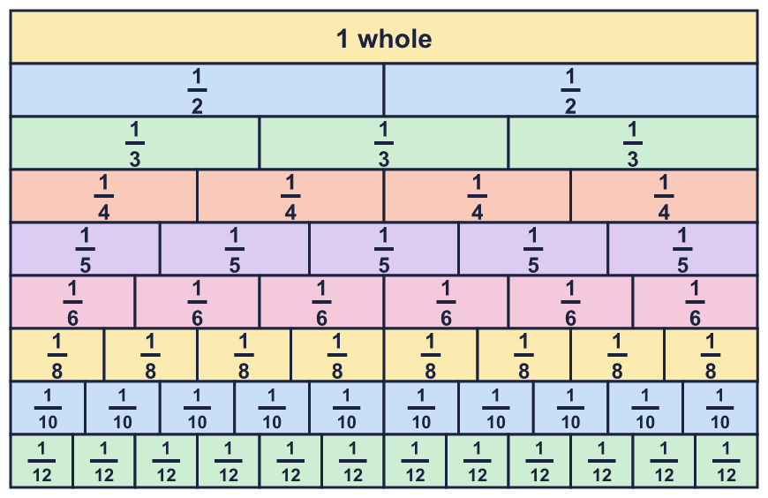 |  | Fraction wall to help you:
  Year 6 · Fractions A · Step 8  Subtracting mixed numbers | 
  Year 6 · Fractions A · Step 8
  Subtracting mixed numbers
  1 | Work out each subtraction. Take away the whole numbers first. Then take away the fractions.  a) 4 ⁵⁄₆ − 2 ¹⁄₆ =  b) 4 ³⁄₄ − 2 ¹⁄₄ =  c) 4 ¹¹⁄₁₂ − 3 ⁷⁄₁₂ =  Hint: Subtract the wholes. Subtract the fractions. Put the two answers together.
  1 | Work out each subtraction. Take away the whole numbers first. Then take away the fractions.  a) 4 ⁵⁄₆ − 2 ¹⁄₆ =  b) 4 ³⁄₄ − 2 ¹⁄₄ =  c) 4 ¹¹⁄₁₂ − 3 ⁷⁄₁₂ =  Hint: Subtract the wholes. Subtract the fractions. Put the two answers together.
  2 | Work out each subtraction. Write each answer in its simplest form.  a) 8 ³⁄₄ − 1 ⁷⁄₁₂ =  b) 6 ¹⁄₂ − 3 ³⁄₈ =  c) 4 ¹⁄₅ − 1 ²⁄₁₅ =  Hint: Change one fraction so both denominators match. Then subtract the wholes and subtract the fractions.
  2 | Work out each subtraction. Write each answer in its simplest form.  a) 8 ³⁄₄ − 1 ⁷⁄₁₂ =  b) 6 ¹⁄₂ − 3 ³⁄₈ =  c) 4 ¹⁄₅ − 1 ²⁄₁₅ =  Hint: Change one fraction so both denominators match. Then subtract the wholes and subtract the fractions.
  3 | Exchange one whole for fractions. Write the missing numerator.  a) 6 ⁴⁄₅ = 5 ?⁄₅  b) 2 ³⁄₄ = 1 ?⁄₄  c) 3 ¹⁄₆ = 2 ?⁄₆  Hint: One whole is the same as a fraction with the numerator and the denominator the same, for example 1 = ⁵⁄₅. Add it to the fraction part.
  3 | Exchange one whole for fractions. Write the missing numerator.  a) 6 ⁴⁄₅ = 5 ?⁄₅  b) 2 ³⁄₄ = 1 ?⁄₄  c) 3 ¹⁄₆ = 2 ?⁄₆  Hint: One whole is the same as a fraction with the numerator and the denominator the same, for example 1 = ⁵⁄₅. Add it to the fraction part.
  4 | Work out each subtraction. You will need to exchange a whole. Write each answer in its simplest form.  a) 5 ³⁄₅ − 3 ⁴⁄₅ =  b) 8 ¹⁄₁₀ − 2 ⁹⁄₁₀ =  c) 5 ¹⁄₈ − 1 ⁷⁄₈ =  Hint: The fraction you take away is bigger. Exchange one whole of the first number for fractions. Then subtract.
  4 | Work out each subtraction. You will need to exchange a whole. Write each answer in its simplest form.  a) 5 ³⁄₅ − 3 ⁴⁄₅ =  b) 8 ¹⁄₁₀ − 2 ⁹⁄₁₀ =  c) 5 ¹⁄₈ − 1 ⁷⁄₈ =  Hint: The fraction you take away is bigger. Exchange one whole of the first number for fractions. Then subtract.
  5 | Work out each subtraction. Write each answer in its simplest form.  a) 5 ¹⁄₂ − 3 ⁴⁄₅ =  b) 8 ¹⁄₅ − 3 ¹⁹⁄₂₀ =  c) 4 ¹⁄₄ − 2 ⁷⁄₈ =  Hint: Find a common denominator first. Then exchange a whole if you need to.
  5 | Work out each subtraction. Write each answer in its simplest form.  a) 5 ¹⁄₂ − 3 ⁴⁄₅ =  b) 8 ¹⁄₅ − 3 ¹⁹⁄₂₀ =  c) 4 ¹⁄₄ − 2 ⁷⁄₈ =  Hint: Find a common denominator first. Then exchange a whole if you need to.
  6 | Work out each subtraction. Write each answer as a mixed number.  a) 9 − 4 ²⁄₅ =  b) 7 − 2 ¹⁄₄ =  c) 7 − 2 ³⁄₈ =  Hint: Exchange one whole of the first number for fractions with the same denominator as the second number.
  6 | Work out each subtraction. Write each answer as a mixed number.  a) 9 − 4 ²⁄₅ =  b) 7 − 2 ¹⁄₄ =  c) 7 − 2 ³⁄₈ =  Hint: Exchange one whole of the first number for fractions with the same denominator as the second number.
  7 | Work out each subtraction. Write each answer as a mixed number.  a) 4 ¹⁄₆ − ⁵⁄₆ =  b) 3 ²⁄₅ − ⁴⁄₅ =  c) 2 ³⁄₅ − ⁴⁄₅ =  Hint: The fraction you take away is bigger than the fraction part of the first number. Exchange one whole first.
  7 | Work out each subtraction. Write each answer as a mixed number.  a) 4 ¹⁄₆ − ⁵⁄₆ =  b) 3 ²⁄₅ − ⁴⁄₅ =  c) 2 ³⁄₅ − ⁴⁄₅ =  Hint: The fraction you take away is bigger than the fraction part of the first number. Exchange one whole first.
  8 | Write the missing number in each calculation.  a) 8 ⁴⁄₅ − ? = 6 ¹¹⁄₁₅  b) 6 ¹⁄₆ − ? = 4 ¹⁄₃  Hint: Use the opposite operation. Check your answer by doing the calculation.
  8 | Write the missing number in each calculation.  a) 8 ⁴⁄₅ − ? = 6 ¹¹⁄₁₅  b) 6 ¹⁄₆ − ? = 4 ¹⁄₃  Hint: Use the opposite operation. Check your answer by doing the calculation.

  9 | A plank is 4 ¹⁄₂ m long.  A shorter plank is 3 ⁴⁄₅ m long.  How much longer is the first plank? Write the answer as a mixed number.  Hint: This is a difference, so subtract the smaller amount from the bigger one. Exchange a whole if you need to.
  9 | A plank is 4 ¹⁄₂ m long.  A shorter plank is 3 ⁴⁄₅ m long.  How much longer is the first plank? Write the answer as a mixed number.  Hint: This is a difference, so subtract the smaller amount from the bigger one. Exchange a whole if you need to.
  10 | Eva has 6 ¹⁄₄ m of ribbon. She uses 2 ¹⁄₂ m for a bow and 1 ³⁄₄ m for a card.  How much ribbon is left? Write the answer as a mixed number in its simplest form.  Hint: Subtract the first amount. Then subtract the second amount from what is left. Exchange a whole if you need to.
  10 | Eva has 6 ¹⁄₄ m of ribbon. She uses 2 ¹⁄₂ m for a bow and 1 ³⁄₄ m for a card.  How much ribbon is left? Write the answer as a mixed number in its simplest form.  Hint: Subtract the first amount. Then subtract the second amount from what is left. Exchange a whole if you need to.
  11 | Is Mo correct? Circle yes or no.  Yes / No  Explain the mistake and give the correct answer.  Hint: Can you take away the fraction parts? Which is bigger?
     | 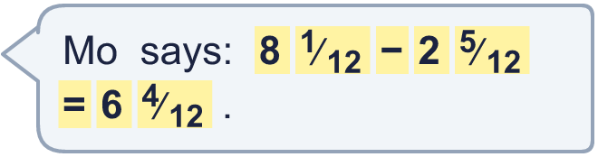
  11 | Is Mo correct? Circle yes or no.  Yes / No  Explain the mistake and give the correct answer.  Hint: Can you take away the fraction parts? Which is bigger?
  12 | Without working them out: is 6 ¹⁄₄ − 2 ³⁄₄ greater than 6 ¹⁄₄ − 1 ³⁄₄? Circle yes or no.  Yes / No  Explain how you know. Then work out both answers to check.  Hint: Both start from the same number. If you take away more, is the answer bigger or smaller?
  12 | Without working them out: is 6 ¹⁄₄ − 2 ³⁄₄ greater than 6 ¹⁄₄ − 1 ³⁄₄? Circle yes or no.  Yes / No  Explain how you know. Then work out both answers to check.  Hint: Both start from the same number. If you take away more, is the answer bigger or smaller?
  13 | Two of these numbers have a difference of 5 ¹⁄₂. Which two? Write the bigger one first.  6 ⁵⁄₆ 1 ¹⁄₆ 6 ²⁄₃ 3 ²⁄₃ 5 ¹⁄₆  Hint: The difference is the bigger number take away the smaller number. Try each pair, or take the difference away from each number.
  13 | Two of these numbers have a difference of 5 ¹⁄₂. Which two? Write the bigger one first.  6 ⁵⁄₆ 1 ¹⁄₆ 6 ²⁄₃ 3 ²⁄₃ 5 ¹⁄₆  Hint: The difference is the bigger number take away the smaller number. Try each pair, or take the difference away from each number.
  14 | A jug holds 5 ¹⁄₂ litres. Amir pours out 1 ³⁄₄ litres, then adds some more. The jug now holds 6 ¹⁄₂ litres.  How much did they add? Write the answer as a mixed number in its simplest form.  Hint: First find how much was in the jug after pouring some out. Then find how much more is needed to reach the total.
  14 | A jug holds 5 ¹⁄₂ litres. Amir pours out 1 ³⁄₄ litres, then adds some more. The jug now holds 6 ¹⁄₂ litres.  How much did they add? Write the answer as a mixed number in its simplest form.  Hint: First find how much was in the jug after pouring some out. Then find how much more is needed to reach the total.

Year 6 · Fractions A · Step 8
Subtracting mixed numbers
Answers (teacher copy)

Fraction wall to help you:
  1 | Work out each subtraction. Take away the whole numbers first. Then take away the fractions.  a) 4 ⁵⁄₆ − 2 ¹⁄₆ = 2 ²⁄₃  b) 4 ³⁄₄ − 2 ¹⁄₄ = 2 ¹⁄₂  c) 4 ¹¹⁄₁₂ − 3 ⁷⁄₁₂ = 1 ¹⁄₃  Hint: Subtract the wholes. Subtract the fractions. Put the two answers together.
  2 | Work out each subtraction. Write each answer in its simplest form.  a) 8 ³⁄₄ − 1 ⁷⁄₁₂ = 7 ¹⁄₆  b) 6 ¹⁄₂ − 3 ³⁄₈ = 3 ¹⁄₈  c) 4 ¹⁄₅ − 1 ²⁄₁₅ = 3 ¹⁄₁₅  Hint: Change one fraction so both denominators match. Then subtract the wholes and subtract the fractions.
  3 | Exchange one whole for fractions. Write the missing numerator.  a) 6 ⁴⁄₅ = 5 ?⁄₅ 9  b) 2 ³⁄₄ = 1 ?⁄₄ 7  c) 3 ¹⁄₆ = 2 ?⁄₆ 7  Hint: One whole is the same as a fraction with the numerator and the denominator the same, for example 1 = ⁵⁄₅. Add it to the fraction part.
  4 | Work out each subtraction. You will need to exchange a whole. Write each answer in its simplest form.  a) 5 ³⁄₅ − 3 ⁴⁄₅ = 1 ⁴⁄₅  b) 8 ¹⁄₁₀ − 2 ⁹⁄₁₀ = 5 ¹⁄₅  c) 5 ¹⁄₈ − 1 ⁷⁄₈ = 3 ¹⁄₄  Hint: The fraction you take away is bigger. Exchange one whole of the first number for fractions. Then subtract.
  5 | Work out each subtraction. Write each answer in its simplest form.  a) 5 ¹⁄₂ − 3 ⁴⁄₅ = 1 ⁷⁄₁₀  b) 8 ¹⁄₅ − 3 ¹⁹⁄₂₀ = 4 ¹⁄₄  c) 4 ¹⁄₄ − 2 ⁷⁄₈ = 1 ³⁄₈  Hint: Find a common denominator first. Then exchange a whole if you need to.
  6 | Work out each subtraction. Write each answer as a mixed number.  a) 9 − 4 ²⁄₅ = 4 ³⁄₅  b) 7 − 2 ¹⁄₄ = 4 ³⁄₄  c) 7 − 2 ³⁄₈ = 4 ⁵⁄₈  Hint: Exchange one whole of the first number for fractions with the same denominator as the second number.
  7 | Work out each subtraction. Write each answer as a mixed number.  a) 4 ¹⁄₆ − ⁵⁄₆ = 3 ¹⁄₃  b) 3 ²⁄₅ − ⁴⁄₅ = 2 ³⁄₅  c) 2 ³⁄₅ − ⁴⁄₅ = 1 ⁴⁄₅  Hint: The fraction you take away is bigger than the fraction part of the first number. Exchange one whole first.
  8 | Write the missing number in each calculation.  a) 8 ⁴⁄₅ − ? = 6 ¹¹⁄₁₅ 2 ¹⁄₁₅  b) 6 ¹⁄₆ − ? = 4 ¹⁄₃ 1 ⁵⁄₆  Hint: Use the opposite operation. Check your answer by doing the calculation.
  9 | A plank is 4 ¹⁄₂ m long.  A shorter plank is 3 ⁴⁄₅ m long.  How much longer is the first plank? Write the answer as a mixed number.  ⁷⁄₁₀ m  Hint: This is a difference, so subtract the smaller amount from the bigger one. Exchange a whole if you need to.
  10 | Eva has 6 ¹⁄₄ m of ribbon. She uses 2 ¹⁄₂ m for a bow and 1 ³⁄₄ m for a card.  How much ribbon is left? Write the answer as a mixed number in its simplest form.  2 m  Hint: Subtract the first amount. Then subtract the second amount from what is left. Exchange a whole if you need to.
  11 | Is Mo correct? Circle yes or no.  Yes / No  Explain the mistake and give the correct answer.  No. Mo took the smaller fraction from the bigger fraction the wrong way round. ¹⁄₁₂ is smaller than ⁵⁄₁₂, so a whole must be exchanged. The correct answer is 5 ²⁄₃.  Hint: Can you take away the fraction parts? Which is bigger?
  12 | Without working them out: is 6 ¹⁄₄ − 2 ³⁄₄ greater than 6 ¹⁄₄ − 1 ³⁄₄? Circle yes or no.  Yes / No  Explain how you know. Then work out both answers to check.  No. You take away more in the first calculation, so the answer is smaller. 6 ¹⁄₄ − 2 ³⁄₄ = 3 ¹⁄₂ and 6 ¹⁄₄ − 1 ³⁄₄ = 4 ¹⁄₂.  Hint: Both start from the same number. If you take away more, is the answer bigger or smaller?
  13 | Two of these numbers have a difference of 5 ¹⁄₂. Which two? Write the bigger one first.  6 ⁵⁄₆ 1 ¹⁄₆ 6 ²⁄₃ 3 ²⁄₃ 5 ¹⁄₆  6 ²⁄₃ and 1 ¹⁄₆  Hint: The difference is the bigger number take away the smaller number. Try each pair, or take the difference away from each number.
  14 | A jug holds 5 ¹⁄₂ litres. Amir pours out 1 ³⁄₄ litres, then adds some more. The jug now holds 6 ¹⁄₂ litres.  How much did they add? Write the answer as a mixed number in its simplest form.  2 ³⁄₄ litres  Hint: First find how much was in the jug after pouring some out. Then find how much more is needed to reach the total.

