  Year 6 · Fractions A · Step 9  Fraction problems with several steps | 
  Year 6 · Fractions A · Step 9
  Fraction problems with several steps
  1 | Work out each calculation. Write each answer in its simplest form.  a) ²⁄₃ + ⁷⁄₁₅ − ⁴⁄₅ =  b) ¹⁄₁₀ + ¹⁄₂ − ²⁄₅ =
  1 | Work out each calculation. Write each answer in its simplest form.  a) ²⁄₃ + ⁷⁄₁₅ − ⁴⁄₅ =  b) ¹⁄₁₀ + ¹⁄₂ − ²⁄₅ =
  2 | Work out each subtraction. Write each answer as a mixed number in its simplest form.  a) 3 ¹⁄₃ − ²⁄₅ =  b) 4 ¹⁄₄ − ³⁄₈ =
  2 | Work out each subtraction. Write each answer as a mixed number in its simplest form.  a) 3 ¹⁄₃ − ²⁄₅ =  b) 4 ¹⁄₄ − ³⁄₈ =
  3 | Write the missing number in each calculation.  a) ²⁄₃ + ¹⁄₃ + ? = 1 ¹⁄₂  b) ¹⁄₆ + ⁵⁄₆ + ? = 4  c) ²⁄₅ + ²⁄₅ + ? = 1 ¹⁄₂
  3 | Write the missing number in each calculation.  a) ²⁄₃ + ¹⁄₃ + ? = 1 ¹⁄₂  b) ¹⁄₆ + ⁵⁄₆ + ? = 4  c) ²⁄₅ + ²⁄₅ + ? = 1 ¹⁄₂
  4 | Complete the part-whole model. Write the missing number in its simplest form.  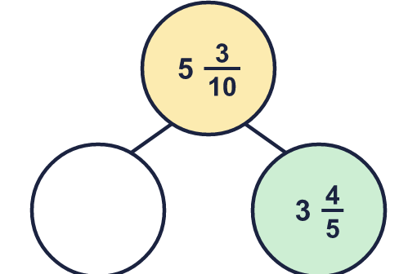
  4 | Complete the part-whole model. Write the missing number in its simplest form.
  5 | Work out each calculation. Write each answer as a mixed number in its simplest form.  a) 4 ²⁄₃ + 3 ⁵⁄₆ − ²⁄₃ =  b) 4 ²⁄₃ + 3 ¹⁄₄ − ¹⁄₄ =
  5 | Work out each calculation. Write each answer as a mixed number in its simplest form.  a) 4 ²⁄₃ + 3 ⁵⁄₆ − ²⁄₃ =  b) 4 ²⁄₃ + 3 ¹⁄₄ − ¹⁄₄ =
  6 | Work out each subtraction. Write each answer in its simplest form.  a) 3 − ²⁄₃ − ³⁄₄ =  b) 3 − ¹⁄₂ − ²⁄₃ =  c) 2 − ¹⁄₃ − ³⁄₄ =
  6 | Work out each subtraction. Write each answer in its simplest form.  a) 3 − ²⁄₃ − ³⁄₄ =  b) 3 − ¹⁄₂ − ²⁄₃ =  c) 2 − ¹⁄₃ − ³⁄₄ =
  7 | Write the missing number in each calculation.  a) 7 ¹⁄₂ − ? − ¹⁄₄ = 4 ¹⁄₂  b) 6 ¹⁄₃ − ? − ⁵⁄₆ = 3 ¹⁄₃
  7 | Write the missing number in each calculation.  a) 7 ¹⁄₂ − ? − ¹⁄₄ = 4 ¹⁄₂  b) 6 ¹⁄₃ − ? − ⁵⁄₆ = 3 ¹⁄₃
  8 | Work out each addition. Write each answer in its simplest form.  a) ¹⁄₄ + ¹⁄₆ + ¹⁄₈ =  b) ¹⁄₄ + ³⁄₅ + ⁷⁄₁₀ =
  8 | Work out each addition. Write each answer in its simplest form.  a) ¹⁄₄ + ¹⁄₆ + ¹⁄₈ =  b) ¹⁄₄ + ³⁄₅ + ⁷⁄₁₀ =

  9 | Which statements are true and which are false? Work them out, or use what you know about the numbers.  A: 2 ¹⁄₄ + 2 ³⁄₄ = 3 ¹⁄₄ + 2 ³⁄₄  B: 5 ³⁄₄ − ¹⁄₂ < 5 ³⁄₄ − ¹⁄₄  C: 5 − ¹⁄₂ = 7 − 2 ¹⁄₂
  9 | Which statements are true and which are false? Work them out, or use what you know about the numbers.  A: 2 ¹⁄₄ + 2 ³⁄₄ = 3 ¹⁄₄ + 2 ³⁄₄  B: 5 ³⁄₄ − ¹⁄₂ < 5 ³⁄₄ − ¹⁄₄  C: 5 − ¹⁄₂ = 7 − 2 ¹⁄₂
  10 | A painter makes green paint with ¹⁄₄ of a litre of blue and ³⁄₅ of a litre of yellow.  She makes purple paint with ²⁄₃ of a litre of red and ¹⁄₆ of a litre of blue.  How much more green paint than purple paint does she have? Write the answer as a fraction of a litre in its simplest form.
  10 | A painter makes green paint with ¹⁄₄ of a litre of blue and ³⁄₅ of a litre of yellow.  She makes purple paint with ²⁄₃ of a litre of red and ¹⁄₆ of a litre of blue.  How much more green paint than purple paint does she have? Write the answer as a fraction of a litre in its simplest form.
  11 | Amir has found an easier way. Work out the answer to this calculation.  ²⁵⁄₁₀₀ + ²⁄₈ − ³⁄₁₂ + ⁵⁄₂₀
    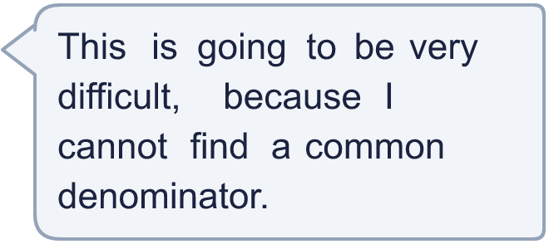
  11 | Amir has found an easier way. Work out the answer to this calculation.  ²⁵⁄₁₀₀ + ²⁄₈ − ³⁄₁₂ + ⁵⁄₂₀
  12 | Cat eats ¹⁄₂ of a cake. Ben eats ¹⁄₃ of the cake. Ana eats ¹⁄₁₂ of the cake.  What fraction of the cake is left? Write the answer in its simplest form.
  12 | Cat eats ¹⁄₂ of a cake. Ben eats ¹⁄₃ of the cake. Ana eats ¹⁄₁₂ of the cake.  What fraction of the cake is left? Write the answer in its simplest form.
  13 | Zach says: 4 ¹⁄₂ − 2 ¹⁄₄ + ¹⁄₂ = 3.  Is Zach correct? Circle yes or no.  Yes / No  Work it out to show how you know.
  13 | Zach says: 4 ¹⁄₂ − 2 ¹⁄₄ + ¹⁄₂ = 3.  Is Zach correct? Circle yes or no.  Yes / No  Work it out to show how you know.
  14 | This sequence goes up by the same amount each time. Write the next two numbers.  ¹⁄₂, 1 ¹⁄₄, 2, 2 ³⁄₄, ..., ...
  14 | This sequence goes up by the same amount each time. Write the next two numbers.  ¹⁄₂, 1 ¹⁄₄, 2, 2 ³⁄₄, ..., ...

Year 6 · Fractions A · Step 9
Fraction problems with several steps
Answers (teacher copy)

  1 | Work out each calculation. Write each answer in its simplest form.  a) ²⁄₃ + ⁷⁄₁₅ − ⁴⁄₅ = ¹⁄₃  b) ¹⁄₁₀ + ¹⁄₂ − ²⁄₅ = ¹⁄₅
  2 | Work out each subtraction. Write each answer as a mixed number in its simplest form.  a) 3 ¹⁄₃ − ²⁄₅ = 2 ¹⁴⁄₁₅  b) 4 ¹⁄₄ − ³⁄₈ = 3 ⁷⁄₈
  3 | Write the missing number in each calculation.  a) ²⁄₃ + ¹⁄₃ + ? = 1 ¹⁄₂ ¹⁄₂  b) ¹⁄₆ + ⁵⁄₆ + ? = 4 3  c) ²⁄₅ + ²⁄₅ + ? = 1 ¹⁄₂ ⁷⁄₁₀
  4 | Complete the part-whole model. Write the missing number in its simplest form.  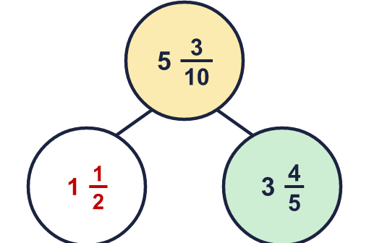  Missing: 1 ¹⁄₂
  5 | Work out each calculation. Write each answer as a mixed number in its simplest form.  a) 4 ²⁄₃ + 3 ⁵⁄₆ − ²⁄₃ = 7 ⁵⁄₆  b) 4 ²⁄₃ + 3 ¹⁄₄ − ¹⁄₄ = 7 ²⁄₃
  6 | Work out each subtraction. Write each answer in its simplest form.  a) 3 − ²⁄₃ − ³⁄₄ = 1 ⁷⁄₁₂  b) 3 − ¹⁄₂ − ²⁄₃ = 1 ⁵⁄₆  c) 2 − ¹⁄₃ − ³⁄₄ = ¹¹⁄₁₂
  7 | Write the missing number in each calculation.  a) 7 ¹⁄₂ − ? − ¹⁄₄ = 4 ¹⁄₂ 2 ³⁄₄  b) 6 ¹⁄₃ − ? − ⁵⁄₆ = 3 ¹⁄₃ 2 ¹⁄₆
  8 | Work out each addition. Write each answer in its simplest form.  a) ¹⁄₄ + ¹⁄₆ + ¹⁄₈ = ¹³⁄₂₄  b) ¹⁄₄ + ³⁄₅ + ⁷⁄₁₀ = 1 ¹¹⁄₂₀
  9 | Which statements are true and which are false? Work them out, or use what you know about the numbers.  A: 2 ¹⁄₄ + 2 ³⁄₄ = 3 ¹⁄₄ + 2 ³⁄₄  B: 5 ³⁄₄ − ¹⁄₂ < 5 ³⁄₄ − ¹⁄₄  C: 5 − ¹⁄₂ = 7 − 2 ¹⁄₂  True: B, C  False: A
  10 | A painter makes green paint with ¹⁄₄ of a litre of blue and ³⁄₅ of a litre of yellow.  She makes purple paint with ²⁄₃ of a litre of red and ¹⁄₆ of a litre of blue.  How much more green paint than purple paint does she have? Write the answer as a fraction of a litre in its simplest form.  ¹⁄₆₀ of a litre
  11 | Amir has found an easier way. Work out the answer to this calculation.  ²⁵⁄₁₀₀ + ²⁄₈ − ³⁄₁₂ + ⁵⁄₂₀  Answer: ¹⁄₂  Each fraction simplifies to ¹⁄₄. So the calculation is ¹⁄₄ + ¹⁄₄ − ¹⁄₄ + ¹⁄₄ = ²⁄₄ = ¹⁄₂.
  12 | Cat eats ¹⁄₂ of a cake. Ben eats ¹⁄₃ of the cake. Ana eats ¹⁄₁₂ of the cake.  What fraction of the cake is left? Write the answer in its simplest form.  ¹⁄₁₂
  13 | Zach says: 4 ¹⁄₂ − 2 ¹⁄₄ + ¹⁄₂ = 3.  Is Zach correct? Circle yes or no.  Yes / No  Work it out to show how you know.  No. 4 ¹⁄₂ − 2 ¹⁄₄ + ¹⁄₂ = 2 ³⁄₄.
  14 | This sequence goes up by the same amount each time. Write the next two numbers.  ¹⁄₂, 1 ¹⁄₄, 2, 2 ³⁄₄, ..., ...  3 ¹⁄₂ 4 ¹⁄₄

