Fraction wall to help you:  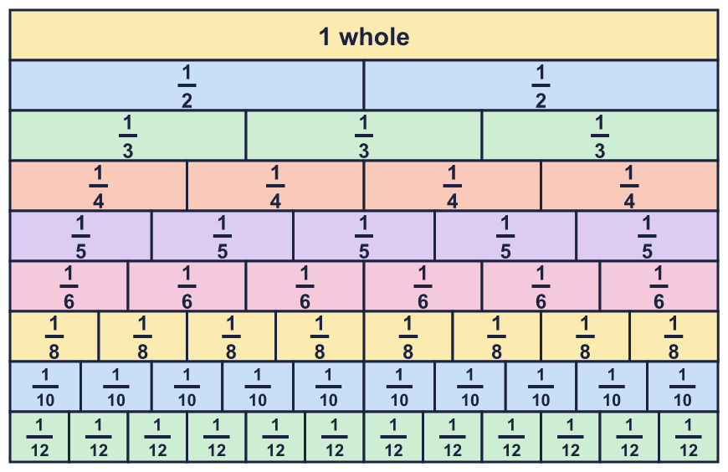 |  | Fraction wall to help you:
  Year 6 · Fractions A · Step 2  Equivalent fractions on a number line | 
  Year 6 · Fractions A · Step 2
  Equivalent fractions on a number line
  1 | Write the fraction shown by each lettered box on the number line.  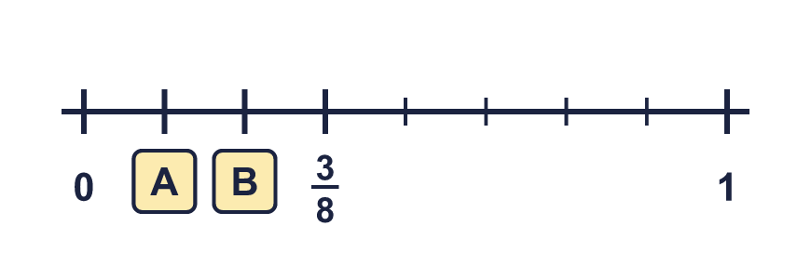  Hint: Count the equal gaps from 0 to 1. That number is the denominator. Count the gaps from 0 to the box for the numerator.
  1 | Write the fraction shown by each lettered box on the number line.  Hint: Count the equal gaps from 0 to 1. That number is the denominator. Count the gaps from 0 to the box for the numerator.
  2 | Each arrow points to a fraction. Write the fraction in its simplest form.  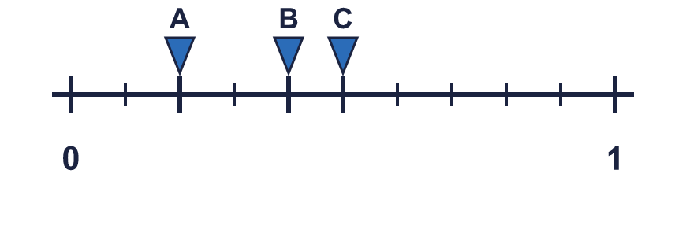  Hint: Read the fraction in tenths first. Then divide the top and the bottom by the same number.
  2 | Each arrow points to a fraction. Write the fraction in its simplest form.  Hint: Read the fraction in tenths first. Then divide the top and the bottom by the same number.
  3 | The number line is split into 8 equal parts. Write the fraction each arrow points to in its simplest form.  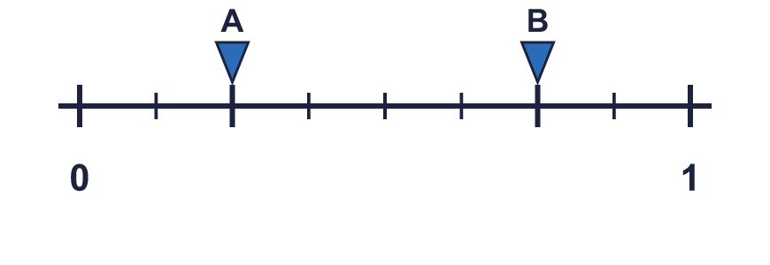  Hint: Each gap is ¹⁄₈. Count the gaps to each arrow, then simplify.
  3 | The number line is split into 8 equal parts. Write the fraction each arrow points to in its simplest form.  Hint: Each gap is ¹⁄₈. Count the gaps to each arrow, then simplify.
  4 | The number line goes from 0 to 2. Write the fraction in each box as a mixed number, or as a fraction in its simplest form if it is less than 1.  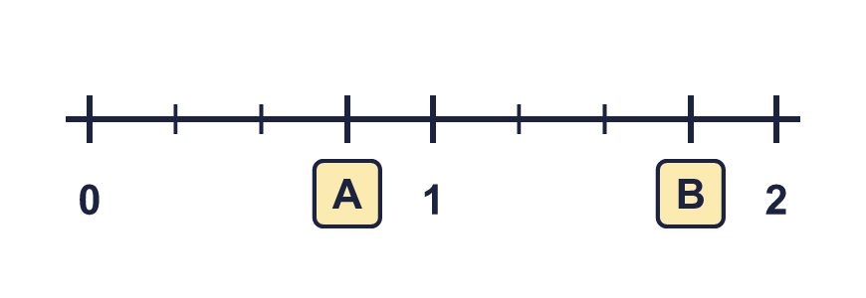  Hint: There are 4 gaps between 0 and 1, so each gap is ¹⁄₄. Count the gaps from 0. Once you pass 4 gaps you are past 1.
  4 | The number line goes from 0 to 2. Write the fraction in each box as a mixed number, or as a fraction in its simplest form if it is less than 1.  Hint: There are 4 gaps between 0 and 1, so each gap is ¹⁄₄. Count the gaps from 0. Once you pass 4 gaps you are past 1.
  5 | The jumps on the number line are equal. Write the missing numbers in their simplest form. Use mixed numbers if they are more than 1.  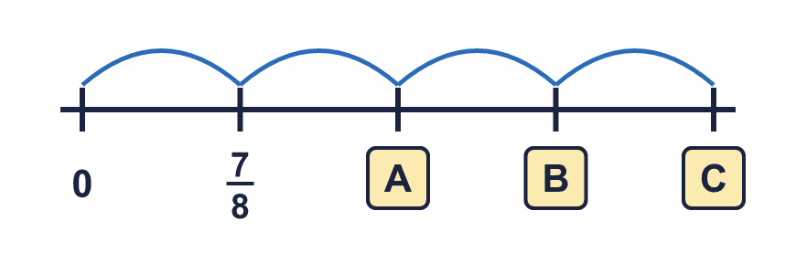  Hint: Each jump is the same size. Add the first jump again each time.
  5 | The jumps on the number line are equal. Write the missing numbers in their simplest form. Use mixed numbers if they are more than 1.  Hint: Each jump is the same size. Add the first jump again each time.
  6 | Which of these fractions are equal to the fraction that arrow A points to? Write them.  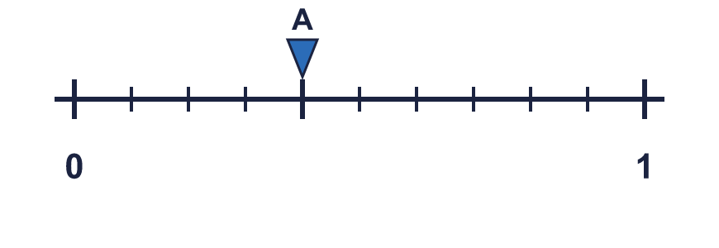  ⁶⁄₁₅ ²⁄₅ ³⁄₆ ²⁄₁₀ ⁸⁄₂₀  Hint: Read arrow A as a fraction. Then see which fractions in the list can be made by multiplying or dividing the top and the bottom by the same number.
  6 | Which of these fractions are equal to the fraction that arrow A points to? Write them.  ⁶⁄₁₅ ²⁄₅ ³⁄₆ ²⁄₁₀ ⁸⁄₂₀  Hint: Read arrow A as a fraction. Then see which fractions in the list can be made by multiplying or dividing the top and the bottom by the same number.
  7 | Arrow A is in the same place on both number lines. Write the missing numerator.  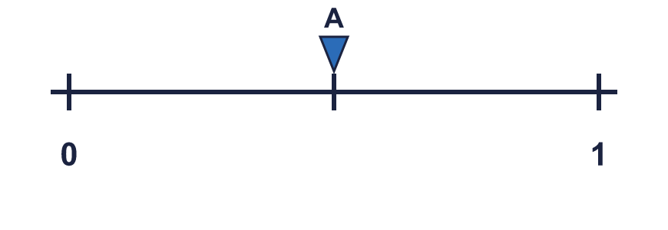  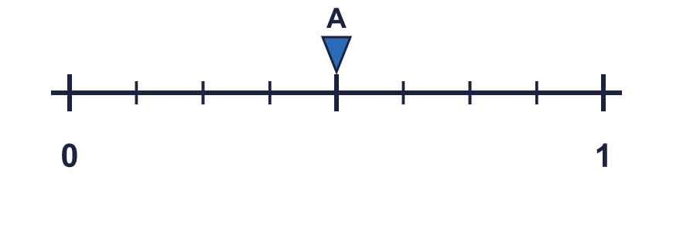  ¹⁄₂ = ?⁄₈  Hint: The second line has more, smaller gaps. How many times more gaps are there? Multiply the numerator by the same number.
  7 | Arrow A is in the same place on both number lines. Write the missing numerator.  ¹⁄₂ = ?⁄₈  Hint: The second line has more, smaller gaps. How many times more gaps are there? Multiply the numerator by the same number.
  8 | The number line goes from 0 to 2. Write the fraction in each box as an improper fraction (the top number is bigger than the bottom number).  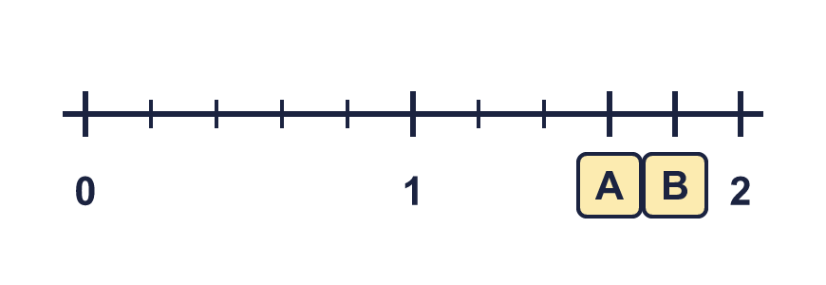  Hint: There are 5 gaps between 0 and 1, so each gap is ¹⁄₅. Keep counting gaps past 1. Write the total number of gaps over 5.
  8 | The number line goes from 0 to 2. Write the fraction in each box as an improper fraction (the top number is bigger than the bottom number).  Hint: There are 5 gaps between 0 and 1, so each gap is ¹⁄₅. Keep counting gaps past 1. Write the total number of gaps over 5.

  9 | Amir says: ¹⁄₄ and ³⁄₆ are in the same place on a number line.  Is Amir correct? Circle yes or no.  Yes / No  Explain how you know.  Hint: Simplify both fractions. If they are the same fraction, they sit in the same place.
  9 | Amir says: ¹⁄₄ and ³⁄₆ are in the same place on a number line.  Is Amir correct? Circle yes or no.  Yes / No  Explain how you know.  Hint: Simplify both fractions. If they are the same fraction, they sit in the same place.
  10 | Arrow A points to ²⁄₃ on the number line. Write two other fractions that are in the same place.  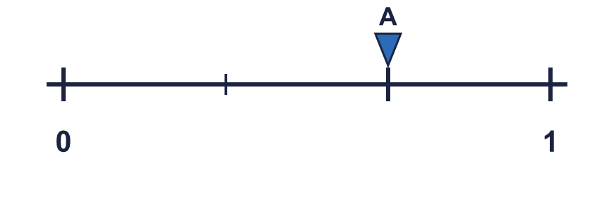  Hint: Multiply the top and the bottom of ²⁄₃ by the same number. Do it twice with different numbers.
  10 | Arrow A points to ²⁄₃ on the number line. Write two other fractions that are in the same place.  Hint: Multiply the top and the bottom of ²⁄₃ by the same number. Do it twice with different numbers.
  11 | The jumps on the number line are equal. Work out the missing numbers. Write mixed numbers where the answer is more than 1.  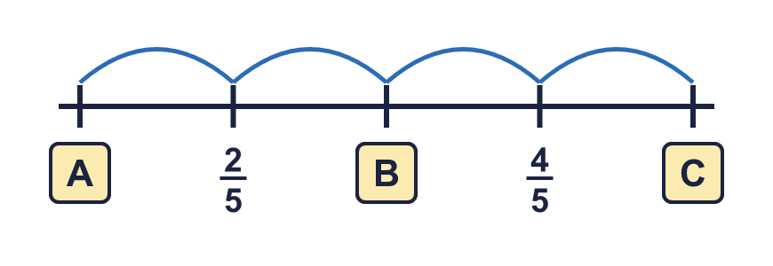  Hint: Two numbers are given. How far is it from one to the other? Halve that to find the size of one jump.
  11 | The jumps on the number line are equal. Work out the missing numbers. Write mixed numbers where the answer is more than 1.  Hint: Two numbers are given. How far is it from one to the other? Halve that to find the size of one jump.
  12 | Tia says: ⁹⁄₁₂ is greater than ³⁄₄, because the numbers are bigger.  Is Tia correct? Circle yes or no.  Yes / No  Explain your answer. You can use a number line.  Hint: Draw a number line from 0 to 1 and mark both fractions, or simplify the bigger-looking fraction.
  12 | Tia says: ⁹⁄₁₂ is greater than ³⁄₄, because the numbers are bigger.  Is Tia correct? Circle yes or no.  Yes / No  Explain your answer. You can use a number line.  Hint: Draw a number line from 0 to 1 and mark both fractions, or simplify the bigger-looking fraction.
  13 | Which arrow is nearer to 1? Write the letter.  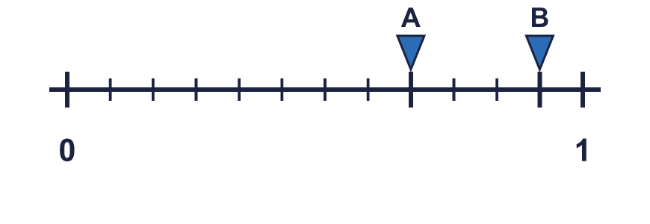  Nearer to 1:  Hint: Count how many gaps each arrow is from 1. The smaller number of gaps is nearer.
  13 | Which arrow is nearer to 1? Write the letter.  Nearer to 1:  Hint: Count how many gaps each arrow is from 1. The smaller number of gaps is nearer.
  14 | I am a fraction. I am equal to ¹⁄₃. My denominator is 16 more than my numerator.  What fraction am I?  Hint: Fractions equal to ¹⁄₃ are ²⁄₆, ³⁄₉, ... Find the one where the bottom number is 16 more than the top number.
  14 | I am a fraction. I am equal to ¹⁄₃. My denominator is 16 more than my numerator.  What fraction am I?  Hint: Fractions equal to ¹⁄₃ are ²⁄₆, ³⁄₉, ... Find the one where the bottom number is 16 more than the top number.

Year 6 · Fractions A · Step 2
Equivalent fractions on a number line
Answers (teacher copy)

Fraction wall to help you:
  1 | Write the fraction shown by each lettered box on the number line.  A = ¹⁄₈ B = ²⁄₈  Hint: Count the equal gaps from 0 to 1. That number is the denominator. Count the gaps from 0 to the box for the numerator.
  2 | Each arrow points to a fraction. Write the fraction in its simplest form.  A = ¹⁄₅ B = ²⁄₅ C = ¹⁄₂  Hint: Read the fraction in tenths first. Then divide the top and the bottom by the same number.
  3 | The number line is split into 8 equal parts. Write the fraction each arrow points to in its simplest form.  A = ¹⁄₄ B = ³⁄₄  Hint: Each gap is ¹⁄₈. Count the gaps to each arrow, then simplify.
  4 | The number line goes from 0 to 2. Write the fraction in each box as a mixed number, or as a fraction in its simplest form if it is less than 1.  A = ³⁄₄ B = 1 ³⁄₄  Hint: There are 4 gaps between 0 and 1, so each gap is ¹⁄₄. Count the gaps from 0. Once you pass 4 gaps you are past 1.
  5 | The jumps on the number line are equal. Write the missing numbers in their simplest form. Use mixed numbers if they are more than 1.  A = 1 ³⁄₄ B = 2 ⁵⁄₈ C = 3 ¹⁄₂  Hint: Each jump is the same size. Add the first jump again each time.
  6 | Which of these fractions are equal to the fraction that arrow A points to? Write them.  ⁶⁄₁₅ ²⁄₅ ³⁄₆ ²⁄₁₀ ⁸⁄₂₀  ⁶⁄₁₅, ²⁄₅, ⁸⁄₂₀  Hint: Read arrow A as a fraction. Then see which fractions in the list can be made by multiplying or dividing the top and the bottom by the same number.
  7 | Arrow A is in the same place on both number lines. Write the missing numerator.  ¹⁄₂ = ?⁄₈ 4  Hint: The second line has more, smaller gaps. How many times more gaps are there? Multiply the numerator by the same number.
  8 | The number line goes from 0 to 2. Write the fraction in each box as an improper fraction (the top number is bigger than the bottom number).  A = ⁸⁄₅ B = ⁹⁄₅  Hint: There are 5 gaps between 0 and 1, so each gap is ¹⁄₅. Keep counting gaps past 1. Write the total number of gaps over 5.
  9 | Amir says: ¹⁄₄ and ³⁄₆ are in the same place on a number line.  Is Amir correct? Circle yes or no.  Yes / No  Explain how you know.  No. ¹⁄₄ is not equal to ³⁄₆: ³⁄₆ = ¹⁄₂ but ¹⁄₄ = ¹⁄₄. Adding the same number to the top and the bottom does not keep a fraction equal. You must multiply or divide.  Hint: Simplify both fractions. If they are the same fraction, they sit in the same place.
  10 | Arrow A points to ²⁄₃ on the number line. Write two other fractions that are in the same place.  for example ⁴⁄₆, ⁶⁄₉  Hint: Multiply the top and the bottom of ²⁄₃ by the same number. Do it twice with different numbers.
  11 | The jumps on the number line are equal. Work out the missing numbers. Write mixed numbers where the answer is more than 1.  A = ¹⁄₅ B = ³⁄₅ C = 1  Hint: Two numbers are given. How far is it from one to the other? Halve that to find the size of one jump.
  12 | Tia says: ⁹⁄₁₂ is greater than ³⁄₄, because the numbers are bigger.  Is Tia correct? Circle yes or no.  Yes / No  Explain your answer. You can use a number line.  No. ⁹⁄₁₂ = ³⁄₄. They are equivalent fractions, so they are in the same place on the number line. Bigger numbers do not always mean a bigger fraction.  Hint: Draw a number line from 0 to 1 and mark both fractions, or simplify the bigger-looking fraction.
  13 | Which arrow is nearer to 1? Write the letter.  Nearer to 1: B  Hint: Count how many gaps each arrow is from 1. The smaller number of gaps is nearer.
  14 | I am a fraction. I am equal to ¹⁄₃. My denominator is 16 more than my numerator.  What fraction am I?  ⁸⁄₂₄  Hint: Fractions equal to ¹⁄₃ are ²⁄₆, ³⁄₉, ... Find the one where the bottom number is 16 more than the top number.

