Fraction wall to help you:  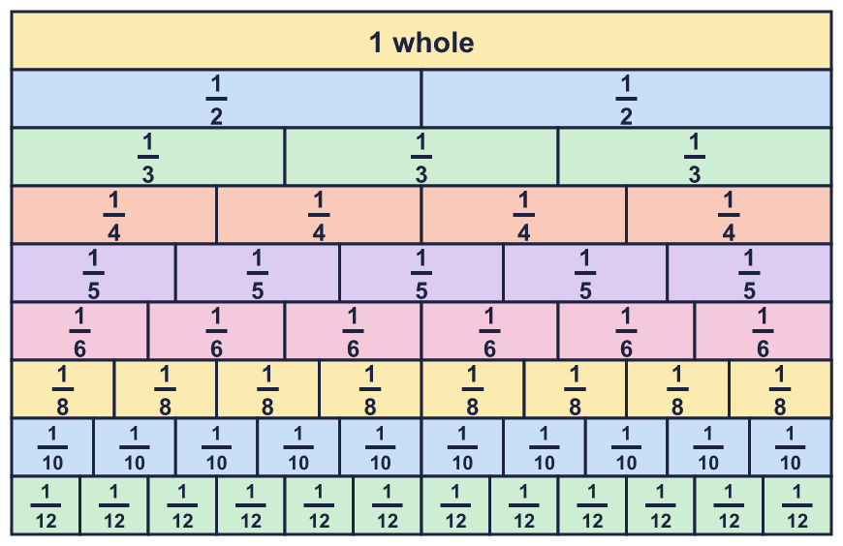 |  | Fraction wall to help you:
  Year 6 · Fractions A · Step 1  Equivalent fractions and simplifying | 
  Year 6 · Fractions A · Step 1
  Equivalent fractions and simplifying
  1 | Each bar is the same length. Use the bars to find the missing numerators.  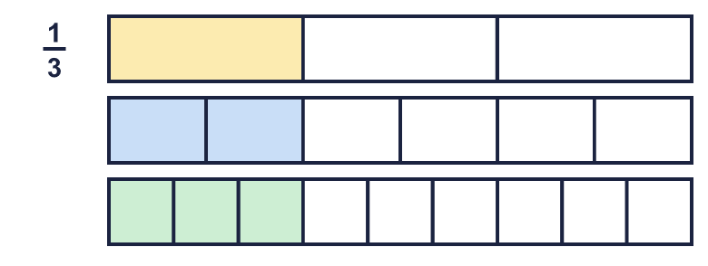  a) ¹⁄₃ = ?⁄₆  b) ¹⁄₃ = ?⁄₉  Hint: Look straight down the bars. The shaded part of the top bar lines up with the shaded part of the other bars. Count the shaded parts.
  1 | Each bar is the same length. Use the bars to find the missing numerators.  a) ¹⁄₃ = ?⁄₆  b) ¹⁄₃ = ?⁄₉  Hint: Look straight down the bars. The shaded part of the top bar lines up with the shaded part of the other bars. Count the shaded parts.
  2 | Write the missing number in each pair of equal fractions.  a) ²⁄₃ = ?⁄₆  b) ³⁄₄ = ?⁄₁₂  c) ⁵⁄₆ = ²⁰⁄?  d) ¹⁄₆ = ?⁄₃₀  Hint: Find what the denominator was multiplied by. Multiply the numerator by the same number.  Multiply the top and the bottom by the same number:  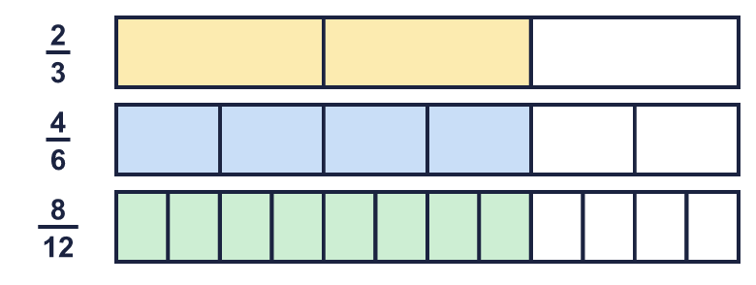
  2 | Write the missing number in each pair of equal fractions.  a) ²⁄₃ = ?⁄₆  b) ³⁄₄ = ?⁄₁₂  c) ⁵⁄₆ = ²⁰⁄?  d) ¹⁄₆ = ?⁄₃₀  Hint: Find what the denominator was multiplied by. Multiply the numerator by the same number.  Multiply the top and the bottom by the same number:
  3 | Write the missing number in each pair of equal fractions.  a) ⁴⁄₆ = ?⁄₃  b) ¹²⁄₁₅ = ⁴⁄?  c) ⁸⁄₁₂ = ?⁄₃  d) ¹⁰⁄₁₅ = ²⁄?  Hint: Find what the numerator was divided by. Divide the denominator by the same number.
  3 | Write the missing number in each pair of equal fractions.  a) ⁴⁄₆ = ?⁄₃  b) ¹²⁄₁₅ = ⁴⁄?  c) ⁸⁄₁₂ = ?⁄₃  d) ¹⁰⁄₁₅ = ²⁄?  Hint: Find what the numerator was divided by. Divide the denominator by the same number.
  4 | Write each fraction in its simplest form.  a) ²⁄₁₄ =  b) ⁹⁄₁₂ =  c) ²⁰⁄₂₈ =  d) ⁵⁄₄₀ =  Hint: Find a number that divides into the numerator AND the denominator. Divide both by it.
  4 | Write each fraction in its simplest form.  a) ²⁄₁₄ =  b) ⁹⁄₁₂ =  c) ²⁰⁄₂₈ =  d) ⁵⁄₄₀ =  Hint: Find a number that divides into the numerator AND the denominator. Divide both by it.
  5 | Write the fractions that are already in their simplest form.  ²⁄₆ ⁹⁄₁₁ ¹⁰⁄₁₅ ¹⁰⁄₁₁ ⁹⁄₁₄ ⁴⁄₆  Hint: A fraction is in its simplest form when no number except 1 divides both the numerator and the denominator.
  5 | Write the fractions that are already in their simplest form.  ²⁄₆ ⁹⁄₁₁ ¹⁰⁄₁₅ ¹⁰⁄₁₁ ⁹⁄₁₄ ⁴⁄₆  Hint: A fraction is in its simplest form when no number except 1 divides both the numerator and the denominator.
  6 | Simplify each fraction in one step. Use the highest common factor.  a) ⁴²⁄₉₁ =  b) ⁶³⁄₉₉ =  c) ¹³⁵⁄₁₆₅ =  d) ⁷⁵⁄₁₉₅ =  Hint: List the factors of the numerator. Find the biggest one that is also a factor of the denominator. Divide both by it.
  6 | Simplify each fraction in one step. Use the highest common factor.  a) ⁴²⁄₉₁ =  b) ⁶³⁄₉₉ =  c) ¹³⁵⁄₁₆₅ =  d) ⁷⁵⁄₁₉₅ =  Hint: List the factors of the numerator. Find the biggest one that is also a factor of the denominator. Divide both by it.
  7 | Three of these fractions are equal to ²⁄₅. Write the fraction that is not.  ⁸⁄₂₀ ¹¹⁄₂₅ ¹²⁄₃₀ ⁶⁄₁₅  Hint: Multiply the top and the bottom of ²⁄₅ by 2, then by 3... Which fractions do you get? Which one is missing from your list?
  7 | Three of these fractions are equal to ²⁄₅. Write the fraction that is not.  ⁸⁄₂₀ ¹¹⁄₂₅ ¹²⁄₃₀ ⁶⁄₁₅  Hint: Multiply the top and the bottom of ²⁄₅ by 2, then by 3... Which fractions do you get? Which one is missing from your list?
  8 | Write each fraction in its simplest form. The answers are more than 1.  a) ²⁴⁄₁₈ =  b) ¹²⁄₈ =  c) ²⁵⁄₂₀ =  Hint: These fractions are top-heavy. You can still divide the top and the bottom by the same number.
  8 | Write each fraction in its simplest form. The answers are more than 1.  a) ²⁴⁄₁₈ =  b) ¹²⁄₈ =  c) ²⁵⁄₂₀ =  Hint: These fractions are top-heavy. You can still divide the top and the bottom by the same number.

  9 | Is Boba correct? Circle yes or no.  Yes / No  Explain your answer. Use an example.  Hint: Pick a fraction such as ⁷⁄₁₀. Can any number except 1 divide both 7 and 10?
     | 
  9 | Is Boba correct? Circle yes or no.  Yes / No  Explain your answer. Use an example.  Hint: Pick a fraction such as ⁷⁄₁₀. Can any number except 1 divide both 7 and 10?
  10 | Tia wants to simplify ²⁵⁄₆₀.  Is Tia correct? Circle yes or no.  Yes / No  Explain your answer.  Hint: Odd and even numbers can still share a factor. Look for a number that divides both.
    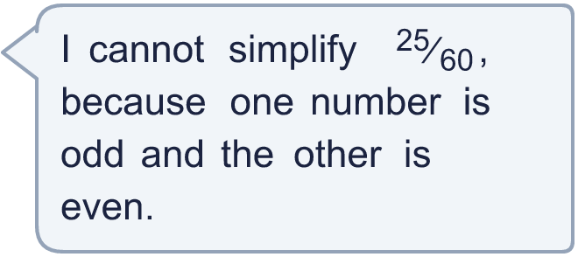
  10 | Tia wants to simplify ²⁵⁄₆₀.  Is Tia correct? Circle yes or no.  Yes / No  Explain your answer.  Hint: Odd and even numbers can still share a factor. Look for a number that divides both.
  11 | Ron simplifies ¹⁶⁄₄₀.  Ron divides the numerator by 4 and the denominator by 2.  Ron gets ⁴⁄₂₀.  What mistake did Ron make? Write the correct answer.  Hint: To keep the fraction the same size, do the same thing to the top and the bottom.
  11 | Ron simplifies ¹⁶⁄₄₀.  Ron divides the numerator by 4 and the denominator by 2.  Ron gets ⁴⁄₂₀.  What mistake did Ron make? Write the correct answer.  Hint: To keep the fraction the same size, do the same thing to the top and the bottom.
  12 | Write three different fractions that simplify to ⁴⁄₉.  All the denominators must be multiples of 7.  Hint: Multiply ⁴⁄₉ by 1 in a different way each time. Choose a multiplier that makes the denominator a multiple of 7.
  12 | Write three different fractions that simplify to ⁴⁄₉.  All the denominators must be multiples of 7.  Hint: Multiply ⁴⁄₉ by 1 in a different way each time. Choose a multiplier that makes the denominator a multiple of 7.
  13 | Eli eats ⁸⁄₁₀ of a pizza. Dee eats ¹⁶⁄₂₀ of an identical pizza.  Who eats more pizza? Explain how you know.  Hint: Simplify both fractions. Are they the same?
  13 | Eli eats ⁸⁄₁₀ of a pizza. Dee eats ¹⁶⁄₂₀ of an identical pizza.  Who eats more pizza? Explain how you know.  Hint: Simplify both fractions. Are they the same?
  14 | I am a fraction. I simplify to ²⁄₇. My numerator and my denominator add up to 54.  What fraction am I?  Hint: Fractions that simplify to ²⁄₇ look like ⁴⁄₁₄, ⁶⁄₂₁... Add the top and the bottom of each one.
  14 | I am a fraction. I simplify to ²⁄₇. My numerator and my denominator add up to 54.  What fraction am I?  Hint: Fractions that simplify to ²⁄₇ look like ⁴⁄₁₄, ⁶⁄₂₁... Add the top and the bottom of each one.

Year 6 · Fractions A · Step 1
Equivalent fractions and simplifying
Answers (teacher copy)

Fraction wall to help you:
  1 | Each bar is the same length. Use the bars to find the missing numerators.  a) ¹⁄₃ = ?⁄₆ 2  b) ¹⁄₃ = ?⁄₉ 3  Hint: Look straight down the bars. The shaded part of the top bar lines up with the shaded part of the other bars. Count the shaded parts.
  2 | Write the missing number in each pair of equal fractions.  a) ²⁄₃ = ?⁄₆ 4  b) ³⁄₄ = ?⁄₁₂ 9  c) ⁵⁄₆ = ²⁰⁄? 24  d) ¹⁄₆ = ?⁄₃₀ 5  Hint: Find what the denominator was multiplied by. Multiply the numerator by the same number.  Multiply the top and the bottom by the same number:
  3 | Write the missing number in each pair of equal fractions.  a) ⁴⁄₆ = ?⁄₃ 2  b) ¹²⁄₁₅ = ⁴⁄? 5  c) ⁸⁄₁₂ = ?⁄₃ 2  d) ¹⁰⁄₁₅ = ²⁄? 3  Hint: Find what the numerator was divided by. Divide the denominator by the same number.
  4 | Write each fraction in its simplest form.  a) ²⁄₁₄ = ¹⁄₇  b) ⁹⁄₁₂ = ³⁄₄  c) ²⁰⁄₂₈ = ⁵⁄₇  d) ⁵⁄₄₀ = ¹⁄₈  Hint: Find a number that divides into the numerator AND the denominator. Divide both by it.
  5 | Write the fractions that are already in their simplest form.  ²⁄₆ ⁹⁄₁₁ ¹⁰⁄₁₅ ¹⁰⁄₁₁ ⁹⁄₁₄ ⁴⁄₆  ⁹⁄₁₁, ¹⁰⁄₁₁, ⁹⁄₁₄  Hint: A fraction is in its simplest form when no number except 1 divides both the numerator and the denominator.
  6 | Simplify each fraction in one step. Use the highest common factor.  a) ⁴²⁄₉₁ = ⁶⁄₁₃  b) ⁶³⁄₉₉ = ⁷⁄₁₁  c) ¹³⁵⁄₁₆₅ = ⁹⁄₁₁  d) ⁷⁵⁄₁₉₅ = ⁵⁄₁₃  Hint: List the factors of the numerator. Find the biggest one that is also a factor of the denominator. Divide both by it.
  7 | Three of these fractions are equal to ²⁄₅. Write the fraction that is not.  ⁸⁄₂₀ ¹¹⁄₂₅ ¹²⁄₃₀ ⁶⁄₁₅  ¹¹⁄₂₅  Hint: Multiply the top and the bottom of ²⁄₅ by 2, then by 3... Which fractions do you get? Which one is missing from your list?
  8 | Write each fraction in its simplest form. The answers are more than 1.  a) ²⁴⁄₁₈ = ⁴⁄₃  b) ¹²⁄₈ = ³⁄₂  c) ²⁵⁄₂₀ = ⁵⁄₄  Hint: These fractions are top-heavy. You can still divide the top and the bottom by the same number.
  9 | Is Boba correct? Circle yes or no.  Yes / No  Explain your answer. Use an example.  No. For example, ³⁄₂₀ cannot be simplified. The only number that divides both 3 and 20 is 1.  Hint: Pick a fraction such as ⁷⁄₁₀. Can any number except 1 divide both 7 and 10?
  10 | Tia wants to simplify ²⁵⁄₆₀.  Is Tia correct? Circle yes or no.  Yes / No  Explain your answer.  No. 25 and 60 are both multiples of 5, so ²⁵⁄₆₀ = ⁵⁄₁₂.  Hint: Odd and even numbers can still share a factor. Look for a number that divides both.
  11 | Ron simplifies ¹⁶⁄₄₀.  Ron divides the numerator by 4 and the denominator by 2.  Ron gets ⁴⁄₂₀.  What mistake did Ron make? Write the correct answer.  Ron divided the top and the bottom by different numbers. You must divide both by the same number. ¹⁶⁄₄₀ = ²⁄₅.  Hint: To keep the fraction the same size, do the same thing to the top and the bottom.
  12 | Write three different fractions that simplify to ⁴⁄₉.  All the denominators must be multiples of 7.  for example ²⁸⁄₆₃, ⁵⁶⁄₁₂₆, ⁸⁴⁄₁₈₉  Hint: Multiply ⁴⁄₉ by 1 in a different way each time. Choose a multiplier that makes the denominator a multiple of 7.
  13 | Eli eats ⁸⁄₁₀ of a pizza. Dee eats ¹⁶⁄₂₀ of an identical pizza.  Who eats more pizza? Explain how you know.  Neither. They eat the same amount. ⁸⁄₁₀ = ⁴⁄₅ and ¹⁶⁄₂₀ = ⁴⁄₅.  Hint: Simplify both fractions. Are they the same?
  14 | I am a fraction. I simplify to ²⁄₇. My numerator and my denominator add up to 54.  What fraction am I?  ¹²⁄₄₂  Hint: Fractions that simplify to ²⁄₇ look like ⁴⁄₁₄, ⁶⁄₂₁... Add the top and the bottom of each one.

