  Year 6 · Fractions A · Step 1  Equivalent fractions and simplifying | 
  Year 6 · Fractions A · Step 1
  Equivalent fractions and simplifying
  1 | Each bar is the same length. Use the bars to find the missing numerators.  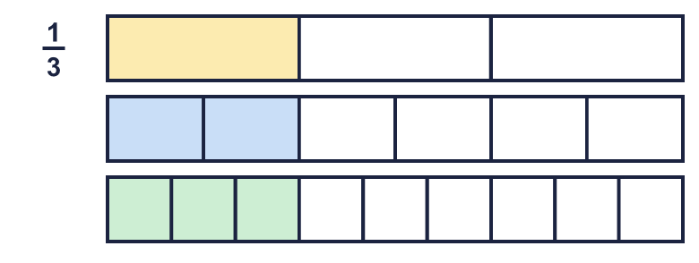  a) ¹⁄₃ = ?⁄₆  b) ¹⁄₃ = ?⁄₉
  1 | Each bar is the same length. Use the bars to find the missing numerators.  a) ¹⁄₃ = ?⁄₆  b) ¹⁄₃ = ?⁄₉
  2 | Write the missing number in each pair of equal fractions.  a) ²⁄₃ = ?⁄₆  b) ³⁄₄ = ?⁄₁₂  c) ⁵⁄₆ = ²⁰⁄?  d) ¹⁄₆ = ?⁄₃₀
  2 | Write the missing number in each pair of equal fractions.  a) ²⁄₃ = ?⁄₆  b) ³⁄₄ = ?⁄₁₂  c) ⁵⁄₆ = ²⁰⁄?  d) ¹⁄₆ = ?⁄₃₀
  3 | Write the missing number in each pair of equal fractions.  a) ⁴⁄₆ = ?⁄₃  b) ¹²⁄₁₅ = ⁴⁄?  c) ⁸⁄₁₂ = ?⁄₃  d) ¹⁰⁄₁₅ = ²⁄?
  3 | Write the missing number in each pair of equal fractions.  a) ⁴⁄₆ = ?⁄₃  b) ¹²⁄₁₅ = ⁴⁄?  c) ⁸⁄₁₂ = ?⁄₃  d) ¹⁰⁄₁₅ = ²⁄?
  4 | Write each fraction in its simplest form.  a) ²⁄₁₄ =  b) ⁹⁄₁₂ =  c) ²⁰⁄₂₈ =  d) ⁵⁄₄₀ =
  4 | Write each fraction in its simplest form.  a) ²⁄₁₄ =  b) ⁹⁄₁₂ =  c) ²⁰⁄₂₈ =  d) ⁵⁄₄₀ =
  5 | Write the fractions that are already in their simplest form.  ²⁄₆ ⁹⁄₁₁ ¹⁰⁄₁₅ ¹⁰⁄₁₁ ⁹⁄₁₄ ⁴⁄₆
  5 | Write the fractions that are already in their simplest form.  ²⁄₆ ⁹⁄₁₁ ¹⁰⁄₁₅ ¹⁰⁄₁₁ ⁹⁄₁₄ ⁴⁄₆
  6 | Simplify each fraction in one step. Use the highest common factor.  a) ⁴²⁄₉₁ =  b) ⁶³⁄₉₉ =  c) ¹³⁵⁄₁₆₅ =  d) ⁷⁵⁄₁₉₅ =
  6 | Simplify each fraction in one step. Use the highest common factor.  a) ⁴²⁄₉₁ =  b) ⁶³⁄₉₉ =  c) ¹³⁵⁄₁₆₅ =  d) ⁷⁵⁄₁₉₅ =
  7 | Three of these fractions are equal to ²⁄₅. Write the fraction that is not.  ⁸⁄₂₀ ¹¹⁄₂₅ ¹²⁄₃₀ ⁶⁄₁₅
  7 | Three of these fractions are equal to ²⁄₅. Write the fraction that is not.  ⁸⁄₂₀ ¹¹⁄₂₅ ¹²⁄₃₀ ⁶⁄₁₅
  8 | Write each fraction in its simplest form. The answers are more than 1.  a) ²⁴⁄₁₈ =  b) ¹²⁄₈ =  c) ²⁵⁄₂₀ =
  8 | Write each fraction in its simplest form. The answers are more than 1.  a) ²⁴⁄₁₈ =  b) ¹²⁄₈ =  c) ²⁵⁄₂₀ =

  9 | Is Boba correct? Circle yes or no.  Yes / No  Explain your answer. Use an example.
     | 
  9 | Is Boba correct? Circle yes or no.  Yes / No  Explain your answer. Use an example.
  10 | Tia wants to simplify ²⁵⁄₆₀.  Is Tia correct? Circle yes or no.  Yes / No  Explain your answer.
    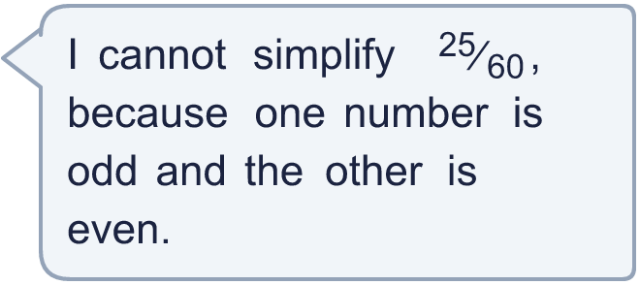
  10 | Tia wants to simplify ²⁵⁄₆₀.  Is Tia correct? Circle yes or no.  Yes / No  Explain your answer.
  11 | Ron simplifies ¹⁶⁄₄₀.  Ron divides the numerator by 4 and the denominator by 2.  Ron gets ⁴⁄₂₀.  What mistake did Ron make? Write the correct answer.
  11 | Ron simplifies ¹⁶⁄₄₀.  Ron divides the numerator by 4 and the denominator by 2.  Ron gets ⁴⁄₂₀.  What mistake did Ron make? Write the correct answer.
  12 | Write three different fractions that simplify to ⁴⁄₉.  All the denominators must be multiples of 7.
  12 | Write three different fractions that simplify to ⁴⁄₉.  All the denominators must be multiples of 7.
  13 | Eli eats ⁸⁄₁₀ of a pizza. Dee eats ¹⁶⁄₂₀ of an identical pizza.  Who eats more pizza? Explain how you know.
  13 | Eli eats ⁸⁄₁₀ of a pizza. Dee eats ¹⁶⁄₂₀ of an identical pizza.  Who eats more pizza? Explain how you know.
  14 | I am a fraction. I simplify to ²⁄₇. My numerator and my denominator add up to 54.  What fraction am I?
  14 | I am a fraction. I simplify to ²⁄₇. My numerator and my denominator add up to 54.  What fraction am I?

Year 6 · Fractions A · Step 1
Equivalent fractions and simplifying
Answers (teacher copy)

  1 | Each bar is the same length. Use the bars to find the missing numerators.  a) ¹⁄₃ = ?⁄₆ 2  b) ¹⁄₃ = ?⁄₉ 3
  2 | Write the missing number in each pair of equal fractions.  a) ²⁄₃ = ?⁄₆ 4  b) ³⁄₄ = ?⁄₁₂ 9  c) ⁵⁄₆ = ²⁰⁄? 24  d) ¹⁄₆ = ?⁄₃₀ 5
  3 | Write the missing number in each pair of equal fractions.  a) ⁴⁄₆ = ?⁄₃ 2  b) ¹²⁄₁₅ = ⁴⁄? 5  c) ⁸⁄₁₂ = ?⁄₃ 2  d) ¹⁰⁄₁₅ = ²⁄? 3
  4 | Write each fraction in its simplest form.  a) ²⁄₁₄ = ¹⁄₇  b) ⁹⁄₁₂ = ³⁄₄  c) ²⁰⁄₂₈ = ⁵⁄₇  d) ⁵⁄₄₀ = ¹⁄₈
  5 | Write the fractions that are already in their simplest form.  ²⁄₆ ⁹⁄₁₁ ¹⁰⁄₁₅ ¹⁰⁄₁₁ ⁹⁄₁₄ ⁴⁄₆  ⁹⁄₁₁, ¹⁰⁄₁₁, ⁹⁄₁₄
  6 | Simplify each fraction in one step. Use the highest common factor.  a) ⁴²⁄₉₁ = ⁶⁄₁₃  b) ⁶³⁄₉₉ = ⁷⁄₁₁  c) ¹³⁵⁄₁₆₅ = ⁹⁄₁₁  d) ⁷⁵⁄₁₉₅ = ⁵⁄₁₃
  7 | Three of these fractions are equal to ²⁄₅. Write the fraction that is not.  ⁸⁄₂₀ ¹¹⁄₂₅ ¹²⁄₃₀ ⁶⁄₁₅  ¹¹⁄₂₅
  8 | Write each fraction in its simplest form. The answers are more than 1.  a) ²⁴⁄₁₈ = ⁴⁄₃  b) ¹²⁄₈ = ³⁄₂  c) ²⁵⁄₂₀ = ⁵⁄₄
  9 | Is Boba correct? Circle yes or no.  Yes / No  Explain your answer. Use an example.  No. For example, ³⁄₂₀ cannot be simplified. The only number that divides both 3 and 20 is 1.
  10 | Tia wants to simplify ²⁵⁄₆₀.  Is Tia correct? Circle yes or no.  Yes / No  Explain your answer.  No. 25 and 60 are both multiples of 5, so ²⁵⁄₆₀ = ⁵⁄₁₂.
  11 | Ron simplifies ¹⁶⁄₄₀.  Ron divides the numerator by 4 and the denominator by 2.  Ron gets ⁴⁄₂₀.  What mistake did Ron make? Write the correct answer.  Ron divided the top and the bottom by different numbers. You must divide both by the same number. ¹⁶⁄₄₀ = ²⁄₅.
  12 | Write three different fractions that simplify to ⁴⁄₉.  All the denominators must be multiples of 7.  for example ²⁸⁄₆₃, ⁵⁶⁄₁₂₆, ⁸⁴⁄₁₈₉
  13 | Eli eats ⁸⁄₁₀ of a pizza. Dee eats ¹⁶⁄₂₀ of an identical pizza.  Who eats more pizza? Explain how you know.  Neither. They eat the same amount. ⁸⁄₁₀ = ⁴⁄₅ and ¹⁶⁄₂₀ = ⁴⁄₅.
  14 | I am a fraction. I simplify to ²⁄₇. My numerator and my denominator add up to 54.  What fraction am I?  ¹²⁄₄₂

