Fraction wall to help you:  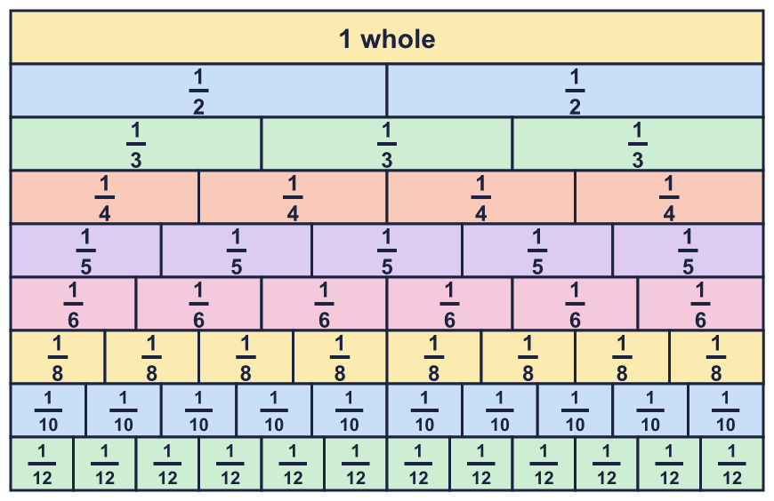 |  | Fraction wall to help you:
  Year 6 · Fractions A · Step 4  Comparing and ordering fractions (numerators) | 
  Year 6 · Fractions A · Step 4
  Comparing and ordering fractions (numerators)
  1 | The three bars are the same length. Which fraction is the smallest? Which is the greatest?  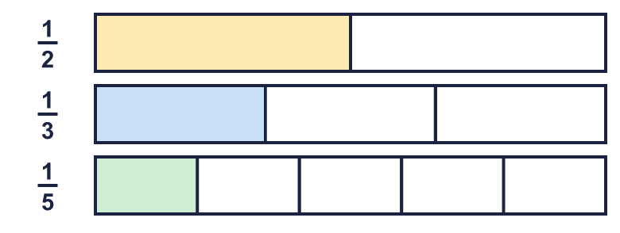  Hint: Look at the shaded part of each bar. The longer the shaded part, the greater the fraction.
  1 | The three bars are the same length. Which fraction is the smallest? Which is the greatest?  Hint: Look at the shaded part of each bar. The longer the shaded part, the greater the fraction.
  2 | Write <, > or = in each box. The numerators are the same.  Hint: When the numerators are the same, the fraction with the bigger denominator is smaller, because the whole is cut into more parts.
    a) | ³⁄₁₀ |  | ³⁄₇
    b) | ¹⁄₃ |  | ¹⁄₁₀
    c) | ³⁄₈ |  | ³⁄₁₀
    d) | ¹⁄₉ |  | ¹⁄₁₀
  2 | Write <, > or = in each box. The numerators are the same.  Hint: When the numerators are the same, the fraction with the bigger denominator is smaller, because the whole is cut into more parts.
    a) | ³⁄₁₀ |  | ³⁄₇
    b) | ¹⁄₃ |  | ¹⁄₁₀
    c) | ³⁄₈ |  | ³⁄₁₀
    d) | ¹⁄₉ |  | ¹⁄₁₀
  3 | Write the fractions in order, greatest first.  ¹⁄₂ ¹⁄₁₀ ¹⁄₅ ¹⁄₁₂  Hint: A unit fraction has 1 as the numerator. The bigger the denominator, the smaller the fraction.
  3 | Write the fractions in order, greatest first.  ¹⁄₂ ¹⁄₁₀ ¹⁄₅ ¹⁄₁₂  Hint: A unit fraction has 1 as the numerator. The bigger the denominator, the smaller the fraction.
  4 | Write the greatest fraction.  ⁷⁄₅₀ ⁷⁄₂₅ ⁷⁄₁₂ ⁷⁄₁₀₀₀  Hint: The numerators are the same. Look for the smallest denominator.
  4 | Write the greatest fraction.  ⁷⁄₅₀ ⁷⁄₂₅ ⁷⁄₁₂ ⁷⁄₁₀₀₀  Hint: The numerators are the same. Look for the smallest denominator.
  5 | Write <, > or = in each box.  Hint: Even when the fraction is more than 1, the same rule works: same numerator, bigger denominator means smaller fraction.
    a) | ³⁶⁄₉ |  | ³⁶⁄₁₀
    b) | ³⁹⁄₁₁ |  | ³⁹⁄₃
    c) | ⁴⁰⁄₁₂ |  | ⁴⁰⁄₅
    d) | ³⁴⁄₄ |  | ³⁴⁄₁₀
  5 | Write <, > or = in each box.  Hint: Even when the fraction is more than 1, the same rule works: same numerator, bigger denominator means smaller fraction.
    a) | ³⁶⁄₉ |  | ³⁶⁄₁₀
    b) | ³⁹⁄₁₁ |  | ³⁹⁄₃
    c) | ⁴⁰⁄₁₂ |  | ⁴⁰⁄₅
    d) | ³⁴⁄₄ |  | ³⁴⁄₁₀
  6 | Write the fractions in order, smallest first.  ⁵⁄₁₁ ⁵⁄₁₄ ⁵⁄₅ ⁵⁄₄  Hint: Put the denominators in order first. Remember: the biggest denominator makes the smallest fraction.
  6 | Write the fractions in order, smallest first.  ⁵⁄₁₁ ⁵⁄₁₄ ⁵⁄₅ ⁵⁄₄  Hint: Put the denominators in order first. Remember: the biggest denominator makes the smallest fraction.
  7 | Write <, > or = in each box. Change one fraction so that the numerators are the same.  Hint: Multiply the top and the bottom of the fraction with the smaller numerator so the numerators match.
    a) | ³⁄₈ |  | ⁶⁄₁₀
    b) | ⁴⁄₇ |  | ¹²⁄₁₃
    c) | ²⁄₅ |  | ⁶⁄₁₂
  7 | Write <, > or = in each box. Change one fraction so that the numerators are the same.  Hint: Multiply the top and the bottom of the fraction with the smaller numerator so the numerators match.
    a) | ³⁄₈ |  | ⁶⁄₁₀
    b) | ⁴⁄₇ |  | ¹²⁄₁₃
    c) | ²⁄₅ |  | ⁶⁄₁₂
  8 | Write the fractions in order, smallest first.  ³⁄₂₁ ⁶⁄₁₅ ¹²⁄₂₅  Hint: Make the numerators the same first. Which fraction is it easiest to change?
  8 | Write the fractions in order, smallest first.  ³⁄₂₁ ⁶⁄₁₅ ¹²⁄₂₅  Hint: Make the numerators the same first. Which fraction is it easiest to change?

  9 | Mo scores 18 out of 24 in a game.  Eva scores 6 out of 9 in a game.  Who did better? Write the name and explain why.  Hint: Write each score as a fraction. Simplify. Then use the numerators or the denominators to compare.
  9 | Mo scores 18 out of 24 in a game.  Eva scores 6 out of 9 in a game.  Who did better? Write the name and explain why.  Hint: Write each score as a fraction. Simplify. Then use the numerators or the denominators to compare.
  10 | Explain how to compare ¹⁄₂ and ²⁄₃ using the same numerator rule.  Hint: Find a number that both numerators go into. Multiply the top and the bottom of each fraction to reach it.
  10 | Explain how to compare ¹⁄₂ and ²⁄₃ using the same numerator rule.  Hint: Find a number that both numerators go into. Multiply the top and the bottom of each fraction to reach it.
  11 | Tia says: ⁶⁄₈ is greater than ⁶⁄₁₃.  Is Tia correct? Circle yes or no.  Yes / No  Explain how you know.  Hint: The numerators match. Which denominator is smaller?
  11 | Tia says: ⁶⁄₈ is greater than ⁶⁄₁₃.  Is Tia correct? Circle yes or no.  Yes / No  Explain how you know.  Hint: The numerators match. Which denominator is smaller?
  12 | Write all the whole numbers that make this correct.  ⁷⁄₅ > ⁷⁄? > ⁷⁄₉  Hint: The numerators are all 7. The denominator in the middle must be bigger than 5 and smaller than 9.
  12 | Write all the whole numbers that make this correct.  ⁷⁄₅ > ⁷⁄? > ⁷⁄₉  Hint: The numerators are all 7. The denominator in the middle must be bigger than 5 and smaller than 9.
  13 | Write a fraction that is greater than ⁶⁄₁₂ and less than ⁶⁄₁₀.  Hint: Keep the numerator the same. Choose a denominator that is between the other two denominators.
  13 | Write a fraction that is greater than ⁶⁄₁₂ and less than ⁶⁄₁₀.  Hint: Keep the numerator the same. Choose a denominator that is between the other two denominators.
  14 | Which fraction is nearer to 1: ⁷⁄₈ or ⁹⁄₁₀?  Think about how much is missing from 1 each time. Explain your answer.  Hint: What do you add to each fraction to make 1? Compare those two amounts.
  14 | Which fraction is nearer to 1: ⁷⁄₈ or ⁹⁄₁₀?  Think about how much is missing from 1 each time. Explain your answer.  Hint: What do you add to each fraction to make 1? Compare those two amounts.

Year 6 · Fractions A · Step 4
Comparing and ordering fractions (numerators)
Answers (teacher copy)

Fraction wall to help you:
  1 | The three bars are the same length. Which fraction is the smallest? Which is the greatest?  smallest: ¹⁄₅ greatest: ¹⁄₂  Hint: Look at the shaded part of each bar. The longer the shaded part, the greater the fraction.
  2 | Write <, > or = in each box. The numerators are the same.  a) ³⁄₁₀ < ³⁄₇  b) ¹⁄₃ > ¹⁄₁₀  c) ³⁄₈ > ³⁄₁₀  d) ¹⁄₉ > ¹⁄₁₀  Hint: When the numerators are the same, the fraction with the bigger denominator is smaller, because the whole is cut into more parts.
  3 | Write the fractions in order, greatest first.  ¹⁄₂ ¹⁄₁₀ ¹⁄₅ ¹⁄₁₂  ¹⁄₂, ¹⁄₅, ¹⁄₁₀, ¹⁄₁₂  Hint: A unit fraction has 1 as the numerator. The bigger the denominator, the smaller the fraction.
  4 | Write the greatest fraction.  ⁷⁄₅₀ ⁷⁄₂₅ ⁷⁄₁₂ ⁷⁄₁₀₀₀  ⁷⁄₁₂  Hint: The numerators are the same. Look for the smallest denominator.
  5 | Write <, > or = in each box.  a) ³⁶⁄₉ > ³⁶⁄₁₀  b) ³⁹⁄₁₁ < ³⁹⁄₃  c) ⁴⁰⁄₁₂ < ⁴⁰⁄₅  d) ³⁴⁄₄ > ³⁴⁄₁₀  Hint: Even when the fraction is more than 1, the same rule works: same numerator, bigger denominator means smaller fraction.
  6 | Write the fractions in order, smallest first.  ⁵⁄₁₁ ⁵⁄₁₄ ⁵⁄₅ ⁵⁄₄  ⁵⁄₁₄, ⁵⁄₁₁, ⁵⁄₅, ⁵⁄₄  Hint: Put the denominators in order first. Remember: the biggest denominator makes the smallest fraction.
  7 | Write <, > or = in each box. Change one fraction so that the numerators are the same.  a) ³⁄₈ < ⁶⁄₁₀  b) ⁴⁄₇ < ¹²⁄₁₃  c) ²⁄₅ < ⁶⁄₁₂  Hint: Multiply the top and the bottom of the fraction with the smaller numerator so the numerators match.
  8 | Write the fractions in order, smallest first.  ³⁄₂₁ ⁶⁄₁₅ ¹²⁄₂₅  ³⁄₂₁, ⁶⁄₁₅, ¹²⁄₂₅  Hint: Make the numerators the same first. Which fraction is it easiest to change?
  9 | Mo scores 18 out of 24 in a game.  Eva scores 6 out of 9 in a game.  Who did better? Write the name and explain why.  Mo  Mo did better. ¹⁸⁄₂₄ and ⁶⁄₉ compare as ³⁄₄ and ²⁄₃.  Hint: Write each score as a fraction. Simplify. Then use the numerators or the denominators to compare.
  10 | Explain how to compare ¹⁄₂ and ²⁄₃ using the same numerator rule.  Write both fractions with the numerator 2: ¹⁄₂ = ²⁄₄ and ²⁄₃ = ²⁄₃. The numerators are the same, and the bigger denominator makes the smaller fraction, so ²⁄₃ is greater.  Hint: Find a number that both numerators go into. Multiply the top and the bottom of each fraction to reach it.
  11 | Tia says: ⁶⁄₈ is greater than ⁶⁄₁₃.  Is Tia correct? Circle yes or no.  Yes / No  Explain how you know.  Yes. ⁶⁄₈ and ⁶⁄₁₃ both have the numerator 6. ⁶⁄₈ has the smaller denominator, so ⁶⁄₈ is the greater fraction.  Hint: The numerators match. Which denominator is smaller?
  12 | Write all the whole numbers that make this correct.  ⁷⁄₅ > ⁷⁄? > ⁷⁄₉ 6, 7, 8  Hint: The numerators are all 7. The denominator in the middle must be bigger than 5 and smaller than 9.
  13 | Write a fraction that is greater than ⁶⁄₁₂ and less than ⁶⁄₁₀.  for example ⁶⁄₁₁  Hint: Keep the numerator the same. Choose a denominator that is between the other two denominators.
  14 | Which fraction is nearer to 1: ⁷⁄₈ or ⁹⁄₁₀?  Think about how much is missing from 1 each time. Explain your answer.  ⁹⁄₁₀  ⁹⁄₁₀ is nearer to 1. ¹⁄₈ is missing from ⁷⁄₈ and ¹⁄₁₀ is missing from ⁹⁄₁₀. ¹⁄₁₀ is smaller than ¹⁄₈, so less is missing.  Hint: What do you add to each fraction to make 1? Compare those two amounts.

