Fraction wall to help you:  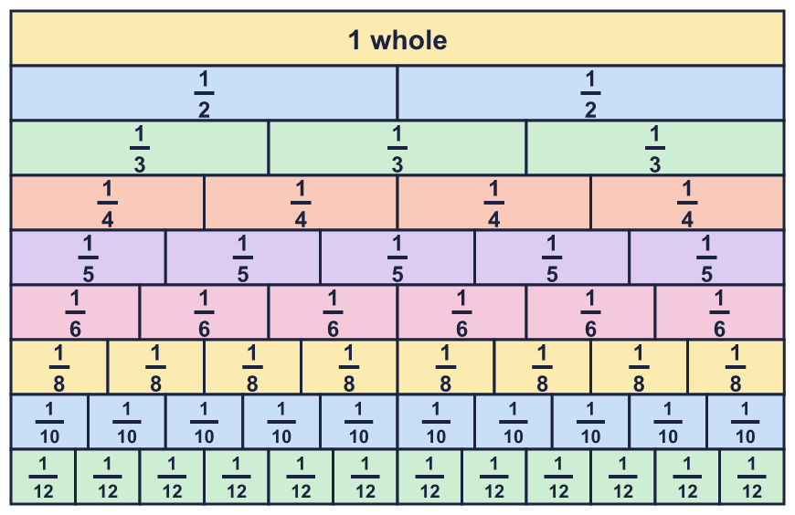 |  | Fraction wall to help you:
  Year 6 · Fractions A · Step 5  Adding and subtracting simple fractions | 
  Year 6 · Fractions A · Step 5
  Adding and subtracting simple fractions
  1 | Work out each addition. The bars help with a).  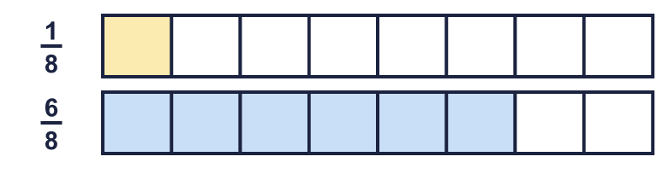  a) ¹⁄₈ + ⁶⁄₈ =  b) ¹⁄₉ + ⁷⁄₉ =  c) ¹⁄₅ + ³⁄₅ =  Hint: The denominators are the same. Add the numerators. Keep the denominator the same.
  1 | Work out each addition. The bars help with a).  a) ¹⁄₈ + ⁶⁄₈ =  b) ¹⁄₉ + ⁷⁄₉ =  c) ¹⁄₅ + ³⁄₅ =  Hint: The denominators are the same. Add the numerators. Keep the denominator the same.
  2 | Work out each calculation. Write the answer in its simplest form.  a) ⁷⁄₈ − ¹⁄₈ =  b) ³⁄₁₀ − ¹⁄₁₀ =  c) ¹⁄₁₂ + ¹¹⁄₁₂ =  d) ¹⁄₅ + ¹⁄₅ =  Hint: Add or subtract the numerators. Then simplify your answer if you can.
  2 | Work out each calculation. Write the answer in its simplest form.  a) ⁷⁄₈ − ¹⁄₈ =  b) ³⁄₁₀ − ¹⁄₁₀ =  c) ¹⁄₁₂ + ¹¹⁄₁₂ =  d) ¹⁄₅ + ¹⁄₅ =  Hint: Add or subtract the numerators. Then simplify your answer if you can.
  3 | Work out each addition. Write each answer as a mixed number.  a) ⁸⁄₉ + ⁵⁄₉ =  b) ³⁄₅ + ³⁄₅ =  c) ⁵⁄₉ + ⁵⁄₉ =  Hint: Add the numerators. If the numerator is bigger than the denominator, find how many wholes you can make.
  3 | Work out each addition. Write each answer as a mixed number.  a) ⁸⁄₉ + ⁵⁄₉ =  b) ³⁄₅ + ³⁄₅ =  c) ⁵⁄₉ + ⁵⁄₉ =  Hint: Add the numerators. If the numerator is bigger than the denominator, find how many wholes you can make.
  4 | Work out each addition. Write each answer in its simplest form.  a) ²⁄₅ + ⁴⁄₂₅ =  b) ²⁄₅ + ²⁄₁₅ =  c) ¹⁄₄ + ⁷⁄₁₂ =  d) ¹⁄₂ + ¹⁄₆ =  Hint: Change the fraction with the smaller denominator so both denominators match. Then add the numerators.
  4 | Work out each addition. Write each answer in its simplest form.  a) ²⁄₅ + ⁴⁄₂₅ =  b) ²⁄₅ + ²⁄₁₅ =  c) ¹⁄₄ + ⁷⁄₁₂ =  d) ¹⁄₂ + ¹⁄₆ =  Hint: Change the fraction with the smaller denominator so both denominators match. Then add the numerators.
  5 | Work out each subtraction. Write each answer in its simplest form.  a) ²⁄₃ − ¹⁄₆ =  b) ¹⁴⁄₁₅ − ²⁄₅ =  c) ³⁄₄ − ¹⁄₂ =  d) ³⁄₅ − ⁷⁄₂₅ =  Hint: Give both fractions the same denominator first. Then subtract the numerators.
  5 | Work out each subtraction. Write each answer in its simplest form.  a) ²⁄₃ − ¹⁄₆ =  b) ¹⁴⁄₁₅ − ²⁄₅ =  c) ³⁄₄ − ¹⁄₂ =  d) ³⁄₅ − ⁷⁄₂₅ =  Hint: Give both fractions the same denominator first. Then subtract the numerators.
  6 | Write the missing fraction in each calculation, in its simplest form.  a) ? + ¹⁷⁄₂₀ = ¹⁹⁄₂₀  b) ? + ²⁷⁄₁₀₀ = ⁸⁄₂₅  Hint: Use the opposite operation. To find a missing part, take the part you know away from the total.
  6 | Write the missing fraction in each calculation, in its simplest form.  a) ? + ¹⁷⁄₂₀ = ¹⁹⁄₂₀  b) ? + ²⁷⁄₁₀₀ = ⁸⁄₂₅  Hint: Use the opposite operation. To find a missing part, take the part you know away from the total.
  7 | Complete the part-whole model. Write the missing fraction in its simplest form.  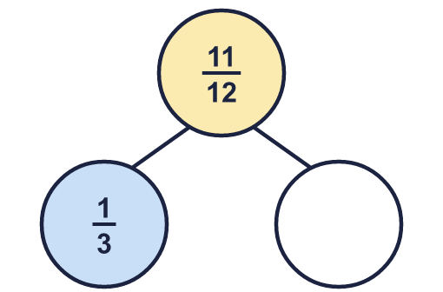  Hint: A part is the whole take away the other part.
  7 | Complete the part-whole model. Write the missing fraction in its simplest form.  Hint: A part is the whole take away the other part.
  8 | Work out each subtraction. Write each answer as a fraction or mixed number in its simplest form.  a) 1 − ⁵⁄₆ =  b) 1 − ⁹⁄₁₀ =  c) 1 − ²⁄₅ =  Hint: Write the whole number as a fraction with the same denominator. For example, 1 = ⁸⁄₈. Then subtract.
  8 | Work out each subtraction. Write each answer as a fraction or mixed number in its simplest form.  a) 1 − ⁵⁄₆ =  b) 1 − ⁹⁄₁₀ =  c) 1 − ²⁄₅ =  Hint: Write the whole number as a fraction with the same denominator. For example, 1 = ⁸⁄₈. Then subtract.

  9 | Eva spends ¹⁄₃ of the pocket money on a present.  Eva gives ⁵⁄₁₂ of the pocket money to charity.  What fraction of the pocket money is left? Write the answer in its simplest form.  Hint: Add the two fractions that were used. Then take the total away from 1 whole.
  9 | Eva spends ¹⁄₃ of the pocket money on a present.  Eva gives ⁵⁄₁₂ of the pocket money to charity.  What fraction of the pocket money is left? Write the answer in its simplest form.  Hint: Add the two fractions that were used. Then take the total away from 1 whole.
  10 | Sort the calculations. Write the letters of the calculations whose answer is less than 1 and the letters of those whose answer is more than 1.  A: ¹¹⁄₁₂ + ⁵⁄₆ B: ¹⁄₅ + ¹¹⁄₁₅ C: ⁷⁄₁₅ − ¹⁄₅  D: ¹⁸⁄₂₅ − ²⁄₅ E: ⁵⁄₆ + ⁵⁄₆ F: ⁴⁄₅ + ³⁄₅  Less than 1:  More than 1:  Hint: You do not always need the exact answer. Is the total more than one whole?
  10 | Sort the calculations. Write the letters of the calculations whose answer is less than 1 and the letters of those whose answer is more than 1.  A: ¹¹⁄₁₂ + ⁵⁄₆ B: ¹⁄₅ + ¹¹⁄₁₅ C: ⁷⁄₁₅ − ¹⁄₅  D: ¹⁸⁄₂₅ − ²⁄₅ E: ⁵⁄₆ + ⁵⁄₆ F: ⁴⁄₅ + ³⁄₅  Less than 1:  More than 1:  Hint: You do not always need the exact answer. Is the total more than one whole?
  11 | Amir says: ²⁄₇ + ¹⁄₇ = ³⁄₁₄.  Is Amir correct? Circle yes or no.  Yes / No  Explain what Amir did wrong and give the correct answer.  Hint: When fractions have the same denominator, only the numerators are added.
  11 | Amir says: ²⁄₇ + ¹⁄₇ = ³⁄₁₄.  Is Amir correct? Circle yes or no.  Yes / No  Explain what Amir did wrong and give the correct answer.  Hint: When fractions have the same denominator, only the numerators are added.
  12 | A jug holds ⁹⁄₁₀ of a litre of milk.  ³⁄₂₀ of a litre is poured into one glass and ³⁄₁₀₀ of a litre is poured into another glass.  How much is left in the jug? Write the answer as a fraction of a litre in its simplest form.  Hint: Add the two amounts that were poured out. Then take the total away from the amount in the jug.
  12 | A jug holds ⁹⁄₁₀ of a litre of milk.  ³⁄₂₀ of a litre is poured into one glass and ³⁄₁₀₀ of a litre is poured into another glass.  How much is left in the jug? Write the answer as a fraction of a litre in its simplest form.  Hint: Add the two amounts that were poured out. Then take the total away from the amount in the jug.
  13 | Two of these fractions add up to ²³⁄₂₅. Which two?  ³⁄₂₅ ²⁄₅ ⁴⁄₅ ⁸⁄₂₅ ⁷⁄₂₅  Hint: Take each fraction away from ²³⁄₂₅. Is the answer in the list?
  13 | Two of these fractions add up to ²³⁄₂₅. Which two?  ³⁄₂₅ ²⁄₅ ⁴⁄₅ ⁸⁄₂₅ ⁷⁄₂₅  Hint: Take each fraction away from ²³⁄₂₅. Is the answer in the list?
  14 | A ribbon is cut into three pieces.  The first piece is ¹⁄₂ m and the second piece is ¹⁄₄ m. The whole ribbon is 1 ¹⁄₂ m long.  How long is the third piece? Write the answer in its simplest form.  Hint: Add the two pieces you know. Then take that total away from the whole length.
  14 | A ribbon is cut into three pieces.  The first piece is ¹⁄₂ m and the second piece is ¹⁄₄ m. The whole ribbon is 1 ¹⁄₂ m long.  How long is the third piece? Write the answer in its simplest form.  Hint: Add the two pieces you know. Then take that total away from the whole length.

Year 6 · Fractions A · Step 5
Adding and subtracting simple fractions
Answers (teacher copy)

Fraction wall to help you:
  1 | Work out each addition. The bars help with a).  a) ¹⁄₈ + ⁶⁄₈ = ⁷⁄₈  b) ¹⁄₉ + ⁷⁄₉ = ⁸⁄₉  c) ¹⁄₅ + ³⁄₅ = ⁴⁄₅  Hint: The denominators are the same. Add the numerators. Keep the denominator the same.
  2 | Work out each calculation. Write the answer in its simplest form.  a) ⁷⁄₈ − ¹⁄₈ = ³⁄₄  b) ³⁄₁₀ − ¹⁄₁₀ = ¹⁄₅  c) ¹⁄₁₂ + ¹¹⁄₁₂ = 1  d) ¹⁄₅ + ¹⁄₅ = ²⁄₅  Hint: Add or subtract the numerators. Then simplify your answer if you can.
  3 | Work out each addition. Write each answer as a mixed number.  a) ⁸⁄₉ + ⁵⁄₉ = 1 ⁴⁄₉  b) ³⁄₅ + ³⁄₅ = 1 ¹⁄₅  c) ⁵⁄₉ + ⁵⁄₉ = 1 ¹⁄₉  Hint: Add the numerators. If the numerator is bigger than the denominator, find how many wholes you can make.
  4 | Work out each addition. Write each answer in its simplest form.  a) ²⁄₅ + ⁴⁄₂₅ = ¹⁴⁄₂₅  b) ²⁄₅ + ²⁄₁₅ = ⁸⁄₁₅  c) ¹⁄₄ + ⁷⁄₁₂ = ⁵⁄₆  d) ¹⁄₂ + ¹⁄₆ = ²⁄₃  Hint: Change the fraction with the smaller denominator so both denominators match. Then add the numerators.
  5 | Work out each subtraction. Write each answer in its simplest form.  a) ²⁄₃ − ¹⁄₆ = ¹⁄₂  b) ¹⁴⁄₁₅ − ²⁄₅ = ⁸⁄₁₅  c) ³⁄₄ − ¹⁄₂ = ¹⁄₄  d) ³⁄₅ − ⁷⁄₂₅ = ⁸⁄₂₅  Hint: Give both fractions the same denominator first. Then subtract the numerators.
  6 | Write the missing fraction in each calculation, in its simplest form.  a) ? + ¹⁷⁄₂₀ = ¹⁹⁄₂₀ ¹⁄₁₀  b) ? + ²⁷⁄₁₀₀ = ⁸⁄₂₅ ¹⁄₂₀  Hint: Use the opposite operation. To find a missing part, take the part you know away from the total.
  7 | Complete the part-whole model. Write the missing fraction in its simplest form.  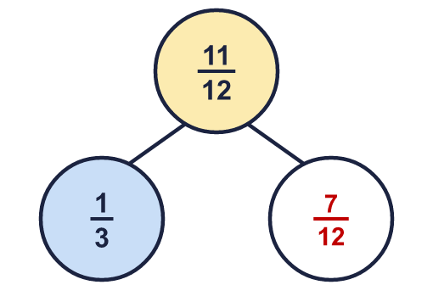  Missing: ⁷⁄₁₂  Hint: A part is the whole take away the other part.
  8 | Work out each subtraction. Write each answer as a fraction or mixed number in its simplest form.  a) 1 − ⁵⁄₆ = ¹⁄₆  b) 1 − ⁹⁄₁₀ = ¹⁄₁₀  c) 1 − ²⁄₅ = ³⁄₅  Hint: Write the whole number as a fraction with the same denominator. For example, 1 = ⁸⁄₈. Then subtract.
  9 | Eva spends ¹⁄₃ of the pocket money on a present.  Eva gives ⁵⁄₁₂ of the pocket money to charity.  What fraction of the pocket money is left? Write the answer in its simplest form.  ¹⁄₄  Hint: Add the two fractions that were used. Then take the total away from 1 whole.
  10 | Sort the calculations. Write the letters of the calculations whose answer is less than 1 and the letters of those whose answer is more than 1.  A: ¹¹⁄₁₂ + ⁵⁄₆ B: ¹⁄₅ + ¹¹⁄₁₅ C: ⁷⁄₁₅ − ¹⁄₅  D: ¹⁸⁄₂₅ − ²⁄₅ E: ⁵⁄₆ + ⁵⁄₆ F: ⁴⁄₅ + ³⁄₅  Less than 1: B, C, D  More than 1: A, E, F  Hint: You do not always need the exact answer. Is the total more than one whole?
  11 | Amir says: ²⁄₇ + ¹⁄₇ = ³⁄₁₄.  Is Amir correct? Circle yes or no.  Yes / No  Explain what Amir did wrong and give the correct answer.  No. Amir added the denominators as well as the numerators. When the denominators match they stay the same. ²⁄₇ + ¹⁄₇ = ³⁄₇.  Hint: When fractions have the same denominator, only the numerators are added.
  12 | A jug holds ⁹⁄₁₀ of a litre of milk.  ³⁄₂₀ of a litre is poured into one glass and ³⁄₁₀₀ of a litre is poured into another glass.  How much is left in the jug? Write the answer as a fraction of a litre in its simplest form.  ¹⁸⁄₂₅ of a litre  Hint: Add the two amounts that were poured out. Then take the total away from the amount in the jug.
  13 | Two of these fractions add up to ²³⁄₂₅. Which two?  ³⁄₂₅ ²⁄₅ ⁴⁄₅ ⁸⁄₂₅ ⁷⁄₂₅  ³⁄₂₅ and ⁴⁄₅  Hint: Take each fraction away from ²³⁄₂₅. Is the answer in the list?
  14 | A ribbon is cut into three pieces.  The first piece is ¹⁄₂ m and the second piece is ¹⁄₄ m. The whole ribbon is 1 ¹⁄₂ m long.  How long is the third piece? Write the answer in its simplest form.  ³⁄₄ m  Hint: Add the two pieces you know. Then take that total away from the whole length.

