5 miles ≈ 8 km, so 1 mile ≈ 1.6 km:  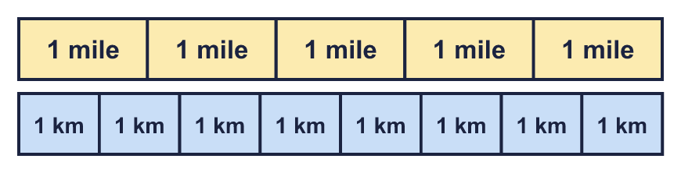 |  | 5 miles ≈ 8 km, so 1 mile ≈ 1.6 km:
  Year 6 · Converting units · Step 4  Miles and kilometres | 
  Year 6 · Converting units · Step 4
  Miles and kilometres
  1 | Two of these statements are true. Use the bar model to help you.  A: 5 miles is shorter than 5 kilometres  B: 1 mile is longer than 1 kilometre  C: 2 miles is shorter than 2 kilometres  D: 1 mile is shorter than 5 kilometres  Write the letters of the two true statements.  Hint: Count the boxes. 5 mile boxes are as long as 8 kilometre boxes, so a kilometre is shorter than a mile.
  1 | Two of these statements are true. Use the bar model to help you.  A: 5 miles is shorter than 5 kilometres  B: 1 mile is longer than 1 kilometre  C: 2 miles is shorter than 2 kilometres  D: 1 mile is shorter than 5 kilometres  Write the letters of the two true statements.  Hint: Count the boxes. 5 mile boxes are as long as 8 kilometre boxes, so a kilometre is shorter than a mile.
  2 | Write the missing numbers on the double number line. Remember: 5 miles ≈ 8 km, so 1 mile ≈ 1.6 km.  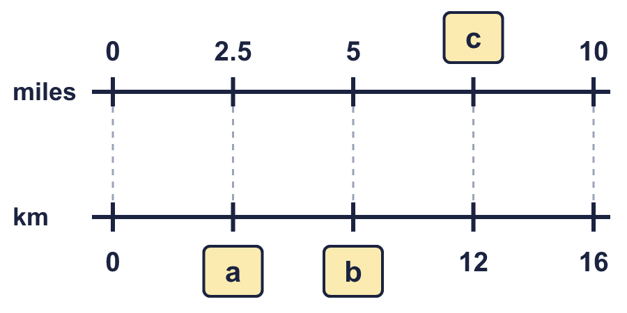  Hint: Each pair of numbers is level. The kilometres are 1.6 times the miles. Use the pairs you can see.
  2 | Write the missing numbers on the double number line. Remember: 5 miles ≈ 8 km, so 1 mile ≈ 1.6 km.  Hint: Each pair of numbers is level. The kilometres are 1.6 times the miles. Use the pairs you can see.
  3 | Use 5 miles ≈ 8 km to complete the conversions.  a) 5 miles ≈ km  b) 10 miles ≈ km  c) 25 miles ≈ km  Hint: Count how many lots of 5 miles there are. Multiply 8 km by that number.
  3 | Use 5 miles ≈ 8 km to complete the conversions.  a) 5 miles ≈ km  b) 10 miles ≈ km  c) 25 miles ≈ km  Hint: Count how many lots of 5 miles there are. Multiply 8 km by that number.
  4 | Use 5 miles ≈ 8 km to complete the conversions.  a) miles ≈ 8 km  b) miles ≈ 16 km  c) miles ≈ 24 km  Hint: Count how many lots of 8 km there are. Multiply 5 miles by that number.
  4 | Use 5 miles ≈ 8 km to complete the conversions.  a) miles ≈ 8 km  b) miles ≈ 16 km  c) miles ≈ 24 km  Hint: Count how many lots of 8 km there are. Multiply 5 miles by that number.
  5 | Complete the conversions. Remember: 5 miles ≈ 8 km, so 1 mile ≈ 1.6 km.  a) 2.5 miles ≈ km  b) miles ≈ 5.6 km  c) 4 miles ≈ km  d) miles ≈ 1.6 km  Hint: 1 mile is 1.6 km. Halve and double 1.6 to help with 0.5 miles and 2 miles.
  5 | Complete the conversions. Remember: 5 miles ≈ 8 km, so 1 mile ≈ 1.6 km.  a) 2.5 miles ≈ km  b) miles ≈ 5.6 km  c) 4 miles ≈ km  d) miles ≈ 1.6 km  Hint: 1 mile is 1.6 km. Halve and double 1.6 to help with 0.5 miles and 2 miles.
  6 | Complete the conversions. Remember: 5 miles ≈ 8 km, so 1 mile ≈ 1.6 km.  a) miles ≈ 400 km  b) 250 miles ≈ km  c) miles ≈ 160 km  d) 95 miles ≈ km  Hint: Use 5 miles ≈ 8 km: split the number of miles into lots of 5, or use 1 mile ≈ 1.6 km and multiply.
  6 | Complete the conversions. Remember: 5 miles ≈ 8 km, so 1 mile ≈ 1.6 km.  a) miles ≈ 400 km  b) 250 miles ≈ km  c) miles ≈ 160 km  d) 95 miles ≈ km  Hint: Use 5 miles ≈ 8 km: split the number of miles into lots of 5, or use 1 mile ≈ 1.6 km and multiply.
  7 | Rosie walks 26.2 miles. Remember: 5 miles ≈ 8 km, so 1 mile ≈ 1.6 km.  About how many kilometres is this?  Hint: Multiply 26.2 by 1.6.
  7 | Rosie walks 26.2 miles. Remember: 5 miles ≈ 8 km, so 1 mile ≈ 1.6 km.  About how many kilometres is this?  Hint: Multiply 26.2 by 1.6.
  8 | A road sign says the next town is 32 km away. Remember: 5 miles ≈ 8 km, so 1 mile ≈ 1.6 km.  About how many miles is this?  Hint: Use 8 km ≈ 5 miles. How many lots of 8 km are there?
  8 | A road sign says the next town is 32 km away. Remember: 5 miles ≈ 8 km, so 1 mile ≈ 1.6 km.  About how many miles is this?  Hint: Use 8 km ≈ 5 miles. How many lots of 8 km are there?

  9 | Tia knows that 5 miles ≈ 8 km. Tia works out 15 miles like this:  5 miles ≈ 8 km  +10 miles ≈ +10 km  15 miles ≈ 18 km  Tia has made a mistake. Explain the mistake, then write the correct answer.  Hint: 15 miles is 3 lots of 5 miles. Multiply 8 km by 3.
  9 | Tia knows that 5 miles ≈ 8 km. Tia works out 15 miles like this:  5 miles ≈ 8 km  +10 miles ≈ +10 km  15 miles ≈ 18 km  Tia has made a mistake. Explain the mistake, then write the correct answer.  Hint: 15 miles is 3 lots of 5 miles. Multiply 8 km by 3.
  10 | The speed limit on main roads in the UK is 60 miles per hour. In Spain it is 110 kilometres per hour. Remember: 5 miles ≈ 8 km, so 1 mile ≈ 1.6 km.  Which country has the higher speed limit? What is the difference in miles per hour?  Hint: Change 110 km per hour to miles per hour: divide by 1.6. Then compare with 60.
  10 | The speed limit on main roads in the UK is 60 miles per hour. In Spain it is 110 kilometres per hour. Remember: 5 miles ≈ 8 km, so 1 mile ≈ 1.6 km.  Which country has the higher speed limit? What is the difference in miles per hour?  Hint: Change 110 km per hour to miles per hour: divide by 1.6. Then compare with 60.
  11 | Tia ran a total of 38 km in 7 days. Amir ran a total of 20 miles in 5 days. Remember: 5 miles ≈ 8 km, so 1 mile ≈ 1.6 km.  Who ran further? About how many kilometres further?  Hint: Change Amir’s miles to kilometres. Multiply by 1.6. Then compare.
  11 | Tia ran a total of 38 km in 7 days. Amir ran a total of 20 miles in 5 days. Remember: 5 miles ≈ 8 km, so 1 mile ≈ 1.6 km.  Who ran further? About how many kilometres further?  Hint: Change Amir’s miles to kilometres. Multiply by 1.6. Then compare.
  12 | Esther cycles 66 miles in 4 days. On day 1 Esther cycles 14 miles. On day 2 Esther cycles 16 km. On day 4 Esther cycles twice as far as on day 3. Remember: 5 miles ≈ 8 km, so 1 mile ≈ 1.6 km.  How far does Esther cycle on day 4?  Hint: Change day 2 to miles. Take days 1 and 2 away from the total. Share the rest between day 3 and day 4 in the ratio 1 to 2.
  12 | Esther cycles 66 miles in 4 days. On day 1 Esther cycles 14 miles. On day 2 Esther cycles 16 km. On day 4 Esther cycles twice as far as on day 3. Remember: 5 miles ≈ 8 km, so 1 mile ≈ 1.6 km.  How far does Esther cycle on day 4?  Hint: Change day 2 to miles. Take days 1 and 2 away from the total. Share the rest between day 3 and day 4 in the ratio 1 to 2.
  13 | Ravi cycles 3 km to school and 3 km home again every weekday. At the weekend Ravi goes on a 5-mile bike ride. Remember: 5 miles ≈ 8 km, so 1 mile ≈ 1.6 km.  About how many kilometres does Ravi cycle in one week?  Hint: Work out the school journeys in km (5 days, there and back). Change the weekend ride to km. Add.
  13 | Ravi cycles 3 km to school and 3 km home again every weekday. At the weekend Ravi goes on a 5-mile bike ride. Remember: 5 miles ≈ 8 km, so 1 mile ≈ 1.6 km.  About how many kilometres does Ravi cycle in one week?  Hint: Work out the school journeys in km (5 days, there and back). Change the weekend ride to km. Add.
  14 | Challenge  Zach knows that 96 km ≈ 60 miles. Zach says: “9.6 km ≈ 60 miles.”  Is Zach correct? Circle yes or no.  Yes / No  Explain how you know. If not, write the correct number of miles.  Hint: Compare 9.6 km with 96 km. Is it 10 or 100 times bigger or smaller? Do the same to 60 miles.
  14 | Challenge  Zach knows that 96 km ≈ 60 miles. Zach says: “9.6 km ≈ 60 miles.”  Is Zach correct? Circle yes or no.  Yes / No  Explain how you know. If not, write the correct number of miles.  Hint: Compare 9.6 km with 96 km. Is it 10 or 100 times bigger or smaller? Do the same to 60 miles.

Year 6 · Converting units · Step 4
Miles and kilometres
Answers (teacher copy)

5 miles ≈ 8 km, so 1 mile ≈ 1.6 km:
  1 | Two of these statements are true. Use the bar model to help you.  A: 5 miles is shorter than 5 kilometres  B: 1 mile is longer than 1 kilometre  C: 2 miles is shorter than 2 kilometres  D: 1 mile is shorter than 5 kilometres  Write the letters of the two true statements.  B, D  Hint: Count the boxes. 5 mile boxes are as long as 8 kilometre boxes, so a kilometre is shorter than a mile.
  2 | Write the missing numbers on the double number line. Remember: 5 miles ≈ 8 km, so 1 mile ≈ 1.6 km.  a = 4 km  b = 8 km  c = 7.5 miles  Hint: Each pair of numbers is level. The kilometres are 1.6 times the miles. Use the pairs you can see.
  3 | Use 5 miles ≈ 8 km to complete the conversions.  a) 5 miles ≈ 8 km  b) 10 miles ≈ 16 km  c) 25 miles ≈ 40 km  Hint: Count how many lots of 5 miles there are. Multiply 8 km by that number.
  4 | Use 5 miles ≈ 8 km to complete the conversions.  a) 5 miles ≈ 8 km  b) 10 miles ≈ 16 km  c) 15 miles ≈ 24 km  Hint: Count how many lots of 8 km there are. Multiply 5 miles by that number.
  5 | Complete the conversions. Remember: 5 miles ≈ 8 km, so 1 mile ≈ 1.6 km.  a) 2.5 miles ≈ 4 km  b) 3.5 miles ≈ 5.6 km  c) 4 miles ≈ 6.4 km  d) 1 miles ≈ 1.6 km  Hint: 1 mile is 1.6 km. Halve and double 1.6 to help with 0.5 miles and 2 miles.
  6 | Complete the conversions. Remember: 5 miles ≈ 8 km, so 1 mile ≈ 1.6 km.  a) 250 miles ≈ 400 km  b) 250 miles ≈ 400 km  c) 100 miles ≈ 160 km  d) 95 miles ≈ 152 km  Hint: Use 5 miles ≈ 8 km: split the number of miles into lots of 5, or use 1 mile ≈ 1.6 km and multiply.
  7 | Rosie walks 26.2 miles. Remember: 5 miles ≈ 8 km, so 1 mile ≈ 1.6 km.  About how many kilometres is this?  41.92 km  Hint: Multiply 26.2 by 1.6.
  8 | A road sign says the next town is 32 km away. Remember: 5 miles ≈ 8 km, so 1 mile ≈ 1.6 km.  About how many miles is this?  20 miles  Hint: Use 8 km ≈ 5 miles. How many lots of 8 km are there?
  9 | Tia knows that 5 miles ≈ 8 km. Tia works out 15 miles like this:  5 miles ≈ 8 km  +10 miles ≈ +10 km  15 miles ≈ 18 km  Tia has made a mistake. Explain the mistake, then write the correct answer.  Tia added 10 km instead of multiplying. 15 miles is 3 times as far as 5 miles, so it is 3 × 8 = 24 km.  Correct answer: 24 km  Hint: 15 miles is 3 lots of 5 miles. Multiply 8 km by 3.
  10 | The speed limit on main roads in the UK is 60 miles per hour. In Spain it is 110 kilometres per hour. Remember: 5 miles ≈ 8 km, so 1 mile ≈ 1.6 km.  Which country has the higher speed limit? What is the difference in miles per hour?  Higher: Spain  Difference: 8.75 miles per hour  Hint: Change 110 km per hour to miles per hour: divide by 1.6. Then compare with 60.
  11 | Tia ran a total of 38 km in 7 days. Amir ran a total of 20 miles in 5 days. Remember: 5 miles ≈ 8 km, so 1 mile ≈ 1.6 km.  Who ran further? About how many kilometres further?  Tia  6 km  Hint: Change Amir’s miles to kilometres. Multiply by 1.6. Then compare.
  12 | Esther cycles 66 miles in 4 days. On day 1 Esther cycles 14 miles. On day 2 Esther cycles 16 km. On day 4 Esther cycles twice as far as on day 3. Remember: 5 miles ≈ 8 km, so 1 mile ≈ 1.6 km.  How far does Esther cycle on day 4?  28 miles  44.8 km  Hint: Change day 2 to miles. Take days 1 and 2 away from the total. Share the rest between day 3 and day 4 in the ratio 1 to 2.
  13 | Ravi cycles 3 km to school and 3 km home again every weekday. At the weekend Ravi goes on a 5-mile bike ride. Remember: 5 miles ≈ 8 km, so 1 mile ≈ 1.6 km.  About how many kilometres does Ravi cycle in one week?  38 km  Hint: Work out the school journeys in km (5 days, there and back). Change the weekend ride to km. Add.
  14 | Challenge  Zach knows that 96 km ≈ 60 miles. Zach says: “9.6 km ≈ 60 miles.”  Is Zach correct? Circle yes or no.  Yes / No  Explain how you know. If not, write the correct number of miles.  No. 9.6 km ≈ 6 miles.  Hint: Compare 9.6 km with 96 km. Is it 10 or 100 times bigger or smaller? Do the same to 60 miles.

