  Year 6 · Converting units · Step 4  Miles and kilometres | 
  Year 6 · Converting units · Step 4
  Miles and kilometres
  1 | Two of these statements are true. Use the bar model to help you.  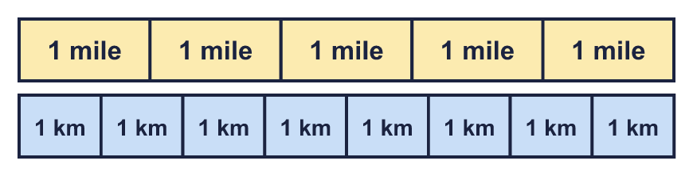  A: 5 miles is shorter than 5 kilometres  B: 1 mile is longer than 1 kilometre  C: 2 miles is shorter than 2 kilometres  D: 1 mile is shorter than 5 kilometres  Write the letters of the two true statements.
  1 | Two of these statements are true. Use the bar model to help you.  A: 5 miles is shorter than 5 kilometres  B: 1 mile is longer than 1 kilometre  C: 2 miles is shorter than 2 kilometres  D: 1 mile is shorter than 5 kilometres  Write the letters of the two true statements.
  2 | Write the missing numbers on the double number line. Remember: 5 miles ≈ 8 km, so 1 mile ≈ 1.6 km.  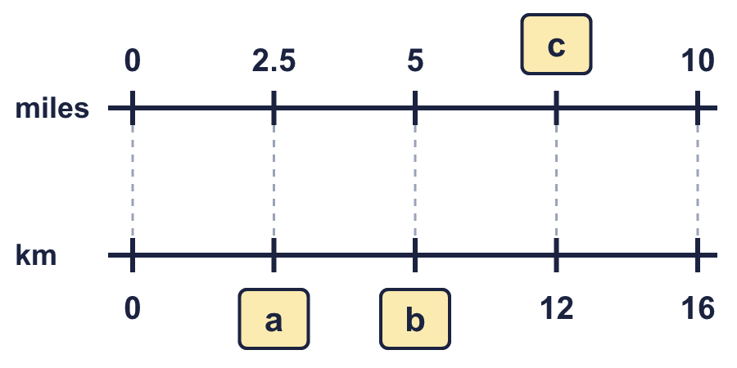
  2 | Write the missing numbers on the double number line. Remember: 5 miles ≈ 8 km, so 1 mile ≈ 1.6 km.
  3 | Use 5 miles ≈ 8 km to complete the conversions.  a) 5 miles ≈ km  b) 10 miles ≈ km  c) 25 miles ≈ km
  3 | Use 5 miles ≈ 8 km to complete the conversions.  a) 5 miles ≈ km  b) 10 miles ≈ km  c) 25 miles ≈ km
  4 | Use 5 miles ≈ 8 km to complete the conversions.  a) miles ≈ 8 km  b) miles ≈ 16 km  c) miles ≈ 24 km
  4 | Use 5 miles ≈ 8 km to complete the conversions.  a) miles ≈ 8 km  b) miles ≈ 16 km  c) miles ≈ 24 km
  5 | Complete the conversions. Remember: 5 miles ≈ 8 km, so 1 mile ≈ 1.6 km.  a) 2.5 miles ≈ km  b) miles ≈ 5.6 km  c) 4 miles ≈ km  d) miles ≈ 1.6 km
  5 | Complete the conversions. Remember: 5 miles ≈ 8 km, so 1 mile ≈ 1.6 km.  a) 2.5 miles ≈ km  b) miles ≈ 5.6 km  c) 4 miles ≈ km  d) miles ≈ 1.6 km
  6 | Complete the conversions. Remember: 5 miles ≈ 8 km, so 1 mile ≈ 1.6 km.  a) miles ≈ 400 km  b) 250 miles ≈ km  c) miles ≈ 160 km  d) 95 miles ≈ km
  6 | Complete the conversions. Remember: 5 miles ≈ 8 km, so 1 mile ≈ 1.6 km.  a) miles ≈ 400 km  b) 250 miles ≈ km  c) miles ≈ 160 km  d) 95 miles ≈ km
  7 | Rosie walks 26.2 miles. Remember: 5 miles ≈ 8 km, so 1 mile ≈ 1.6 km.  About how many kilometres is this?
  7 | Rosie walks 26.2 miles. Remember: 5 miles ≈ 8 km, so 1 mile ≈ 1.6 km.  About how many kilometres is this?
  8 | A road sign says the next town is 32 km away. Remember: 5 miles ≈ 8 km, so 1 mile ≈ 1.6 km.  About how many miles is this?
  8 | A road sign says the next town is 32 km away. Remember: 5 miles ≈ 8 km, so 1 mile ≈ 1.6 km.  About how many miles is this?

  9 | Tia knows that 5 miles ≈ 8 km. Tia works out 15 miles like this:  5 miles ≈ 8 km  +10 miles ≈ +10 km  15 miles ≈ 18 km  Tia has made a mistake. Explain the mistake, then write the correct answer.
  9 | Tia knows that 5 miles ≈ 8 km. Tia works out 15 miles like this:  5 miles ≈ 8 km  +10 miles ≈ +10 km  15 miles ≈ 18 km  Tia has made a mistake. Explain the mistake, then write the correct answer.
  10 | The speed limit on main roads in the UK is 60 miles per hour. In Spain it is 110 kilometres per hour. Remember: 5 miles ≈ 8 km, so 1 mile ≈ 1.6 km.  Which country has the higher speed limit? What is the difference in miles per hour?
  10 | The speed limit on main roads in the UK is 60 miles per hour. In Spain it is 110 kilometres per hour. Remember: 5 miles ≈ 8 km, so 1 mile ≈ 1.6 km.  Which country has the higher speed limit? What is the difference in miles per hour?
  11 | Tia ran a total of 38 km in 7 days. Amir ran a total of 20 miles in 5 days. Remember: 5 miles ≈ 8 km, so 1 mile ≈ 1.6 km.  Who ran further? About how many kilometres further?
  11 | Tia ran a total of 38 km in 7 days. Amir ran a total of 20 miles in 5 days. Remember: 5 miles ≈ 8 km, so 1 mile ≈ 1.6 km.  Who ran further? About how many kilometres further?
  12 | Esther cycles 66 miles in 4 days. On day 1 Esther cycles 14 miles. On day 2 Esther cycles 16 km. On day 4 Esther cycles twice as far as on day 3. Remember: 5 miles ≈ 8 km, so 1 mile ≈ 1.6 km.  How far does Esther cycle on day 4?
  12 | Esther cycles 66 miles in 4 days. On day 1 Esther cycles 14 miles. On day 2 Esther cycles 16 km. On day 4 Esther cycles twice as far as on day 3. Remember: 5 miles ≈ 8 km, so 1 mile ≈ 1.6 km.  How far does Esther cycle on day 4?
  13 | Ravi cycles 3 km to school and 3 km home again every weekday. At the weekend Ravi goes on a 5-mile bike ride. Remember: 5 miles ≈ 8 km, so 1 mile ≈ 1.6 km.  About how many kilometres does Ravi cycle in one week?
  13 | Ravi cycles 3 km to school and 3 km home again every weekday. At the weekend Ravi goes on a 5-mile bike ride. Remember: 5 miles ≈ 8 km, so 1 mile ≈ 1.6 km.  About how many kilometres does Ravi cycle in one week?
  14 | Challenge  Zach knows that 96 km ≈ 60 miles. Zach says: “9.6 km ≈ 60 miles.”  Is Zach correct? Circle yes or no.  Yes / No  Explain how you know. If not, write the correct number of miles.
  14 | Challenge  Zach knows that 96 km ≈ 60 miles. Zach says: “9.6 km ≈ 60 miles.”  Is Zach correct? Circle yes or no.  Yes / No  Explain how you know. If not, write the correct number of miles.

Year 6 · Converting units · Step 4
Miles and kilometres
Answers (teacher copy)

  1 | Two of these statements are true. Use the bar model to help you.  A: 5 miles is shorter than 5 kilometres  B: 1 mile is longer than 1 kilometre  C: 2 miles is shorter than 2 kilometres  D: 1 mile is shorter than 5 kilometres  Write the letters of the two true statements.  B, D
  2 | Write the missing numbers on the double number line. Remember: 5 miles ≈ 8 km, so 1 mile ≈ 1.6 km.  a = 4 km  b = 8 km  c = 7.5 miles
  3 | Use 5 miles ≈ 8 km to complete the conversions.  a) 5 miles ≈ 8 km  b) 10 miles ≈ 16 km  c) 25 miles ≈ 40 km
  4 | Use 5 miles ≈ 8 km to complete the conversions.  a) 5 miles ≈ 8 km  b) 10 miles ≈ 16 km  c) 15 miles ≈ 24 km
  5 | Complete the conversions. Remember: 5 miles ≈ 8 km, so 1 mile ≈ 1.6 km.  a) 2.5 miles ≈ 4 km  b) 3.5 miles ≈ 5.6 km  c) 4 miles ≈ 6.4 km  d) 1 miles ≈ 1.6 km
  6 | Complete the conversions. Remember: 5 miles ≈ 8 km, so 1 mile ≈ 1.6 km.  a) 250 miles ≈ 400 km  b) 250 miles ≈ 400 km  c) 100 miles ≈ 160 km  d) 95 miles ≈ 152 km
  7 | Rosie walks 26.2 miles. Remember: 5 miles ≈ 8 km, so 1 mile ≈ 1.6 km.  About how many kilometres is this?  41.92 km
  8 | A road sign says the next town is 32 km away. Remember: 5 miles ≈ 8 km, so 1 mile ≈ 1.6 km.  About how many miles is this?  20 miles
  9 | Tia knows that 5 miles ≈ 8 km. Tia works out 15 miles like this:  5 miles ≈ 8 km  +10 miles ≈ +10 km  15 miles ≈ 18 km  Tia has made a mistake. Explain the mistake, then write the correct answer.  Tia added 10 km instead of multiplying. 15 miles is 3 times as far as 5 miles, so it is 3 × 8 = 24 km.  Correct answer: 24 km
  10 | The speed limit on main roads in the UK is 60 miles per hour. In Spain it is 110 kilometres per hour. Remember: 5 miles ≈ 8 km, so 1 mile ≈ 1.6 km.  Which country has the higher speed limit? What is the difference in miles per hour?  Higher: Spain  Difference: 8.75 miles per hour
  11 | Tia ran a total of 38 km in 7 days. Amir ran a total of 20 miles in 5 days. Remember: 5 miles ≈ 8 km, so 1 mile ≈ 1.6 km.  Who ran further? About how many kilometres further?  Tia  6 km
  12 | Esther cycles 66 miles in 4 days. On day 1 Esther cycles 14 miles. On day 2 Esther cycles 16 km. On day 4 Esther cycles twice as far as on day 3. Remember: 5 miles ≈ 8 km, so 1 mile ≈ 1.6 km.  How far does Esther cycle on day 4?  28 miles  44.8 km
  13 | Ravi cycles 3 km to school and 3 km home again every weekday. At the weekend Ravi goes on a 5-mile bike ride. Remember: 5 miles ≈ 8 km, so 1 mile ≈ 1.6 km.  About how many kilometres does Ravi cycle in one week?  38 km
  14 | Challenge  Zach knows that 96 km ≈ 60 miles. Zach says: “9.6 km ≈ 60 miles.”  Is Zach correct? Circle yes or no.  Yes / No  Explain how you know. If not, write the correct number of miles.  No. 9.6 km ≈ 6 miles.

