Change to the same unit before you add or subtract:  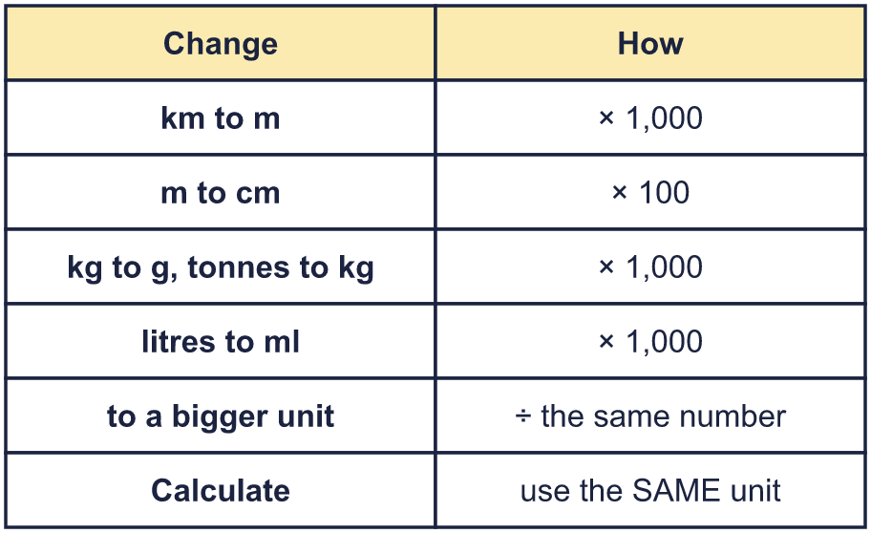 |  | Change to the same unit before you add or subtract:
  Year 6 · Converting units · Step 3  Calculating with metric units | 
  Year 6 · Converting units · Step 3
  Calculating with metric units
  1 | A running track is 400 m all the way round. Jo runs 4 laps.  How far does Jo run? Write your answer in metres and in kilometres.  Hint: Multiply 400 by 4. To change metres to kilometres divide by 1,000.
  1 | A running track is 400 m all the way round. Jo runs 4 laps.  How far does Jo run? Write your answer in metres and in kilometres.  Hint: Multiply 400 by 4. To change metres to kilometres divide by 1,000.
  2 | Work out each answer. Change to the same unit first.  a) 2.3 km + 650 m = km  b) 7.2 litres − 700 ml = litres  c) 6.5 m + 200 cm = cm  Hint: Write both amounts in the unit you want for the answer. Then add or subtract.
  2 | Work out each answer. Change to the same unit first.  a) 2.3 km + 650 m = km  b) 7.2 litres − 700 ml = litres  c) 6.5 m + 200 cm = cm  Hint: Write both amounts in the unit you want for the answer. Then add or subtract.
  3 | Work out each answer.  a) 350 ml × 5 = litres  b) 25 cm × 5 = m  c) 250 m × 4 = km  Hint: Multiply first. Then change to the unit asked for.
  3 | Work out each answer.  a) 350 ml × 5 = litres  b) 25 cm × 5 = m  c) 250 m × 4 = km  Hint: Multiply first. Then change to the unit asked for.
  4 | Work out each answer. Give the answer in the unit shown.  a) 2.4 km ÷ 3 = m  b) 5.5 km ÷ 5 = m  c) 0.8 kg ÷ 8 = g  Hint: Change the big unit to the small unit first. Then divide.
  4 | Work out each answer. Give the answer in the unit shown.  a) 2.4 km ÷ 3 = m  b) 5.5 km ÷ 5 = m  c) 0.8 kg ÷ 8 = g  Hint: Change the big unit to the small unit first. Then divide.
  5 | Ron has 2 litres of orange juice. Ron drinks 200 ml. Ron then shares the rest equally between 4 glasses.  How much juice is in each glass?  Hint: Change the litres to millilitres. Take away 200 ml. Then divide by 4.
  5 | Ron has 2 litres of orange juice. Ron drinks 200 ml. Ron then shares the rest equally between 4 glasses.  How much juice is in each glass?  Hint: Change the litres to millilitres. Take away 200 ml. Then divide by 4.
  6 | A rabbit is 65 cm long from its nose to the end of its tail. A kangaroo is 3 times as long.  How long is the kangaroo? Give your answer in metres.  Hint: Multiply 65 by 3. Then divide by 100 to change centimetres to metres.
  6 | A rabbit is 65 cm long from its nose to the end of its tail. A kangaroo is 3 times as long.  How long is the kangaroo? Give your answer in metres.  Hint: Multiply 65 by 3. Then divide by 100 to change centimetres to metres.
  7 | A swimming pool is 50 m long. Rosie swims 1 km.  How many lengths of the pool does Rosie swim?  Hint: Change 1 km to metres. Then see how many 50 m lengths fit.
  7 | A swimming pool is 50 m long. Rosie swims 1 km.  How many lengths of the pool does Rosie swim?  Hint: Change 1 km to metres. Then see how many 50 m lengths fit.
  8 | A pool is 25 m long. Eva swims 700 m. Amir swims 1.5 km.  How many more lengths does Amir swim than Eva?  Hint: Change the kilometres to metres. Find the difference in metres, then divide by 25.
  8 | A pool is 25 m long. Eva swims 700 m. Amir swims 1.5 km.  How many more lengths does Amir swim than Eva?  Hint: Change the kilometres to metres. Find the difference in metres, then divide by 25.

  9 | Jo collects rainwater in a 1 litre jug.  On Monday Jo collects 250 ml. On Tuesday Jo collects 0.3 litres.  On Wednesday Jo collects some more. The jug now needs another 0.05 litres to be full.  How much water does Jo collect on Wednesday? Give your answer in millilitres.  Hint: Add Monday and Tuesday in millilitres. The jug holds 1,000 ml. How much is missing before the last part?
  9 | Jo collects rainwater in a 1 litre jug.  On Monday Jo collects 250 ml. On Tuesday Jo collects 0.3 litres.  On Wednesday Jo collects some more. The jug now needs another 0.05 litres to be full.  How much water does Jo collect on Wednesday? Give your answer in millilitres.  Hint: Add Monday and Tuesday in millilitres. The jug holds 1,000 ml. How much is missing before the last part?
  10 | Jack has a mass of 59.7 kg. Jack holds a suitcase and steps onto the scales. The scales show 74 kg 400 g.  What is the mass of the suitcase? Give your answer in kilograms.  Hint: Change the scale reading to kilograms: 200 g is 0.2 kg. Then take away the mass of the person.
  10 | Jack has a mass of 59.7 kg. Jack holds a suitcase and steps onto the scales. The scales show 74 kg 400 g.  What is the mass of the suitcase? Give your answer in kilograms.  Hint: Change the scale reading to kilograms: 200 g is 0.2 kg. Then take away the mass of the person.
  11 | A bag of potatoes has a mass of 400 g. A box holds 15 bags.  What is the mass of 10 boxes of potatoes? Give your answer in kilograms.  Hint: Work out the mass of one box in grams. Then multiply by 10. Then change grams to kilograms.
  11 | A bag of potatoes has a mass of 400 g. A box holds 15 bags.  What is the mass of 10 boxes of potatoes? Give your answer in kilograms.  Hint: Work out the mass of one box in grams. Then multiply by 10. Then change grams to kilograms.
  12 | Here is a recipe for 8 cupcakes. Complete the recipe for 40 cupcakes.  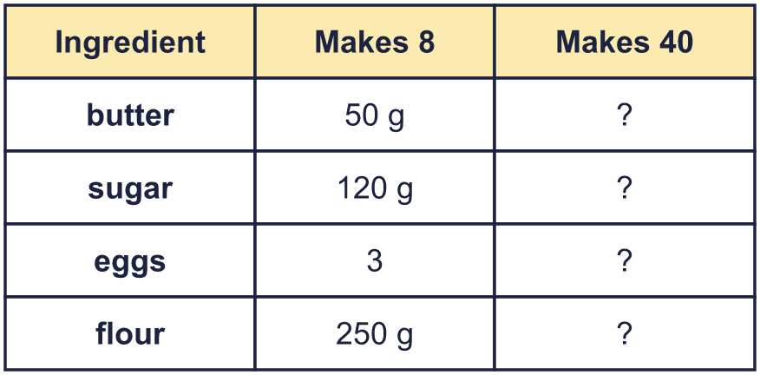  Hint: 40 is 5 times as many as 8. Multiply every amount by 5.
  12 | Here is a recipe for 8 cupcakes. Complete the recipe for 40 cupcakes.  Hint: 40 is 5 times as many as 8. Multiply every amount by 5.
  13 | Rosie has a roll of ribbon 8 m long. Rosie cuts it into pieces that are each 70 cm long.  How many whole pieces can Rosie cut? How much ribbon is left over?  Hint: Change 8 m to centimetres. Divide by 70. The remainder is the ribbon left over.
  13 | Rosie has a roll of ribbon 8 m long. Rosie cuts it into pieces that are each 70 cm long.  How many whole pieces can Rosie cut? How much ribbon is left over?  Hint: Change 8 m to centimetres. Divide by 70. The remainder is the ribbon left over.
  14 | Challenge  A bag has 250 sweets. Each sweet has a mass of 2.5 g. The empty bag has a mass of 20 g.  Huan has some full bags of sweets. Together they have a mass of 5.16 kg.  How many bags does Huan have?  Hint: Work out the mass of the sweets in one bag. Add the mass of the bag. Change the kilograms to grams, then divide.
  14 | Challenge  A bag has 250 sweets. Each sweet has a mass of 2.5 g. The empty bag has a mass of 20 g.  Huan has some full bags of sweets. Together they have a mass of 5.16 kg.  How many bags does Huan have?  Hint: Work out the mass of the sweets in one bag. Add the mass of the bag. Change the kilograms to grams, then divide.

Year 6 · Converting units · Step 3
Calculating with metric units
Answers (teacher copy)

Change to the same unit before you add or subtract:
  1 | A running track is 400 m all the way round. Jo runs 4 laps.  How far does Jo run? Write your answer in metres and in kilometres.  1,600 m  1.6 km  Hint: Multiply 400 by 4. To change metres to kilometres divide by 1,000.
  2 | Work out each answer. Change to the same unit first.  a) 2.3 km + 650 m = 2.95 km  b) 7.2 litres − 700 ml = 6.5 litres  c) 6.5 m + 200 cm = 850 cm  Hint: Write both amounts in the unit you want for the answer. Then add or subtract.
  3 | Work out each answer.  a) 350 ml × 5 = 1.75 litres  b) 25 cm × 5 = 1.25 m  c) 250 m × 4 = 1 km  Hint: Multiply first. Then change to the unit asked for.
  4 | Work out each answer. Give the answer in the unit shown.  a) 2.4 km ÷ 3 = 800 m  b) 5.5 km ÷ 5 = 1,100 m  c) 0.8 kg ÷ 8 = 100 g  Hint: Change the big unit to the small unit first. Then divide.
  5 | Ron has 2 litres of orange juice. Ron drinks 200 ml. Ron then shares the rest equally between 4 glasses.  How much juice is in each glass?  450 ml  Hint: Change the litres to millilitres. Take away 200 ml. Then divide by 4.
  6 | A rabbit is 65 cm long from its nose to the end of its tail. A kangaroo is 3 times as long.  How long is the kangaroo? Give your answer in metres.  1.95 m  Hint: Multiply 65 by 3. Then divide by 100 to change centimetres to metres.
  7 | A swimming pool is 50 m long. Rosie swims 1 km.  How many lengths of the pool does Rosie swim?  20 lengths  Hint: Change 1 km to metres. Then see how many 50 m lengths fit.
  8 | A pool is 25 m long. Eva swims 700 m. Amir swims 1.5 km.  How many more lengths does Amir swim than Eva?  32 lengths  Hint: Change the kilometres to metres. Find the difference in metres, then divide by 25.
  9 | Jo collects rainwater in a 1 litre jug.  On Monday Jo collects 250 ml. On Tuesday Jo collects 0.3 litres.  On Wednesday Jo collects some more. The jug now needs another 0.05 litres to be full.  How much water does Jo collect on Wednesday? Give your answer in millilitres.  400 ml  Hint: Add Monday and Tuesday in millilitres. The jug holds 1,000 ml. How much is missing before the last part?
  10 | Jack has a mass of 59.7 kg. Jack holds a suitcase and steps onto the scales. The scales show 74 kg 400 g.  What is the mass of the suitcase? Give your answer in kilograms.  14.7 kg  Hint: Change the scale reading to kilograms: 200 g is 0.2 kg. Then take away the mass of the person.
  11 | A bag of potatoes has a mass of 400 g. A box holds 15 bags.  What is the mass of 10 boxes of potatoes? Give your answer in kilograms.  60 kg  Hint: Work out the mass of one box in grams. Then multiply by 10. Then change grams to kilograms.
  12 | Here is a recipe for 8 cupcakes. Complete the recipe for 40 cupcakes.  butter: 250 g  sugar: 600 g  eggs: 15  flour: 1,250 g  Hint: 40 is 5 times as many as 8. Multiply every amount by 5.
  13 | Rosie has a roll of ribbon 8 m long. Rosie cuts it into pieces that are each 70 cm long.  How many whole pieces can Rosie cut? How much ribbon is left over?  Pieces: 11  Left over: 30 cm  Hint: Change 8 m to centimetres. Divide by 70. The remainder is the ribbon left over.
  14 | Challenge  A bag has 250 sweets. Each sweet has a mass of 2.5 g. The empty bag has a mass of 20 g.  Huan has some full bags of sweets. Together they have a mass of 5.16 kg.  How many bags does Huan have?  8 bags  Hint: Work out the mass of the sweets in one bag. Add the mass of the bag. Change the kilograms to grams, then divide.

