  Year 6 · Converting units · Step 3  Calculating with metric units | 
  Year 6 · Converting units · Step 3
  Calculating with metric units
  1 | A running track is 400 m all the way round. Jo runs 4 laps.  How far does Jo run? Write your answer in metres and in kilometres.
  1 | A running track is 400 m all the way round. Jo runs 4 laps.  How far does Jo run? Write your answer in metres and in kilometres.
  2 | Work out each answer. Change to the same unit first.  a) 2.3 km + 650 m = km  b) 7.2 litres − 700 ml = litres  c) 6.5 m + 200 cm = cm
  2 | Work out each answer. Change to the same unit first.  a) 2.3 km + 650 m = km  b) 7.2 litres − 700 ml = litres  c) 6.5 m + 200 cm = cm
  3 | Work out each answer.  a) 350 ml × 5 = litres  b) 25 cm × 5 = m  c) 250 m × 4 = km
  3 | Work out each answer.  a) 350 ml × 5 = litres  b) 25 cm × 5 = m  c) 250 m × 4 = km
  4 | Work out each answer. Give the answer in the unit shown.  a) 2.4 km ÷ 3 = m  b) 5.5 km ÷ 5 = m  c) 0.8 kg ÷ 8 = g
  4 | Work out each answer. Give the answer in the unit shown.  a) 2.4 km ÷ 3 = m  b) 5.5 km ÷ 5 = m  c) 0.8 kg ÷ 8 = g
  5 | Ron has 2 litres of orange juice. Ron drinks 200 ml. Ron then shares the rest equally between 4 glasses.  How much juice is in each glass?
  5 | Ron has 2 litres of orange juice. Ron drinks 200 ml. Ron then shares the rest equally between 4 glasses.  How much juice is in each glass?
  6 | A rabbit is 65 cm long from its nose to the end of its tail. A kangaroo is 3 times as long.  How long is the kangaroo? Give your answer in metres.
  6 | A rabbit is 65 cm long from its nose to the end of its tail. A kangaroo is 3 times as long.  How long is the kangaroo? Give your answer in metres.
  7 | A swimming pool is 50 m long. Rosie swims 1 km.  How many lengths of the pool does Rosie swim?
  7 | A swimming pool is 50 m long. Rosie swims 1 km.  How many lengths of the pool does Rosie swim?
  8 | A pool is 25 m long. Eva swims 700 m. Amir swims 1.5 km.  How many more lengths does Amir swim than Eva?
  8 | A pool is 25 m long. Eva swims 700 m. Amir swims 1.5 km.  How many more lengths does Amir swim than Eva?

  9 | Jo collects rainwater in a 1 litre jug.  On Monday Jo collects 250 ml. On Tuesday Jo collects 0.3 litres.  On Wednesday Jo collects some more. The jug now needs another 0.05 litres to be full.  How much water does Jo collect on Wednesday? Give your answer in millilitres.
  9 | Jo collects rainwater in a 1 litre jug.  On Monday Jo collects 250 ml. On Tuesday Jo collects 0.3 litres.  On Wednesday Jo collects some more. The jug now needs another 0.05 litres to be full.  How much water does Jo collect on Wednesday? Give your answer in millilitres.
  10 | Jack has a mass of 59.7 kg. Jack holds a suitcase and steps onto the scales. The scales show 74 kg 400 g.  What is the mass of the suitcase? Give your answer in kilograms.
  10 | Jack has a mass of 59.7 kg. Jack holds a suitcase and steps onto the scales. The scales show 74 kg 400 g.  What is the mass of the suitcase? Give your answer in kilograms.
  11 | A bag of potatoes has a mass of 400 g. A box holds 15 bags.  What is the mass of 10 boxes of potatoes? Give your answer in kilograms.
  11 | A bag of potatoes has a mass of 400 g. A box holds 15 bags.  What is the mass of 10 boxes of potatoes? Give your answer in kilograms.
  12 | Here is a recipe for 8 cupcakes. Complete the recipe for 40 cupcakes.  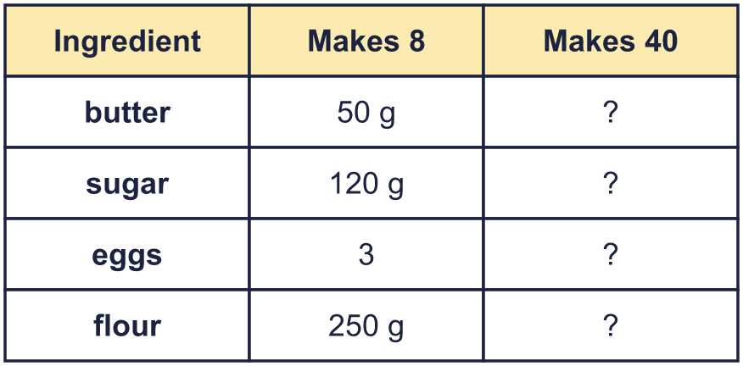
  12 | Here is a recipe for 8 cupcakes. Complete the recipe for 40 cupcakes.
  13 | Rosie has a roll of ribbon 8 m long. Rosie cuts it into pieces that are each 70 cm long.  How many whole pieces can Rosie cut? How much ribbon is left over?
  13 | Rosie has a roll of ribbon 8 m long. Rosie cuts it into pieces that are each 70 cm long.  How many whole pieces can Rosie cut? How much ribbon is left over?
  14 | Challenge  A bag has 250 sweets. Each sweet has a mass of 2.5 g. The empty bag has a mass of 20 g.  Huan has some full bags of sweets. Together they have a mass of 5.16 kg.  How many bags does Huan have?
  14 | Challenge  A bag has 250 sweets. Each sweet has a mass of 2.5 g. The empty bag has a mass of 20 g.  Huan has some full bags of sweets. Together they have a mass of 5.16 kg.  How many bags does Huan have?

Year 6 · Converting units · Step 3
Calculating with metric units
Answers (teacher copy)

  1 | A running track is 400 m all the way round. Jo runs 4 laps.  How far does Jo run? Write your answer in metres and in kilometres.  1,600 m  1.6 km
  2 | Work out each answer. Change to the same unit first.  a) 2.3 km + 650 m = 2.95 km  b) 7.2 litres − 700 ml = 6.5 litres  c) 6.5 m + 200 cm = 850 cm
  3 | Work out each answer.  a) 350 ml × 5 = 1.75 litres  b) 25 cm × 5 = 1.25 m  c) 250 m × 4 = 1 km
  4 | Work out each answer. Give the answer in the unit shown.  a) 2.4 km ÷ 3 = 800 m  b) 5.5 km ÷ 5 = 1,100 m  c) 0.8 kg ÷ 8 = 100 g
  5 | Ron has 2 litres of orange juice. Ron drinks 200 ml. Ron then shares the rest equally between 4 glasses.  How much juice is in each glass?  450 ml
  6 | A rabbit is 65 cm long from its nose to the end of its tail. A kangaroo is 3 times as long.  How long is the kangaroo? Give your answer in metres.  1.95 m
  7 | A swimming pool is 50 m long. Rosie swims 1 km.  How many lengths of the pool does Rosie swim?  20 lengths
  8 | A pool is 25 m long. Eva swims 700 m. Amir swims 1.5 km.  How many more lengths does Amir swim than Eva?  32 lengths
  9 | Jo collects rainwater in a 1 litre jug.  On Monday Jo collects 250 ml. On Tuesday Jo collects 0.3 litres.  On Wednesday Jo collects some more. The jug now needs another 0.05 litres to be full.  How much water does Jo collect on Wednesday? Give your answer in millilitres.  400 ml
  10 | Jack has a mass of 59.7 kg. Jack holds a suitcase and steps onto the scales. The scales show 74 kg 400 g.  What is the mass of the suitcase? Give your answer in kilograms.  14.7 kg
  11 | A bag of potatoes has a mass of 400 g. A box holds 15 bags.  What is the mass of 10 boxes of potatoes? Give your answer in kilograms.  60 kg
  12 | Here is a recipe for 8 cupcakes. Complete the recipe for 40 cupcakes.  butter: 250 g  sugar: 600 g  eggs: 15  flour: 1,250 g
  13 | Rosie has a roll of ribbon 8 m long. Rosie cuts it into pieces that are each 70 cm long.  How many whole pieces can Rosie cut? How much ribbon is left over?  Pieces: 11  Left over: 30 cm
  14 | Challenge  A bag has 250 sweets. Each sweet has a mass of 2.5 g. The empty bag has a mass of 20 g.  Huan has some full bags of sweets. Together they have a mass of 5.16 kg.  How many bags does Huan have?  8 bags

