  Year 6 · Add, subtract, multiply and divide · Step 11  Starting long division | 
  Year 6 · Add, subtract, multiply and divide · Step 11
  Starting long division
  1 | Use the multiples of 36 to work out each division.  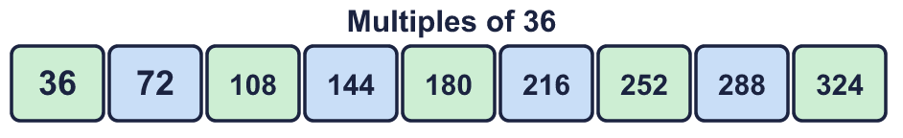  a) 72 ÷ 36 =  b) 252 ÷ 36 =  c) 324 ÷ 36 =  Hint: Find the number in the list. Count how many 36s it is: the first multiple is 1 × 36, the second is 2 × 36, and so on.
  1 | Use the multiples of 36 to work out each division.  a) 72 ÷ 36 =  b) 252 ÷ 36 =  c) 324 ÷ 36 =  Hint: Find the number in the list. Count how many 36s it is: the first multiple is 1 × 36, the second is 2 × 36, and so on.
  2 | Write the first five multiples of 17.  Hint: Start with 17. Add 17 again each time. Check: 2 × 17 = 34.
  2 | Write the first five multiples of 17.  Hint: Start with 17. Add 17 again each time. Check: 2 × 17 = 34.
  3 | Use long division to work out each division.  a) 456 ÷ 24 =  b) 943 ÷ 23 =  Hint: Write the multiples of the divisor first. Then see how many fit into the first digits of the number, and subtract.  Worked example: 420 ÷ 14. Use the multiples of 14 to take the biggest group away each time.  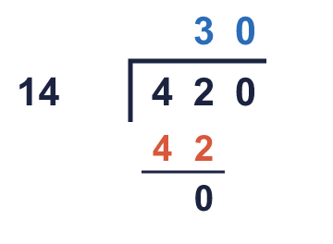
  3 | Use long division to work out each division.  a) 456 ÷ 24 =  b) 943 ÷ 23 =  Hint: Write the multiples of the divisor first. Then see how many fit into the first digits of the number, and subtract.  Worked example: 420 ÷ 14. Use the multiples of 14 to take the biggest group away each time.
  4 | Use long division to work out each division.  a) 1,504 ÷ 16 =  b) 3,408 ÷ 24 =  Hint: Work from the left. Say: how many groups of the divisor fit into the first digits? Write the digit above, subtract, bring down the next digit.
  4 | Use long division to work out each division.  a) 1,504 ÷ 16 =  b) 3,408 ÷ 24 =  Hint: Work from the left. Say: how many groups of the divisor fit into the first digits? Write the digit above, subtract, bring down the next digit.
  5 | A rectangular garden has an area of 3,480 m². It is 24 m long.  Hint: Area = length × width, so width = area ÷ length. Use long division.
    What is the width of the garden?
    m
  5 | A rectangular garden has an area of 3,480 m². It is 24 m long.  Hint: Area = length × width, so width = area ÷ length. Use long division.
    What is the width of the garden?
    m
  6 | Which of these divisions give the answer 29? Write the letters.  a) 1,015 ÷ 35  b) 1,704 ÷ 24  c) 936 ÷ 36  Hint: Check each one by multiplying: answer × divisor should make the number.
  6 | Which of these divisions give the answer 29? Write the letters.  a) 1,015 ÷ 35  b) 1,704 ÷ 24  c) 936 ÷ 36  Hint: Check each one by multiplying: answer × divisor should make the number.
  7 | Amir sews 17 stars and 29 hearts onto each flag. He has 408 stars and 1160 hearts.  How many flags can he complete?  Hint: Find how many flags the stars make, then how many the hearts make. He can only make as many as the smaller number.
  7 | Amir sews 17 stars and 29 hearts onto each flag. He has 408 stars and 1160 hearts.  How many flags can he complete?  Hint: Find how many flags the stars make, then how many the hearts make. He can only make as many as the smaller number.
  8 | Write the missing number.  Hint: Divide 4,851 by 63. Or ask: 63 × what = 4,851?
    4,851 ÷ |  | = 63
  8 | Write the missing number.  Hint: Divide 4,851 by 63. Or ask: 63 × what = 4,851?
    4,851 ÷ |  | = 63

  9 | Complete the calculation.  Hint: Work out 252 × 5. Then use long division to divide it by 35.
    252 × 5 = |  | × 35
  9 | Complete the calculation.  Hint: Work out 252 × 5. Then use long division to divide it by 35.
    252 × 5 = |  | × 35
  10 | A water tank holds 2,312 litres. It must last for 17 days.  How many litres can be used each day?  Hint: Share the litres equally between the days. Use long division.
  10 | A water tank holds 2,312 litres. It must last for 17 days.  How many litres can be used each day?  Hint: Share the litres equally between the days. Use long division.
  11 | Is Boba correct? Circle yes or no.  Yes / No  Explain how you know. Use multiplication to check.  Hint: Multiply the answer by the divisor. You should get back to the number you started with.
     | 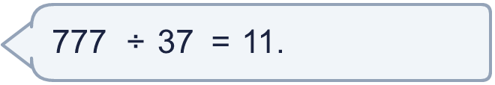
  11 | Is Boba correct? Circle yes or no.  Yes / No  Explain how you know. Use multiplication to check.  Hint: Multiply the answer by the divisor. You should get back to the number you started with.
  12 | • It is a multiple of 19.  • The hundreds digit is 4.  • The ones digit is 6.  What is my number?  Hint: List the 3-digit multiples of 19 that fit the clues. Use long division to check a number: does 19 go into it exactly?
    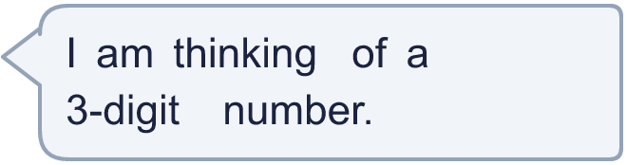
  12 | • It is a multiple of 19.  • The hundreds digit is 4.  • The ones digit is 6.  What is my number?  Hint: List the 3-digit multiples of 19 that fit the clues. Use long division to check a number: does 19 go into it exactly?
  13 | A factory packs 3,465 biscuits into boxes. Each box holds 77 biscuits.  How many boxes are filled?  Hint: Divide the number of biscuits by the number in each box. Use long division and the multiples of 77.
  13 | A factory packs 3,465 biscuits into boxes. Each box holds 77 biscuits.  How many boxes are filled?  Hint: Divide the number of biscuits by the number in each box. Use long division and the multiples of 77.
  14 | Write two different long divisions that have the answer 30. Each one must be a 3-digit number ÷ a 2-digit number.  Hint: Pick a 2-digit number. Multiply it by 30. That gives the number to divide.
  14 | Write two different long divisions that have the answer 30. Each one must be a 3-digit number ÷ a 2-digit number.  Hint: Pick a 2-digit number. Multiply it by 30. That gives the number to divide.

Year 6 · Add, subtract, multiply and divide · Step 11
Starting long division
Answers (teacher copy)

  1 | Use the multiples of 36 to work out each division.  a) 72 ÷ 36 = 2  b) 252 ÷ 36 = 7  c) 324 ÷ 36 = 9  Hint: Find the number in the list. Count how many 36s it is: the first multiple is 1 × 36, the second is 2 × 36, and so on.
  2 | Write the first five multiples of 17.  17, 34, 51, 68, 85  Hint: Start with 17. Add 17 again each time. Check: 2 × 17 = 34.
  3 | Use long division to work out each division.  a) 456 ÷ 24 = 19  b) 943 ÷ 23 = 41  Hint: Write the multiples of the divisor first. Then see how many fit into the first digits of the number, and subtract.  Worked example: 420 ÷ 14. Use the multiples of 14 to take the biggest group away each time.
  4 | Use long division to work out each division.  a) 1,504 ÷ 16 = 94  b) 3,408 ÷ 24 = 142  Hint: Work from the left. Say: how many groups of the divisor fit into the first digits? Write the digit above, subtract, bring down the next digit.
  5 | A rectangular garden has an area of 3,480 m². It is 24 m long.  What is the width of the garden? 145 m  Hint: Area = length × width, so width = area ÷ length. Use long division.
  6 | Which of these divisions give the answer 29? Write the letters.  a) 1,015 ÷ 35  b) 1,704 ÷ 24  c) 936 ÷ 36  a  Hint: Check each one by multiplying: answer × divisor should make the number.
  7 | Amir sews 17 stars and 29 hearts onto each flag. He has 408 stars and 1160 hearts.  How many flags can he complete? 24  Hint: Find how many flags the stars make, then how many the hearts make. He can only make as many as the smaller number.
  8 | Write the missing number.  4,851 ÷ 77 = 63  Hint: Divide 4,851 by 63. Or ask: 63 × what = 4,851?
  9 | Complete the calculation.  252 × 5 = 36 × 35  Hint: Work out 252 × 5. Then use long division to divide it by 35.
  10 | A water tank holds 2,312 litres. It must last for 17 days.  How many litres can be used each day? 136  Hint: Share the litres equally between the days. Use long division.
  11 | Is Boba correct? Circle yes or no.  Yes / No  Explain how you know. Use multiplication to check.  11 × 37 = 407, not 777. The correct answer is 21, because 21 × 37 = 777.  Hint: Multiply the answer by the divisor. You should get back to the number you started with.
  12 | • It is a multiple of 19.  • The hundreds digit is 4.  • The ones digit is 6.  What is my number? 456  Hint: List the 3-digit multiples of 19 that fit the clues. Use long division to check a number: does 19 go into it exactly?
  13 | A factory packs 3,465 biscuits into boxes. Each box holds 77 biscuits.  How many boxes are filled? 45  Hint: Divide the number of biscuits by the number in each box. Use long division and the multiples of 77.
  14 | Write two different long divisions that have the answer 30. Each one must be a 3-digit number ÷ a 2-digit number.  Any two divisions with answer 30, for example 420 ÷ 14 or 360 ÷ 12  Hint: Pick a 2-digit number. Multiply it by 30. That gives the number to divide.

