  Year 6 · Add, subtract, multiply and divide · Step 11  Starting long division | 
  Year 6 · Add, subtract, multiply and divide · Step 11
  Starting long division
  1 | Use the multiples of 36 to work out each division.  a) 72 ÷ 36 =  b) 252 ÷ 36 =  c) 324 ÷ 36 =
  1 | Use the multiples of 36 to work out each division.  a) 72 ÷ 36 =  b) 252 ÷ 36 =  c) 324 ÷ 36 =
  2 | Write the first five multiples of 17.
  2 | Write the first five multiples of 17.
  3 | Use long division to work out each division.  a) 456 ÷ 24 =  b) 943 ÷ 23 =
  3 | Use long division to work out each division.  a) 456 ÷ 24 =  b) 943 ÷ 23 =
  4 | Use long division to work out each division.  a) 1,504 ÷ 16 =  b) 3,408 ÷ 24 =
  4 | Use long division to work out each division.  a) 1,504 ÷ 16 =  b) 3,408 ÷ 24 =
  5 | A rectangular garden has an area of 3,480 m². It is 24 m long.
    What is the width of the garden?
    m
  5 | A rectangular garden has an area of 3,480 m². It is 24 m long.
    What is the width of the garden?
    m
  6 | Which of these divisions give the answer 29? Write the letters.  a) 1,015 ÷ 35  b) 1,704 ÷ 24  c) 936 ÷ 36
  6 | Which of these divisions give the answer 29? Write the letters.  a) 1,015 ÷ 35  b) 1,704 ÷ 24  c) 936 ÷ 36
  7 | Amir sews 17 stars and 29 hearts onto each flag. He has 408 stars and 1160 hearts.  How many flags can he complete?
  7 | Amir sews 17 stars and 29 hearts onto each flag. He has 408 stars and 1160 hearts.  How many flags can he complete?
  8 | Write the missing number.
    4,851 ÷ |  | = 63
  8 | Write the missing number.
    4,851 ÷ |  | = 63

  9 | Complete the calculation.
    252 × 5 = |  | × 35
  9 | Complete the calculation.
    252 × 5 = |  | × 35
  10 | A water tank holds 2,312 litres. It must last for 17 days.  How many litres can be used each day?
  10 | A water tank holds 2,312 litres. It must last for 17 days.  How many litres can be used each day?
  11 | Is Boba correct? Circle yes or no.  Yes / No  Explain how you know. Use multiplication to check.
     | 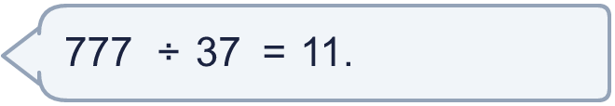
  11 | Is Boba correct? Circle yes or no.  Yes / No  Explain how you know. Use multiplication to check.
  12 | • It is a multiple of 19.  • The hundreds digit is 4.  • The ones digit is 6.  What is my number?
    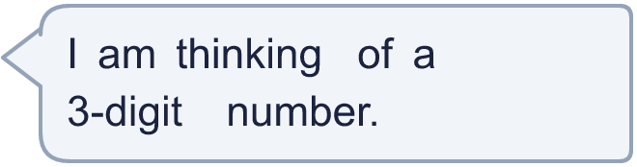
  12 | • It is a multiple of 19.  • The hundreds digit is 4.  • The ones digit is 6.  What is my number?
  13 | A factory packs 3,465 biscuits into boxes. Each box holds 77 biscuits.  How many boxes are filled?
  13 | A factory packs 3,465 biscuits into boxes. Each box holds 77 biscuits.  How many boxes are filled?
  14 | Write two different long divisions that have the answer 30. Each one must be a 3-digit number ÷ a 2-digit number.
  14 | Write two different long divisions that have the answer 30. Each one must be a 3-digit number ÷ a 2-digit number.

Year 6 · Add, subtract, multiply and divide · Step 11
Starting long division
Answers (teacher copy)

  1 | Use the multiples of 36 to work out each division.  a) 72 ÷ 36 = 2  b) 252 ÷ 36 = 7  c) 324 ÷ 36 = 9
  2 | Write the first five multiples of 17.  17, 34, 51, 68, 85
  3 | Use long division to work out each division.  a) 456 ÷ 24 = 19  b) 943 ÷ 23 = 41
  4 | Use long division to work out each division.  a) 1,504 ÷ 16 = 94  b) 3,408 ÷ 24 = 142
  5 | A rectangular garden has an area of 3,480 m². It is 24 m long.  What is the width of the garden? 145 m
  6 | Which of these divisions give the answer 29? Write the letters.  a) 1,015 ÷ 35  b) 1,704 ÷ 24  c) 936 ÷ 36  a
  7 | Amir sews 17 stars and 29 hearts onto each flag. He has 408 stars and 1160 hearts.  How many flags can he complete? 24
  8 | Write the missing number.  4,851 ÷ 77 = 63
  9 | Complete the calculation.  252 × 5 = 36 × 35
  10 | A water tank holds 2,312 litres. It must last for 17 days.  How many litres can be used each day? 136
  11 | Is Boba correct? Circle yes or no.  Yes / No  Explain how you know. Use multiplication to check.  11 × 37 = 407, not 777. The correct answer is 21, because 21 × 37 = 777.
  12 | • It is a multiple of 19.  • The hundreds digit is 4.  • The ones digit is 6.  What is my number? 456
  13 | A factory packs 3,465 biscuits into boxes. Each box holds 77 biscuits.  How many boxes are filled? 45
  14 | Write two different long divisions that have the answer 30. Each one must be a 3-digit number ÷ a 2-digit number.  Any two divisions with answer 30, for example 420 ÷ 14 or 360 ÷ 12

