  Year 6 · Add, subtract, multiply and divide · Step 9  Short division | 
  Year 6 · Add, subtract, multiply and divide · Step 9
  Short division
  1 | Look at the pattern. Work out the divisions.  a) 35 ÷ 5 =  b) 350 ÷ 5 =  c) 3,500 ÷ 5 =  d) 35,000 ÷ 5 =  Hint: Each time the number you divide gets 10 times bigger, the answer gets 10 times bigger. Start from 35 ÷ 5.
  1 | Look at the pattern. Work out the divisions.  a) 35 ÷ 5 =  b) 350 ÷ 5 =  c) 3,500 ÷ 5 =  d) 35,000 ÷ 5 =  Hint: Each time the number you divide gets 10 times bigger, the answer gets 10 times bigger. Start from 35 ÷ 5.
  2 | Use short division to work out each division.  a) 684 ÷ 6 =  b) 8,814 ÷ 6 =  c) 9,000 ÷ 8 =  Hint: Divide one digit at a time from the left. If a digit is too small, carry it to the next column.  Worked example: 180 ÷ 3. Carry the remainder to the next digit.  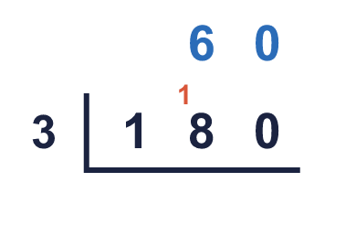
  2 | Use short division to work out each division.  a) 684 ÷ 6 =  b) 8,814 ÷ 6 =  c) 9,000 ÷ 8 =  Hint: Divide one digit at a time from the left. If a digit is too small, carry it to the next column.  Worked example: 180 ÷ 3. Carry the remainder to the next digit.
  3 | Work out the divisions. Write any remainder like this: 56 r 3.  a) 964 ÷ 5 =  b) 867 ÷ 6 =  c) 7,023 ÷ 5 =  Hint: When you reach the last digit, what is left over is the remainder. It must be smaller than the number you divide by.  Worked example: 199 ÷ 7. Carry the remainder to the next digit.  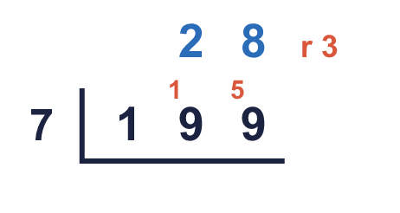
  3 | Work out the divisions. Write any remainder like this: 56 r 3.  a) 964 ÷ 5 =  b) 867 ÷ 6 =  c) 7,023 ÷ 5 =  Hint: When you reach the last digit, what is left over is the remainder. It must be smaller than the number you divide by.  Worked example: 199 ÷ 7. Carry the remainder to the next digit.
  4 | Write the remainder when 776 is divided by each number.  ÷ 2, ÷ 3, ÷ 4, ÷ 5, ÷ 6:  Hint: Do each division on its own. The remainder is what is left after the last whole group.
  4 | Write the remainder when 776 is divided by each number.  ÷ 2, ÷ 3, ÷ 4, ÷ 5, ÷ 6:  Hint: Do each division on its own. The remainder is what is left after the last whole group.
  5 | Complete the calculations.  a) 411 ÷ 5 =  b) 8,257 ÷ 8 =  Hint: Remember to write the remainder, for example 127 r 2.
  5 | Complete the calculations.  a) 411 ÷ 5 =  b) 8,257 ÷ 8 =  Hint: Remember to write the remainder, for example 127 r 2.
  6 | Work out the division.  five thousand divided by 13 =  Hint: Write the number in digits first. Then use short division. A big remainder needs you to carry more.
  6 | Work out the division.  five thousand divided by 13 =  Hint: Write the number in digits first. Then use short division. A big remainder needs you to carry more.
  7 | Farm workers pick 38,191 strawberries. They are sold in boxes of 7.  How many full boxes can be made?  1,457 people want to ride a ride that holds 7 people at a time.  How many times must the ride go round?  Hint: a) Divide: ignore the remainder because only FULL boxes count. b) Divide, then round UP if there is a remainder: a ride with only a few people still has to go.
  7 | Farm workers pick 38,191 strawberries. They are sold in boxes of 7.  How many full boxes can be made?  1,457 people want to ride a ride that holds 7 people at a time.  How many times must the ride go round?  Hint: a) Divide: ignore the remainder because only FULL boxes count. b) Divide, then round UP if there is a remainder: a ride with only a few people still has to go.
  8 | Write the missing number.  Hint: Division and multiplication are opposites. Multiply the answer by the number you divide by.
    a) |  | ÷ 7 = 132
    b) |  | ÷ 12 = 84
  8 | Write the missing number.  Hint: Division and multiplication are opposites. Multiply the answer by the number you divide by.
    a) |  | ÷ 7 = 132
    b) |  | ÷ 12 = 84

  9 | • I divide it by 4 and the remainder is 1.  • I divide it by 5 and the remainder is 1.  • I divide it by 7 and the remainder is 1.  What is my number?  Hint: The number is 1 more than a number that 4, 5, 7 all divide into exactly. Find a common multiple of 4, 5, 7 first.
     | 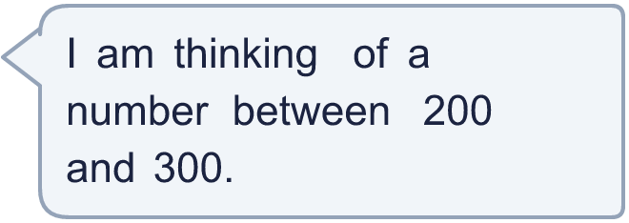
  9 | • I divide it by 4 and the remainder is 1.  • I divide it by 5 and the remainder is 1.  • I divide it by 7 and the remainder is 1.  What is my number?  Hint: The number is 1 more than a number that 4, 5, 7 all divide into exactly. Find a common multiple of 4, 5, 7 first.
  10 | Work out the missing number.  Hint: Work out 48 × 33 first. Then divide it by 8 to find the missing number.
    48 × 33 = |  | × 8
  10 | Work out the missing number.  Hint: Work out 48 × 33 first. Then divide it by 8 to find the missing number.
    48 × 33 = |  | × 8
  11 | Is Boba correct? Circle yes or no.  Yes / No  Explain how you know.  Hint: A remainder is always smaller than the number you divide by.
     | 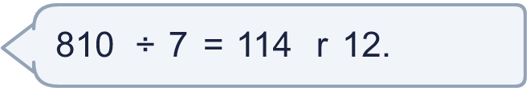
  11 | Is Boba correct? Circle yes or no.  Yes / No  Explain how you know.  Hint: A remainder is always smaller than the number you divide by.
  12 | a) How many times must the ride go round so that everyone rides once?  b) How many people are on the last ride?  Hint: a) Divide. If there is a remainder, one more ride is needed. b) The remainder is the number of people on the last ride.
     | 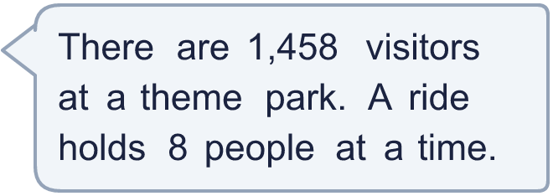
  12 | a) How many times must the ride go round so that everyone rides once?  b) How many people are on the last ride?  Hint: a) Divide. If there is a remainder, one more ride is needed. b) The remainder is the number of people on the last ride.
  13 | Which is greater: 4,081 ÷ 3 or four thousand nine hundred and thirty-six ÷ 3?  Write a or b. (a is the first calculation.)  Hint: Work out both divisions, with their remainders. Compare the whole-number parts first, then the remainders.
  13 | Which is greater: 4,081 ÷ 3 or four thousand nine hundred and thirty-six ÷ 3?  Write a or b. (a is the first calculation.)  Hint: Work out both divisions, with their remainders. Compare the whole-number parts first, then the remainders.
  14 | Write three different 4-digit numbers that leave a remainder of 6 when divided by 7.  Hint: Pick any number in the 7 times table, then add 6. Make sure it has 4 digits.
  14 | Write three different 4-digit numbers that leave a remainder of 6 when divided by 7.  Hint: Pick any number in the 7 times table, then add 6. Make sure it has 4 digits.

Year 6 · Add, subtract, multiply and divide · Step 9
Short division
Answers (teacher copy)

  1 | Look at the pattern. Work out the divisions.  a) 35 ÷ 5 = 7  b) 350 ÷ 5 = 70  c) 3,500 ÷ 5 = 700  d) 35,000 ÷ 5 = 7,000  Hint: Each time the number you divide gets 10 times bigger, the answer gets 10 times bigger. Start from 35 ÷ 5.
  2 | Use short division to work out each division.  a) 684 ÷ 6 = 114  b) 8,814 ÷ 6 = 1,469  c) 9,000 ÷ 8 = 1,125  Hint: Divide one digit at a time from the left. If a digit is too small, carry it to the next column.  Worked example: 180 ÷ 3. Carry the remainder to the next digit.
  3 | Work out the divisions. Write any remainder like this: 56 r 3.  a) 964 ÷ 5 = 192 r 4  b) 867 ÷ 6 = 144 r 3  c) 7,023 ÷ 5 = 1,404 r 3  Hint: When you reach the last digit, what is left over is the remainder. It must be smaller than the number you divide by.  Worked example: 199 ÷ 7. Carry the remainder to the next digit.
  4 | Write the remainder when 776 is divided by each number.  ÷ 2, ÷ 3, ÷ 4, ÷ 5, ÷ 6: 0, 2, 0, 1, 2  Hint: Do each division on its own. The remainder is what is left after the last whole group.
  5 | Complete the calculations.  a) 411 ÷ 5 = 82 r 1  b) 8,257 ÷ 8 = 1,032 r 1  Hint: Remember to write the remainder, for example 127 r 2.
  6 | Work out the division.  five thousand divided by 13 = 384 r 8  Hint: Write the number in digits first. Then use short division. A big remainder needs you to carry more.
  7 | Farm workers pick 38,191 strawberries. They are sold in boxes of 7.  How many full boxes can be made? 5,455  1,457 people want to ride a ride that holds 7 people at a time.  How many times must the ride go round? 209  Hint: a) Divide: ignore the remainder because only FULL boxes count. b) Divide, then round UP if there is a remainder: a ride with only a few people still has to go.
  8 | Write the missing number.  a) 924 ÷ 7 = 132  b) 1,008 ÷ 12 = 84  Hint: Division and multiplication are opposites. Multiply the answer by the number you divide by.
  9 | • I divide it by 4 and the remainder is 1.  • I divide it by 5 and the remainder is 1.  • I divide it by 7 and the remainder is 1.  What is my number? 281  Hint: The number is 1 more than a number that 4, 5, 7 all divide into exactly. Find a common multiple of 4, 5, 7 first.
  10 | Work out the missing number.  48 × 33 = 198 × 8  Hint: Work out 48 × 33 first. Then divide it by 8 to find the missing number.
  11 | Is Boba correct? Circle yes or no.  Yes / No  Explain how you know.  The remainder 12 is bigger than 7, so another group of 7 can be made. 810 ÷ 7 = 115 r 5.  Hint: A remainder is always smaller than the number you divide by.
  12 | a) How many times must the ride go round so that everyone rides once? 183  b) How many people are on the last ride? 2  Hint: a) Divide. If there is a remainder, one more ride is needed. b) The remainder is the number of people on the last ride.
  13 | Which is greater: 4,081 ÷ 3 or four thousand nine hundred and thirty-six ÷ 3?  Write a or b. (a is the first calculation.) b  Hint: Work out both divisions, with their remainders. Compare the whole-number parts first, then the remainders.
  14 | Write three different 4-digit numbers that leave a remainder of 6 when divided by 7.  Any three 4-digit numbers with remainder 6 when divided by 7, for example 1,007, 2,106, 3,212  Hint: Pick any number in the 7 times table, then add 6. Make sure it has 4 digits.

