  Year 6 · Add, subtract, multiply and divide · Step 9  Short division | 
  Year 6 · Add, subtract, multiply and divide · Step 9
  Short division
  1 | Look at the pattern. Work out the divisions.  a) 35 ÷ 5 =  b) 350 ÷ 5 =  c) 3,500 ÷ 5 =  d) 35,000 ÷ 5 =
  1 | Look at the pattern. Work out the divisions.  a) 35 ÷ 5 =  b) 350 ÷ 5 =  c) 3,500 ÷ 5 =  d) 35,000 ÷ 5 =
  2 | Use short division to work out each division.  a) 684 ÷ 6 =  b) 8,814 ÷ 6 =  c) 9,000 ÷ 8 =
  2 | Use short division to work out each division.  a) 684 ÷ 6 =  b) 8,814 ÷ 6 =  c) 9,000 ÷ 8 =
  3 | Work out the divisions. Write any remainder like this: 56 r 3.  a) 964 ÷ 5 =  b) 867 ÷ 6 =  c) 7,023 ÷ 5 =
  3 | Work out the divisions. Write any remainder like this: 56 r 3.  a) 964 ÷ 5 =  b) 867 ÷ 6 =  c) 7,023 ÷ 5 =
  4 | Write the remainder when 776 is divided by each number.  ÷ 2, ÷ 3, ÷ 4, ÷ 5, ÷ 6:
  4 | Write the remainder when 776 is divided by each number.  ÷ 2, ÷ 3, ÷ 4, ÷ 5, ÷ 6:
  5 | Complete the calculations.  a) 411 ÷ 5 =  b) 8,257 ÷ 8 =
  5 | Complete the calculations.  a) 411 ÷ 5 =  b) 8,257 ÷ 8 =
  6 | Work out the division.  five thousand divided by 13 =
  6 | Work out the division.  five thousand divided by 13 =
  7 | Farm workers pick 38,191 strawberries. They are sold in boxes of 7.  How many full boxes can be made?  1,457 people want to ride a ride that holds 7 people at a time.  How many times must the ride go round?
  7 | Farm workers pick 38,191 strawberries. They are sold in boxes of 7.  How many full boxes can be made?  1,457 people want to ride a ride that holds 7 people at a time.  How many times must the ride go round?
  8 | Write the missing number.
    a) |  | ÷ 7 = 132
    b) |  | ÷ 12 = 84
  8 | Write the missing number.
    a) |  | ÷ 7 = 132
    b) |  | ÷ 12 = 84

  9 | • I divide it by 4 and the remainder is 1.  • I divide it by 5 and the remainder is 1.  • I divide it by 7 and the remainder is 1.  What is my number?
     | 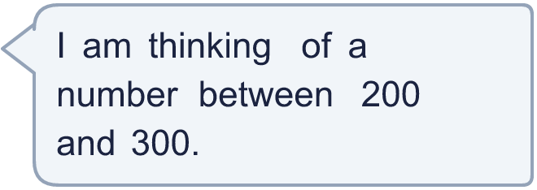
  9 | • I divide it by 4 and the remainder is 1.  • I divide it by 5 and the remainder is 1.  • I divide it by 7 and the remainder is 1.  What is my number?
  10 | Work out the missing number.
    48 × 33 = |  | × 8
  10 | Work out the missing number.
    48 × 33 = |  | × 8
  11 | Is Boba correct? Circle yes or no.  Yes / No  Explain how you know.
     | 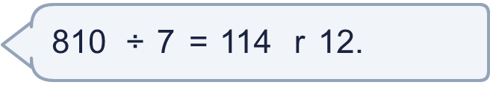
  11 | Is Boba correct? Circle yes or no.  Yes / No  Explain how you know.
  12 | a) How many times must the ride go round so that everyone rides once?  b) How many people are on the last ride?
     | 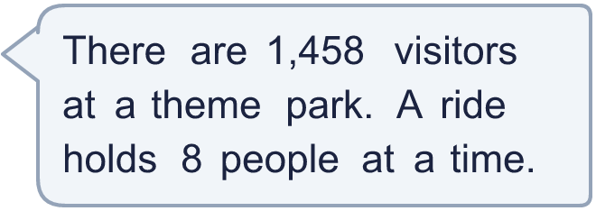
  12 | a) How many times must the ride go round so that everyone rides once?  b) How many people are on the last ride?
  13 | Which is greater: 4,081 ÷ 3 or four thousand nine hundred and thirty-six ÷ 3?  Write a or b. (a is the first calculation.)
  13 | Which is greater: 4,081 ÷ 3 or four thousand nine hundred and thirty-six ÷ 3?  Write a or b. (a is the first calculation.)
  14 | Write three different 4-digit numbers that leave a remainder of 6 when divided by 7.
  14 | Write three different 4-digit numbers that leave a remainder of 6 when divided by 7.

Year 6 · Add, subtract, multiply and divide · Step 9
Short division
Answers (teacher copy)

  1 | Look at the pattern. Work out the divisions.  a) 35 ÷ 5 = 7  b) 350 ÷ 5 = 70  c) 3,500 ÷ 5 = 700  d) 35,000 ÷ 5 = 7,000
  2 | Use short division to work out each division.  a) 684 ÷ 6 = 114  b) 8,814 ÷ 6 = 1,469  c) 9,000 ÷ 8 = 1,125
  3 | Work out the divisions. Write any remainder like this: 56 r 3.  a) 964 ÷ 5 = 192 r 4  b) 867 ÷ 6 = 144 r 3  c) 7,023 ÷ 5 = 1,404 r 3
  4 | Write the remainder when 776 is divided by each number.  ÷ 2, ÷ 3, ÷ 4, ÷ 5, ÷ 6: 0, 2, 0, 1, 2
  5 | Complete the calculations.  a) 411 ÷ 5 = 82 r 1  b) 8,257 ÷ 8 = 1,032 r 1
  6 | Work out the division.  five thousand divided by 13 = 384 r 8
  7 | Farm workers pick 38,191 strawberries. They are sold in boxes of 7.  How many full boxes can be made? 5,455  1,457 people want to ride a ride that holds 7 people at a time.  How many times must the ride go round? 209
  8 | Write the missing number.  a) 924 ÷ 7 = 132  b) 1,008 ÷ 12 = 84
  9 | • I divide it by 4 and the remainder is 1.  • I divide it by 5 and the remainder is 1.  • I divide it by 7 and the remainder is 1.  What is my number? 281
  10 | Work out the missing number.  48 × 33 = 198 × 8
  11 | Is Boba correct? Circle yes or no.  Yes / No  Explain how you know.  The remainder 12 is bigger than 7, so another group of 7 can be made. 810 ÷ 7 = 115 r 5.
  12 | a) How many times must the ride go round so that everyone rides once? 183  b) How many people are on the last ride? 2
  13 | Which is greater: 4,081 ÷ 3 or four thousand nine hundred and thirty-six ÷ 3?  Write a or b. (a is the first calculation.) b
  14 | Write three different 4-digit numbers that leave a remainder of 6 when divided by 7.  Any three 4-digit numbers with remainder 6 when divided by 7, for example 1,007, 2,106, 3,212

